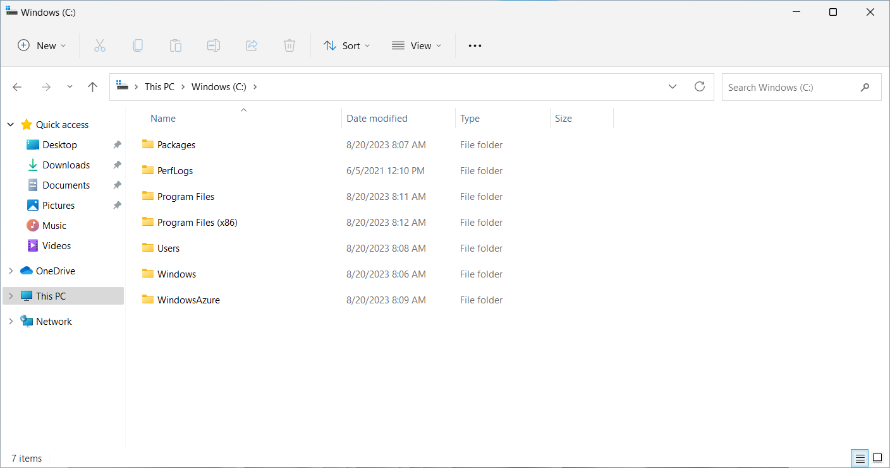

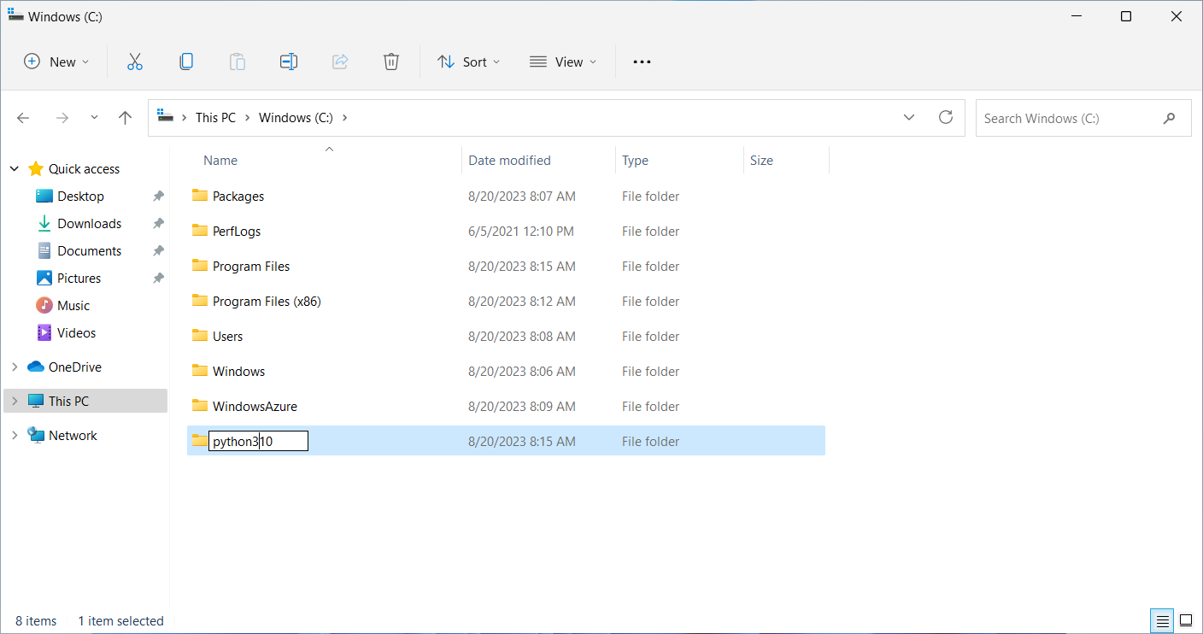

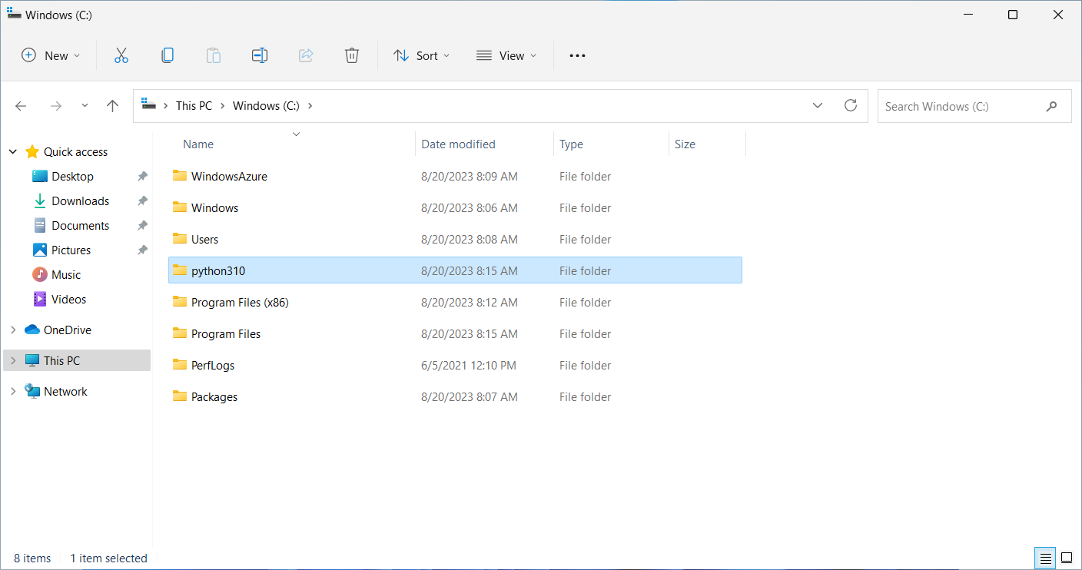

下載 python 3.10

[Python Release Python 3.10.0 | Python.org](https://www.python.org/downloads/release/python-3100/)

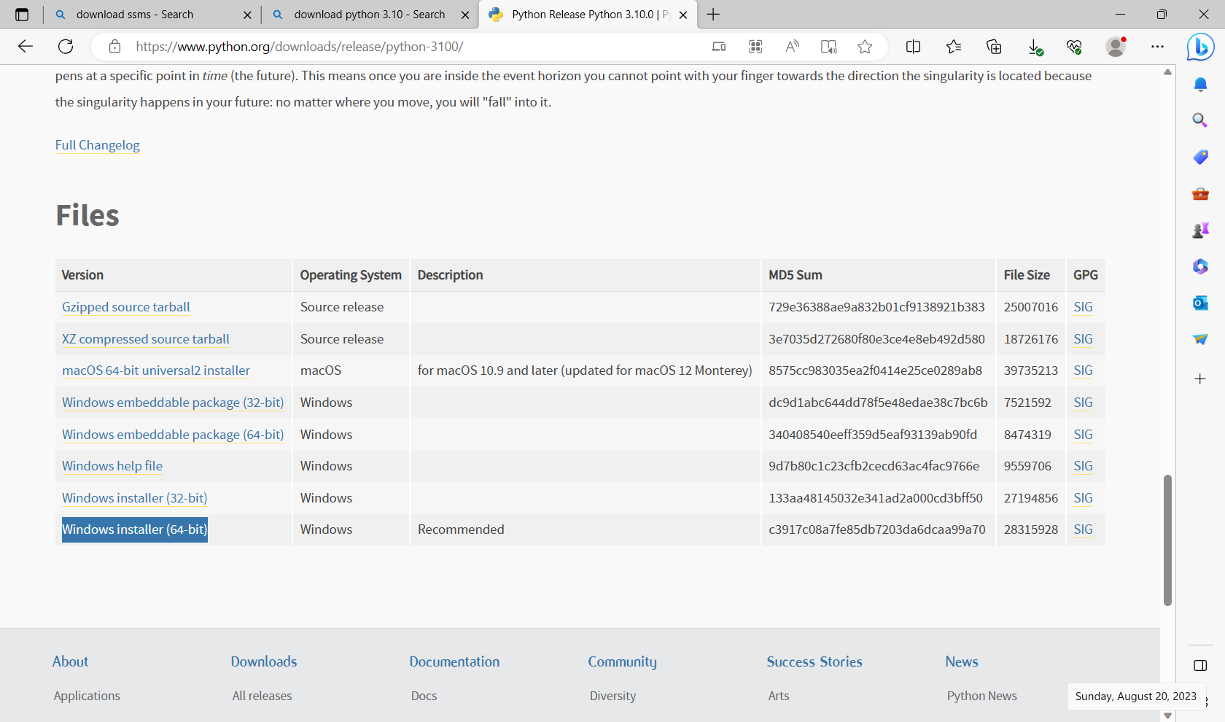

準備安裝python 3.10

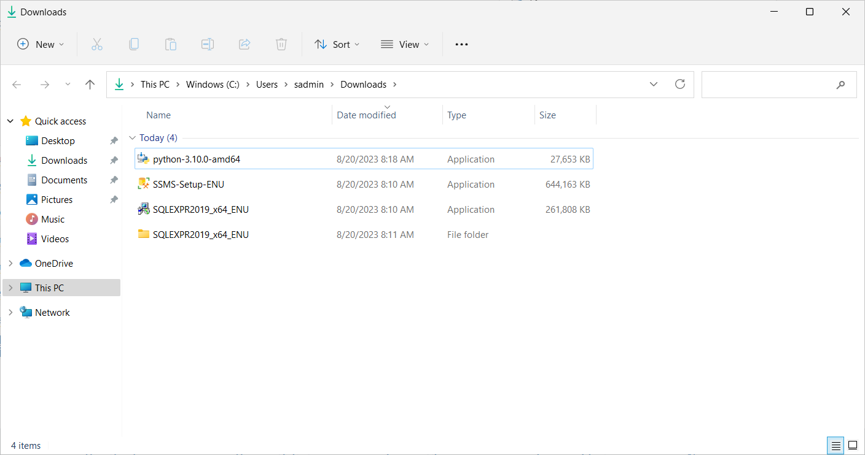

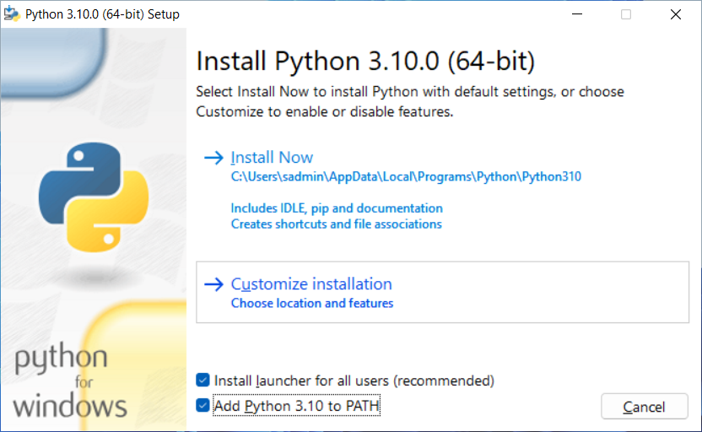

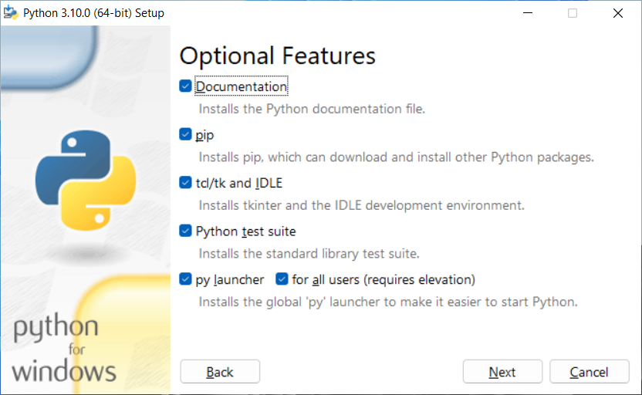

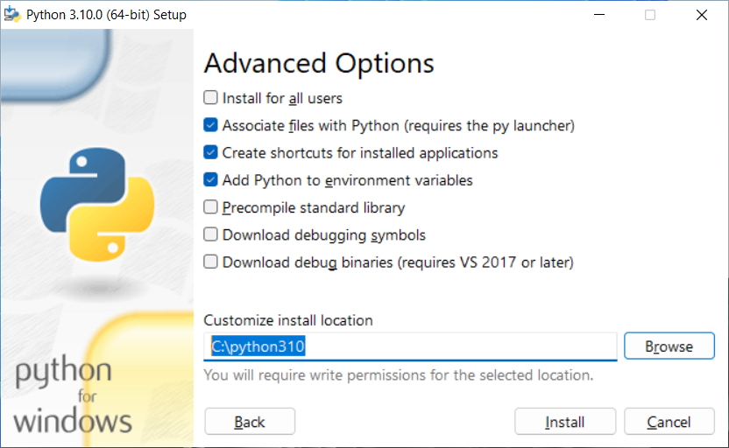

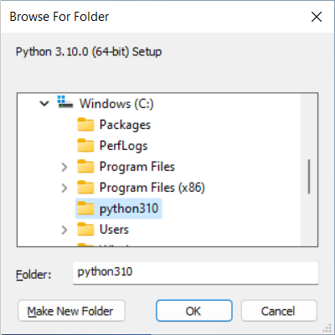

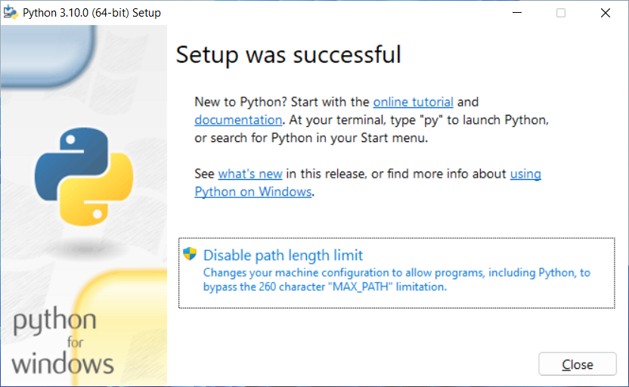

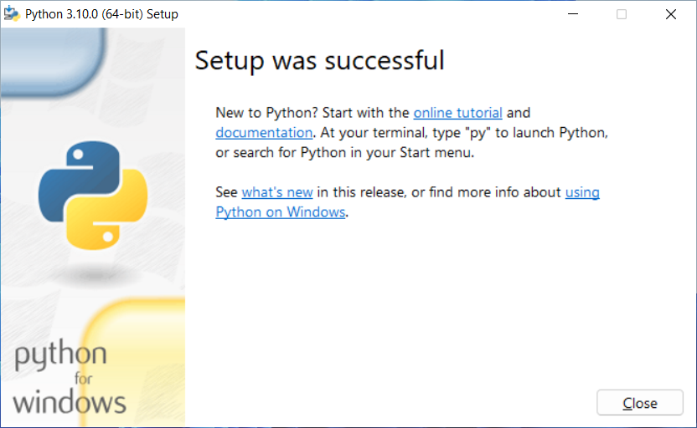

開命列列 CMD

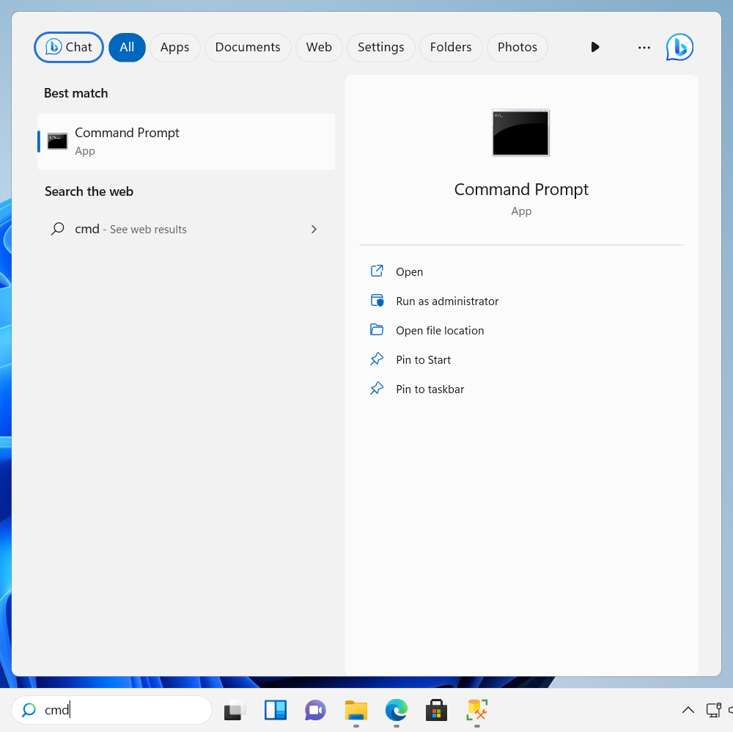

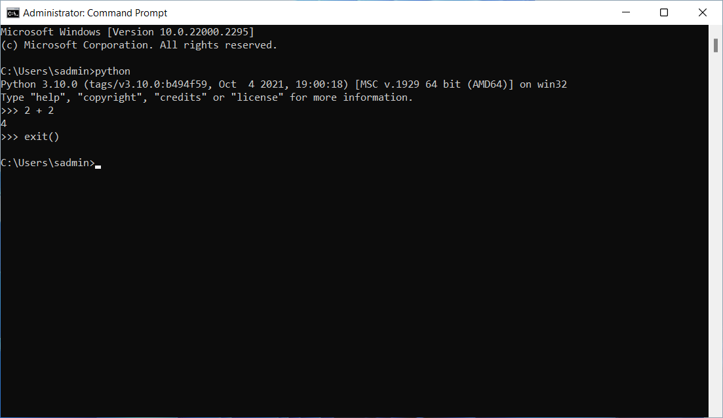

pip install pandas numpy matplotlib jupyter seaborn scikit-learn streamlit

pip install pyodbc pymssql

安裝套件

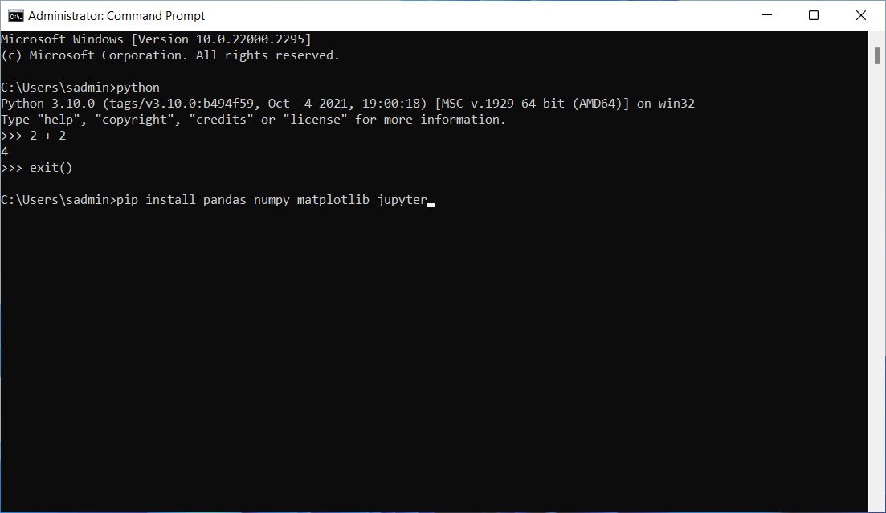

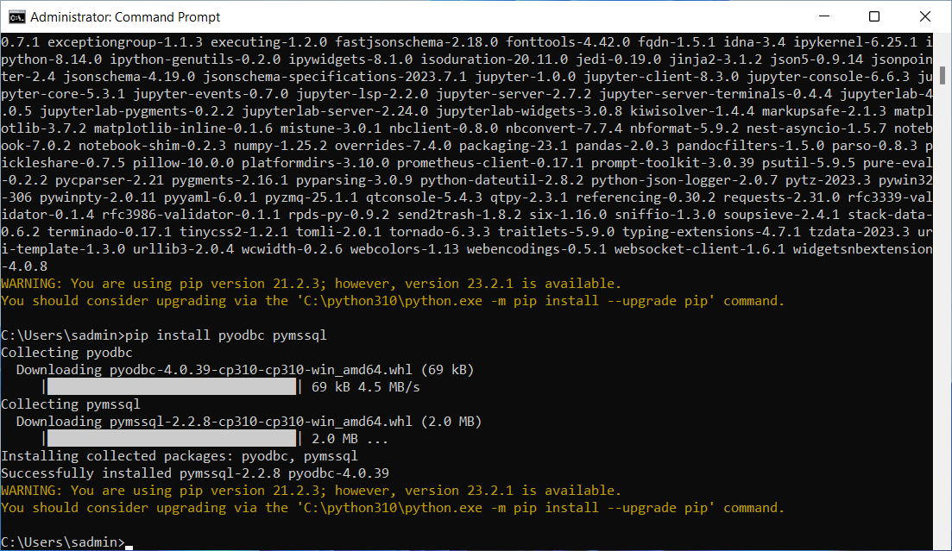

啟動Jupyter notebook

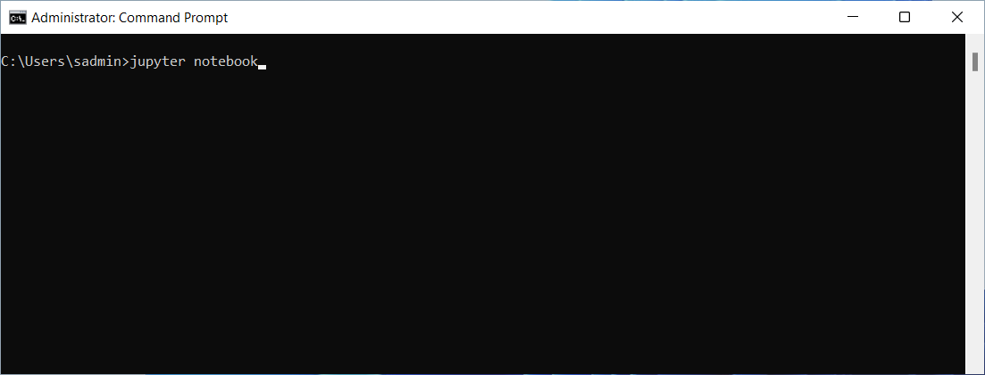

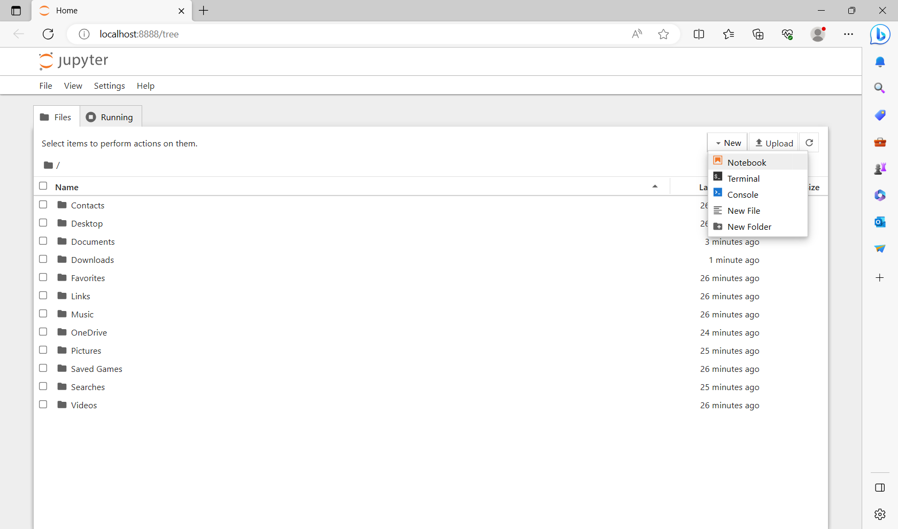

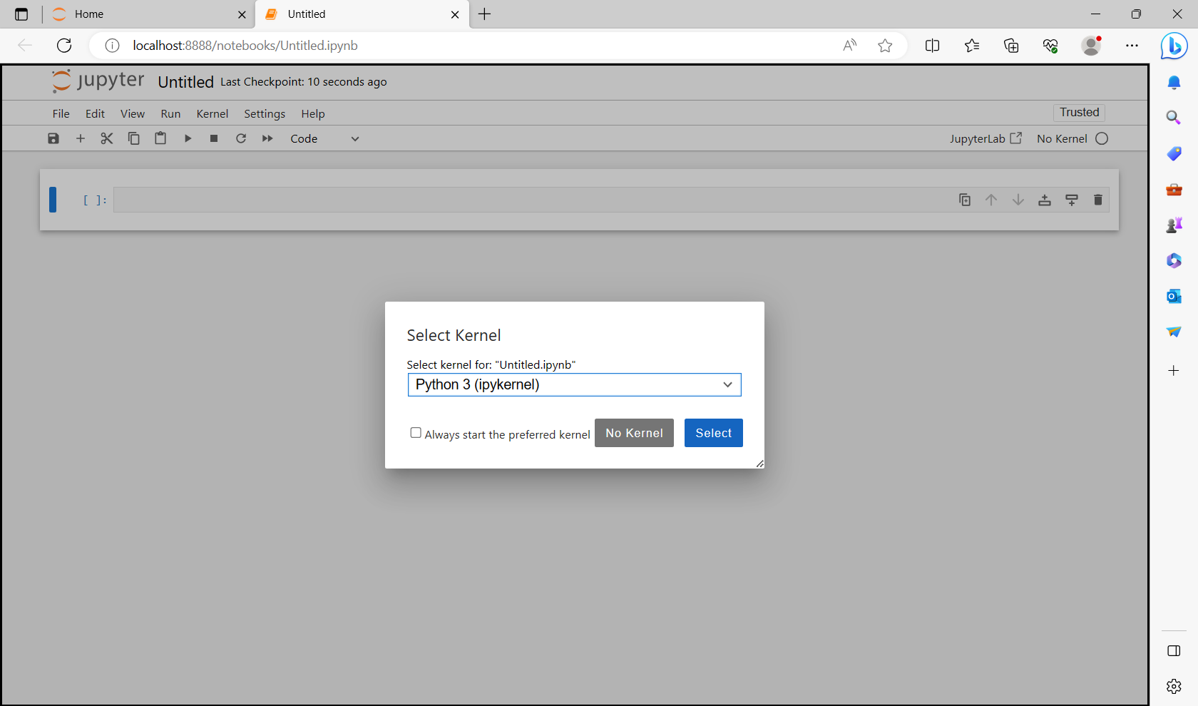

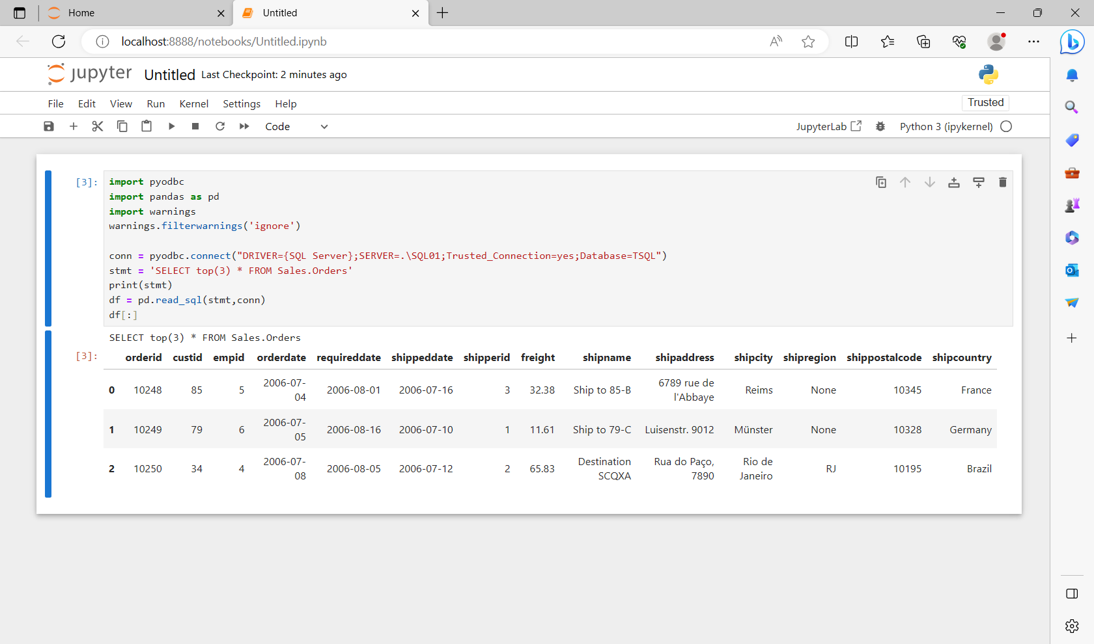

import pyodbc

import pandas as pd

import warnings

warnings.filterwarnings('ignore')

conn = pyodbc.connect("DRIVER={SQL Server};SERVER=.\SQL01;Trusted_Connection=yes;Database=TSQL")

stmt = 'SELECT top(3) * FROM Sales.Orders'

print(stmt)

df = pd.read_sql(stmt,conn)

df[:]

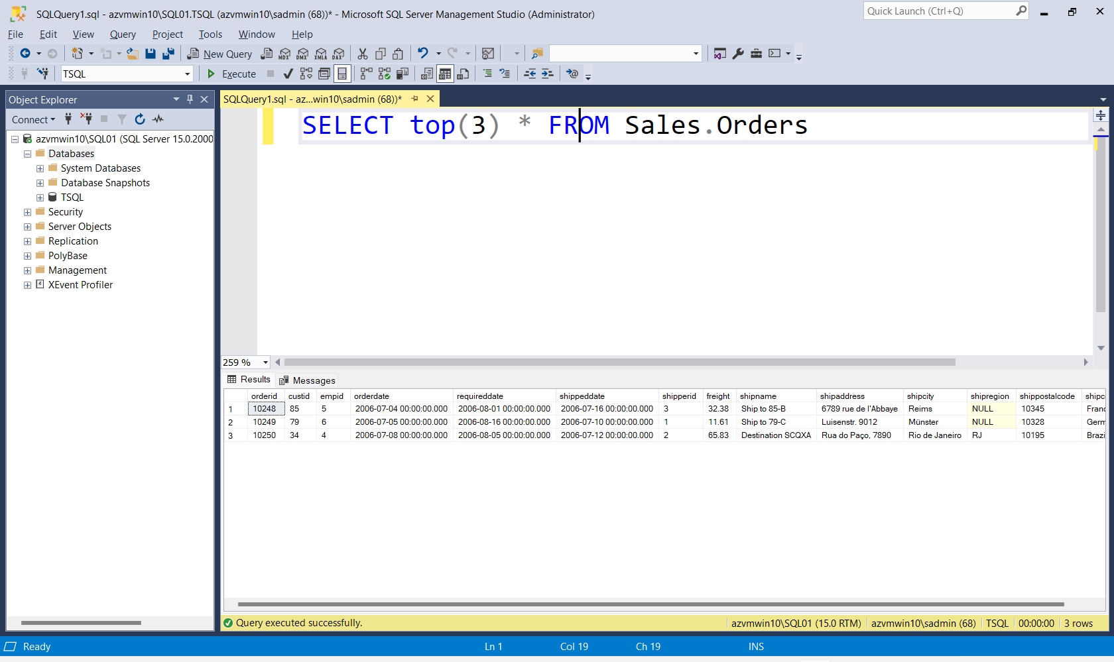

import pyodbc

import pandas as pd

import matplotlib.pyplot as plt

warnings.filterwarnings('ignore')

conn = pyodbc.connect("DRIVER={SQL Server};SERVER=.\SQL01;Trusted_Connection=yes;Database=TSQL")

stmt = 'SELECT * FROM Sales.OrderDetails'

print(stmt)

df = pd.read_sql(stmt,conn)

df['unitprice'].plot(kind='hist', figsize=(12, 2))

plt.show()

df[:3]

