1. IPv6 Multicast address format: FF:XY: (112 bits)
X – Flags: xxPT (4 bits)
P – Prefix for unicast-based assignment
T – 0: permanent, 1: temporary
Y – Scope: yyyy (4 bits) Totally 15 scopes

Example:
FF01::1 all nodes on the node-local (that is, only for that host)
FF02::1 all nodes on the local-link scope
FF01::2 all routers on the node-local scope
FF02::2 all routers on the link-local scope
FF05::2 all routers in the site (site-local scope)
FF02::1:FFXX:XXXX Solicited-Node

Solicited-Node Multicast Address:
FF02::1:FF00:0000/104
The 24 bits 00:0000 will be replaced by unicast IPv6 ip address’s last 24 bits

2. Mutlicast Layer 2 MAC address:

IPv4 multicast MAC: 01-00-5e-xx.xx.xx
Mapping: IP address’s last 28 bits → MAC last 23 bits ( 5 IP multicast: 1 MAC)

IPv6 multicast MAC format: 33-33-xx.xx.xx.xx
Mapping: IPv6 address’ last 32 bits map to MAC last 32 bits.
FF02::1 (all node IPv6 multicast address) → 33:33:00:00:00:01 ( Ether MAC)

3. Different type of IPv6 addresses:
1) Aggregatable Global Unicast Address 2000::/3 : Internet IPv6 address

| Provider (48bit) | Site (16bit) | Host (64bit) |
Figure 1 Aggregatable Global Address Format
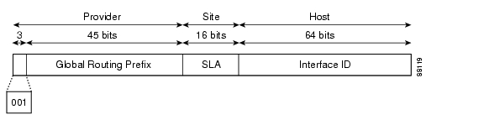
Interface IDs are constructed in the modified EUI-64 format in one of the following ways:
•For all IEEE 802 interface types (for example, Ethernet, and FDDI interfaces), the first three octets (24 bits) are taken from the Organizationally Unique Identifier (OUI) of the 48-bit link-layer address (MAC address) of the interface, the fourth and fifth octets (16 bits) are a fixed hexadecimal value of FFFE, and the last three octets (24 bits) are taken from the last three octets of the MAC address. The construction of the interface ID is completed by setting the Universal/Local (U/L) bit—the seventh bit of the first octet—to a value of 0 or 1. A value of 0 indicates a locally administered identifier; a value of 1 indicates a globally unique IPv6 interface identifier.
•For all other interface types (for example, serial, loopback, ATM, Frame Relay, and tunnel interface types—except tunnel interfaces used with IPv6 overlay tunnels), the interface ID is constructed in the same way as the interface ID for IEEE 802 interface types; however, the first MAC address from the pool of MAC addresses in the router is used to construct the identifier (because the interface does not have a MAC address).
•For tunnel interface types that are used with IPv6 overlay tunnels, the interface ID is the IPv4 address assigned to the tunnel interface with all zeros in the high-order 32 bits of the identifier.

Note For interfaces using PPP, given that the interfaces at both ends of the connection might have the same MAC address, the interface identifiers used at both ends of the connection are negotiated (picked randomly and, if necessary, reconstructed) until both identifiers are unique. The first MAC address in the router is used to construct the identifier for interfaces using PPP.

If no IEEE 802 interface types are in the router, link-local IPv6 addresses are generated on the interfaces in the router in the following sequence:
1. The router is queried for MAC addresses (from the pool of MAC addresses in the router).
2. If no MAC addresses are available in the router, the serial number of the router is used to form the link-local addresses.
3. If the serial number of the router cannot be used to form the link-local addresses, the router uses a Message Digest 5 (MD5) hash to determine the MAC address of the router from the host name of the router.

IANA Assignments of Aggregatable Global Unicast Prefixes:

2001::/16 --- IPv6 Internet
2002::/16 --- 6to4 transition mechanism
2003::/16 to 3FFD::/16 --- Unassigned
3FFE::/16 --- 6bone

2) Site-Local Address: similar to private ip address FEC0::/10
| FEC0::/10 (10 bit) | Subnet-ID (54bit) | Interface ID (64bit) |

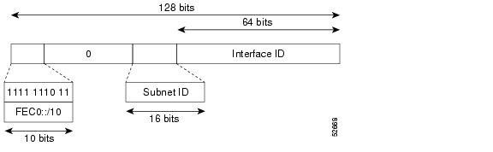
3) Link-local Address FE80::/10: between nodes connected to the same local link . Automatically assigned.

| FE80::/10 (10bit ) | 0 ( 54 bit) | Interface ID EUI-64 (64) |

EUI-64: derived from Link-layer address

4) Anycast Address: used for one-to-nearest communication
send the packet to an anycast address of the nearest node member of the anycast group. It is impossible to distinguish an anycast address from a unicast address.

http://www.cisco.com/univercd/cc/td/doc/product/software/ios123/123cgcr/ipv6_c/sa_bconn.htm

An anycast address is an address that is assigned to a set of interfaces that typically belong to different nodes. A packet sent to an anycast address is delivered to the closest interface—as defined by the routing protocols in use—identified by the anycast address. Anycast addresses are syntactically indistinguishable from unicast addresses because anycast addresses are allocated from the unicast address space. Assigning a unicast address to more than one interface makes a unicast address an anycast address. Nodes to which the anycast address is assigned must be explicitly configured to recognize that the address is an anycast address.
Note Anycast addresses can be used only by a router, not a host, and anycast addresses must not be used as the source address of an IPv6 packet.
Subnet-Router anycast address: UNICAST_PREFIX::

5) Lookback address ::1 (equivalent to IPv4 127.0.0.1)

6) Unspecified Address :: (send with DHCP request packets)

7) IPv4-compatible IPv6 address ::192.168.30.1 (equivalent to ::C0A8:1E01)

