###### Debugging – Log monitoring

***Objective:***

Logs have been enabled in SAOS 10x and can be used for troubleshooting. Objective of this test is to setup and monitor logs for different features.

***Procedure:***

* CLI logs can be accessed through the following command:
  + log view cli-log
* CLI commands for the session will be displayed:

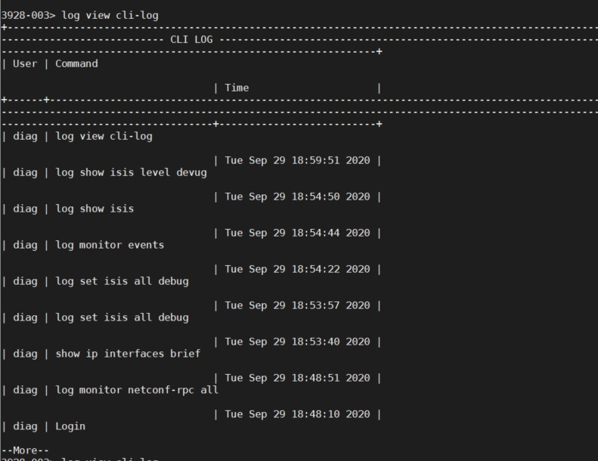

* Enter the following command to enable ISIS debug logs – similar provisioning can be used to check for LDP/OSPF/MPLS/BGP logs.
  + log set isis all debug
* Check for ISIS debug logs - for real-time monitoring:
  + log monitor troubleshoot
* Check for ISIS debug logs – for historical logs:
  + log view troubleshoot
* Output of the logs should be similar to below:

Test Case Results:

Passed: Yes No Verified by Date/Time Comments