###### Debugging – Port Mirroring

***Objective:***

Port mirroring enables traffic ingressing or egressing a particular port to be mirrored to another port. This can be used for troubleshooting and verification.

Config Parameters:

destination-logical-port

Logical Port which will have traffic mirrored-to. All traffic for this Mirror Session will egress the destination logical port.

egress-mirror-logical-ports

A list of logical-ports whose egress traffic is mirrored to the destination logical-port.

ingress-mirror-logical-ports

A list of logical-ports whose ingress traffic is mirrored to the destination logical-port.

***Procedure:***

* Configure mirror destination port

mirror-sessions mirror-session P22_to_P01 destination-logical-port 1

* Configure mirror source port along with direction (ingress, egress or both)

mirror-sessions mirror-session P22_to_P01 egress-mirror-logical-ports 22 mirror-sessions mirror-session P22_to_P01 ingress-mirror-logical-ports 22

***Validation:***

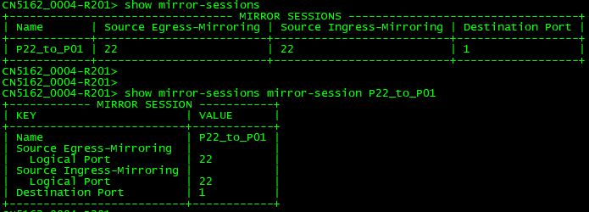

Test Case Results:

Passed: Yes No Verified by Date/Time Comments