###### Built in Trial License

Trial License means a License granted to a User or an Organization for a limited duration (90 days), to enable the User or the Organization to evaluate the Software and to do demo of Software Trial Licenses are provided free of charge. This will help FSE and customer to

test devices/software without purchasing the actual license.

***Objective:***

In earlier releases (SAOS 10.4,SAOS 10.5) we do not have this functionaly. So in order to test device or software we need to register device and purchase license. But now in 10.6 build in trial license support come. A trial license in built come with software which just need to activate and its free. User can use this license for 90 days after that they have to purchage new trial license or permanent license.

On expiration of trial license all data traffic will be block but control traffic will work. User need to purchase license in order to continue services traffic.

Valcli command to activate license on device. Initially no need to download external license:

5164 > license activate built-in-trial-license

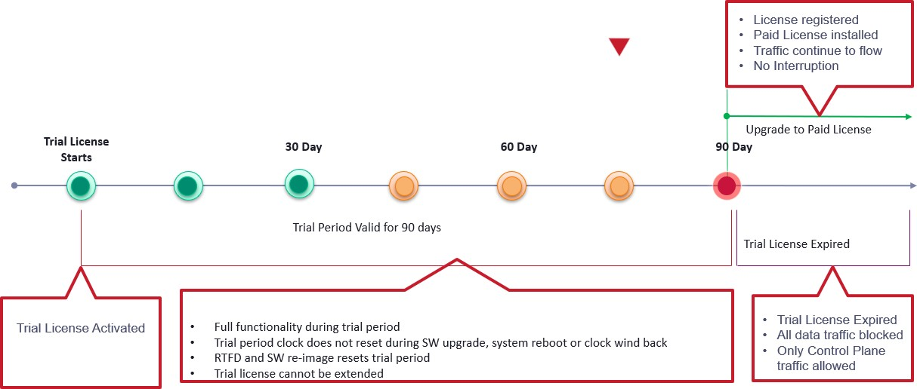

#### Functional Behavior

* Temporary, trial/evaluation licenses are built into SW across all Valimar product variants
* Valid only for fixed, pre-defined period (90-Days)
* Enables full feature functionality supported in that SW release for the trial period
* Built-in trial licenses are explicitly activated by user to start the 90-Day trial period
  + Trial period clock does not reset upon clock wind back or SW upgrade or system reboot
  + SW re-image or RTFD on the device will result in a new trial period
* Built-in trial license cannot be extended
  + Extending the trial /period requires a new trial license to be obtained from the portal and installed on the device
  + Moving to paid local(manual)license requires registering the device on the portal, mapping entitlements to device, generating device specific license file and installing it on the device. Once perament license insalled you can not use trial license after that.
* Built-in trial license cannot be extracted out of a SW instance and applied to elsewhere.
* Once the built-in license expires, traffic is blocked in the data plane ;control plane traffic is still allowed
* Acquisition of a paid license(local or server-based) will invalidate the built-in trial license even if the trial period has not expired.

**Note** Event/alarm notification for expiry of built-in license will trigger on 45, 30, 15, 7, 6, 5, 4,

3, 2, 1 day(s) before

Test Case Results:

Passed: Yes No Verified by Date/Time Comments