###### Layer 2 Control Protocol

Overview:

L2 control protocol (L2CP) allows the network operator to change the handling of L2 control frames such that they are discarded or forwarded as if they were data frames instead of being processed locally.

When an untagged L2CP frame is received on an ETTP, it is either trapped and sent to an L2 protocol for further processing, that is, peered, or it is treated as L2 data traffic, that is, classified as untagged data traffic. L2CP exposes a mechanism for modifying this default behavior, so that the L2CPs for certain protocols can be discarded or forwarded as L2 data traffic.

L2CP is supported on XGS platforms in SAOS 10.6

Scenario 1: L2CP Handling

***Objective***

The objective of this test is to create an L2CP profile and apply discard/forward dispositions to L2 protocols.

The default behavior for most Layer 2 control protocols in 10.X is to be forwarded as L2 data. In this scenario, we will apply a discard disposition to 802.1x, link-oam and Cisco-CDP protocols as an example on a 392X device. The control frames will be dropped at the UNI-port.

Procedure

* Create L2CP profile
  + l2cp-profiles l2cp-profile l2cpf1 protocol-disposition port-auth

untagged-disposition discard/forward protocol-disposition cisco-cdp untagged-disposition discard/forward protocol-disposition link-oam untagged-disposition discard/forward

* Attach an L2 control plane profile to a forwarding domain
  + fds fd FD1
  + mode vpls vlan-id 20(The FD is created without vlan-id on DNX)
  + l2cp-profile l2cpf1
* Create Untagged and L2CP classifier
  + classifiers classifier untagged filter-entry vtag-stack untagged-exclude-priority-tagged true
  + classifiers classifier class_l2cp filter-entry vtag-stack l2cp-exclude-priority true
* Create flow point and add the untagged and l2cp classifier to the flow-point
  + fps fp l2cp4 fd-name FD1 logical-port 4

classifier-list untagged classifier-list class_l2cp

ingress-l2-transform push-vid-400 vlan-stack 1 push-tpid tpid-8100 push-vid 20

exit exit

egress-l2-transform pop-vid-20vlan-stack 1 pop-type

Before applying the l2cp profile, L2CP frames sent from one test port are forwarded and received on the other port.

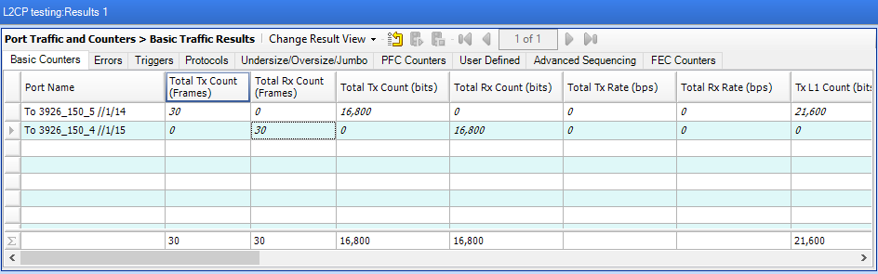

After applying the “discard disposition” under L2CP profile, we can see that L2 control frames are no longer received on the other side of the test set as they get dropped at the UNI-port of device.

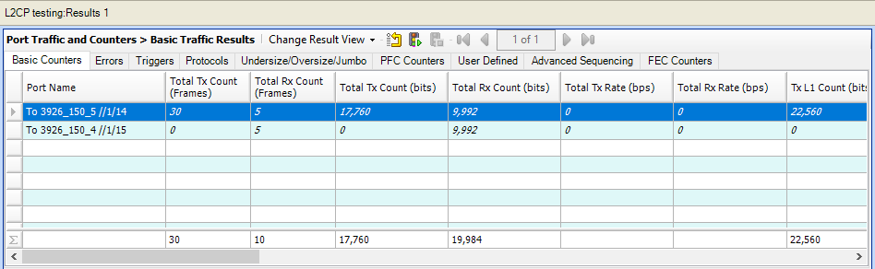

3926-150> show ettps ettp 4 statistics

+ ETTP STATISTICS +

| KEY | VALUE |

+ + +

| Name | 4 |

| | |

| In Bytes | 2100 |

| In Packets | 30 |

| In Broadcast Packets | 0 |

| Out Bytes | 503 |

| In Multicast Packets | 30 |

|  |  |  |  |  |
| --- | --- | --- | --- | --- |
| | | Out Packets | | | 3 | | |
| | | Out Unicast Packets | | | 0 | | |
| | | In Errors | | | 0 | | |
| | | Out Errors | | | 0 | | |
| | | Out Broadcast Packets | | | 0 | | |
| | | In Undersize Packets | | | 0 | | |
| | | Out Multicast Packets | | | 3 | | |
| | | In 64 Octet Packets | | | 0 | | |
| | | In 65 to 127 Octet Packets | | | 30 | | |
| | | In 128 to 255 Octet Packets | | | 0 | | |
| | | In 256 to 511 Octet Packets | | | 0 | | |
| | | In 512 to 1023 Octet Packets | | | 0 | | |
| | | In 1024 to 1518 Octet Packets | | | 0 | | |
| | | In 1519 to 2047 Octet Packets | | | 0 | | |
| | | In 2048 to 4095 Octet Packets | | | 0 | | |
| | | In 4096 to 9216 Octet Packets | | | 0 | | |
| | | Out 1519 to 2047 Octet Packets | | | 0 | | |

|  |  |  |  |  |  |
| --- | --- | --- | --- | --- | --- |
| | | Out 2048 to 4095 Octet | Packets | | | 0 | | |
| | | Out 4096 to 9216 Octet | Packets | | | 0 | | |
| | | In Oversize Packets |  | | | 0 | | |
| | | In Jabber Packets |  | | | 0 | | |
| | | In Crc Error Packets |  | | | 0 | | |
| | | Link Flap Events |  | | | 0 | | |
| | | Out Discards |  | | | 0 | | |
| | | In Unicast Packets |  | | | 0 | | |
| | | **In Discards Packets** |  | **|** | **30** | | |
| + |  |  | + |  | + |

L2CP configuration can be displayed by executing the commands below.

3926-150> show flow-points flow-point l2cp4

+ FLOW POINT +

| KEY | VALUE |

+ + +

| Name | l2cp4 |

| Forwarding Domain Name | FD1 |

| Logical Port | 4 |

| MTU Size | 2000 |

| Ingress L2 Transform | |

| Ingress Name | push-vid-20 |

| Ingress VLAN Stack | |

| Tag | 1 |

| Push TPID | tpid-8100 |

| Push VID | 20 |

| Egress L2 Transform | |

| Egress Name | pop-vid-20 |

| Egress VLAN Stack | |

| Tag | 1 |

| Pop Type | - |

| Classifier List | |

| | **untagged** |

| | **class_l2cp** |

+ + +

+ FLOW POINT STATISTICS +

| KEY | VALUE |

+ + +

| Name | l2cp4 |

+ + +

3926-150> show classifiers

+ CLASSIFIER +

| Name | Filter Parameter |

+ + +

| **class_l2cp | Classifier:untagged** |

| default-vid-127 | Classifier:tagged-all |

| **untagged | Classifier:untagged** |

+ + +

3926-150> show l2cp-profiles l2cp-profile l2cpf1

+ L2CP PROFILE +

| KEY | VALUE |

+ + +

| Name | l2cpf1 |

| Protocol Disposition | |

| Protocol | **port-auth** |

| Untagged Disposition | **discard** |

| | |

| Protocol | **cisco-cdp** |

| Untagged Disposition | **discard** |

| | |

| Protocol | **link-oam** |

| Untagged Disposition | **discard** |

+ + +

Scenario 2: L2PT (Layer 2 Protocol Tunneling)

Layer 2 protocol tunneling is supported in 10.6 on DNX and XGS platforms. L2PT form requires that the frame’s original MAC DA get replaced with a configurable L2PT MAC address. In the reverse direction L2PT MAC address is replaced with proper IEEE or Cisco MAC DA.

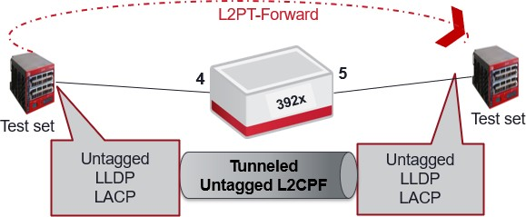

***Objective:***

The objective of this test is to configure L2PT disposition for LACP, LACP Marker and LLDP as these protocols have a default “Peering” disposition. After provisioning the L2PT form, L2 protocol frames will be forwarded to the other test set instead of being processed on 392X device.

***Procedure***

* Create the L2PT MAC list with l2pt destination MAC
  + l2cp-profiles l2pt-macs 01:00:0C:CD:CD:D0
* Create the L2 control protocol profile
  + l2cp-profiles l2cp-profile l2cpf1
* Provision the forwarding-domain, classifiers and flow-point
  + fds fd FD1 mode vpls vlan-id 20 l2cp-profile l2cpf1
  + classifiers classifier untagged filter-entry vtag-stack untagged-exclude-priority-tagged true
  + classifiers classifier class_l2cp filter-entry vtag-stack l2cp-exclude-priority true
  + fps fp l2cp4fd-name FD1 logical-port 4 classifier-list untagged

classifier-list class_l2cp

ingress-l2-transform push-vid-20 vlan-stack 1 push-tpid tpid-8100 push-vid 20

exit exit

egress-l2-transform pop-vid-20 vlan-stack 1 pop-type

The steps below should be provisioned under the l2cp profile:

* Set the protocol in the protocol-disposition
  + protocol-disposition lldp
  + protocol-disposition lacp
  + protocol-disposition lamp
* Set the L2PT MAC address for the protocol for which L2PT forwarding needs to be enabled. This should be same MAC that is added in l2pt-macs list:
  + l2pt-mac 01:00:0C:CD:CD:D0
* Set the untagged disposition as “l2pt-forward”:
  + untagged-disposition l2pt-forward

After applying the “l2pt-forward disposition” under L2CP profile, we can see that L2 control frames (LACP/LLDP/LACP Marker) are now l received on the other side of the test without getting processed on the device.

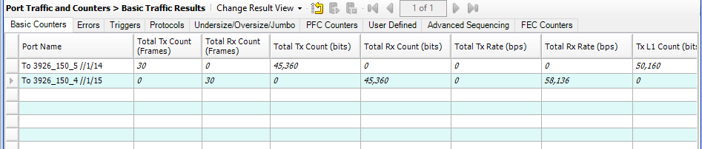

L2CP configuration can be displayed by executing the commands below.

3926-150> show l2cp-profiles l2cp-profile l2cpf1

+ L2CP PROFILE +

| KEY | VALUE |

+ + +

| Name | l2cpf1 |

| Protocol Disposition | |

| Protocol | lldp |

| Untagged Disposition | **l2pt-forward** |

| L2PT MAC Address | **01:00:0c:cd:cd:d0** |

| | |

| Protocol | lacp |

| Untagged Disposition | **l2pt-forward** |

| L2PT MAC Address | **01:00:0c:cd:cd:d0** |

| | |

| Protocol | lamp |

| Untagged Disposition | **l2pt-forward** |

| L2PT MAC Address | **01:00:0c:cd:cd:d0** |

+ + +

Test Case Results:

Passed: Yes No Verified by Date/Time Comments