###### SAT testing with inner VLAN ID validation

**Objective:**

Objective is to configure SAT (Service Activation Test) on a doubled tagged customer traffic by validation inner VLAN ID. Inner VLAN ID validation is either Enabled or Disabled depending on the Reflector capability to reflect traffic with inner VLAN ID.

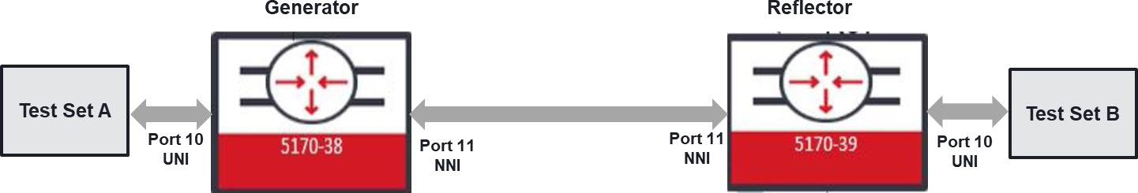

**Procedure:**

Following steps needs to be applied.

* Configure EVPL service by using double tag configuration on the UNI port
* Generator and Reflector configurations are slightly different than each other. Generator configuration:
  + Configure SAT Entity
  + Configure SAT KPI Profile
  + Configure SAT Test Profile
  + Configure SAT Test Instance
  + Enable global-sat
* Reflector configuration:
  + Configure SAT Entity
  + Configure SAT Test Instance
  + Enable global-sat
* After Generator and Reflector is configured, “sat-global” needs to be enabled on both

nodes

* SAT test can be started from the Generator node if “sat ping” issued in Generator node

gives successful connection with the Reflector node.

**EVPL service creation on Generator and Reflector nodes:**

Following configurations will be used on both Generator and Reflector nodes.

*config*

*classifiers classifier dtag filter-entry vtag-stack vtags 1 vlan-id 200 classifiers classifier dtag filter-entry vtag-stack vtags 2 vlan-id 400*

*classifiers classifier vlan_111 filter-entry vtag-stack vtags 1 vlan-id 111*

*fds fd fd_sat_inner mode vpws fps fp fp_sat_inner_uni*

*fd-name fd_sat_inner logical-port 10*

*mtu-size 9216*

*classifier-list-precedence 1 classifier-list dtag*

*exit exit*

*fps fp fp_sat_inner_nni fd-name fd_sat_inner*

*logical-port 11*

*mtu-size 9216*

*classifier-list-precedence 1 classifier-list vlan_111*

*ingress-l2-transform pop_111 vlan-stack 1*

*pop-type exit*

*exit*

*egress-l2-transform v111 vlan-stack 1*

*push-tpid tpid-88a8 push-vid 111*

*exit exit exit exit*

**SAT Generator node configuration:**

**SAT Entity configuration:**

*config*

*sat entity ent_gen_inner*

*port 10*

*role generator*

*mode evc-out-of-service admin-state enabled exit*

*exit*

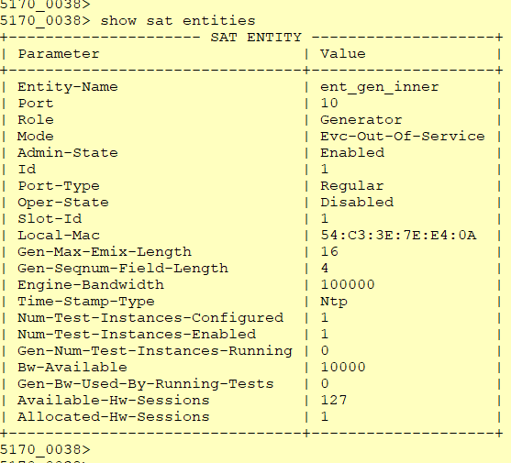

**SAT KPI Profile configuration:**

*config*

*sat kpi-profile kpi_inner pcp 0 throughput 50000*

*frameloss 100*

*latency 1*

*pdv 2*

*single-outage-max 1*

*sum-outages-max 2 exit*

*exit exit*

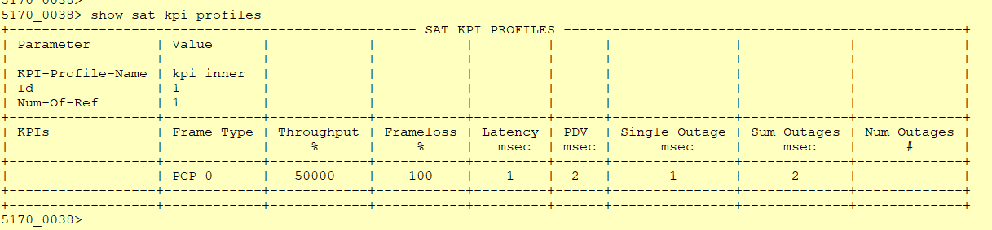

Provisioned throughput number here provides how much of the total bandwidth can be allocated for overheads as in 4 point of decimal and by percent of this number. For the UNI port 10G rate “50000” entry means, up to % 5 of 10G rate can be used for overheads. So customer should be able to use 9.5G rate of traffic.

Provisioned frame loss number here provides how much loss can be tolerated as in 4 point of decimal and b percent of this number. For the UNI port 10G rate “100” entry means, up to % 0.01 loss is accepted.

**SAT Test Profile configuration:**

*config*

*sat test-profile prf_inner bandwidth 10000*

*interval tCompletion duration tOnce*

*frameloss-test true*

*inner-vid-validation true vid-validation false*

*dst-mac 54:C3:3E:B2:F8:8A*

*kpi-profile-name kpi_inner encap-type qinq*

*frame-size 80 256 512 1280 1518 exit*

*exit*

“dst-mac” in the configuration will be the “shared-mac” MAC address of Reflector which can be

queried via “show system macs.”

It is suggested to use “duration” as “tOnce” and “interval” as “tCompletion.”

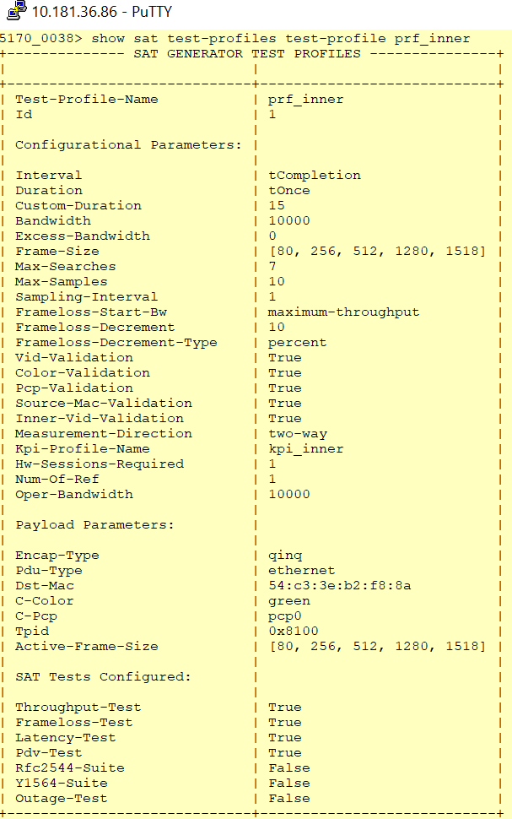

**SAT Test Instance configuration:**

*config*

*sat test-instance ins_gen_inner*

*flow-point-id fp_sat_inner_uni profile prf_inner*

*dst-mac 54:c3:3e:b2:f8:8a c-vid 400*

*s-vid 200*

*admin-state enabled exit*

*exit*

“dst-mac” in the configuration will be the “shared-mac” MAC address of Reflector which can be queried via “show system macs.”

# 10.181.36.86 - PuTTY

**5170_0038> show sat test-instances**

+ SAT TEST INSTANCES +

**I Parameter** I Value

+

**Test-Instance-Name**

**Flow-Point-Id**

**Profile**

S-Vid C-Vid

Untagged

**Dst-Mac Ad.min-State** Id

**Current-Interval Total-Intervals**

**Last-Iteration-Start-Timestamp**

**Assoc-Entity** Oper-State **Active-5-Vid Active-C-Vid Active-Ost-Mac Active-Start-Bw Required-Start-SW Active-Frame-Size**

**Test-Start-Timestamp**

**Test-End-Timestamp**

**Session Keys:**

**Session-Id** Slot-Id Lif-Id S-Vid S-Pcp

S-Color C-Vid C-Pcp

C-Color Untagged

Mask

**Profile running configuration:**

**Interval**

**OU.ration**

**Sampling-Interval Max-Samples**

**Max-Searches Bandwidth**

**Excess-Bandwidth Frameloss-Start-Bw Frame-Size-List Emix-Sequence**

Kpi-Profile

Bli-Alloc-Profile **Yid-Validation Color-Validation PCP-Validation** VLAN-TPID

**VLAN-Encapsulation**

Pdu-Type **Destination MAC Test Configured:**

+

+ +

**ins_gen_inner**

**fp_sat_inner_uni prf_inner**

200

400

**False**

54:c3:3e:b2:f8:8a

**enabled**

l l l

2020-01-28T21:59:432

**ent_gen_inner**

disabled 200

400

54:c3:3e:b2:f8:8a

10000

10000.00

(80, 256, 512, 1280, 1518] 2020-01-28T21:59:432

2020-01-28T22:0l:202

0

l

33917

200

0

**green**

400

0

**green**

0

11111111

**tCompletion tOnce**

l

10

7

10000

0

**maximum-throughput**

(80, 256, 512, 1280, 1518]

**Not configured 1.'"pi_inner**

**Not configured True**

**True**

**True**

0x8100

qinq

**ethernet**

54:c3:3e:b2:f8:8a

**Throughput-Test Frameloss-Test Latency-Test**

PDV-Test

+ +

**Enable global-sat**

After all the steps above completed, global-sat needs to be enabled.

*config*

*sat sat-global admin-state enabled*

**SAT Reflector node configuration:**

**SAT Entity configuration:**

*config*

*sat entity ent_ref_inner port 10*

*role reflector*

*mode evc-out-of-service reflection-level l2-to-l4*

*assoc-gen-vendor-type other admin-state enabled*

*exit exit*

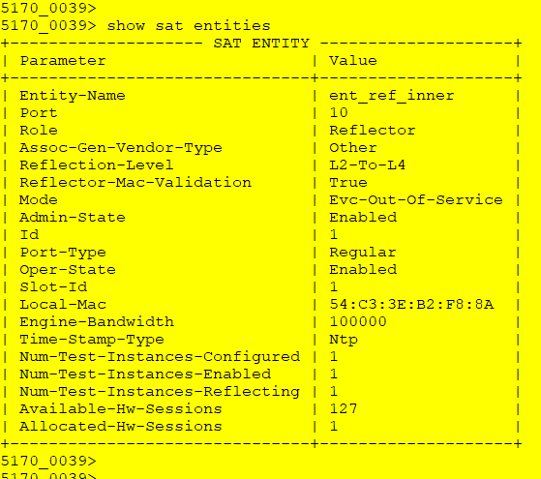

**SAT Test Instance configuration:**

*config*

*sat test-instance ins_gen_inner flow-point-id fp_sat_inner_uni admin-state enabled*

*exit exit*

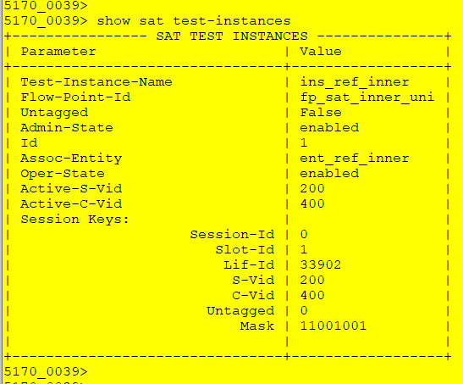

**Enable global-sat**

After all the steps above completed, global-sat needs to be enabled.

*config*

*sat sat-global admin-state enabled*

**Running SAT test**

Before running the SAT test, first step is to check whether Generator and Reflector node can

communicate with each other. This can be done via “ping” on the Generator node.

*sat ping test-instances test-instance ins_gen_inner*

After making sure that “ping” is successful SAT can be started with the following command on the

Generator node.

*sat start test-instances test-instance ins_gen_inner*



Test results can only be queried after the SAT test is over, till then it is possible to query test status.

*show sat test-instances status*

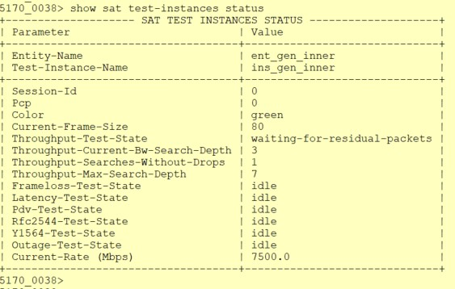

Test results will be shows with the following command after the test is over.

*show sat test-instances statistics*

*li1'* 10.181.36.86 - PuTTY

**51 70_0038> show sat test-instances statistics**

+

**SATTEST INSTANCES STATISTICS & RESULTS** +

I I I I I I I I I I

|  |  |  |  |  |  |  |  |
| --- | --- | --- | --- | --- | --- | --- | --- |
| **Test duration**  + | **tOnce**  + | + | **I**  + + | + | + | + | + + |
| **I Throughput Results**  I  +  I I I I I  +  **I Latency Results**  I  +  I I I I I  +  **I PDV Results**  I  +  I I I I I  ***i*** | **I Frame**  I Size  +  I so  I 256  I 512  I 1280  I 1518  +  **I Frame**  I **Size**  +  I BO  I 256  I 512  I 1280  I 1518  +  **I Frame**  I size  +  I BO  I 256  I 512  I 12so  I 1518  ***i*** | **I PCP I Color I Min I**  I I I Mbps I  + + + +  I o I green I 7750.00 I I o I green I 9130.43 I I o I green I 9624. 06 I Io I green I 9846.15 I I o I green I 9869.96 I  + + + +  **I PCP I Color I Min I**  I I I **usec I**  + + + +  I O I green I B I  I o I green I a I  I o I green I 9 I  I o I green I 11 I  I O I green I 11 I  + + + +  **I PCP I Color I Avg** I I I I usec I  + + + +  I o I green I o I  I o I green I o I  I o I green I o I  I o I green I o I  I O I green I O I  ***i i i i*** | | **Avg**  Mbps  7750.00  9130.43  9624. 06  9846.15  9869.96  **Avg usec**  379  20  379  166  143 | **I Max I KPI Result I Iterations I**  I Mbps I I I  + + + +  I 7750.00 I pass I 1 I  I 9130.43 I pass I 1 I  I 9624. 06 I pass I 1 I  I 9846.15 I pass I I  I 9869.96 I pass I I  + + + +  **I Max I KPI Result I Samples I I usec** I I I  + + + +  I 767 I pass I 10 I  I 29 I pass I 10 I  I 764 I pass I 10 I  I 326 I pass I 10 I  I 277 I pass I 10 I  + + + +  I I **KPI Result I Samples I**  I I I I  + + + +  I Ipass I 10 I  I Ipass I 10 I  I I pass I 10 I  I I pass I 10 I  I I pass I 10 I  ***i i i i*** | | |
|  |  |  |  |  |  |  |  |
|  |  |  |  |  |  |  |  |

+- - - - - - - - - - - - - - - - - - - - - - - - - - - - - - - - - -+- - - - - - - - -- - - - - - - - - - - - -+- - - -- +- - - - - - -+- - - - - - - - -+- - - - - - - - - - - - - - - - +-- - - - - - - -+- - - - - - - -- - - - + +

|  |  |  |
| --- | --- | --- |
| **Test-Instance-Name**  **Associated-Entity-Name** | **ins_gen_inner**  **ent gen inner** | **I**  **I** |
| **Associated-Test-Profile-Name** | **prf-inn;r** | **I** |
| **Test-Bandwidth** | **10000** | **J** |
| **Active destination MAC** | **54:c3:3e:b2:f8:8a** | **J** |
| **Test-Packet Encapsulation Type** | **qinq** | **I** |
| **Active vtag-stack** | **200: 400** | **J** |
| **Last Test Start timestamp** | **2020-01-2BT21:59:43Z** | **I** |
| **Test End timestamp** | **2020-01-2 8T22: 01: 20Z** | **I** |
| **Port Type** | **regular** | **I** |
| **Test interval** | **tCompletion** | **I** |

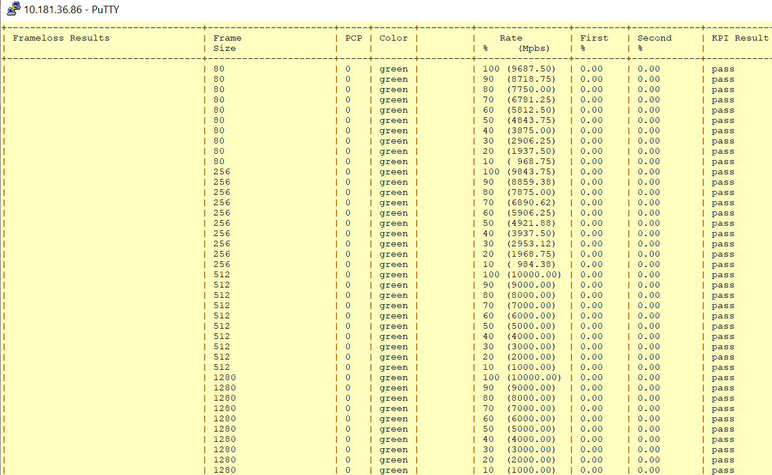

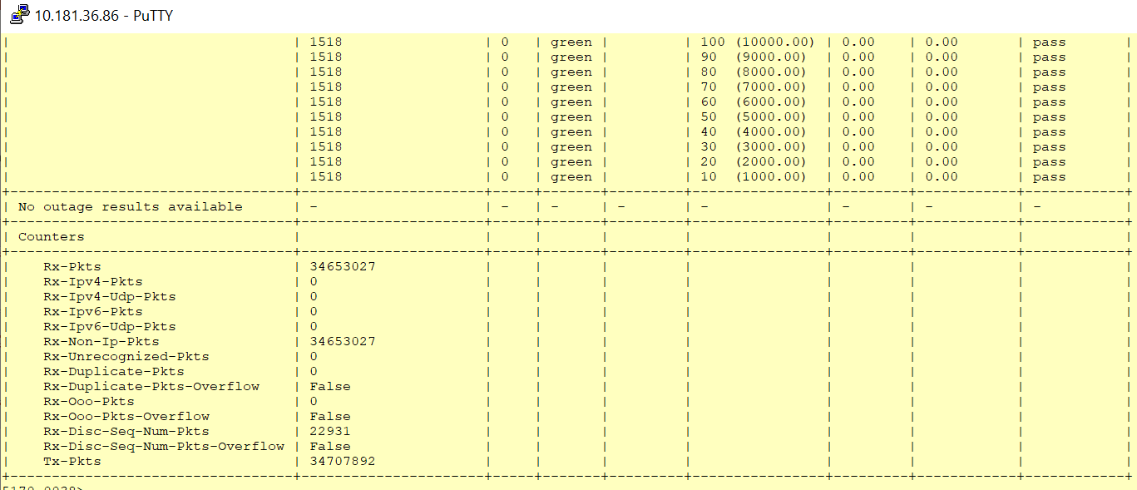

Frames sent by Generator

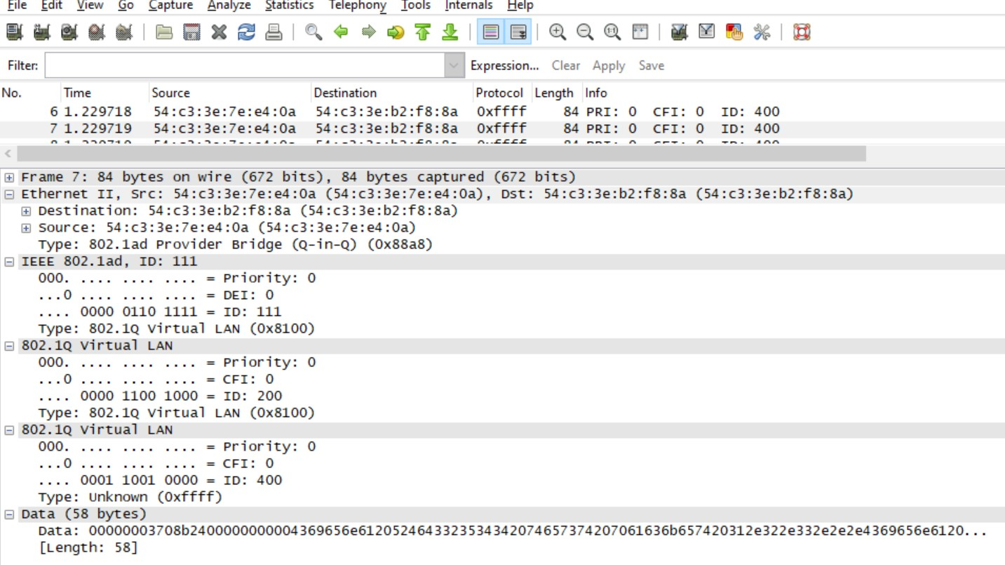

Frames reflected by Reflector

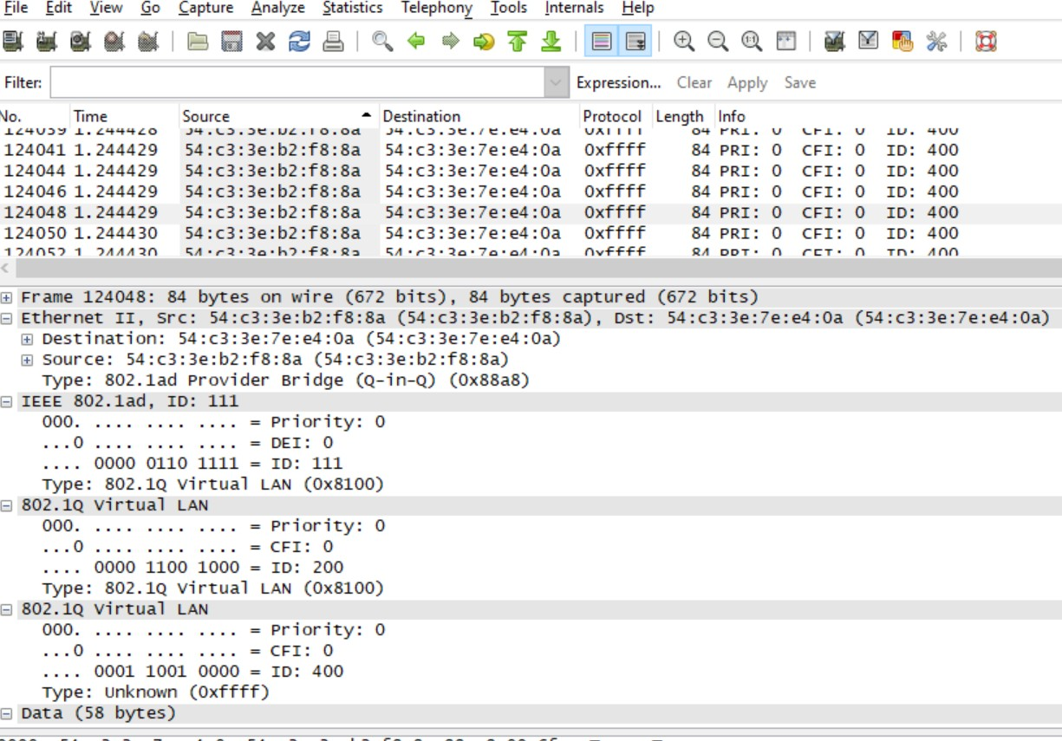

Test Case Results:

Passed: Yes No Verified by Date/Time Comments