###### SAT testing with 1:1 LAG on UNI

**Objective:**

Objective is to configure SAT (Service Activation Test) on an untagged customer traffic while using 1:1 LAG at the UNI interface. 1:1 LAG is supported as active / standby operation, so there will be no load sharing.

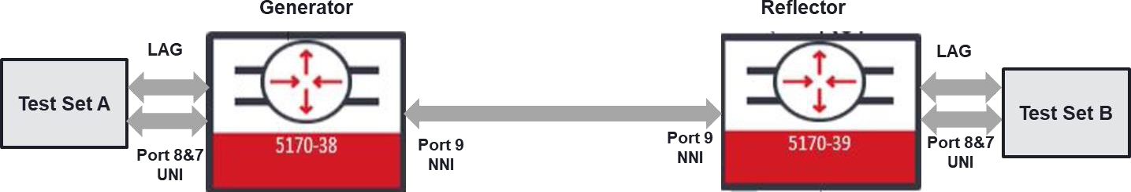

**Procedure:**

Following steps needs to be applied.

* Configure 1:1 LAG on the ports that will be used as UNI
* Configure EPL service by using untagged classifier configuration on the 1:1 LAG UNI port
* Generator and Reflector configurations are slightly different than each other. Generator configuration:
  + Configure SAT Entity
  + Configure SAT KPI Profile
  + Configure SAT Test Profile
  + Configure SAT Test Instance
  + Enable global-sat
* Reflector configuration:
  + Configure SAT Entity
  + Configure SAT Test Instance
  + Enable global-sat
* After Generator and Reflector is configured, “sat-global” needs to be enabled on both

nodes

* SAT test can be started from the Generator node if “sat ping” issued in Generator node

gives successful connection with the Reflector node.

**1:1 LAG configuration**

*config*

*agg-global global-admin-state enabled*

*oc-if:interfaces interface SAT_LAG config name SAT_LAG cn-if:type lag*

*oc-if:interfaces interface SAT_LAG config agg agg-admin-mode agg-mode-manual oc-if:interfaces interface SAT_LAG config agg member-ports 7 protection-port false*

*oc-if:interfaces interface SAT_LAG config agg member-ports 8 protection-port true oc-if:interfaces interface SAT_LAG config agg lag-protection-revert-state on*

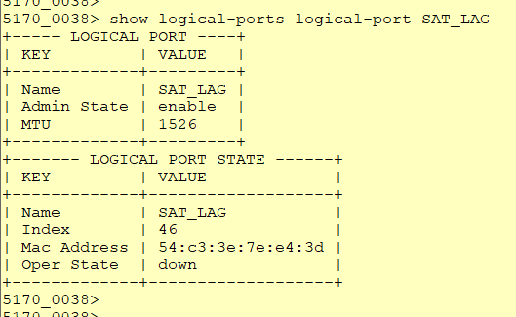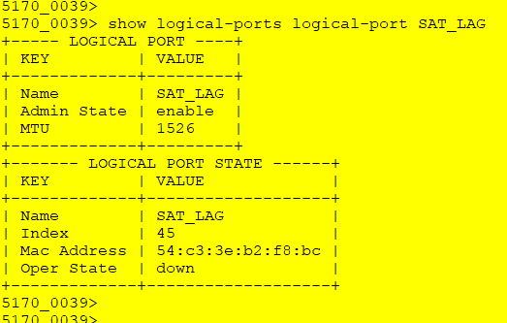

*(#*10.181.36.86 - PuTTY

**5170_0038> show aggregation aggregation-ports port SAT_LAG**

+ AGGREGATION PORTS +

I Name I Value I

+ + +

**Interface Name SAT_LAG**

**Ad.min Mode agg-mode-manual**

**Hash Mode mac-based-hash-mode**

**LACP Protection Mode Revert Protection Revert Timeout {ms) Minimum Link Aggregation Minimum Link Threshold** Node Id

**Member Ports**

**Port**

**Protection Port Port**

**Protection Port** Agg MAC Address Agg PTN Oper Key Agg PTN System ID Agg PTN System Prio Agg ACT Oper Key Agg ACT System ID

**Aggregate/Individual Evlag State**

**Sync State**

**Distribution Port Selected Aggregation ID Attached Aggregation ID Aggregate/Individual PTN** Oper Port

**PTN Oper Port Priority**

**PTN** Oper System ID

**PTN Oper System Priority**

**PTN** Oper Key ACT Port

ACT System ID

Illegal Frames Rx **Unknown Frames Rx** LACP Frames Rx **LACP Frames Tx Marker Frames Rx Marker Frames Tx**

**Marker Response Frames Rx**

**Marker Response Frames Tx Distribution Port**

**Selected Aggregation ID**

**Attached Aggregation ID Aggregate/Individual** PTN Oper Port

**PIN Oper Port Priority**

PTN Oper System ID

**PIN Oper System Priority**

PTN Oper Key ACT Port

ACT System ID

Illegal Frames Rx **Unknown Frames Rx** LACP Frames Rx **LACP Frames Tx Marker Frames Rx Marker Frames Tx**

**Marker Response Frames Rx**

**Marker Response Frames Tx**

**lag-protection-mode-proprietary**

on

5,000

**min-link-off**

1

0

7

**False**

8

**True**

54:c3:3e:7e:e4:00

8

54:c3:3e:7e:e4:00

32,768

so, 178

54:c3:3e:7e:e4:00

**True**

**ciena-ext-lag:ev-lag-disable ciena-ext-lag:ev-lag-sync-on**

7

1,026

1,026

**True**

7

65,535

54:c3:3e:7e:e4:00

32,768

8

7

54:c3:3e:7e:e4:00

0

0

0

0

0

0

0

0

8

1,026

1,026

**True**

8

65,535

54:c3:3e:7e:e4:00

32,768

8

8

54:c3:3e:7e:e4:00

0

0

0

641

0

0

0

0

*fl,* 10.181.36.87 - PuTTY

5170_0039> show aggregation aggregation-ports port SAT_LAG

+ AGGREGATION PORTS +

I Name I Value I

+ + +

Inter-:ace Name SAT_LAG

Ad.min Mode agg-mode-manual

Hash Mode mac-based-hash-mode

LACP Protection Mode Revert Protection Revert Timeout {ms) Minimum Lin}: Aggregation

Minimum Link Threshold

Node Id

¥.ember Ports

Port

Protection Port

Port

Protection Port

Agg MAC Address Agg PIN Oper Key Agg PIN System ID

Agg PIN System Prio Agg ACT Oper Key Agg ACT System ID

Aggregate/Individual Evlag State

Sync State Distribution Port

Selected Aggregation ID

Attached Aggregation ID Aggregate/Individual PIN Oper Port

PIN Oper Port Priority PIN Oper System ID

PIN Oper System Priority PIN Oper Key

ACT Port

ACT System ID Illegal Frames Rx Unknown Frames Rx LACP Fr-ames Rx LACP Frames Ix

Mar-ker Fr-ames Rx

Marker Frames Ix

Mar-ker Response Fr-ames Rx

Marker Response Frames Ix Distribution Port

Selected Aggregation ID

Attached Aggregation ID Aggregate/Individual PIN Oper Port

PIN Oper Port Priority PIN Oper System ID

PIN Oper System Priority PIN Oper Key

ACT Port

ACT System ID Illegal Frames Rx Unknown Frames Rx LACP Frames Rx LACP Frames Ix Marker Frames Rx Marker Frames Ix

Marker Response Frames Rx

lag-protection-mode-proprietary

on

5,000

min-link-o::

l

0

7

False

8

True 54:c3:3e:b2::3:30

8

54:c3:3e:b2::3:30

32,7€3

50,177

54:c3:3e:b2::3:30

True

ciena-ext-lag:ev-lag-disable ciena-ext-lag:ev-lag-sync-on

7

1,025

1,025

True

7

65,535

54:c3:3e:b2::3:30

32,7€3

8

7

54:c3:3e:b2::3:30

0

0

0

0

0

0

0

0

8

1,025

1,025

True

8

65,535

54:c3:3e:b2::3:30

32,7€3

8

8

54:c3:3e:b2::3:30

0

0

0

641

0

0

0

Marker Response Frames Ix 0

**EPL service creation on Generator and Reflector nodes:**

Following configurations will be used on both Generator and Reflector nodes.

*config*

*classifiers classifier untag_class filter-entry vtag-stack untagged-exclude-priority-tagged false classifiers classifier vlan_222 filter-entry vtag-stack vtags 1 vlan-id 222*

*fds fd fd_sat_LAG mode vpls fps fp fp_sat_LAG_uni*

*fd-name fd_sat_LAG logical-port SAT_LAG mtu-size 9216*

*classifier-list-precedence 1 classifier-list untag_class exit*

*exit*

*fps fp fp_sat_LAG_nni fd-name fd_sat_LAG*

*logical-port 9*

*mtu-size 9216*

*classifier-list-precedence 1 classifier-list vlan_222*

*ingress-l2-transform pop_222 vlan-stack 1*

*pop-type exit*

*exit*

*egress-l2-transform v222 vlan-stack 1*

*push-tpid tpid-88a8 push-vid 222*

*exit exit exit exit*

**SAT Generator node configuration:**

**SAT Entity configuration:**

*config*

*sat entity ent_gen_LAG port SAT_LAG*

*role generator*

*mode evc-out-of-service admin-state enabled exit*

*exit*

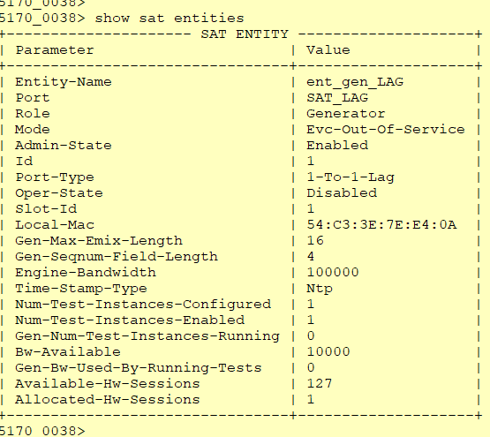

**SAT KPI Profile configuration:**

*config*

*sat kpi-profile kpi_LAG untagged throughput 50000*

*frameloss 100*

*latency 1*

*pdv 2*

*single-outage-max 1*

*sum-outages-max 2 exit*

*exit exit*

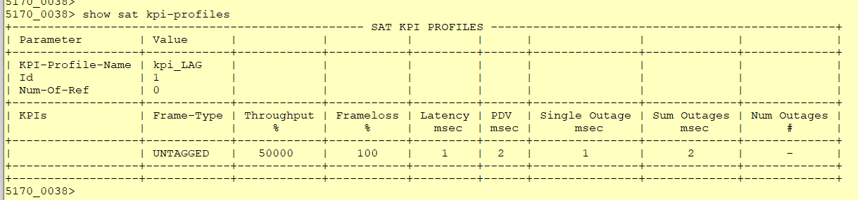

Provisioned throughput number here provides how much of the total bandwidth can be allocated for overheads as in 4 point of decimal and by percent of this number. For the UNI port 10G rate “50000” entry means, up to % 5 of 10G rate can be used for overheads. So customer should be able to use

9.5G rate of traffic.

Provisioned frameloss number here provides how much loss can be tolerated as in 4 point of decimal and b percent of this number. For the UNI port 10G rate “100” entry means, up to % 0.01 loss is accepted.

**SAT Test Profile configuration:**

*sat test-profile prf_LAG bandwidth 10000 interval tCompletion duration tOnce frameloss-test true*

*inner-vid-validation false vid-validation false*

*dst-mac 54:C3:3E:B2:F8:8A*

*kpi-profile-name kpi_LAG*

*encap-type untagged color false*

*pcp false*

*frame-size 80 256 512 1280 1518 exit*

*exit*

“dst-mac” in the configuration will be the “shared-mac” MAC address of Reflector which can be queried via “show system macs.”

It is suggested to use “duration” as “tOnce” and “interval” as “tCompletion.”

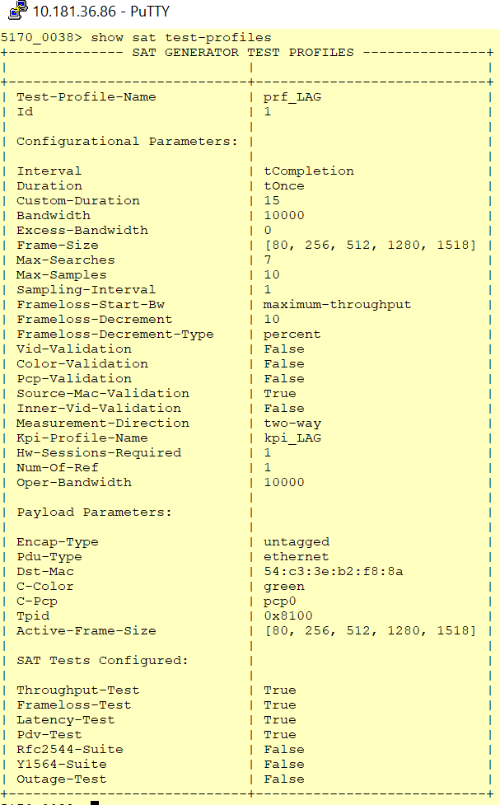

**SAT Test Instance configuration:**

*sat test-instance ins_gen_LAG flow-point-id fp_sat_LAG_uni*

*profile prf_LAG*

*dst-mac 54:c3:3e:b2:f8:8a untagged true*

*admin-state enabled exit*

*exit*

“dst-mac” in the configuration will be the “shared-mac” MAC address of Reflector which can be queried via “show system macs.”

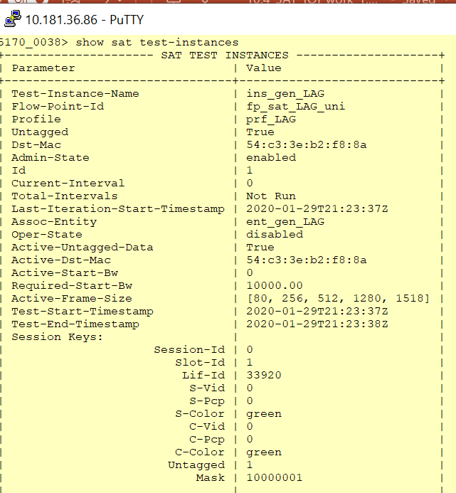

**Enable global-sat**

After all the steps above completed, global-sat needs to be enabled.

*config*

*sat sat-global admin-state enabled*

**SAT Reflector node configuration:**

**SAT Entity configuration:**

*config*

*sat entity ent_ref_LAG*

*port SAT_LAG role reflector*

*mode evc-out-of-service reflection-level l2-to-l4*

*assoc-gen-vendor-type other admin-state enabled*

*exit exit*

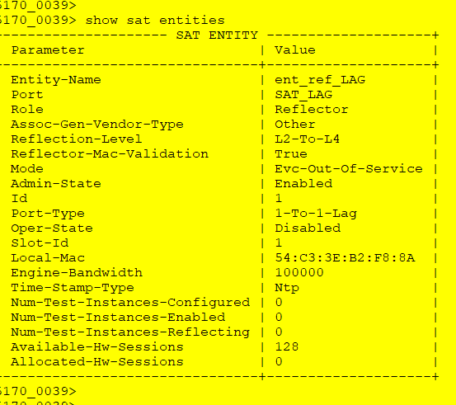

**SAT Test Instance configuration:**

*sat test-instance ins_ref_LAG flow-point-id fp_sat_LAG_uni untagged true*

*admin-state enabled exit*

*exit*

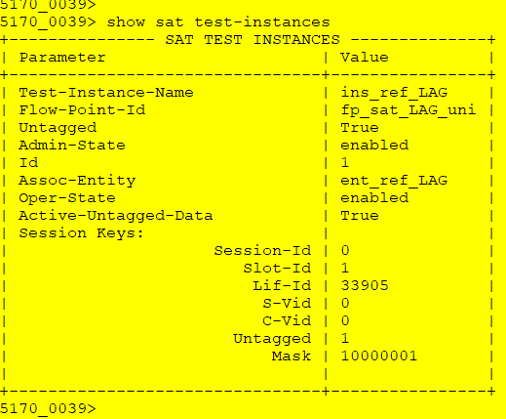

**Enable global-sat**

After all the steps above completed, global-sat needs to be enabled.

*config*

*sat sat-global admin-state enabled*

**Running SAT test**

Before running the SAT test, first step is to check whether Generator and Reflector node can

communicate with each other. This can be done via “ping” on the Generator node.

*sat ping test-instances test-instance ins_gen_LAG*

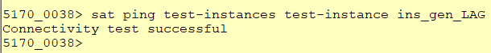

After making sure that “ping” is successful SAT can be started with the following command on the

Generator node.

*sat start test-instances test-instance ins_gen_LAG*



Test results can only be queried after the SAT test is over, till then it is possible to query test status.

*show sat test-instances status*

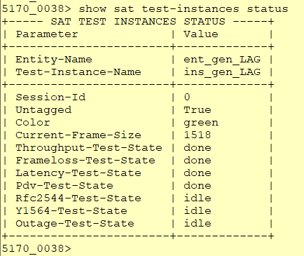

Test results will be shows with the following command after the test is over.

*show sat test-instances statistics*

Test Case Results:

Passed: Yes No Verified by Date/Time Comments