###### Deleting SAT configurations

**Objective:**

Objective is to delete SAT (Service Activation Test) configuration on an EVPL service.

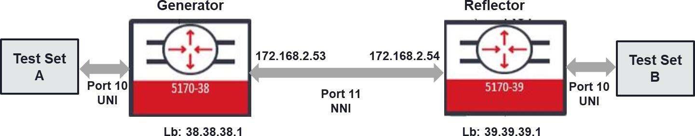

**Procedure:**

Deleting of SAT configuration needs to be started from the reverse order of creating the SAT configuration.

On the Generator:

* Disable SAT global
* Disable and delete SAT Test Instance
* Delete SAT Test Profile
* Delete SAT KPI Profile
* Disable and delete SAT Entity

On the Reflector:

* Disable SAT global
* Delete SAT Entity
* Delete SAT Test Instance

**Generator deletion commands:**

*config*

*no sat sat-global admin-state*

*sat test-instance ins_gen_ldp admin-state disabled no sat test-instance ins_gen_ldp*

*no sat test-profile prf_ldp no sat kpi-profile kpi_ldp*

*sat entity ent_gen_ldp admin-state disabled no sat entity ent_gen_ldp*

**Reflector deletion commands:**

*config*

*no sat sat-global admin-state*

*sat test-instance ins_ref_ldp admin-state disabled no sat test-instance ins_ref_ldp*

*sat entity ent_ref_ldp admin-state disabled no sat entity ent_ref_ldp*

Make sure that all the SAT configuration parameters returns null under “show sat” menu below.

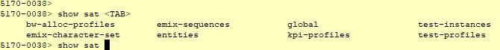

Example:

Test Case Results:

Passed: Yes No Verified by Date/Time Comments