###### Manage Active CLI sessions

In saos 10.x release , normally four or six concurrent sessions are allowed to login using CLI based on the system’s capability. When the system detects more than allowed concurrent logins, CLI enters the limited mode.

In the limited mode, users can view session information but cannot view & make changes to the configuration, for example, configure OSPF.

In this case it becomes important to bring system out of limited mode.In order to bring the system out of the limited mode, new enhancement has been added in saos 10.7.1 release.What happens with this is that a user with super privileges can terminate one or more active CLI sessions which allows us to bump the unwanted user who is loggined.

***Objective:***

Objective is to manage multiple CLI session on 10.x device.

***Procedure:***

There are 2 steps using which we can kill the unwanted cli session on the node.

First is identifying which session do we need to kill, this can be done using user who.

**STEP1:-** Identify the session which is to be terminated

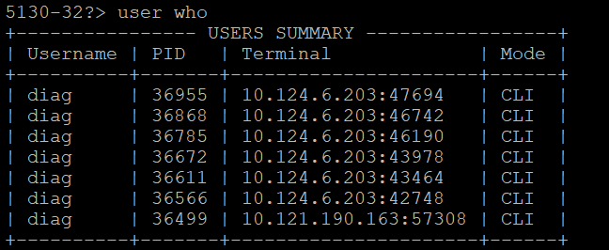

Once the session has been identified "use kill session " command in step 2 can be used to terminate that particular session.

**STEP 2 :-** Terminate the active session using process id

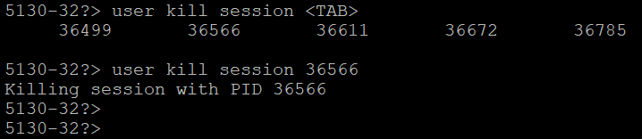

Few points to remember while accessing this functionality are ..

* User can terminate cli session regardless of whether the CLI is in limited mode. i.e user can kill other sessions even from limited mode as well.
* User has to have super priviledge to perform this functionality.
* User cannot terminate the current active session in which it is currently login.

Test Case Results:

Passed: Yes No Verified by Date/Time Comments