###### DHCP Options (Client Identifier & User Class Options)

***Objective:***

DHCP options are the smart way to configure to configure clients. The DHCP clients can request and receive information from the DHCP server in the form of DHCP options. The requirement of these DHCP options in addition with existing Options is to help DHCP servers to return the configuration parameter & IP allocation more intelligently.

Example: Sending configuration parameters & IP address allocation from a particular address pool to different clients based on the set of options transported I the protocol frame.

Note: In addition to this CATP, you can also refer to 10.6.0 TOI, which may complement in building improved understanding of this topic from conceptual standpoint. However, here in CATP will focus more on CLI & validation of this feature.

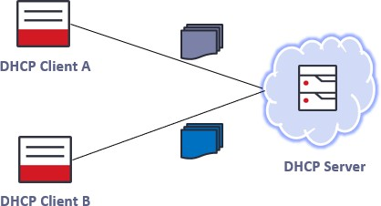

***Requirement:***

As per specific customer requirement, there is a request to use DHCP Client Identifier & User Class Options which Ciena 10x SAOS does not support prior to 10.6.0 release.

* SAOS 10x devices must support CLI configurable DHCPv4 Client Identifier Option 61 & DHCPv6 Option 1 as stated in below table.
* Ciena must support DHCP User class Option 77 & Option 15 and it must contain make, model, and software version separated by a delimiter (i.e. Vendor, Model, OS_Version) & configured/visible in DHCPv4/DHCPv6 packets as per RFC 3004/RFC 3315.

|  |  |  |  |
| --- | --- | --- | --- |
| **DHCP Option** | **Version** | **Option Type** | **Identification Factor** |
| 61 | DHCPv4 | Client Identifier | IAID-DUID/Chassis-ID/Mac-Address |
| 1 | DHCPv6 | Client Identifier | DUID-EN/DUID-LL/DUID-LLT |
| 77 | DHCPv4 | User Class Option | Vendor, Model, OS-Version |
| 15 | DHCPv6 | User Class Option | Vendor, Model, OS-Version |

***Objective:***

Ensure that with DHCPv6 client enabled, the DHCP Client Identifier Option will be configured via VALCLI to specify their unique identifier & User class string will be configured as Vendor, Model, OS_Version (Visible in packet Capture). The interface will acquire an IPv6 address automatically, **Only stateful DHCPv6 (no SLAAC) is currently supported.**

***Procedure:***

* Dual IPv4 and IPv6 stack on mgmt. interfaces are supported as of 10.3 and onwards. Enable DHCPv6 client on mgmtbr0/Remote. Ensure that:
  + config
  + dhcpv6-client client mgmtbr0 admin-enable true
  + dhcpv6-client client 'mgmtbr0' duid **DUID-LL**
* Display the **Option 1** Dhcpv6-client DUID config on the node.

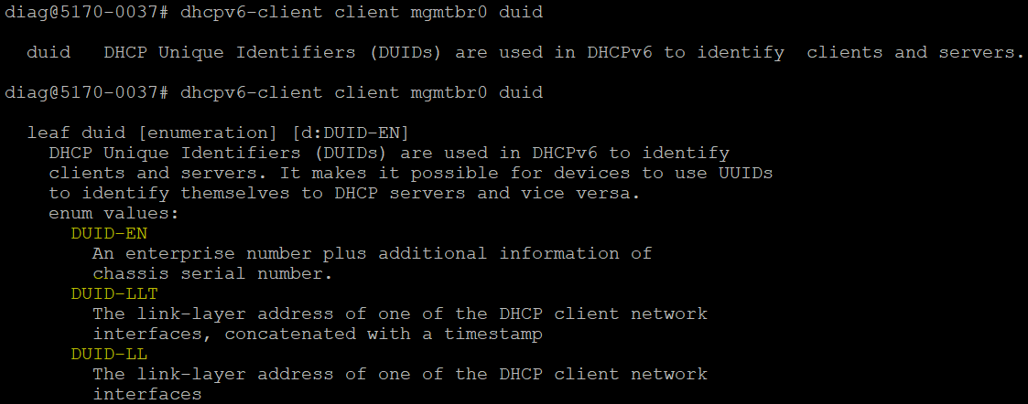

* Configure IPv4 static IP on the mgmtbr0 as well.
  + dhcp-client client mgmtbr0 admin-enable false
  + oc-if:interfaces interface mgmtbr0 ipv4 address address

x.x.x.x config ip x.x.x.x prefix-length 20

* + rib vrf default ipv4 x.x.x.x/8 next-hop x.x.x.x description "lab default"

Ex:

dhcp-client client mgmtbr0 admin-enable false

oc-if:interfaces interface mgmtbr0 ipv4 address address 10.181.36.85 config ip 10.181.36.85 prefix-length 20

rib vrf default ipv4 10.0.0.0/8 next-hop 10.181.32.1 description "lab default"

* Display the IPv6 and IPv4 interfaces on the node.
  + 5170-0037> show ipv6 interfaces brief

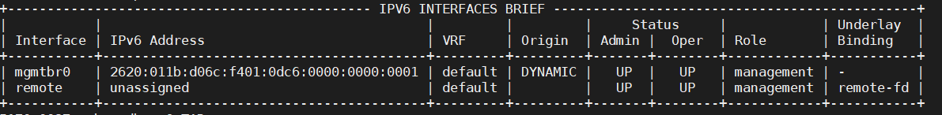

* + 5170-0037> show ip interfaces brief

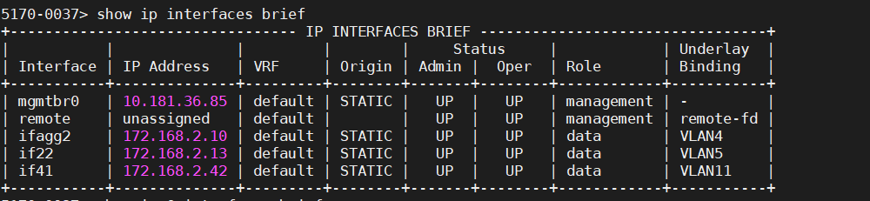

5170-0037> show dhcpv6

+-------- DHCPV6 CLIENT CONFIGURATION +

| Name | Value |

+ + +

| Interface Name | **mgmtbr0** |

| Admin State | Enabled |

| Rapid Commit | Enabled |

| Requested Preferred Lifetime (s) | 0 |

| Requested Valid Lifetime (s) | 0 |

**| DUID | DUID-LL |**

| Option | |

| DNS Server List | Enabled |

| Domain Search List | Enabled |

| Posix Time Zone | Disabled |

| TZDB Time Zone | Enabled |

| NTP Server | Enabled |

| Bootfile URL | Enabled |

+ + +

| Interface Name | remote |

| Admin State | Enabled |

| Rapid Commit | Enabled |

| Requested Preferred Lifetime (s) | 0 |

| Requested Valid Lifetime (s) | 0 |

| Option | |

| DNS Server List | Enabled |

| Domain Search List | Enabled |

| Posix Time Zone | Disabled |

| TZDB Time Zone | Enabled |

| NTP Server | Enabled |

| Bootfile URL | Enabled |

+ + +

+ DHCPV6 CLIENT STATE +

| Name | Value |

+ + +

| Interface Name | remote |

| Oper State | Enabled |

| DHCPv6 State | preinit |

| Config State | stateful |

| Renewal (T1) Time (s) | |

| Renewal (T1) Time Remaining (s) | |

| Rebinding (T2) Time (s) | |

| Rebinding (T2) Time Remaining (s) | |

| Preferred Lifetime (s) | |

| Preferred Lifetime Remaining (s) | |

| Valid Lifetime (s) | |

| Valid Lifetime Remaining (s) | |

| DHCPv6 Server DUID | |

| Option Value | |

| DNS Server List | |

| Domain Search List | |

| Posix Time Zone | |

| TZDB Time Zone | |

| NTP servers | |

| Boot File URL | |

+ + +

| Interface Name | mgmtbr0 |

**| Oper State | Enabled |**

**| DHCPv6 State | bound |**

**| Config State | stateful |**

| Renewal (T1) Time (s) | 302400 |

| Renewal (T1) Time Remaining (s) | 241733 |

| Rebinding (T2) Time (s) | 453600 |

| Rebinding (T2) Time Remaining (s) | 392933 |

| Preferred Lifetime (s) | 604800 |

| Preferred Lifetime Remaining (s) | 544133 |

|  |  |  |  |  |  |
| --- | --- | --- | --- | --- | --- |
| | | Valid Lifetime (s) |  | | | 604800 | | |
| | | Valid Lifetime Remaining | (s) | | | 544133 | | |
| | | DHCPv6 Server DUID |  | | | 0:1:0:1:25:22:d:24:0:0:5e:0:1:81 | | |
| | | Option Value |  | | |  | | |
| | | DNS Server List |  | | |  | | |
| | | Domain Search List |  | | |  | | |
| | | Posix Time Zone |  | | |  | | |
| | | TZDB Time Zone |  | | |  | | |
| | | NTP servers |  | | |  | | |
| | | Boot File URL |  | | |  | | |
| + |  |  | + |  | + |

NOTE: The above steps can be also used for dhcpv4-client by configuring the mgmtbr0 or remote interface as dynamic Mgmt IPv4 setup and Static Mgmt IPv6 setup.

* + config
  + dhcp-client client 'remote' admin-enable true
  + dhcp-client client remote client-identifier **IAID-DUID**
* Display the **Option 61** Dhcpv4-client config on the node.

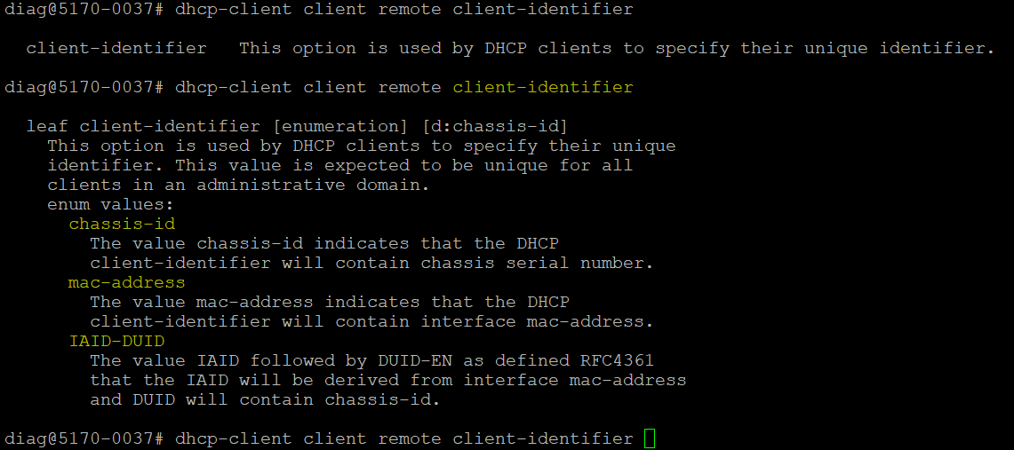

5170-0037> show dhcp

+------------ DHCP CLIENT CONFIGURATION +

| Name | Value |

+ + +

| Interface Name | mgmtbr0 |

| Admin State | Disabled |

| Lease Time (s) | 3600 |

| Client Identifer | chassis-id |

| Option | |

| Subnet Mask | Enabled |

|  |  |  |  |  |  |
| --- | --- | --- | --- | --- | --- |
| | | Time Offset |  | | | Enabled | | |
| | | Router |  | | | Enabled | | |
| | | Domain Name | Server | | | Enabled | | |
| | | Log Server |  | | | Enabled | | |
| | | Host Name |  | | | Enabled | | |
| | | Domain Name |  | | | Enabled | | |
| | | NTP Servers |  | | | Enabled | | |
| | | Lease Time |  | | | Disabled | | |
| | | Tftp Server | Name | | | Enabled | | |

| Bootfile Name | Enabled |

| Vendor-Identifying Vendor-Specific | Enabled |

+ + +

| Interface Name | remote |

| Admin State | Enabled |

| Lease Time (s) | 3600 |

**| Client Identifer | IAID-DUID |**

| Option | |

| Subnet Mask | Enabled |

| Time Offset | Enabled |

| Router | Enabled |

| Domain Name Server | Enabled |

| Log Server | Enabled |

| Host Name | Enabled |

| Domain Name | Enabled |

| NTP Servers | Enabled |

| Lease Time | Disabled |

| Tftp Server Name | Enabled |

| Bootfile Name | Enabled |

| Vendor-Identifying Vendor-Specific | Enabled |

+ + +

* **DHCP User Class Option 77 & 15** will be configured/Visible in DHCPv4/DHCPv6 packets as per RFC 3004/RFC 3315.
* User Class string will be configured as "**ciena,cnXXXX,saos-10-06-00-XXXX**“ Example: "ciena,cn5170,saos-10-06-00-0252".

**Packet Capture of DHCPv4 Client Identifier Option 61 & User Class Option 77:**

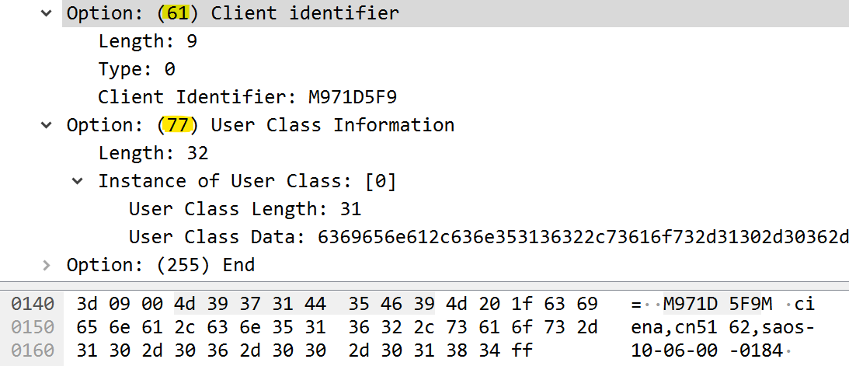

**Packet Capture of DHCPv6 User Class Option 15:**

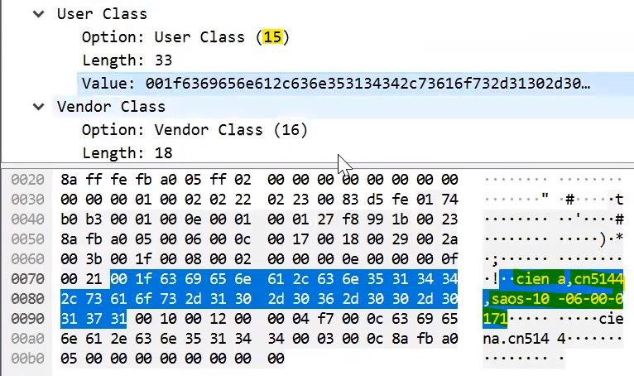

**Test Case Results:**

Passed: Yes No Verified by Date/Time Comments