###### 5171 Front Temperature Sensor – Early Notification of High Temperature

***Objective:***

* + - * Verify that early notification alarm for high temperature threshold crossing is working. This testcase only applies to 5171 front temperature sensor.

Pre-requisites:

* + - * 5171 running SAOS 10.7.1 or later.
      * 20C below the max-temp-threshold would raise an early notification warning
      * 10C below the max-temp-threshold would raise a major early notification warning
      * When max-temp-threshold is crossed, a critical alarm is raised.

***Procedure:***

* + - * Display the current temperature threshold settings, and also the instantaneous temperatures on 5171 as monitored by the front temperature sensor.

5171_0042> show system components component front-temperature

+------------- COMPONENT: FRONT-TEMPERATURE +

| Name | Value |

+ + +

| name | front-temperature |

| type | openconfig-platform-types:SENSOR |

| instant | 32.0 C |

| avg | 32.0 C |

| min | 32.0 C |

| max | 33.0 C |

| max-temp-threshold | 65.00 C |

| min-temp-threshold | -40.00 C |

| state | Ok |

+ + +

* + - * Enable alarm early notification :

config

components component front-temperature properties property alarm-early-notification config name alarm-early-notification value enabled

* + - * Configure the max-temp-threshold to 45C.

config

components component front-temperature properties property max- temperature-limit config name max-temperature-limit value 45

* + - * Display the front temperature

CN5171_0040> **show system components component front-temperature**

+ COMPONENT: FRONT-TEMPERATURE +

| Name | Value |

+ + +

| name | front-temperature |

| type | openconfig-platform-types:SENSOR |

| instant | 33.0 C |

| avg | 32.0 C |

| min | 32.0 C |

| max | 33.0 C |

| max-temp-threshold | 45.00 C |

| min-temp-threshold | -40.00 C |

| max-operating-temp | 65.00 |

| min-operating-temp | -40.00 |

| state | Ok |

| alarm-early-notification | enabled |

+ + +

* + - * Display alarm – expectation is that a Warning alarm is raised when temperature of device crosses 25C. ie: 20C below the max-temp-threshold
      * Next set the max temperature threshold to 40C.

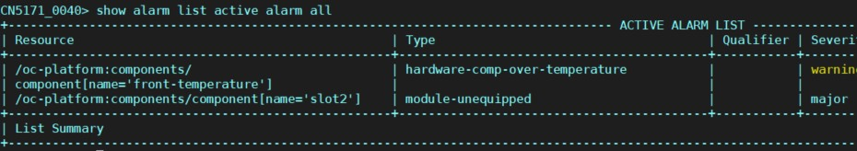

components component front-temperature properties property max- temperature-limit config name max-temperature-limit value 40

* + - * Display the temperature settings:

CN5171_0040> show system components component front-temperature

+ COMPONENT: FRONT-TEMPERATURE +

| Name | Value |

+ + +

| name | front-temperature |

| type | openconfig-platform-types:SENSOR |

| instant | 33.0 C |

| avg | 32.0 C |

| min | 32.0 C |

| max | 33.0 C |

| max-temp-threshold | 40.00 C |

| min-temp-threshold | -40.00 C |

| max-operating-temp | 65.00 |

| min-operating-temp | -40.00 |

| state | Ok |

| alarm-early-notification | enabled |

+ + +

CN5171_0040>

* + - * Display the alarms now, expectation is for a major alarm to be raised when the temperature crosses 35C ie: 10C below the max-temp-threshold

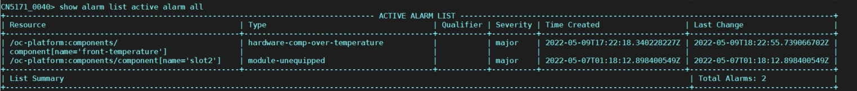

Test Case Results:

Passed: Yes No Verified by Date/Time

Comments