###### TWAMP Server and Session Reflector

***Objective:***

This test goes through the setup for a TWAMP server and session reflector on a SAOS 10x device connected with TWAMP client and session generator on SAOS 6x. SAOS 10.7 introduced TWAMP server for 5164, 5166, 5168, 8110, 8112, 8114. SAOS 10.6 introduced TWAMP server on 5170 and

5171.

***Procedure:***

* This is the topology used for this test

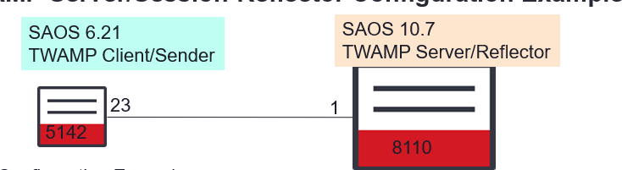

* On SAOS 10.7 device, create the flow point and IP interface to prepare for TWAMP session.

classifiers classifier vlan8 filter-entry vtag-stack vtags 1 vlan-id 8 fds fd vlan8 mode vpls

fps fp vlan8 fd-name vlan8 logical-port 1 classifier-list vlan8 fps fp vlan8 fd-name vlan8 stats-collection on

fps fp vlan8 fd-name vlan8 egress-l2-transform pushvid8 vlan-stack 1 push- vid 8

oc-if:interfaces interface if1 config name if1 vrfName default cn-if:type ip mtu 1500 admin-status true underlay-binding config fd vlan8

oc-if:interfaces interface if1 ipv4 addresses address **172.16.8.2** config ip

**172.16.8.2** prefix-length 30

**oc-if:interfaces interface if1 config mtu 9136 logical-ports logical-port 1 mtu 9216**

* On SAOS 6.21 node 5142, create the IP interface

vlan create vlan 8 vlan add vlan 8 port 23

interface remote set vlan 8 interface remote set ip 172.16.8.1/30

* Setup TWAMP Server ad session reflector on SAOS 10.7 device

twamp server admin-state true twamp server server-tcp-port 5678

twamp session-reflector admin-state true

* Setup TWAMP client and generator on SAOS 6.21 device.

twamp set port 5678 twamp enable port 15

**#### HOST name is far end device - the server's IP, not local client session's IP.**

twamp client session create name 107TOI host 172.16.8.2 cos-policy ip-prec ip-prec 7 repeat off type fixed

twamp client test name 107TOI

twamp client session create name 107TOI type poisson

* Start TWAMP test from SAOS 6.21 device

twamp client test name 107TOI start

* Display Statistics SAOS 10x

show twamp session-refelector test-sessions



SAOS 6x

TWAMP client show

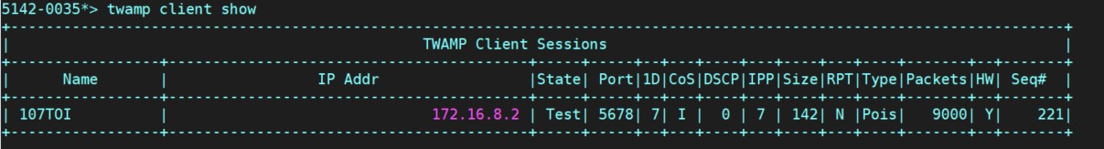

Test Case Results:

Passed: Yes No Verified by Date/Time Comments