###### MPLS-TP Tunnel Configuration

***Objective:***

Objective is to configure MPLS-TP Tunnel and to verify the creation of the MPLS-TP tunnels. In this section, following the steps will configure the various part of the tunnels to achieve end to end connection.

Pre-requisites:

* Create Classifier, FP, FD, IP interfaces, Loopback interface and IGP routing instance on a router for the applicable topology (Please refer to SAOS 10.X CATP for configuration samples)
* Necessary licenses applied
* Familiarity with VALCLI

Topology used in this test case:

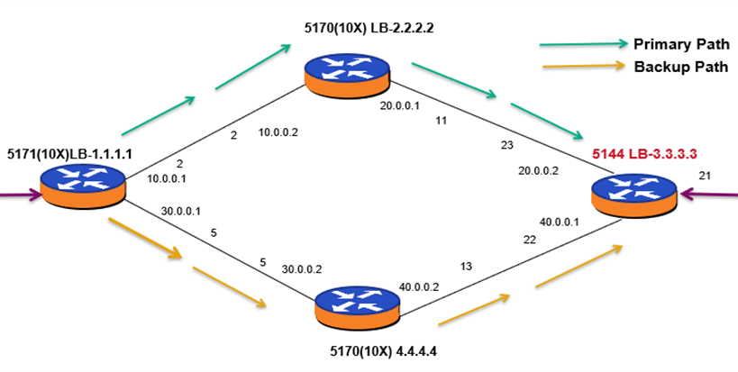

PE4

PE3

PE1

PE2

***Procedure:***

***The procedure below provides the configuration of MPLS-TP tunnel with above topology as reference.***

* Go to the configuration terminal config
* Enter the following command to configure MPLS TP Primary Ingress tunnel on PE1.

tp-corouted-tunnels tunnel tunnel_150 1.1.1.1 3.3.3.3 tunnel-type static-ingress-corouted

forward-out-segment forward-out-label 4500

next-hop-ip 10.0.0.2 exit

reverse-in-segment reverse-in-label 4501 exit

exit

* Enter the following command to configure MPLS TP Primary Egress tunnel on PE3

tp-corouted-tunnels tunnel tunnel_150 1.1.1.1 3.3.3.3 tunnel-type static-egress-corouted

reverse-out-segment reverse-out-label 4501

prev-hop-ip 20.0.0.1 exit

forward-in-segment forward-in-label 4500 exit

exit

* Enter the following command to configure MPLS TP primary transit tunnel on PE2 tp-corouted-tunnels tunnel tunnel_150 1.1.1.1 3.3.3.3

tunnel-type static-transit-corouted forward-out-segment

forward-out-label 4500

next-hop-ip 20.0.0.2 exit

reverse-in-segment reverse-in-label 4501 reverse-out-segment

reverse-out-label 4501

prev-hop-ip 10.0.0.1 exit

forward-in-segment forward-in-label 4500 exit

exit

* Enter the following command to configure MPLS TP Ingress Backup tunnel on PE1

*tp-corouted-tunnels tunnel bkup-tunnel_150* 1.1.1.1 3.3.3.3

*tunnel-type static-ingress-corouted tunnel-role-type backup*

*forward-out-segment forward-out-label 4502*

*next-hop-ip 30.0.0.2 exit*

*primary-tunnel-configuration primary-tunnel-name tunnel_150*

*primary-tunnel-type static-ingress-corouted exit*

*reverse-in-segment reverse-in-label 4503 exit*

*exit*

* Enter the following command to configure MPLS TP Egress Backup tunnel on PE3 tp-corouted-tunnels tunnel bkup-tunnel_150 1.1.1.1 3.3.3.3

tunnel-type static-egress-corouted tunnel-role-type backup

reverse-out-segment reverse-out-label 4503

prev-hop-ip 40.0.0.2 exit

primary-tunnel-configuration primary-tunnel-name tunnel_150

primary-tunnel-type static-egress-corouted exit

forward-in-segment forward-in-label 4502 exit

exit

* Enter the following command to configure MPLS TP backup transit tunnel on PE4 tp-corouted-tunnels tunnel bkup-tunnel_150 1.1.1.1 3.3.3.3

tunnel-type static-transit-corouted

forward-out-segment forward-out-label 4502

next-hop-ip 40.0.0.1 exit

reverse-in-segment reverse-in-label 4503 reverse-out-segment

reverse-out-label 4503

prev-hop-ip 30.0.0.1 exit

forward-in-segment forward-in-label 4502 exit

* Sample Pseudowire configuration

To create Pseudowire with MPLS TP tunnel pseudowires pseudowire pw_A150 mode spoke

tunel-type static-egress-corouted tunnel-name tunnel_150

tunnel-source-ip 1.1.1.1

tunnel-destination-ip 3.3.3.3

configured-pw peer-ip 1.1.1.1 pw-id 151

transmit-label 151

receive-label 151

* Sample L2VPN configuration

To configure L2VPN Service & Attach Pseudowire l2vpn-services l2vpn l2vpn-services_A150

mtu 1500

service-type vlan forwarding-domain fd_A150 pseudowire pw_A150

exit exit

Test Case Results:

Passed: Yes No Verified by Date/Time Comments