###### Static MPLS-TP LSP BFD

LSP BFD session will run from LER A to LER B monitoring the tunnel path between LERs.

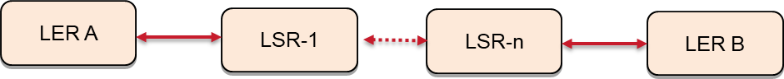

Objective:

**To Enable BFD session on MPLS TP Tunnel with default values Procedure:**

* Goto the configuration terminal config
* Enter the following command to Enable BFD session on primary ingress Tunnel

tp-corouted-tunnels tunnel tunnel_150 1.1.1.1 3.3.3.3 tunnel-type static-ingress-corouted

bfd-cfg-parms “admin-down false”

exit

* Enter the following command to Enable BFD session on primary Egress Tunnel tp-corouted-tunnels tunnel tunnel_150 1.1.1.1 3.3.3.3

tunnel-type static-egress-corouted

bfd-cfg-parms “admin-down false”

exit

Test Case Results:

Passed: Yes No Verified by Date/Time Comments