###### LSP BFD CLI Show Commands

Objective:

To review the configured LSP BFD parameters and to verify the operational status of the LSP BFD.

#### Procedure:

* To display all the BFD sessions configured on MPLS-TP LSPs Show tp-tunnel-corouted bfd-session

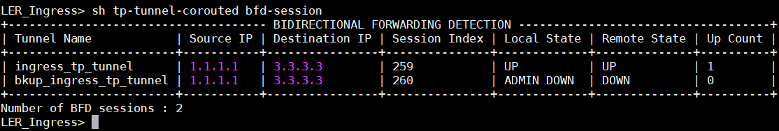

* To display all BFD sessions configured on ingress MPLS-TP LSPs Show tp-tunnel-corouted ingress-tunnel bfd-session

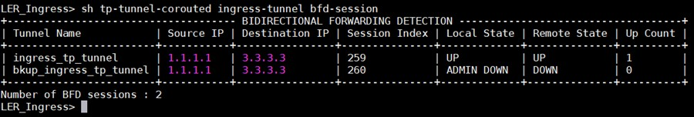

* To display all BFD sessions configured on egress MPLS-TP LSPs Show tp-tunnel-corouted egress-tunnel bfd-session

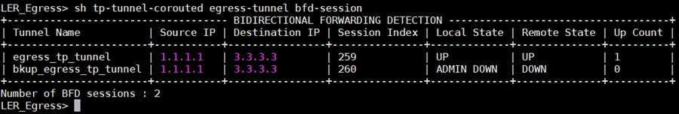

* To display the details of bfd session for a given Static MPLS-TP LSP

Show tp-tunnel-corouted tunnel ingress_tp_tunnel source-ip 1.1.1.1 destination-ip 3.3.3.3 bfd session

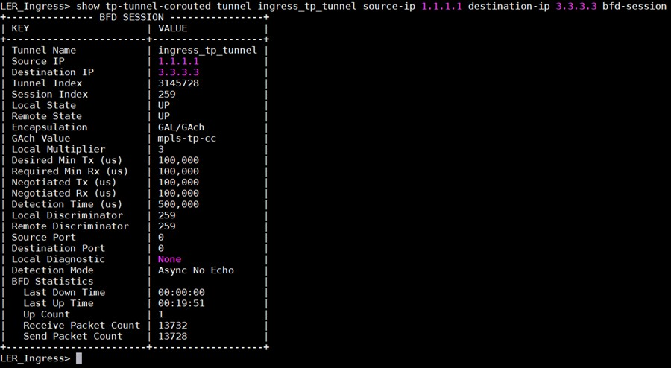

Test Case Results:

Passed: Yes No Verified by Date/Time Comments