###### MPLS-TP Static Tunnel – LSP BFD – Hardware acceleration

***Objective:***

Validate that LSP BFD session can be enabled on MPLS-TP tunnel. Also test hardware acceleration on the LSP BFD session. Only supported on 51xx devices.

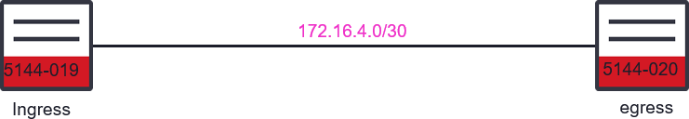

***Procedure:***

* Create static MPLS-TP tunnel with LSP BFD session – hardware acceleration disabled.
  + config

## Ingress Node

tp-corouted-tunnels tunnel to5144-20-b 192.168.44.236 192.168.44.237

tunnel-type static-ingress-corouted forward-out-segment forward-out-label 30

forward-out-segment next-hop-ip 172.16.4.2

reverse-in-segment reverse-in-label 31

source-tunnel-id 30

destination-tunnel-id 31

bfd-cfg-parms admin-down false **bfd-cfg-parms accelerate false** exit

exit

##Egress Node

tp-corouted-tunnels tunnel to5144-20-b 192.168.44.236 192.168.44.237

tunnel-type static-egress-corouted reverse-out-segment reverse-out-label 31

reverse-out-segment prev-hop-ip 172.16.4.1

forward-in-segment forward-in-label 30

source-tunnel-id 30

destination-tunnel-id 31 bfd-cfg-parms admin-down false **bfd-cfg-parms accelerate false** exit

exit

* Validate that the BFD session is not hardware accelerated, and the MPLS-TP tunnel is operational

Local Node

* show tp-tunnel-corouted

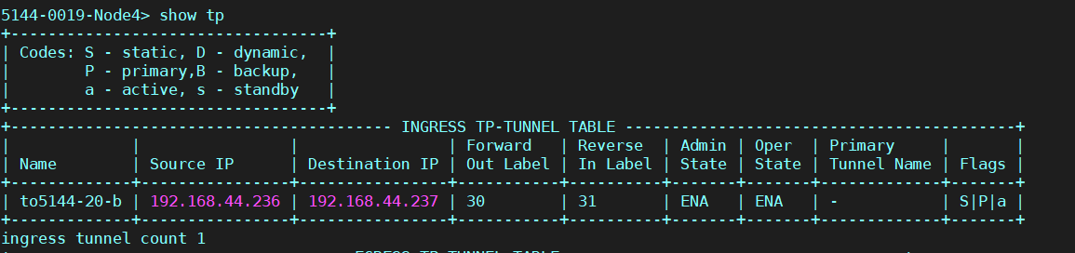

Remote Node

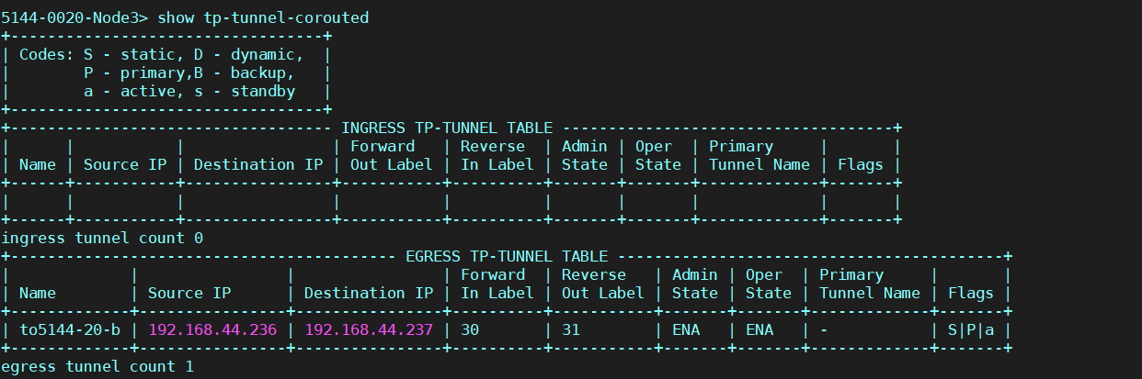

* + 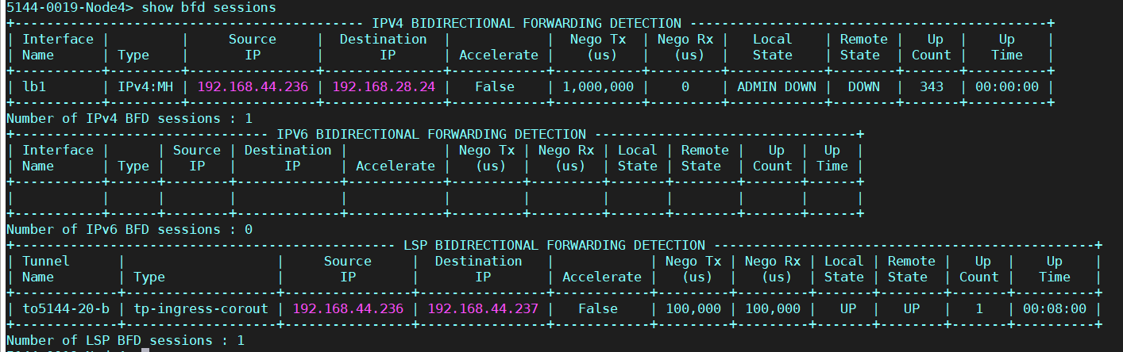show bfd sessions Local Node

Remote Node

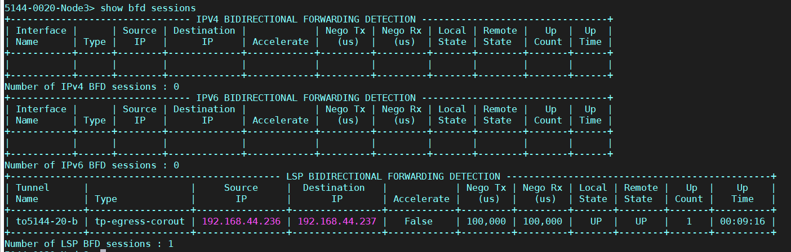

* Set the hardware acceleration to enabled – must admin-disable the BFD session first.

##Ingress Node

tp-corouted-tunnels tunnel to5144-20-b 192.168.44.236 192.168.44.237

bfd-cfg-parms statistics-collection on

bfd-cfg-parms admin-down true bfd-cfg-parms accelerate true

bfd-cfg-parms required-min-rx-interval 3300

bfd-cfg-parms desired-min-tx-interval 3300 apply

bfd-cfg-parms admin-down false

apply

exit exit

##Egress Node

tp-corouted-tunnels tunnel to5144-20-b 192.168.44.236 192.168.44.237

tunnel-type static-egress-corouted

bfd-cfg-parms statistics-collection on

bfd-cfg-parms admin-down true bfd-cfg-parms accelerate true

bfd-cfg-parms required-min-rx-interval 3300

bfd-cfg-parms desired-min-tx-interval 3300 apply

bfd-cfg-parms admin-down false

apply exit exit

* Validate that the MPLS-TP tunnel and the hardware accelerated bfd session are up.
  + show tp-tunnel-corouted

Local Node:

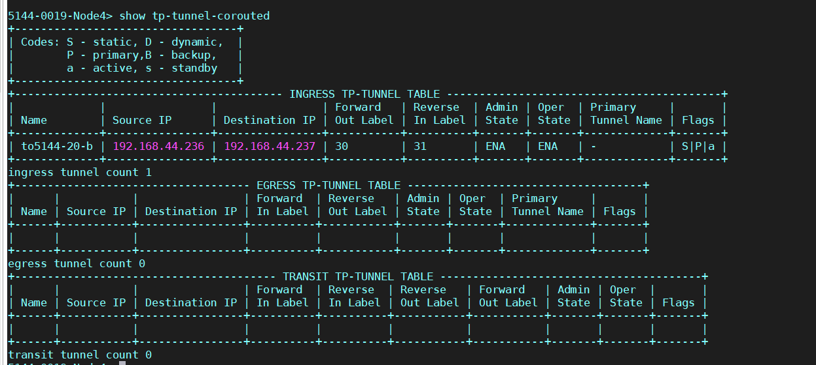

**Remote Node:**

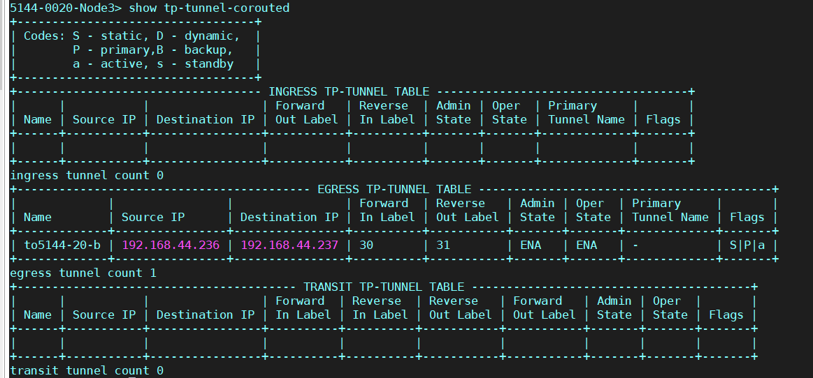

>show bfd sessions

**Local Node:**

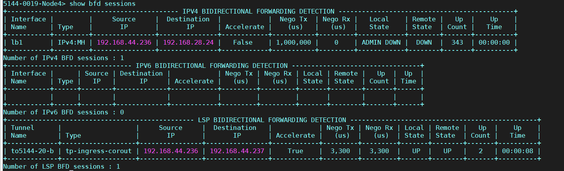

**Remote Node:**

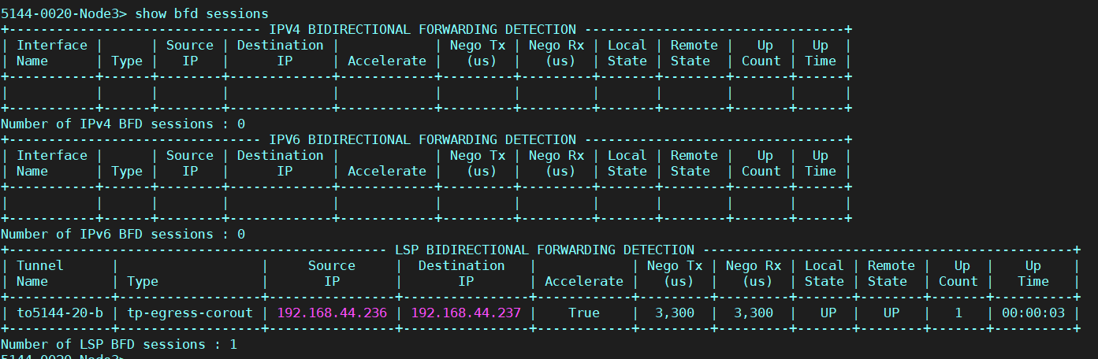

**Test Case Results:**

Passed: Yes No Verified by Date/Time Comments