###### Static PWE – Multi-Segmented PWE

***Objective:***

Provision a Multi-segmented PWE with PWE transported on different MPLS tunnel technologies. Please note MS-PWE only supported for static PWEs. Pseudowires being stitched on the S-PE must have the same setting on following paameters: control word value, cc-type, cv-type, MTU, FAT, FAT Capability, PW-status setting. MS-PW Identifier must also be identical for all segments of the MS- PWE.

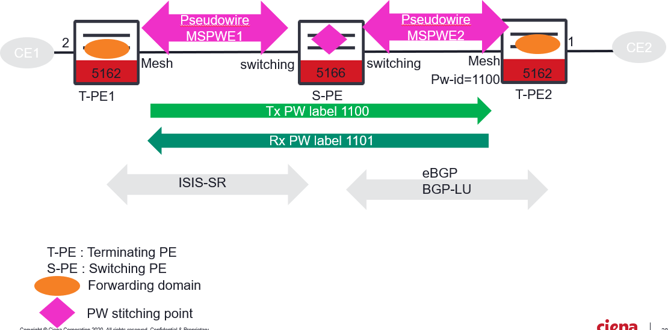

***Procedure:***

* Go to the configuration terminal and provision the PWE on TPE-1, TPE-2, and S-PE as follows:
  + config

TPE-1

classifiers classifier vlan1100 filter-entry vtag-stack vtags

1 vlan-id 1100

fds fd **MSPWE1** mode vpls

fps fp fp2MSPWE fd-name MSPWE1 logical-port 2 classifier-list vlan1100

pseudowires pseudowire **MSPWE1**

mode mesh

stats-collection on mac-withdraw true

configured-pw pw-status true

configured-pw peer-ip 10.181.102.151

configured-pw pw-id 1100

configured-pw transmit-label **1100** receive-label **1101**

**mtu 9600** exit exit

l2vpn-services l2vpn service1100 service-type vlan forwarding-domain MSPWE1 pseudowire MSPWE1

TPE-2

classifiers classifier vlan1101 filter-entry vtag-stack vtags

1 vlan-id 1101

fds fd MSPWE2 mode vpls

fps fp fp1MSPWE fd-name MSPWE2 logical-port 1 classifier-list vlan1101

pseudowires pseudowire MSPWE2

mode mesh

stats-collection on mac-withdraw true

configured-pw pw-status true

configured-pw peer-ip 10.181.102.151

configured-pw pw-id 1101

configured-pw transmit-label 1101 receive-label 1100

**mtu 9600** exit exit

l2vpn-services l2vpn service1100 service-type vlan forwarding-domain MSPWE2 pseudowire MSPWE2

S-PE

pseudowires pseudowire MSPWE1

**mode switching** stats-collection on **ms-pw-identifier 1200** mac-withdraw true mtu 9600

configured-pw pw-status true configured-pw peer-ip 10.181.102.146

configured-pw pw-id 1100

configured-pw transmit-label 1101 receive-label 1100 exit

exit

pseudowires pseudowire MSPWE2

mode switching

stats-collection on **ms-pw-identifier 1200** mac-withdraw true

mtu 9600

configured-pw pw-status true configured-pw peer-ip 62.62.62.72

configured-pw pw-id 1101

configured-pw transmit-label 1100 receive-label 1101

* Validate that the MS-PWE is in operational state on T-PE1.

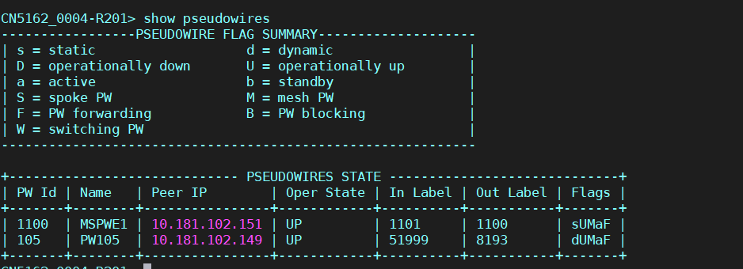

Test Case Results:

Passed: Yes No Verified by Date/Time Comments