###### Dynamic PWE with MTU – Ignore MTU Mismatch

***Objective:***

Validate Ignore MTU mismatch parameter on pseudowire. PWE will not be established with remote node if dynamic PWE has mismatched MTU setting. However, Ignore MTU Mismatch can be set on

PWE so that PWE can be operational even with MTU mismatched. There is no validation of MTU range but the supported range is 1500B to 9216B.

***Procedure:***

* Create PWE with mismatched MTU on either end.
* Local PE

***pseudowires pseudowire CustomerA***

mode **spoke**

stats-collection on

mtu 10000

**ignore-mtu-mismatch true**

configured-pw peer-ip 192.168.33.245 pw-id 1

***l2vpn-services l2vpn l2vpnCustomerA*** signaling-type* ldp forwarding-domain CustomerA pseudowire CustomerA

* Remote PE

***pseudowires pseudowire CustomerA***

mode **spoke**

stats-collection on

mtu 1500

**ignore-mtu-mismatch true**

configured-pw peer-ip 10.181.102.151 pw-id 1

* ***l2vpn-services l2vpn l2vpnCustomerA*** signaling-type* ldp forwarding-domain CustomerA pseudowire CustomerA
  + The above PWE will not be operational because of mismatched MTU but with ignore-mtu- mismatch set to true, the PWE will become operational and MTU setting will be ignored.
  + Validate the PWE :

□ show pseudowire pseudowire CustomerA

* + 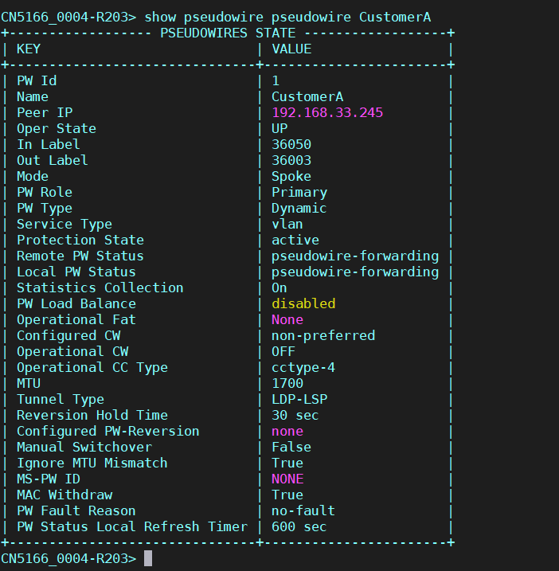

Test Case Results:

Passed: Yes No Verified by Date/Time Comments