###### FAT PW Verification & Results

***Objective:***

Objective of this section is to provide a cli commands for verification of FAT PW status & results analysis. We will be using various alternate methods to verify, however at the moment there is no direct cli command available to verify FAT PW status. We will capture cli outputs from PE nodes.

***Procedure:***

* On PE nodes

5170-0037> show pseudowires

PSEUDOWIRE FLAG SUMMARY

| s = static d = dynamic |

| D = operationally down U = operationally up |

| a = active b = standby |

| S = spoke PW M = mesh PW |

| F = PW forwarding B = PW blocking |

+ PSEUDOWIRES STATE +

| PW-Id | Name | Peer IP | Oper State | In Label | Out Label | Flags |

+ + + + + + + +

| 1 | pe1_pe2_spoke_pw1 | 39.39.39.1 | UP | 24320 | 24320 | dUSaF |

+ + + + + + + +

5170-0039> show pseudowires

PSEUDOWIRE FLAG SUMMARY

| s = static d = dynamic |

| D = operationally down U = operationally up |

| a = active b = standby |

| S = spoke PW M = mesh PW |

| F = PW forwarding B = PW blocking |

+ PSEUDOWIRES STATE +

| PW-Id | Name | Peer IP | Oper State | In Label | Out Label | Flags |

+ + + + + + + +

| 33 | PW_SAT_LDP | 38.38.38.1 | UP | 24321 | 24320 | dUMaF |

| 1 | pe1_pe2_spoke_pw1 | 37.37.37.1 | UP | 24320 | 24320 | dUSaF |

+ + + + + + + +

5170-0037> show pseudowires pseudowire pe1_pe2_spoke_pw1

+ PSEUDOWIRES STATE +

|  |  |  |  |
| --- | --- | --- | --- |
| | KEY | | | VALUE | | |
| + | + |  | + |
| | PW-Id | | | 1 | | |
| | Name | | | pe1_pe2_spoke_pw1 | | |
| | Peer IP | | | 39.39.39.1 | | |
| | Oper State | | | UP | | |

| In Label | 24320 |

| Out Label | 24320 |

| Mode | Spoke |

| Pw-Role | Primary |

| Pw-Type | Dynamic |

| Service Type | vlan |

| Protection State | active |

| Remote PW-status | pseudowire-forwarding |

| Local PW-status | pseudowire-forwarding |

| Remote Refresh Timer | 0 |

| Stats Collection | Off |

| Pw-Loadbalance | fat-pw |

| Fat-Capability | tx-rx |

| Configured CW | non-preferred |

| Operational CW | OFF |

| Operational CC-type | cctype-4 |

+ + +

* Packet Capture taken on port 17 of PE2 node which shows the of FAT PW label (label 491 can be seen generated)

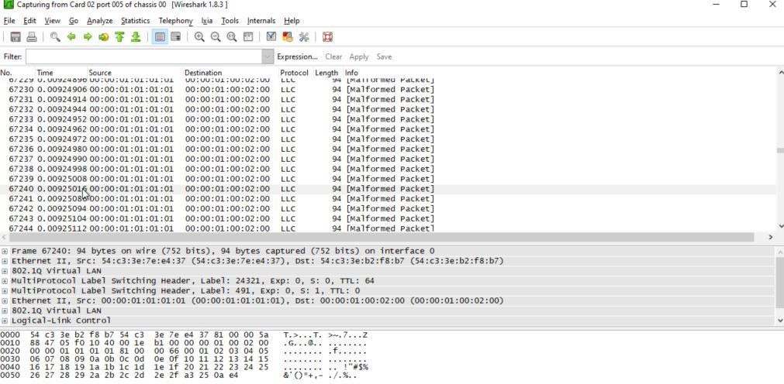

* On PE2 node the output of ettps shows an even spread of traffic on ingress direction of LAG ports 17 & 18, for traffic originated by ixia cd 2 pt 4 and destined towards cd 2 pt 5. This uniform distribution of traffic along with wireshark snapshot of packet capture proves that 10x node is hashing traffic on two links of LAG for a L2VPN VPWS.

5170-0039> show ettps statistics

+

+

ETTP STATISTICS

| Name | In Bytes | In Packets | Out Bytes | Out Packets | Link Flap Events | In Discards Bytes | Out Discards Bytes |

+ + + + + + +

+ +

|  |  |  |  |  |  |  |  |  |  |  |  |  |
| --- | --- | --- | --- | --- | --- | --- | --- | --- | --- | --- | --- | --- |
| |  | | 1 |  | | | 0 | | 0 | | | | 0 | | 0 | | 0 | | | | |
| |  |  | | 2  3 | |  | | | 0  0 | | 0  | 0 | | | 0  | 0 | | | 0  | 0 | | 0  | 0 | |  | | |  | |
| |  | | 4 | | | | 0 | | 0 | | | 0 | | | 0 | | 0 | | | | |
| |  | | 5 | | | | 0 | | 0 | | | 0 | | | 0 | | 0 | | | | |
| |  | | 6 | | | | 468539 | | 5248 | | | 195036 | | | 919 | | 0 | | | | |
| |  | | 7 | | | | 0 | | 0 | | | 104138 | | | 338 | | 0 | | | | |
| |  | | 8 | | | | 0 | | 0 | | | 0 | | | 0 | | 0 | | | | |
| |  | | 9 | | | | 468539 | | 5248 | | | 195036 | | | 919 | | 0 | | | | |
| |  | | 10 | | | | 0 | | 0 | | | 6859959271708 | | | 100881751968 | | 0 | | | | |
| |  | | 11 | | | | 468828 | | 5248 | | | 195326 | | | 919 | | 0 | | | | |
| |  | | 12 | | | | 0 | | 0 | | | 0 | | | 0 | | 0 | | | | |
| |  | | 13 | | | | 0 | | 0 | | | 0 | | | 0 | | 0 | | | | |
| |  | | 14 | | | | 0 | | 0 | | | 104138 | | | 338 | | 0 | | | | |
| |  | | 15 | | | | 0 | | 0 | | | 104138 | | | 338 | | 0 | | | | |
| |  | | 16 | | | | 0 | | 0 | | | 104138 | | | 338 | | 0 | | | | |
| | |  |  | |  |  | |  | |  |  |  |  |
| |  |  | | 17  18 | |  | | | 4780348745982 | 50854762124 | 4619761  6187525795506 | 65824742790 | 91002 | | | | | | 9293  | 580 | | 0  | 0 | |  | | |  | |
| | |  |  | |  | | | | |  |  |  |  |

* For details of hashing algorithm works please refer to FAT PW 10.4 TOI topic, however in our test setup we are using ixia to create two different source MACs, which separates different traffic flows, essentially resulting in FAT label generation and efficient hashing. Snapshot setting from Ixia can be seen below

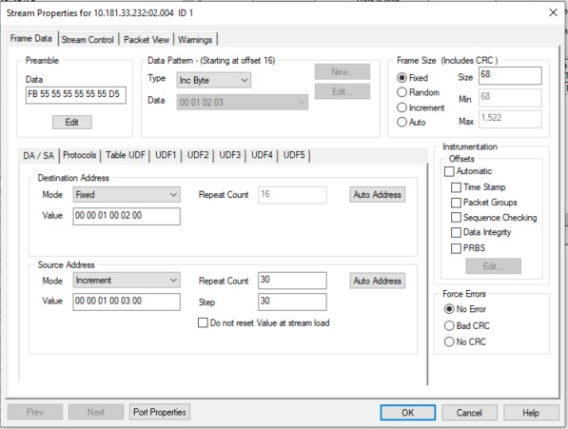

Test Case Results:

Passed: Yes No Verified by Date/Time Comments