* + 1. FAT PW Verification & Results

***Objective:***

Objective of this section is to provide a cli commands for verification of FAT PW status & results analysis. We will be using various alternate methods to verify, however at the moment there is no direct cli command available in 10.5.1 to verify FAT PW status. We will capture cli outputs from PE nodes PW.

***Procedure:***

On PE nodes

***Verify PW status:***

Ping response of PW

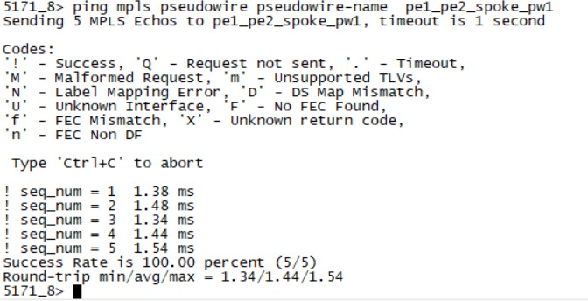

***Verify FAT signalling enable on node:***

* On PE1 node the output of ettps shows an even spread of traffic on ingress direction of LAG ports 20 & 21, for traffic originated by ixia connected for pt 1 5 and destined towards ixia connected port 1 at PE2.

This uniform distribution of traffic along with wireshark snapshot of packet capture proves that 10x node is hashing traffic on two links of LAG for a L2VPN VPLS.

PE 1 ETTP stats

**PE 2 ETTP stats**

* Ingress Packet Capture taken on port 20 of PE2 node which shows the of FAT PW label (label 360 can be seen generated)

* For details of hashing algorithm works please refer to FAT PW Signaling capability 10.5 TOI topic, however in our test setup we are using ixia to create two different source MACs, which separates different traffic flows, essentially resulting in FAT label generation and efficient hashing. Snapshot setting from Ixia can be seen below

Test Case Results:

Passed: Yes No Verified by Date/Time Comments