* + 1. Verification & Results

***Objective:***

Objective of this section is to provide a cli commands for verification of PW status.

**#PW status**

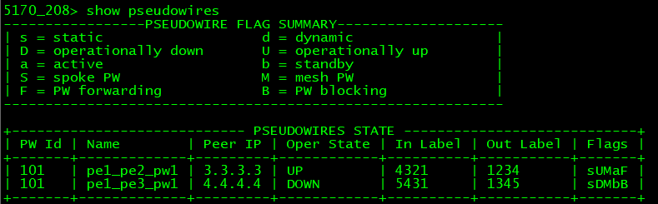

#### Routing table

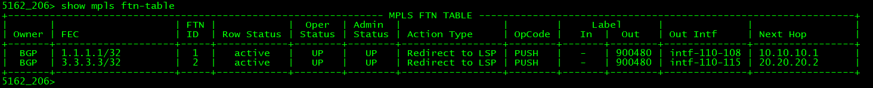**MPLS FTN table**

**Test Case Results:**

Passed: Yes No Verified by Date/Time Comments