###### Assigning CoS to Non-conforming Packets

***Objective:***

Objective is to verify Frame to Cos profiles can assign a cos value to untagged packets. On L2 switched circuits, untagged packet is deemed a non-conforming packet for frame-to-cos maps. The use case for ROE/CPRI on 5168 where the CPRI packets are untagged but must be set to a high priority

***Procedure:***

* When there is no provisioning for non-conforming packets in frame-to-cos map. All non- conforming traffic is going to Queue 0.

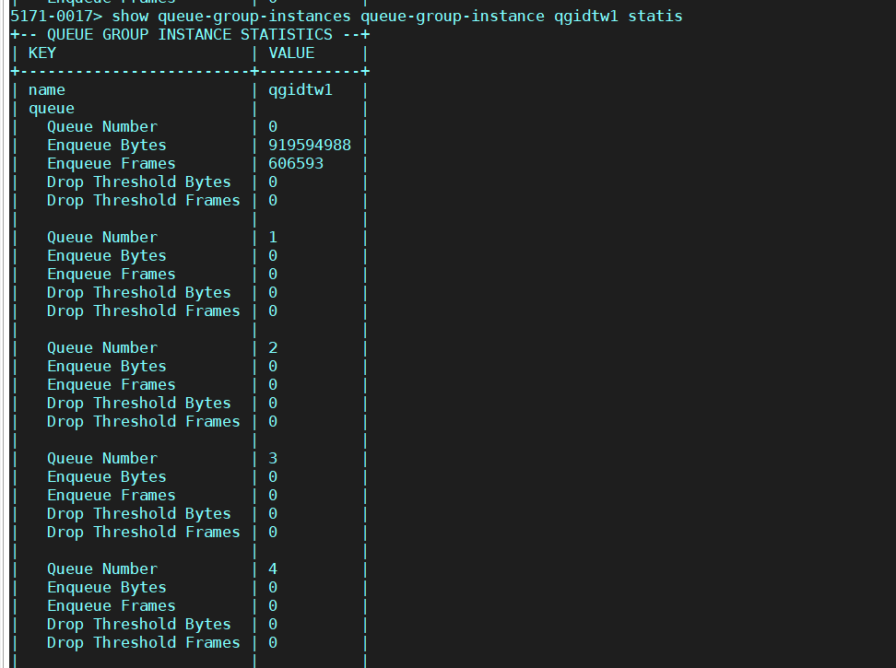

* Configure non-conforming cos in frame-to-cos map

frame-to-cos-maps frame-to-cos-map **FTCdtw1**

non-conforming-cos 32

non-conforming-color green

frame-to-cos-maps frame-to-cos-map **FTCdtw1**

map-entry FtcPcp0Dei0 pcp 0

dei disabled cos 8

color green exit

map-entry FtcPcp0Dei1 pcp 0

dei enabled cos 8

color yellow exit

map-entry FtcPcp4Dei0 pcp 4

dei disabled

cos 16 color green exit

map-entry FtcPcp4Dei1 pcp 4

dei enabled cos 16

color yellow exit

frame-to-cos-maps frame-to-cos-map FTCdtw1 map-entry mplsTos0Cos8

mpls-tc 0

cos 8 exit

map-entry mplsTos4Cos16 mpls-tc 4

cos 16 exit

frame-to-cos-maps frame-to-cos-map FTCdtw1 map-entry ipdscp0Cos8 ip-dscp 0

cos 8 exit

map-entry ipdscp32Cos16 ip-dscp 32

cos 16 exit

* Validate that the frame-to-cos map is created properly.

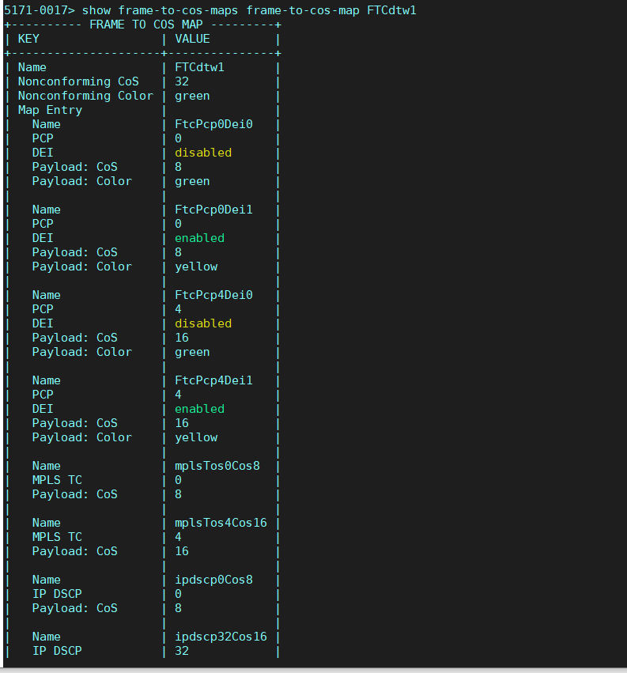

* + With Egress QoS provisioned, internal cos value of 32 is mapped to egress Queue 4, therefore untagged packets are being processed in Queue 4.
    - show queue-group-instances queue-group-instance qgidtw1 statistics

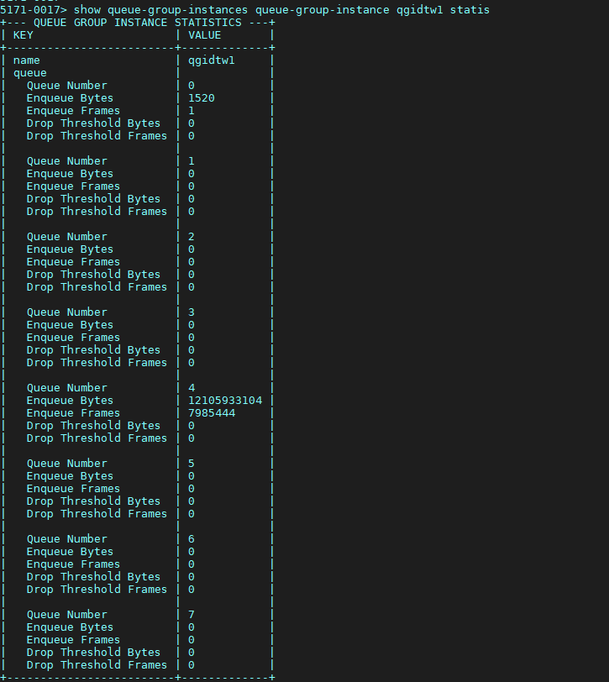

Test Case Results:

Passed: Yes No Verified by Date/Time Comments