###### H-EQOS

***Objective:***

The objective of this section is to demonstrate how to configure H-EQOS on DNX platforms.

H-EQoS uses multi-level scheduling to distinguish user-specific or service-specific traffic and provide differentiated bandwidth management. Allows a network operator a high degree of granularity in

traffic management. H-EQOS is supported on DNX Platforms and is officially supported only on L2 services in 10.7.1.

***Topology:***

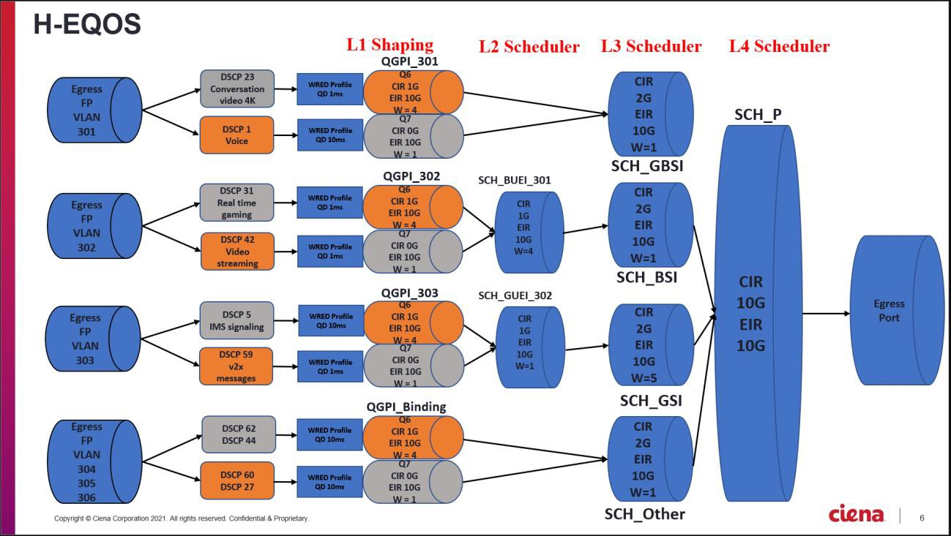

***Pre-requisite:***

* Create your L2 service with flows points, classifiers, Forwarding Domain etc.
* Create your desired Frame-To-Cos and Cos-To Queue Map
* Create your required WRED profile to be applied to the Queue group

***Procedure:***

* Before the CQG is applied to the FP an E-Qos interface binding should be applied to logical port.
* Config error will be seen, If the CQG instance is attached to FP before interface-qos-binding.
* It is possible to build out H-EQoS configuration before applying eqos-binding for the logical- port.
* The ‘default’ queue group instance will apply QOS functionality to FPs that doesn’t have the

CQG attached to them.

egress-qos queue-group-profile QGP_Binding

queue-count 8

queue 0 cir 100000

queue 0 eir 10000000

queue 0 cbs 64

queue 0 ebs 128

queue 1 cir 100000

queue 1 eir 10000000

queue 1 cbs 64

queue 1 ebs 128

queue 2 cir 100000

queue 2 eir 10000000

queue 2 cbs 64

queue 2 ebs 128

queue 3 cir 100000

queue 3 eir 10000000

queue 3 cbs 64

queue 3 ebs 128

queue 4 cir 100000

queue 4 eir 10000000

queue 4 cbs 64

queue 4 ebs 128

queue 5 cir 100000

queue 5 eir 10000000

queue 5 cbs 64

queue 5 ebs 128

queue 6 cir 1000000

queue 6 eir 10000000

queue 6 cbs 64

queue 6 ebs 128

queue 7 cir 0

queue 7 eir 10000000

queue 7 cbs 0

queue 7 ebs 128 exit

exit

egress-qos scheduler-profile SCH_Other scheduling-algorithm wfq

tap-point-count 8

cir 2000000

cbs 64

eir 10000000

ebs 128

tap-point 0 priority 0 weight 1

tap-point 1 priority 1 weight 1

tap-point 2 priority 2 weight 1

tap-point 3 priority 3 weight 1

tap-point 4 priority 4 weight 1

tap-point 5 priority 5 weight 1

tap-point 6 priority 6 weight 4

tap-point 7 priority 7 weight 1 exit

exit

* Create the Root Scheduler which sits at the top of the hierarchy
* Each tap-point can have a child scheduler attached to it and can aggregate multiple child schedulers.

egress-qos scheduler-profile SCH_P scheduling-algorithm wrr

tap-point-count 32

cir 10000000

cbs 64

eir 10000000

ebs 128

tap-point 0 priority 1 weight 5

tap-point 1 priority 1 weight 1

tap-point 2 priority 1 weight 1

tap-point 3 priority 1 weight 1

tap-point 4 priority 1 weight 1

tap-point 5 priority 1 weight 1

tap-point 6 priority 1 weight 1

tap-point 7 priority 1 weight 1

tap-point 8 priority 1 weight 1

tap-point 9 priority 1 weight 1

tap-point 10 priority 1 weight 1

tap-point 11 priority 1 weight 1

tap-point 12 priority 1 weight 1

tap-point 13 priority 1 weight 1

tap-point 14 priority 1 weight 1

tap-point 15 priority 1 weight 1

tap-point 16 priority 1 weight 1

tap-point 17 priority 1 weight 1

tap-point 18 priority 1 weight 1

tap-point 19 priority 1 weight 1

tap-point 20 priority 1 weight 1

tap-point 21 priority 1 weight 1

tap-point 22 priority 1 weight 1

tap-point 23 priority 1 weight 1

tap-point 24 priority 1 weight 1

tap-point 25 priority 1 weight 1

tap-point 26 priority 1 weight 1

tap-point 27 priority 1 weight 1

tap-point 28 priority 1 weight 1

tap-point 29 priority 1 weight 1

tap-point 30 priority 1 weight 1

tap-point 31 priority 1 weight 1 exit

exit

egress-qos scheduler SCH_PI instance-id 1

parent-port 3

scheduler-profile SCH_P stats-collection on

exit exit

egress-qos scheduler SCHI_Other instance-id 1

parent-scheduler SCH_PI parent-tap-point 2 scheduler-profile SCH_Other exit

exit

egress-qos queue-group QGPI_Binding instance-id 1

parent-scheduler SCHI_Other queue-group-profile QGP_Binding stats-collection on

exit exit

interface-qos-binding interface-qos-binding IQB3 logical-port 3

queue-group-instance QGPI_Binding exit

exit

* Create a Custom Queue Group Profile which will perform the L1 shaping.

egress-qos queue-group-profile QGP cos-queue-map CTQ

queue-count 8

queue 0 cir 0

queue 0 eir 10000000

queue 0 cbs 0

queue 0 ebs 128

queue 1 cir 0

queue 1 eir 10000000

queue 1 cbs 0

queue 1 ebs 128

queue 2 cir 0

queue 2 eir 10000000

queue 2 cbs 0

queue 2 ebs 128

queue 3 cir 0

queue 3 eir 10000000

queue 3 cbs 0

queue 3 ebs 128

queue 4 cir 0

queue 4 eir 10000000

queue 4 cbs 0

queue 4 ebs 128

queue 5 cir 0

queue 5 eir 10000000

queue 5 cbs 0

queue 5 ebs 128

queue 6 cir 1000000

queue 6 eir 10000000

queue 6 cbs 64

queue 6 ebs 128

queue 7 cir 0

queue 7 eir 10000000

queue 7 cbs 0

queue 7 ebs 128 exit

exit

* Create an L2 Scheduler which can act as scheduler to the Queue Groups

egress-qos scheduler-profile SCH_UE scheduling-algorithm wrr

tap-point-count 8

cir 1000000

cbs 64

eir 10000000

ebs 128

tap-point 0 priority 1 weight 1

tap-point 1 priority 1 weight 1

tap-point 2 priority 1 weight 1

tap-point 3 priority 1 weight 1

tap-point 4 priority 1 weight 1

tap-point 5 priority 1 weight 1

tap-point 6 priority 1 weight 4

tap-point 7 priority 1 weight 1 exit

exit

* + Create an L3 Scheduler which can act as a parent to the L2 Scheduler

egress-qos scheduler-profile SCH_SL scheduling-algorithm wrr

tap-point-count 8

cir 2000000

cbs 64

eir 10000000

ebs 128

tap-point 0 priority 1 weight 4

tap-point 1 priority 1 weight 1

tap-point 2 priority 1 weight 1

tap-point 3 priority 1 weight 1

tap-point 4 priority 1 weight 1

tap-point 5 priority 1 weight 1

tap-point 6 priority 1 weight 1

tap-point 7 priority 1 weight 1 exit

exit

* + Create all necessary instances to the queue group and scheduler profiles created earlier.

egress-qos scheduler SCH_GSI instance-id 1

parent-scheduler SCH_PI parent-tap-point 0 scheduler-profile SCH_SL stats-collection on

exit exit

egress-qos scheduler SCH_BSI instance-id 1

parent-scheduler SCH_PI parent-tap-point 1 scheduler-profile SCH_SL stats-collection on

exit exit

egress-qos scheduler SCH_GBSI instance-id 1

parent-scheduler SCH_PI parent-tap-point 3 scheduler-profile SCH_SL stats-collection on

exit exit

egress-qos scheduler SCH_BUEI_301 instance-id 1

parent-scheduler SCH_BSI parent-tap-point 0 scheduler-profile SCH_UE stats-collection on

exit exit

egress-qos scheduler SCH_GUEI_302 instance-id 1

parent-scheduler SCH_GSI parent-tap-point 1

scheduler-profile SCH_UE stats-collection on

exit exit

egress-qos queue-group QGPI_301 instance-id 1

parent-scheduler SCH_GBSI queue-group-profile QGP stats-collection on

exit exit

egress-qos queue-group QGPI_302 instance-id 1

parent-scheduler SCH_BUEI_301 queue-group-profile QGP

stats-collection on exit

exit

egress-qos queue-group QGPI_303 instance-id 1

parent-scheduler SCH_GUEI_302 queue-group-profile QGP

stats-collection on exit

exit

* + Apply the Custom Queue Group on the egress flow points

fps fp Port3-301 queue-group-instance QGPI_301 fps fp Port3-302 queue-group-instance QGPI_302 fps fp Port3-303 queue-group-instance QGPI_303

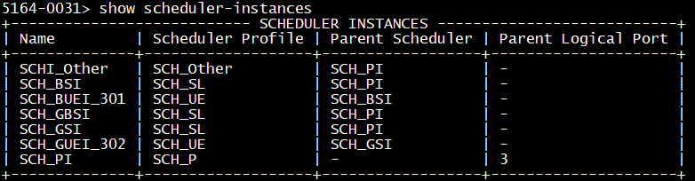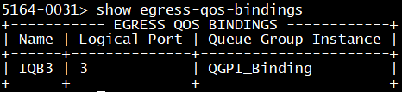

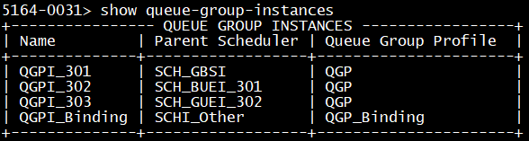

***Test Case Results:***

Passed: Yes No Verified by Date/Time Comments