* + 1. IGMP Snooping

IGMP snooping is a method that network switches use to identify multicast groups, which are groups of devices that all receive the same network traffic. It enables switches to forward packets to the correct devices in their network instead of the default behaviour i.e to broadcast the multicast traffic to all the members on the same broadcast domain.

***Objective:***

To enable IGMP snooping on the Switch.

***Topology:***

**Please note**, As shown below, IGMP snooping was configured and tested with XGS-PON components. This test setup was intended to verify the IGMP snooping feature and not to verify the multicast service over XGS-PON solution which might need further testing.

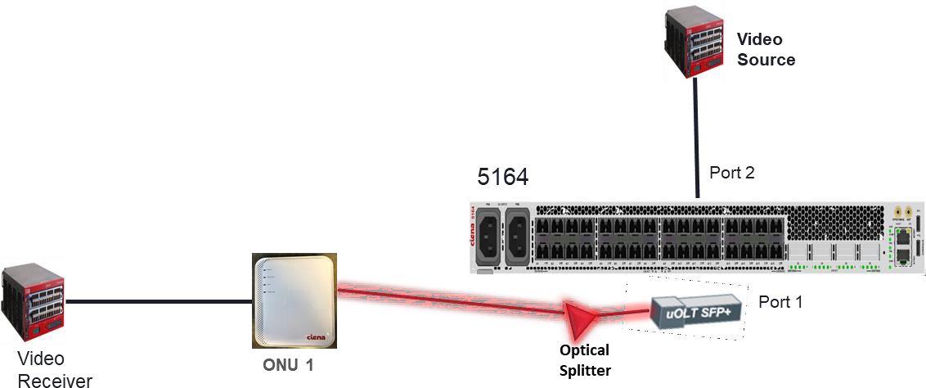

Few items to highlight in the above setup:

* Test set is used at the ends as the Video source at one end and as the video receiver at other end.
* Above setup has only receiver/member
* Three multicast groups are created on the test set such as 225.0.0.1, 225.0.0.2 and 225.0.0.3.

***Procedure:***

 Dynamic IGMP snooping Config

Dynamic IGMP snooping is enabled at two level

1. Go to the configuration terminal
   * config
2. Create classifier and forwarding domain.

classifiers classifier vlan200 filter-entry vtag-stack vtags 1 vlan-id 200 fds fd iptv_fd mode vpls

1. Create flow point.

fps

fp iptv_fp_1

fd-name iptv_fd logical-port 1

mac-learning enabled stats-collection on

classifier-list-precedence 10 classifier-list vlan200

mtu-size 9216 exit

exit

fps

fp iptv_fp_2

fd-name iptv_fd logical-port 2

mac-learning enabled stats-collection on

classifier-list-precedence 10 classifier-list vlan200

mtu-size 9216 exit

exit

**XGS-PON Config**

Please refer to XGS-PON section to configure the OLT and ONU provisioning, only XGS-PON interface used for this setup is shown below for your reference.

1. Create XGS-PON interfaces such as NNI network interface, datalink interface and PON connection interface.

pon-ctrl olts olt OLT_1 nni-networks nni-network NNI_Network_1 match-stag 0

match-ctag-1 200

match-ctag-2 65535 tag-action none

exit exit exit exit exit

pon-ctrl onus onu ONU_1 OLT_1 datalinks datalink datalink_1 admin-state enabled

uni-ports 1

sla-profile sla_1 add-ctag 200 exit

exit exit exit exit

pon-ctrl onus onu ONU_1 OLT_1 uni-ports uni-port 1 admin-state enabled

pon-ctrl onus onu ONU_1 OLT_1 pon-connections pon-connection pon_con_1 datalink datalink_1

nni-network NNI_Network_1 match-ctag-1 200

match-ctag-2 65535

match-stag 0 tag-action none exit

exit exit exit exit

1. **Enable IGMP snooping at global level**

igmp-snooping global-snoop-state enable

1. **Enable IGMP snooping at FD level**

igmp-snooping instance iptv_fd snoop-state enable

**Expected Results:**

5164-0027> show igmp-snooping brief

+-------- GLOBAL STATE +

| Parameter | Value |

+ + +

| Global Snoop State | enable |

+ + +

+

IGMP SNOOPING INSTANCE STATE +

| | | | Dynamic | Static | Dynamic | Router | Linger | |

| | Snooping | Snooping | Router | Groups | Groups | Groups | Groups | Total Dynamic |

| FD Name | Admin | Oper | Interface | Count | Count | Count | Count | Group Members |

+ + + + + + + + + +

| iptv_fd | enable | enable | N/A | 0 | 3 | 3 | 0 | 1 |

+ + + + + + + + + +

5164-0027> show igmp-snooping instance fd-name iptv_fd group-information

+ +

| IGMP SNOOPING FORWARDING DOMAIN |

+ +

| iptv_fd |

+ +

+ GROUP STATS +

| Parameter | Value |

+ + +

| IP Address | 225.0.0.1 |

| State | Active |

| Type | Dynamic |

| Source | Server |

| Member | 1 |

| Uptime | 0 days, 0 hrs, 0 min, 47 sec |

| Compatibility Mode | V2 |

| Group Timer | N/A |

| IGMP V2 Host Present Time remaining | 896539 |

| Group Filter Mode | Exclude |

+ + +

| IP Address | 225.0.0.2 |

| State | Active-linger |

| Type | Dynamic |

| Source | Server |

| Member | 0 |

| Uptime | 0 days, 0 hrs, 0 min, 42 sec |

| Compatibility Mode | V2 |

| Group Timer | N/A |

| IGMP V2 Host Present Time remaining | 896488 |

| Group Filter Mode | Exclude |

+ + +

| IP Address | 225.0.0.3 |

| State | Active-linger |

| Type | Dynamic |

| Source | Server |

| Member | 0 |

| Uptime | 0 days, 0 hrs, 0 min, 37 sec |

| Compatibility Mode | V2 |

| Group Timer | N/A |

| IGMP V2 Host Present Time remaining | 896503 |

| Group Filter Mode | Exclude |

+ + +

5164-0027> show igmp-snooping instance fd-name iptv_fd group-members

+ +

| IGMP SNOOPING FORWARDING DOMAIN |

+ +

| iptv_fd |

+ +

+----- GROUP MEMBER +

| Fp Name | Address |

+ + +

| iptv_fp_1 | 225.0.0.2 |

+ + +

**Test Case Results:**

Passed: Yes No Verified by Date/Time Comments

 Static IGMP Join Config

Additional to dynamic IGMP snooping, static IGMP Join can be configured using below steps.

Static Configuration means that all interfaces are part of the multicast cast group without any need to wait for IGMP join from the host. Static multicast groups are created to reduce the latency, the moment router sends IGMP generic query switch will immediately respond and no need to wait for response from hosts.

**Please refer to above dynamic IGMP snooping config steps above as static IGMP join is configured on top of the dynamic IGMP snooping to make it work.**

1. Create static groups at instance level

igmp-snooping instance iptv_fd static-groups address 225.0.0.2

**Expected Results:**

5164-0027> show igmp-snooping brief

+-------- GLOBAL STATE +

| Parameter | Value |

+ + +

| Global Snoop State | enable |

+ + +

+

IGMP SNOOPING INSTANCE STATE +

| | | | Dynamic | Static | Dynamic | Router | Linger | |

| | Snooping | Snooping | Router | Groups | Groups | Groups | Groups | Total Dynamic |

| FD Name | Admin | Oper | Interface | Count | Count | Count | Count | Group Members |

+ + + + + + + + + +

| iptv_fd | enable | enable | N/A | 1 | 0 | 1 | 0 | 0 |

+ + + + + + + + + +

5164-0027> show igmp-snooping instance fd-name iptv_fd group-information

+ +

| IGMP SNOOPING FORWARDING DOMAIN |

+ +

| iptv_fd |

+ +

+ GROUP STATS +

| Parameter | Value |

+ + +

| IP Address | 225.0.0.2 |

| State | Active |

| Type | Static |

| Source | Server |

| Member | 2 |

| Uptime | 0 days, 0 hrs, 0 min, 26 sec |

| Compatibility Mode | V3 |

| Group Timer | N/A |

| IGMP V2 Host Present Time remaining | 0 |

| Group Filter Mode | Exclude |

+ + +

**Test Case Results:**

Passed: Yes No Verified by Date/Time Comments