#### FlexE Introduction

The general capabilities supported by FlexE are:

* Bonding e.g., supporting a 200G MAC over two bonded 100GBASE-R PHYs
* Channelization e.g. support a 50G and two 25G MACs over a 100GBASE-R PHY
* A picture containing text, weapon, knife

  Description automatically generatedSubrating e.g., supporting a 75G MAC over a 100GBASE-R PHY

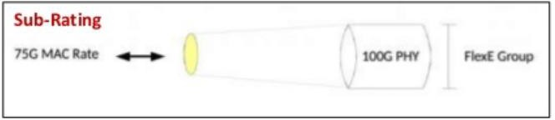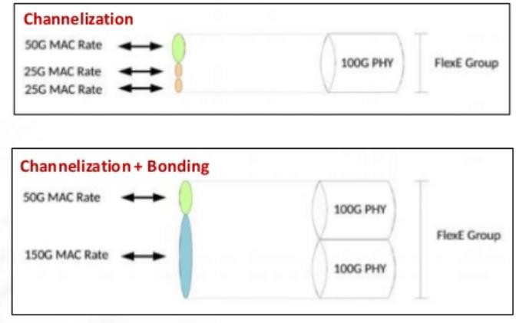

Sebastien Gareau, Hardware Systems Architect at Ciena, talks about the industry effort to introduce flexibility at the Ethernet service layer.

<https://www.ciena.com/insights/videos/Chalk-Talk---What-is-Flex-Ethernet-FlexE.html>

###### Configure a FlexE Client Port

***Objective:***

The objective of this test is to configure a 25GE L1 flexE client port.

***Topology:***

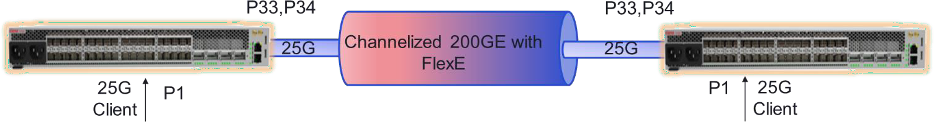

***Procedure:***

1. Set the client port (port 1) to 25GE, remove the default remote flow point, remove the port binding and set the port to L1 cross connect mode. The user can enable or disable RS-FEC as required.

oc-if:interfaces interface 1 config port-speed 25Gb

oc-if:interfaces interface 1 config forward-error-correction disabled no fps fp remote-fp1

no logical-ports logical-port 1 binding

oc-if:interfaces interface 1 config ettp-mode l1-cross-connect

***Expected Results:***

Port 1 should be configured as a FlexE client and set to layer 1 cross connect mode.

5164> show ettps ettp 1

+ ETTP +

| KEY | VALUE |

|  |  |  |  |  |
| --- | --- | --- | --- | --- |
| + |  | + |  | + |
| | | Name | | | 1 | | |
| | | Description | | | 1 | | |
| | | Type | | | ettp | | |
| | | Admin Status | | | True | | |
| | | Mode | | | auto | | |
| | | Link Flap Detect | | | False | | |
| | | Link Flap Count | | | 5 | | |
| | | Link Flap Detect Time | | | 10 | | |
| | | Link Flap Hold Time | | | 300 | | |
| | | Duplex | | | full | | |
| | | Port Speed | | | 25Gb | | |
| | | Flow Control | | | off | | |
| | | Auto Negotiation | | | False | | |
| | | Forward Error Correction | | | disabled | | |
| | | PTP Id | | | 1 | | |
| | | ETTP Mode | | | l1-cross-connect | | |

+ + +

Test Case Results:

Passed: Yes No Verified by Date/Time Comments

###### Configure FlexE Network Port

***Objective:***

The objective of this test is to configure FlexE network ports.

***Topology:***

***Procedure:***

The user sets NNI ports to FlexE mode.

1. Configure NNI ports for FlexE mode. In the example below ports 33 and 34 are configured as FlexE NNI ports. Port binding is removed and the port is set to FlexE.

no fps fp remote-fp33

no logical-ports logical-port 33 binding

no oc-if:interfaces interface 33 config ptp-id

flexe-ports flexe-port flexe-port1 ptp-id 33 port-speed 100Gb no fps fp remote-fp34

no logical-ports logical-port 34 binding

no oc-if:interfaces interface 34 config ptp-id

flexe-ports flexe-port flexe-port2 ptp-id 34 port-speed 100Gb

***Expected Results:***

NNI ports are set to FlexE mode.

5164> show flexe-ports flexe-port flexe-port1

+ FLEXE PORT +

| Key | Value |

+ + +

| FlexE Port | flexe-port1 |

| Admin State | enabled |

| PTP ID | 33 |

| Port Speed | 100Gb |

| Forward Error Correction | auto |

+ + +

+--- FLEXE PORT STATUS +

| Key | Value |

+ + +

| FlexE Port | flexe-port1 |

| Oper State | disabled |

+ + +

5164> show flexe-ports flexe-port flexe-port2

+ FLEXE PORT +

| Key | Value |

+ + +

| FlexE Port | flexe-port2 |

| Admin State | enabled |

| PTP ID | 34 |

| Port Speed | 100Gb |

| Forward Error Correction | auto |

+ + +

+--- FLEXE PORT STATUS +

| Key | Value |

+ + +

| FlexE Port | flexe-port2 |

| Oper State | disabled |

+ + +

Test Case Results:

Passed: Yes No Verified by Date/Time Comments

###### Create a FlexE Group

***Objective:***

The objective of this test is to create a 200 GE FlexE Group (also know as port binding).

***Topology:***

***Procedure:***

Configure a 200 GE FlexE group with ports 33 and 34.

2. Create a FlexE group by adding FlexE ports “flexe-port1” and “flexe-port2” (created in the previous step) to the group. The group is also assigned slot granularity (5G) and a calendar (slot map).

flexe-groups flexe-group group1 group-number 1

calendar-slot-granularity slot-5G phy-type flexe-phy-100GBASE-R calendar calendar-A

calendar-protocol-enable false

flexe-phys 1 local-interface flexe-port1 flexe-phys 2 local-interface flexe-port2 exit

exit

***Expected Results:***

A 200 GE FlexE group should have been created with 40 5G calendar slots.

5164> show flexe-groups flexe-group group1

+ FLEXE GROUPS +

| KEY | VALUE |

+ + +

| FlexE Group | group1 |

| Admin State | enabled |

| Group No. | 1 |

| Calendar Slot Granularity | slot-5G |

| Phy Type | flexe-phy-100GBASE-R |

| Calendar | calendar-A |

| FlexE Phys | |

| Phy No. In Grp | 1 |

| Local Interface | flexe-port1 |

| | |

| Phy No. In Grp | 2 |

| Local Interface | flexe-port2 |

+ + +

###### Create a FlexE Channel

***Objective:***

The objective of this test is to create a 25G FlexE channel.

***Topology:***

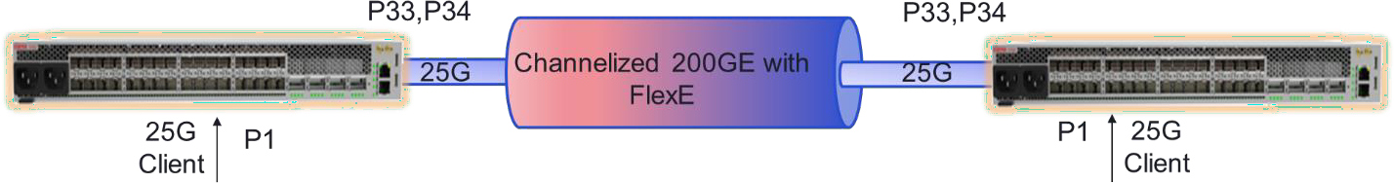

***Procedure:***

Configure a 25 FlexE channel.

* + - 1. Create a FlexE channel by assigning 5G calendar slots equal to the bandwidth required. In the following example we are creating a 25G FlexE channel.

flexe-channels flexe-channel channel-1

channel-number 512 group-name group1

channel-mapping L1-mapped

|  |  |  |
| --- | --- | --- |
| calendar-A-slots-list | 1 | 1 |
| exit |  |  |
| calendar-A-slots-list | 1 | 2 |
| exit |  |  |
| calendar-A-slots-list | 1 | 3 |
| exit |  |  |
| calendar-A-slots-list | 1 | 4 |
| exit |  |  |
| calendar-A-slots-list | 1 | 5 |
| exit |  |  |
| exit |  |  |
| exit  ***Expected Results:*** |  |  |

A 25 GE FlexE channel should have been created.

5164> show flexe-groups flexe-group group1

+ FLEXE GROUPS +

| KEY | VALUE |

+ + +

| FlexE Group | group1 |

| Admin State | enabled |

| Group No. | 1 |

| Calendar Slot Granularity | slot-5G |

| Phy Type | flexe-phy-100GBASE-R |

| Calendar | calendar-A |

| FlexE Phys | |

| Phy No. In Grp | 1 |

| Local Interface | flexe-port1 |

| | |

| Phy No. In Grp | 2 |

| Local Interface | flexe-port2 |

+ + +

Test Case Results:

Passed: Yes No Verified by Date/Time Comments

###### Create a FlexE Cross Connect

***Objective:***

The objective of this test is to create a FlexE cross connect.

***Topology:***

***Procedure:***

Create a channel MAC termination point and then cross connect the channel MAC termination point with the FlexE client port.

* + - 1. Create a MAC termination point on the 25G FlexE channel.

oc-if:interfaces interface macEttp1 config name macEttp1 type ettp ettp-mode flexe-mac oc-if:interfaces interface macEttp1 config name macEttp1 flexe-channel channel-1

* + - 1. Cross connect the FlexE channel with the FlexE client port.

flexe-cross-connects flexe-cross-connect fxc-1 ettp-end-point-a macEttp1 ettp-end-point- b 1

***Expected Results:***

The cross connect should have been created successfully.

5164> show ettps ettp macEttp1

+ ETTP +

| KEY | VALUE |

|  |  |  |  |  |
| --- | --- | --- | --- | --- |
| + |  | + |  | + |
| | | Name | | | macEttp1 | | |
| | | Type | | | ettp | | |
| | | Admin Status | | | True | | |
| | | Mode | | | auto | | |
| | | Link Flap Detect | | | False | | |

| Link Flap Count | 5 |

| Link Flap Detect Time | 10 |

| Link Flap Hold Time | 300 |

| Duplex | full |

| Forward Error Correction | auto |

| ETTP Mode | flexe-mac |

| FlexE Channel ID | channel-1 |

+ + +

5164> show flexe-cross-connects

+ FLEXE-CROSS-CONNECTS +

| Flexe-Cross-Connect | End-Point-A | End-Point-B |

+ + + +

| fxc-1 | Ettp: macEttp1 | Ettp: 1 |

+ + + +

5164> show flexe-cross-connects flexe-cross-connect fxc-1

+----- FLEXE-CROSS-CONNECTS +

| Key | Value |

+ + +

| Flexe-Cross-Connect | fxc-1 |

| Ettp-End-Point-A | macEttp1 |

| Ettp-End-Point-B | 1 |

+ + +

Test Case Results:

Passed: Yes No Verified by Date/Time Comments

###### L2 FlexE

Layer 2 FlexE is now supported in 10.6+ on the following devices: 5130, 5164, 5166 and 5168. When network devices are connected via L2 FlexE, client ports and flexE channels are connected to FDs via FPs. Conceptually, a FlexE channel becomes a “logical port” and uses a 10.x FD/FP L2 configuration method for DP connectivity.

L2 Cross Connect L2 Cross Connect



FlexE

ETTP

10GE

FlexE

ETTP

L2 FD

10G ETTP

L2 FD

10G ETTP

Figure (1): Device has GPS and PTP Inputs

Layer 2 FlexE Configuration

***Objective:***

The objective of this test is to configure a L2 FlexE channel.

***Procedure:***

* Configure a FlexE Group:

flexe-groups flexe-group group1 group-number 1

calendar-slot-granularity slot-5G phy-type flexe-phy-100GBASE-R calendar calendar-A

calendar-protocol-enable false

flexe-phys 3 local-interface flexe-port1

* Configure a FlexE channel (10G channel configured in this example):

flexe-channels flexe-channel channel-1 channel-number 512

group-name group1

channel-mapping L2-mapped calendar-A-slots-list 3 1

calendar-A-slots-list 3 2

calendar-B-slots-list 3 11

calendar-B-slots-list 3 12

* Create a mac termination point and a “FlexE” logical port:

oc-if:interfaces interface macEttp1 config name macEttp1 type ettp ettp-mode flexe-mac

oc-if:interfaces interface macEttp1 config name macEttp1 flexe-channel channel-1

logical-ports logical-port flexe_lp_1 binding macEttp1

* Create a forwarding domain and a flow point on the “FlexE” logical port.

fds fd fd_vlan mode vpls

fps fp fp_flexe_lp_1 classifier-list AnyTag classifier-list untagged stats-collection on

fd-name fd_vlan

logical-port flexe_lp_1 mtu-size 9216

Test Case Results:

Passed: Yes No Verified by Date/Time Comments