#### G.8032: Ethernet Ring Protection

G8032 is supported ON DNX platforms in **10.7.1** release. The configuration is similar to previous SW releases. The only difference to XGS platforms is that the FD creation does not require a vlan-id.

The feature was introduced previously introduced on 8180 in SAOS 10.4 and on 392X series in SAOS

10.6. In this topology we will set port 4 on Node A as the **RPL owner**.

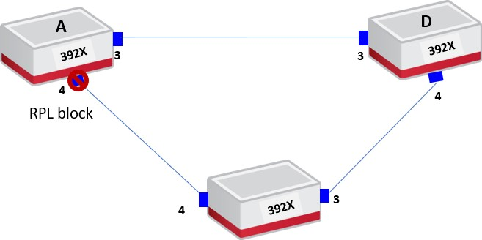

***Objective***

The objective of this test is to setup the configuration of G.8032 ring protection. The following section describes the creation of logical ring, virtual ring and data member which is the service to be protected through G.8032.

***Procedure:***

* Provision the forwarding-domain, classifier and flow-point
  + classifiers classifier VLAN1000 filter-entry vtag-stack vtags 1 vlan-id 1000
  + fds fd FD1000 mode vpls vlan-id 1000

1. fps fp fp4.1 fd-name FD1000 logical-port 4 classifier-list VLAN1000
   * fps fp fp3.1 fd-name FD1000 logical-port 3 classifier-list VLAN1000

* Enable G8032 and G8032 notification at global level
  + g8032-rings ring-system-control enabled
  + g8032-rings notification-enabled true
* Create the logical-ring
  + g8032-rings g8032-ring G8032 ring-id 1

ring-ports ring-port port0 interface 4 ring-ports ring-port port1 interface 3 exit

exit exit

* Create the ERP instance
  + g8032-rings g8032-ring G8032 erp-instances erp-instance G8032-VR-1

erp-instance-construct major-ring raps-vid 3000

wtr-timer 1

data-members FD1000 raps-level 1

ports

port port0 rpl owner port port1 rpl none

G8032 configurable parameters are shown in the outputs below. The RPL owner is in a blocking state when the ring is in idle mode.

3926_0150> show ring-protection g8032-ring ring G8032

+ RING-PROTECTION LOGICAL-RING INFO +

| Parameter | Value |

+ + +

| Ring Name | G8032 |

| Ring Id | 1 |

| Ring-Ports | |

| Port0 | 3 |

| Port1 | 4 |

+ + +

+-- VIRTUAL-RINGS ---+

| Name | State |

+ + +

| G8032-VR-1 | Idle |

+ + +

3926_0150> show ring-protection erp-instance instance G8032-VR-1

+-------- RING-PROTECTION VIRTUAL-RING INFO +

| Parameter | Value |

+ + +

| Name | G8032-VR-1 |

| Raps VID | 3000 |

| Raps Level | 1 |

| Ring Type | Major-ring |

| Reversion | Revertive |

| WTR Timer | 1 min |

| Guard Timer | 500 ms |

| Hold Off Time | 0 ms |

| Logical Ring | G8032 |

| WTB Timer | 5500ms |

| Virtual Ring State | **Idle** |

| Status | **Clear** |

| No of Switchovers | 1 |

| Up Time From Last Failure Hr:min:sec | 0:46:44 |

| Total Down Time Hr:min:sec | 0:04:58 |

+ + +

+---- VIRTUAL-RING RING-PORT INFO +

| Parameter | Port0 | Port1 |

+ + + +

| RPL | **None** | **Owner** |

| State | **Forwarding** | **Blocking** |

| Status | Clear | Clear |

| Force Switch | Off | Off |

+ + + +

+--------------- VIRTUAL-RING RING-PORT STATISTICS +

| R-APS Frame Type | Port0 Tx | Port0 Rx | Port1 Tx | Port1 Rx |

+ + + + + +

| NR, RPL Blocked (RB) | 190 | 0 | 190 | 0 |

| No Request (NR) | 0 | 0 | 0 | 0 |

| Signal Fail (SF) | 0 | 0 | 0 | 0 |

| Forced Switch (FS) | 0 | 0 | 0 | 0 |

+ + + + + +

+ VIRTUAL-RING DATA MEMBERS +

| Data Members |

+ +

| **FD1000** |

+ +

After generating a fiber cut between node A and D, we can verify that the virtual ring state switches to “Protection” and the RPL owner moves from a blocking state to a forwarding state. Thus, the running traffic will switch to that alternate path.

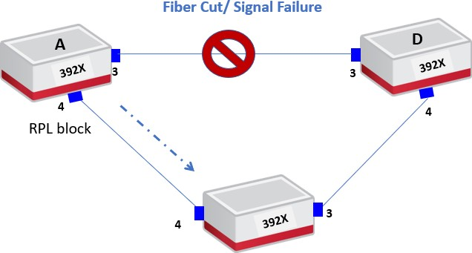

3926_0150> show ring-protection erp-instance instance G8032-VR-1

+------------- RING-PROTECTION VIRTUAL-RING INFO +

| Parameter | Value |

+ + +

| Name | G8032-VR-1 |

| Raps VID | 3000 |

| Raps Level | 1 |

| Ring Type | Major-ring |

| Reversion | Revertive |

| WTR Timer | 1 min |

| Guard Timer | 500 ms |

| Hold Off Time | 0 ms |

| Logical Ring | G8032 |

| WTB Timer | 5500ms |

| Virtual Ring State | **Protection** |

| Status | **Local Signal Failure** |

| No of Switchovers | 2 |

| Up Time From Last Failure Hr:min:sec | 0:00:00 |

| Total Down Time Hr:min:sec | 0:08:22 |

+ + +

+---------- VIRTUAL-RING RING-PORT INFO +

| Parameter | Port0 | Port1 |

+ + + +

| RPL | **None** | **Owner** |

| State | **Blocking** | **Forwarding** |

| Status | Down | Remote Signal Failure |

| Force Switch | Off | Off |

+ + + +

+--------------- VIRTUAL-RING RING-PORT STATISTICS +

| R-APS Frame Type | Port0 Tx | Port0 Rx | Port1 Tx | Port1 Rx |

+ + + + + +

| NR, RPL Blocked (RB) | 244 | 0 | 244 | 0 |

| No Request (NR) | 0 | 0 | 0 | 0 |

| Signal Fail (SF) | 43 | 0 | 43 | 43 |

| Forced Switch (FS) | 0 | 0 | 0 | 0 |

+ + + + + +

+ VIRTUAL-RING DATA MEMBERS +

| Data Members |

+ +

| FD1000 |

+ +

Test Case Results:

Passed: Yes No Verified by Date/Time Comments