#### Macsec Encryption

***Overview***

MACsec (Media Access Control Security) is an IEEE standard for security in wired ethernet LANs that provides authenticity, integrity, and encryption of the layer 2 payload. The MACsec Key Agreement (MKA) protocol, defined as part of the IEEE 802.1X-2010 standard, operates at Layer 2 to generate and distribute the cryptographic keys used by the MACsec functionality installed in the hardware.

MACsec operates in two modes: **Hop-by-hop** and **end-to-end.**

MACsec is supported on **port 7** and **8** on a **3926-905** device only (in SAOS 10.6). The ports can either be configured at 1G or 10G rate.

###### Hop By Hop Mode on 3926

This mode only support ETTP-based encryption in 10.6. This is standard MACsec implementation where all the traffic between two directly connected node is MACsec encrypted.

In hop-by-hop mode, all underlying technologies are supported as all the encrypted traffic will be decrypted at the receiver side (i.e MPLS /SR /G8032 Ring..).

* **Scenario1: Vlan-based**

MKA session

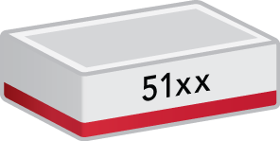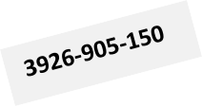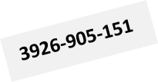

**7**

**8**

**7**

**8**

**MKA session**

**L2-Switching**

***Objective***

The objective of this test is to establish hop-by-hop MACsec connection-association between the two nodes over an L2 switching circuit and verify that the traffic running is being encrypted.

***Procedure:***

* Go to the configuration terminal
  + config
* Setup the Forwarding Domains, classifiers and flow points in CLI
  + fds fd fd2 mode vpls
  + classifiers classifier cvid-2 filter-entry classifier: vtag-stack vtags 1 vlan-id 2
  + fps fp fp8 logical-port 8 fd-name fd2 classifier-list cvid- 2
* Create a **key-chain** for authentication and key establishment, it’s used to generate SAK keys to be used to program hardware. It can use both 128 and 256 cryptographic algorithms. The pre-shared key must match on both MACsec devices for the session to be established
  + macsec key-chains key-chain KC1 mka-keys mka-key 01 key 0123456789abcdef0123456789abcdef0123456789abcdef0123456789a bcdef

macsec key-chains key-chain KC1 mka-keys mka-key 01 cryptographic-algorithm AES_128_CMAC

exit

* Create a **profile** that combines various user configurable parameters for security
  + macsec macsec-profiles profile pf1

encryption-on true

key-server-priority 10 **(On the server only to generate the SAK)**

macsec-cipher-suite GCM_AES_128 replay-window-size 2

sak-rekey-interval 30

* Enable MACsec on interface. We can exclude L2 protocols not to be MACsec encrypted when configuring the interface
  + macsec config interfaces interface 7 strict-mode-on true

exclude-protocols lacp exclude-protocols lldp

* Create a **connection-association** which is a security relationship, established and maintained by key agreement protocols
  + macsec config connection-association CA1 macsec-admin-state enabled

key-chain KC1

macsec-profile pf1 ettp-name 7

The above commands need to be configured at both MACsec nodes to perform encryption.

Once the configuration is performed at both nodes and CA connection is setup, MACsec configuration can be viewed using below commands.

* + show macsec key-chains key-chain KC1

+ KEY-CHAIN +

| Key-Chain | KC1 |

+ + +

| MKA Name | 01 |

| MKA Crypto Algo | AES_128_CMAC |

+ + +

* + show macsec profiles profile pf1

+ MACSEC-PROFILES +

| KEY | VALUE |

+ + +

| Profile Name | pf1 |

| Cipher Suite | GCM_AES_128 |

| Conf Offset | 0_BYTES |

| Replay Window Size | 2 |

| Additional Bytes In Clear | 0 |

| Encryption | True |

| Key Server Priority | 10 |

| SAK Rekey Interval | 30 |

+ + +

* + show macsec connection-associations

+ CONNECTION-ASSOCIATION +

| CA Name | Admin State | Oper State | Service Type | Macsec Profile | Key Chain |

+ + + + + + +

| CA1 | **enabled** | **enabled** | ETTP | pf1 | KC1 |

+ + + + + + +

* + show macsec connection-associations connection-association CA1

+ CONNECTION-ASSOCIATION +

| Parameter | Value |

+ + +

| CA Name | CA1 |

| Admin State | enabled |

| Oper State | enabled |

| Oper State Reason | **Operational Up.** |

| Key Server | True |

| Destination Address | 01:80:C2:00:00:03 |

| Mka Ethertype | 0x888e |

| Macsec Profile | pf1 |

| Key Chain Name | KC1 |

| Service Type | ETTP |

| Service Name | 8 |

+ + +

| Peer Secure Channel | |

+ + +

| Mac Address | 94:43:4d:86:7f:d1 |

| Port Identifier | 01-00 |

+ + +

| MKA Statistics | |

+ + +

| In EAPOL MKA invalid CKN Len Frames | 0 |

| In EAPOL MKA invalid Frames | 0 |

| In EAPOL MKA Frames | 44946 |

| Out EAPOL MKA Frames | 50136 |

| In Version Mismatch Frames | 0 |

| In CKN Mismatch Frames | 0 |

| In ICV Mismatch Frames | 0 |

+ + +

| Data Statistics | |

+ + +

| In Valid Packets | 92898269 |

| In Error Packets | 0 |

| In Transform Error Packets | 0 |

| In Control Packets | 80 |

| In Untagged Packets | 0 |

| In No Tag Packets | 0 |

|  |  |  |  |  |  |  |  |
| --- | --- | --- | --- | --- | --- | --- | --- |
| | | In | Bad Tag Packets |  | | | | 0 | | |
| | | In | No SCI Packets |  | | | | 0 | | |
| | | In | Unknown Packets |  | | | | 0 | | |
| | | In | Unused SA Packets |  | | | | 0 | | |
| | | In | Unused SA Discarded | Packets | | | | 0 | | |
| | | In | Overrun Discarded Packets | |  | | | 0 | | |
| | | In | Unchecked Packets | |  | | | 0 | | |
| | | In | Invalid Packets | |  | | | 0 | | |
| | | In | Invalid with Sectag C-bit=1 | | Packets | | | 0 | | |
| | | In | Delayed Packets | |  | | | 0 | | |
| | | In | Late Packets | |  | | | 0 | | |
| | | In | Decrypted Octets | |  | | | 12448383971 | | |
| | | In | Validated Octets | |  | | | 0 | | |
| | | Out Encrypted Packets | | | | | | 24988129 | | |
| | | Out Protected Packets | | | | | | 24988129 | | |
| | | Out Control Packets | | | | | | 76 | | |
| | | Out Untagged Packets | | | | | | 0 | | |
| | | Out Transform Error Packets | | | | | | 0 | | |
| | | Out Too Long Discarded Packets | | | | | | 0 | | |
| | | Out Encrypted Octets | | | | | | 0 | | |
| |  + | Out Protected Octets | | | |  + | | 3348411075 | |  + |

We can test the encrypted traffic using an inline packet capture device between the two nodes.

Below is a packet capture of encrypted MACsec traffic, we can see that the MACSsec 802.1AE header

**(w/ Ethertype 0x88e5)** is prepended immediately after SA/DA.

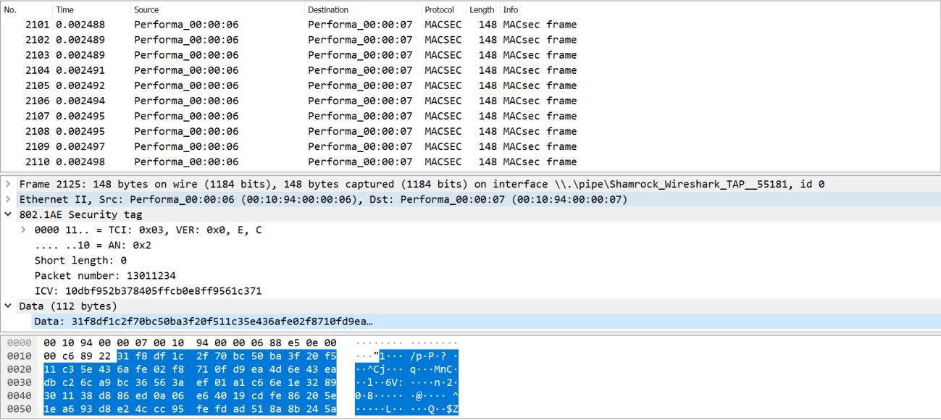

Test Case Results:

Passed: Yes No Verified by Date/Time Comments

* + **Scenario 2: MPLS based**

MACsec encryption is also supported over MPLS transport for hop-by-hop mode.

The test-case below is using an L2VPN service to test the encrypted traffic and it’s assumed that L2VPN

and MPLS/LDP are already running on underlying IGP.

**IS-IS/MPLS-LDP**

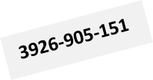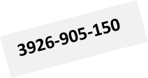

**MKA session**

**8**

**8**

If8

If8

**L2VPN**

***Objective***

The objective of this test is to establish a hop-by-hop MACsec connection-association between the two nodes running MPLS and verify that the traffic running is being encrypted.

***Procedure:***

* Create a **key-chain** for authentication and key establishment, it’s used to generate SAK keys to be used to program hardware. It can use both 128 and 256 cryptographic algorithms. The pre-shared key must match on both MACsec devices for the session to be established
  + macsec key-chains key-chain KC1 mka-keys mka-key 01 key 0123456789abcdef0123456789abcdef0123456789abcdef0123456789a bcdef

macsec key-chains key-chain KC1 mka-keys mka-key 01 cryptographic-algorithm AES_128_CMAC

* Create a **profile** that combines various user configurable parameters for security.
  + macsec macsec-profiles profile pf1 encryption-on true

key-server-priority 10 **(On the server only to generate the SAK)**

macsec-cipher-suite GCM_AES_128

additional-bytes-in-clear 4 **(Optional, to leave C-tag in clear)**

replay-window-size 2

sak-rekey-interval 30

* Enable MACsec on **interface**
  + macsec config interfaces interface 7 strict-mode-on true

exclude-protocols lacp

exclude-protocols lacp exit

* Create a **connection-association** which is a security relationship, established and maintained by key agreement protocols
  + macsec config connection-association CA1 macsec-admin-state enabled

key-chain KC1

macsec-profile pf1 ettp-name 7

Once the configuration is performed at both the nodes and CA connection is setup between the nodes, it can be viewed using below commands.

* + 3926_0150> show macsec connection-associations

+ CONNECTION-ASSOCIATION +

| CA Name | Admin State | Oper State | Service Type | Macsec Profile | Key Chain |

+ + + + + + +

| CA1 | **enabled** | **enabled** | ETTP | pf1 | KC1 |

+ + + + + + +

* + show macsec connection-associations connection-association CA1

+ CONNECTION-ASSOCIATION +

| Parameter | Value |

+ + +

| CA Name | CA1 |

| Admin State | enabled |

| Oper State | enabled |

| Oper State Reason | **Operational Up.** |

| Key Server | True |

| Destination Address | 01:80:C2:00:00:03 |

| Mka Ethertype | 0x888e |

| Macsec Profile | pf1 |

| Key Chain Name | KC1 |

| Service Type | ETTP |

| Service Name | 8 |

+ + +

| Peer Secure Channel | |

+ + +

| Mac Address | 94:43:4d:86:7f:d1 |

| Port Identifier | 01-00 |

+ + +

| MKA Statistics | |

+ + +

| In EAPOL MKA invalid CKN Len Frames | 0 |

| In EAPOL MKA invalid Frames | 0 |

| In EAPOL MKA Frames | 44946 |

| Out EAPOL MKA Frames | 50136 |

| In Version Mismatch Frames | 0 |

| In CKN Mismatch Frames | 0 |

| In ICV Mismatch Frames | 0 |

+ + +

| Data Statistics | |

+ + +

| In Valid Packets | 92898269 |

| In Error Packets | 0 |

| In Transform Error Packets | 0 |

| In Control Packets | 80 |

| In Untagged Packets | 0 |

| In No Tag Packets | 0 |

| In Bad Tag Packets | 0 |

| In No SCI Packets | 0 |

| In Unknown Packets | 0 |

| In Unused SA Packets | 0 |

| In Unused SA Discarded Packets | 0 |

| In Overrun Discarded Packets | 0 |

| In Unchecked Packets | 0 |

| In Invalid Packets | 0 |

| In Invalid with Sectag C-bit=1 Packets | 0 |

| In Delayed Packets | 0 |

| In Late Packets | 0 |

| In Decrypted Octets | 12448383971 |

| In Validated Octets | 0 |

| Out Encrypted Packets | 24988129 |

| Out Protected Packets | 24988129 |

| Out Control Packets | 76 |

| Out Untagged Packets | 0 |

| Out Transform Error Packets | 0 |

|  |  |  |
| --- | --- | --- |
| | Out Too Long Discarded Packets | | 0 | | |
| | Out Encrypted Octets | | 0 | | |
| | Out Protected Octets | | 3348411075 | | |
| + | + | + |

Other underlying protocols and services such as PW, LDP, ISIS and MPLS can also be viewed on below outputs:

* + 3926_0150> show pseudowires

+ PSEUDOWIRES STATE +

| PW Id | Name | Peer IP | Oper State | In Label | Out Label | Flags |

+ + + + + + + +

| 100 | PW1 | 2.2.2.2 | Up | 36008 | 36008 | dUMaF |

+ + + + + + + +

* + 3926_0150> show isis neighbors

+ ISIS NEIGHBOR STATE +

| Neighbor | | | | | Hold | | |

| Type | System ID | Interface | SNPA | State | Time (s) | Type | Protocol |

+ + + + + + + + +

| P2P | 0101.8110.2151 | if8 | 9443.4d86.7fc5 | Up | 27 | L2 | IS-IS |

+ + + + + + + + +

* + 3926_0150> show mpls forwarding-table

+ MPLS FORWARDING TABLE +

| | | FTN | | Label | | |

| Code | FEC | ID | LSP-Type | In | Out | Out Intf | Next Hop |

+ + + + + + + + +

| L> | 2.2.2.2/32 | 0 | LSP_DEFAULT | - | 3 | if8 | 172.18.8.2 |

+ + + + + + + + +

* + 3926_0150> show ldp adjacencies

+ LDP ADJACENCY STATE +

| | | Hold | | |

| IP Addr | Interface | Time (s) | LDP Identifier | Type |

+ + + + + +

| 172.18.8.2 | if8 | 15 | 2.2.2.2:0 | LINK HELLO |

| 2.2.2.2 | if8 | 45 | 2.2.2.2:0 | TARGETED_HELLO |

+ + + + + +

The encrypted traffic is depicted on the packet capture below. In this case the VLAN tag is left in clear:

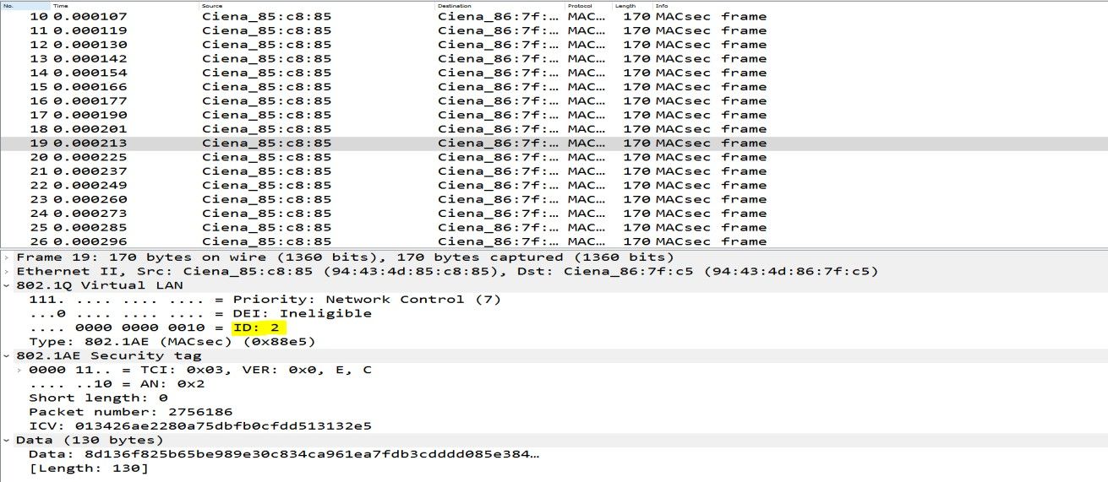

**Test Case Results:**

Passed: Yes No Verified by Date/Time Comments

###### End to End Mode on 3926

MACsec end end-to-end is also supported over the WAN and allows transport through non-MACsec intermediate network.

In this mode, we support both ETTP based as well as Flow Point based service. FP-based service allows MACsec and non-MACsec traffic flows to run on same physical interface. We will be covering FP-based service in the following sections.

* Scenario1: Vlan-based

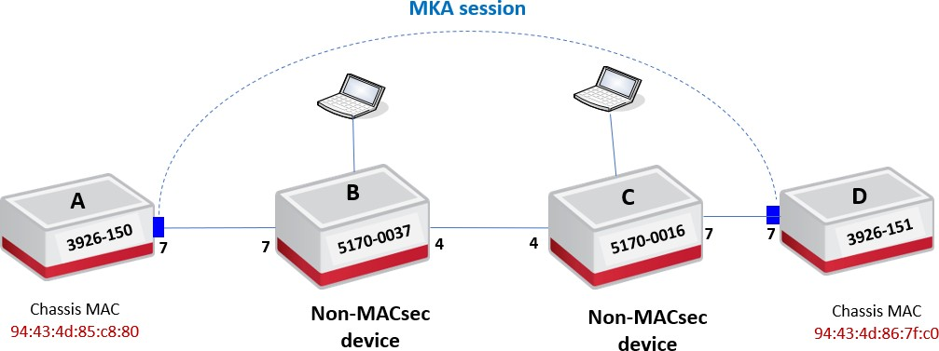

***Objective:***

The objective of this test is to establish end-to-end MACsec connection-association between the two nodes over an L2 switching circuit and verify that the traffic running is being encrypted. 5170s devices used in the topology are not MACsec aware.

***Procedure:***

***On Node A & Node D***

* Go to the configuration terminal
  + Config
* Setup the Forwarding Domains, classifiers and flow points in CLI on nodes A and D
  + classifiers classifier cvid-10 filter-entry classifier:vtag-stack vtags 1 vlan-id 10
  + fds fd FD1 vlan-id 10 mode vpls
  + fps fp fp7.1 logical-port 7 fd-name FD1 classifier-list cvid-10
* Create a **key-chain** for authentication and key establishment
  + macsec key-chains key-chain kc2002 mka-keys mka-key 2002 key 0123456789abcdef0123456789abcdef0123456789abcdef0123456789a bcdef

macsec key-chains key-chain kc2002 mka-keys mka-key 2002 cryptographic-algorithm AES_128_CMAC

* Create a MACsec **profile**
  + macsec macsec-profiles profile pf2002 encryption-on true

additional-bytes-in-clear 4 **(Optional, to leave C-tag in clear)**

key-server-priority 10

macsec-cipher-suite GCM_AES_128 replay-window-size 2

sak-rekey-interval 30

* Enable MACsec on **interface**
  + macsec config interfaces interface 7 strict-mode-on false

exclude-protocols lldp

exclude-protocols lacp

**Note:** In this case, strict mode needs to be set to false (Lenient mode) to allow MACsec and non- MACsec traffic flows to run over the same PHY.

* Create a **connection-association**

On node A:

* + macsec config connection-association CA2002 macsec-admin-state enabled

destination-address 94:43:4d:86:7f:c0 **(MAC of the peer chassis)**

mka-ether type 0x9001 key-chain kc2002 macsec-profile pf2002 flow-point untag-fp7.1

On node D:

* + macsec config connection-association CA2002 macsec-admin-state enabled

destination-address 94:43:4d:85:c8:80 **(MAC of the peer chassis)**

mka-ether type 0x9001 key-chain kc2002 macsec-profile pf2002 flow-point untag-fp7.1

**Note:** other devices within the provider network can process MKA frames. To avoid this behavior, the MAC@/Ether type for the control frames need to be changed so that they are not consumed when forwarded through the provider’s network.

We support 3 scenarios in end-to-end Flow point-based mode:

* Default multicast destination MAC **(01:80:C2:00:00:03)** and default Ether type **(0x888E).**
* Non-default multicast destination MAC **(01:01:01:01:01:01)** and non-default Ethertype

(0x9001).

* UNICAST destination MAC (**peer Chassis MAC**) and non-default Ethertype **(0x9001).**

***On Node B & Node C***

* + Go to the configuration terminal
    - Config
  + Setup the Forwarding Domains, classifiers and flow points in CLI on nodes A and D
    - classifiers classifier cvid-10 filter-entry classifier:vtag-stack vtags 1 vlan-id 10
    - classifiers classifier cvid-1002 filter-entry classifier:vtag-stack vtags 1 vlan-id 1002
    - fds fd FD1 mode vpls
    - fps fp fp7.1 logical-port 7 fd-name FD1 classifier-list cvid-10

ingress-l2-transform push-svid-1002 vlan-stack 1 push-tpid tpid-8100 push-vid 1002

egress-l2-transform pop-svid-1002 vlan-stack 1 pop-type fps fp fp4.1 logical-port 4 fd-name FD1 classifier-list cvid-1002

MACsec configuration on the nodes can be viewed using below commands.

3926_0150> show macsec connection-associations

+ CONNECTION-ASSOCIATION +

| CA Name | Admin State | Oper State | Service Type | Macsec Profile | Key Chain |

+ + + + + + +

| CA2002 | enabled | enabled | Flow Point | pf2002 | kc2002 |

+ + + + + + +

3926_0150> show macsec connection-associations connection-association CA2002

+ CONNECTION-ASSOCIATION +

| Parameter | Value |

+ + +

| CA Name | CA2002 |

| Admin State | enabled |

| Oper State | enabled |

| Oper State Reason | **Operational Up.** |

| Key Server | True |

| Destination Address | **94:43:4d:86:7f:c0** |

| Mka Ethertype | **0x9001** |

| Macsec Profile | pf2002 |

| Key Chain Name | kc2002 |

| Service Type | **Flow Point** |

| Service Name | fp7.1 |

+ + +

| Peer Secure Channel | |

+ + +

| Mac Address | 94:43:4d:86:7f:c0 |

| Port Identifier | 01-00 |

+ + +

|  |  |  |  |
| --- | --- | --- | --- |
| |  + | MKA Statistics | |  + | |  + |
| | | In EAPOL MKA invalid CKN Len Frames | | 0 | | |
| | | In EAPOL MKA invalid Frames | | 0 | | |
| | | In EAPOL MKA Frames | | 220 | | |
| | | Out EAPOL MKA Frames | | 242 | | |

| In Version Mismatch Frames | 0 |

| In CKN Mismatch Frames | 0 |

| In ICV Mismatch Frames | 0 |

+ + +

| Data Statistics | |

+ + +

| In Valid Packets | 0 |

| In Error Packets | 0 |

| In Transform Error Packets | 0 |

| In Control Packets | 0 |

| In Untagged Packets | 0 |

| In No Tag Packets | 0 |

| In Bad Tag Packets | 0 |

| In No SCI Packets | 0 |

| In Unknown Packets | 0 |

| In Decrypted Octets | 0 |

| In Validated Octets | 0 |

| Out Encrypted Packets | 0 |

| Out Protected Packets | 0 |

| Out Control Packets | 0 |

| Out Untagged Packets | 0 |

| Out Transform Error Packets | 0 |

| Out Encrypted Octets | 0 |

| Out Protected Octets | 0 |

+ + +

The captured encrypted traffic is depicted below. After configuring the 4 additional bytes in clear, we can see that both C-Tag and S-tag are displayed on the packet capture **(flow-point-based MACsec include the service provider’s S-tag in the clear by default).**

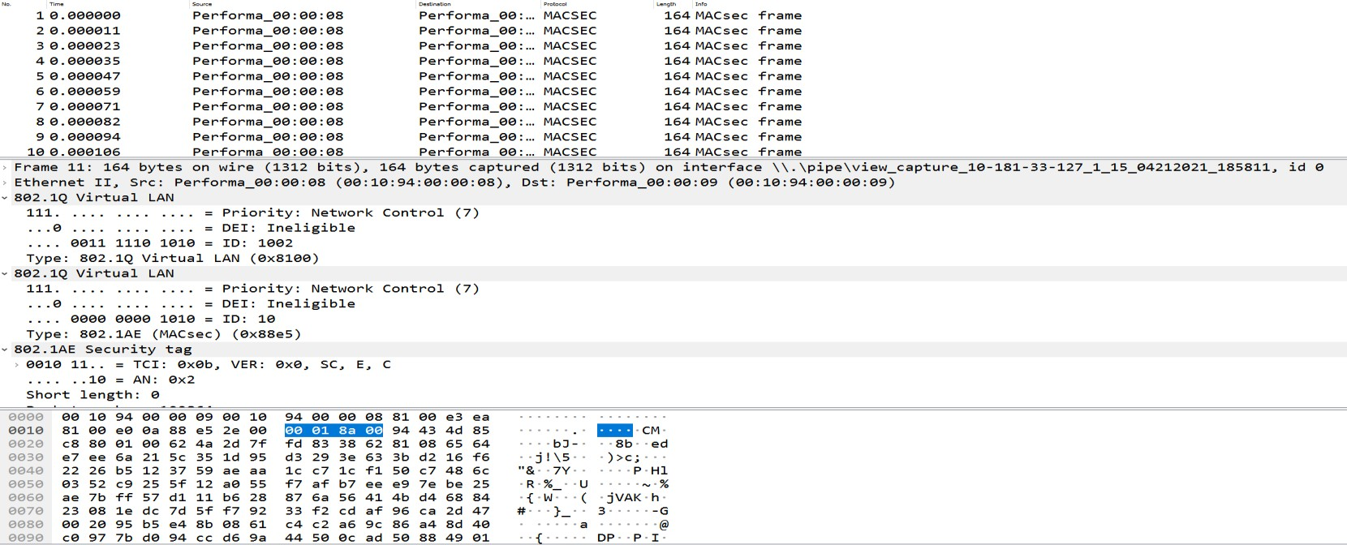

C-TAG

S-TAG

**Test Case Results:**

Passed: Yes No Verified by Date/Time Comments

**Scenario2: Macsec over G8032 ring**

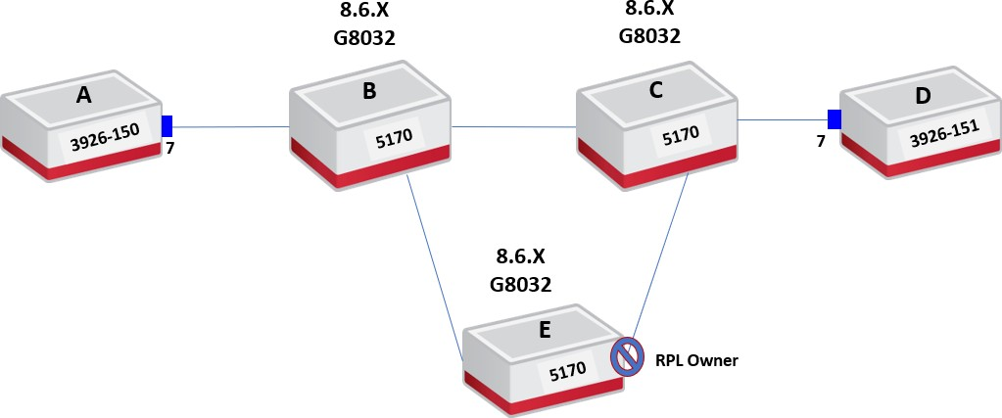

***Objective:***

The objective of this test is to setup end-to-end macsec along with G8032 ring. In this case MACsec devices shouln’t be part of the ring as the ethernet ring protection and the encryption are working independetly.

G8032 as an ecrypted MACsec service is not supported in **SAOS 10.6** and will be introduced in future relases.

***Procedure:***

Here it is assumed that G8032 is already running on 5170 devices running 8.6.x SW.

***On Node A & Node D***

* + Go to the configuration terminal
    - Config
  + Setup the Forwarding Domains, classifiers and flow points in CLI on nodes A and D:
    - classifiers classifier VLAN1000 filter-entry classifier:vtag-stack vtags 1 vlan-id 1000
    - fds fd FD1000 vlan-id 1000 mode vpls
    - fps fp FP7 logical-port 7 fd-name FD1000 classifier-list VLAN1000
  + Create a **key-chain** for authentication and key establishment
    - macsec key-chains key-chain KC1000 mka-keys mka-key 01 key 0123456789abcdef0123456789abcdef0123456789abcdef0123456789a bcdef
    - macsec key-chains key-chain KC1000 mka-keys mka-key 2002 cryptographic-algorithm AES_128_CMAC
  + Create a MACsec **profile**
    - macsec macsec-profiles profile pf1 encryption-on true

key-server-priority 10

macsec-cipher-suite GCM_AES_128 replay-window-size 2

sak-rekey-interval 30

* + Enable MACsec on **interface**
    - macsec config interfaces interface 7 strict-mode-on false
  + Create a **connection-association On node A:**
    - macsec config connection-association CA1000 macsec-admin-state enabled

destination-address 94:43:4d:86:7f:c0 **(MAC of the peer**

chassis)

mka-ethertype 0x9001 key-chain KC1000 macsec-profile pf1 flow-point FP1

* + Create a **connection-association On node D:**
    - macsec config connection-association CA1000 macsec-admin-state enabled

destination-address 94:43:4d:85:c8:80 **(MAC of the peer**

chassis)

mka-ethertype 0x9001 key-chain KC1 macsec-profile pf1 flow-point FP1

MACsec configuration on the nodes can be viewed using below commands.

3926-150> show macsec connection-associations

+ CONNECTION-ASSOCIATION +

| CA Name | Admin State | Oper State | Service Type | Macsec Profile | Key Chain |

+ + + + + + +

| CA1000 | enabled | enabled | Flow Point | pf1 | KC1000 |

+ + + + + + +

3926-150> show macsec connection-associations connection-association CA1000

+ CONNECTION-ASSOCIATION +

| Parameter | Value |

+ + +

| CA Name | CA1000 |

| Admin State | enabled |

| Oper State | enabled |

| Oper State Reason | **Operational Up.** |

| Key Server | True |

| Destination Address | **94:43:4d:86:7f:c0** |

| Mka Ethertype | **0x9001** |

| Macsec Profile | pf1 |

| Key Chain Name | KC1000 |

| Service Type | **Flow Point** |

| Service Name | FP7 |

+ + +

| Peer Secure Channel | |

+ + +

| Mac Address | 94:43:4d:86:7f:c0 |

| Port Identifier | 01-00 |

+ + +

| MKA Statistics | |

+ + +

| In EAPOL MKA invalid CKN Len Frames | 0 |

| In EAPOL MKA invalid Frames | 0 |

| In EAPOL MKA Frames | 5334 |

| Out EAPOL MKA Frames | 5089 |

|  |  |  |  |  |
| --- | --- | --- | --- | --- |
| | | In Version Mismatch Frames | | | 0 | | |
| | | In CKN Mismatch Frames | | | 0 | | |
| | | In ICV Mismatch Frames | | | 0 | | |

+ + +

| Data Statistics | |

+ + +

| In Valid Packets | 5216 |

| In Error Packets | 0 |

| In Transform Error Packets | 0 |

| In Control Packets | 5334 |

| In Untagged Packets | 0 |

| In No Tag Packets | 0 |

| In Bad Tag Packets | 0 |

| In No SCI Packets | 0 |

| In Unknown Packets | 0 |

| In Unused SA Packets | 0 |

| In Unused SA Discarded Packets | 0 |

| In Overrun Discarded Packets | 0 |

| In Unchecked Packets | 0 |

| In Invalid Packets | 0 |

| In Invalid with Sectag C-bit=1 Packets | 0 |

| In Delayed Packets | 0 |

| In Late Packets | 0 |

| In Decrypted Octets | 563328 |

| In Validated Octets | 563328 |

| Out Encrypted Packets | 3 |

| Out Protected Packets | 3 |

| Out Control Packets | 5089 |

| Out Untagged Packets | 0 |

| Out Transform Error Packets | 0 |

| Out Too Long Discarded Packets | 0 |

| Out Encrypted Octets | 324 |

| Out Protected Octets | 324 |

+ + +

We can see on the capture below that the traffic running end-to-end (NodeA-Node D) is being encrypted. As mentioned previously, the S-tag is left in clear by default.

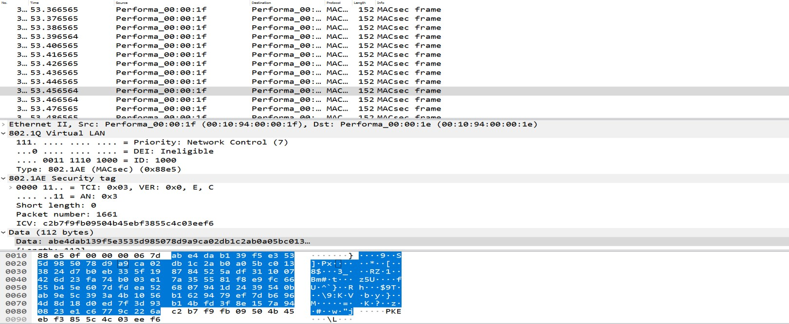

**Test Case Results:**

Passed: Yes No Verified by Date/Time Comments

###### End-to-end mode on 5171

Starting from 10.7.1, MACsec feature is supported on 5171 platforms using 100G interfaces on FRU modules.

The only difference on 5171 in 10.7.1 compared to 3926 is that we are adding a l2-transform on the FD only for **FP-based end-end mode**. At the opposite of XGS, control frames are sent untagged on DNX. When MACsec is configured, MKA frames should have the same VLAN tag configured on the classifier of the FP on which the feature is configured.

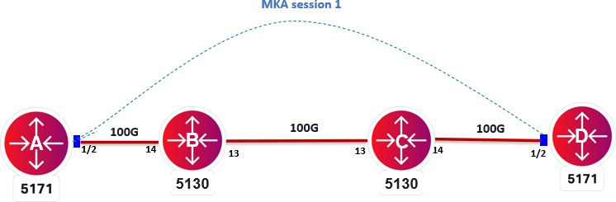

***Objective***

The objective of this test is to establish FP-based end-to-end MACsec connection-association between the two 5171s over a L2 switched circuit.

***Procedure:***

* Go to the configuration terminal
  + config
* Setup the Forwarding Domains, classifiers and flow points in CLI
  + fds fd fd-Msec5171 mode vpls
  + fds fd fd-Msec5171 initiate-l2-transform vlan-stack 1 push- vid 10
  + classifiers classifier cvid-10 filter-entry classifier:vtag-stack vtags 1 vlan-id 10
  + fps fp p5171-NNI logical-port 1/2 fd-name fd-Msec5171 classifier-list cvid-10
* Create a **key-chain** for authentication and key establishment, it’s used to generate SAK keys to be used to program hardware. It can use both 128 and 256 cryptographic algorithms. The pre-shared key must match on both MACsec devices for the session to be established
  + macsec key-chains key-chain kc10 mka-keys mka-key 01 key 0123456789abcdef0123456789abcdef0123456789abcdef0123456789a bcdef

macsec key-chains key-chain kc10 mka-keys mka-key 01 cryptographic-algorithm AES_128_CMAC

exit

* Create a **profile** that combines various user configurable parameters for security
  + macsec macsec-profiles profile pf1 encryption-on true

key-server-priority 10 **(On the server only to generate the SAK)**

macsec-cipher-suite GCM_AES_128 replay-window-size 2

sak-rekey-interval 30

* Enable MACsec on interface. We can exclude L2 protocols not to be MACsec encrypted when configuring the interface
  + macsec config interfaces interface 1/2 strict-mode-on false
* Create a **connection-association** which is a security relationship, established and maintained by key agreement protocols
  + macsec config connection-association CA10 macsec-admin-state enabled

key-chain kc10 macsec-profile pf10 flow-point fp5171-NNI

The above commands need to be configured at both MACsec nodes to perform encryption.

Once the configuration is performed at both nodes and CA connection is setup, MACsec configuration can be verified using below commands.

* + show macsec key-chains key-chain kc10

+ KEY-CHAIN +

| Key-Chain | KC1 |

+ + +

| MKA Name | 01 |

| MKA Crypto Algo | AES_128_CMAC |

+ + +

* + show macsec profiles profile pf10

+ MACSEC-PROFILES +

| KEY | VALUE |

+ + +

| Profile Name | pf10 |

| Cipher Suite | GCM_AES_128 |

| Conf Offset | 0_BYTES |

| Replay Window Size | 2 |

| Additional Bytes In Clear | 0 |

| Encryption | True |

| Key Server Priority | 10 |

| SAK Rekey Interval | 30 |

+ + +

* + show macsec connection-associations

+ CONNECTION-ASSOCIATION +

| CA Name | Admin State | Oper State | Service Type | Macsec Profile | Key Chain |

+ + + + + + +

| CA10 | **enabled** | **enabled** | Flow Point | pf10 | kc10 |

+ + + + + + +

* + show macsec connection-associations connection-association CA10

+ CONNECTION-ASSOCIATION +

| Parameter | Value |

+ + +

| CA Name | CA10 |

| Admin State | enabled |

| Oper State | **enabled** |

| Oper State Reason | Operational Up. |

| Key Server | True |

| Destination Address | 01:80:C2:00:00:03 |

| Mka Ethertype | 0x888e |

| Macsec Profile | **pf10** |

| Key Chain Name | **kc10** |

| Service Type | **Flow Point** |

| Service Name | fp5171-NNI |

+ + +

| Peer Secure Channel | |

+ + +

| Mac Address | d0:19:6a:c9:6c:80 |

| Port Identifier | 01-00 |

+ + +

| MKA Statistics | |

+ + +

| In EAPOL MKA invalid CKN Len Frames | 0 |

| In EAPOL MKA invalid Frames | 0 |

| In EAPOL MKA Frames | 338534 |

| Out EAPOL MKA Frames | 321587 |

|  |  |  |  |  |
| --- | --- | --- | --- | --- |
| | | In Version Mismatch Frames | | | 0 | | |
| | | In CKN Mismatch Frames | | | 0 | | |
| | | In ICV Mismatch Frames | | | 0 | | |
| + |  | + |  | + |

Test Case Results:

Passed: Yes No Verified by Date/Time Comments