#### ETTP loopback:

***Objective*** :

In **SAOS 10.7.1**, we have ETTP loopback support on DNX families after it was introduced on XGS platforms since 10.1.

ETTP loopback is a very useful feature for debugging purposes. We support two types of ETTP loopback:

* **Facility loopback:** When facility loopback is enabled on a an ETTP, the traffic due to ingress is looped back in egress direction.

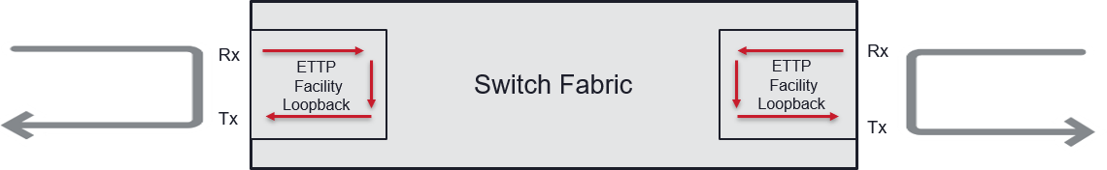

* + Below is the command used to enable facility loopback on port 3:

oc-if:interfaces interface 3 config facility-loopback true

* + Displaying the ETTP details to confirm that the feature is enabled. Please note that the port will remain UP when facility loopback is enabled:

5171-0018-A> show ettps ettp 3

+ ETTP +

| KEY | VALUE |

+ + +

| Name | 3 |

| Description | 3 |

| Type | ettp |

| Admin Status | True |

| Mode | auto |

| Link Flap Detect | False |

| Link Flap Count | 5 |

| Link Flap Detect Time | 10 |

| Link Flap Hold Time | 300 |

| Duplex | full |

| Port Speed | 10Gb |

| Flow Control | off |

| Auto Negotiation | False |

| Terminal Loopback | False |

| Facility Loopback | **True** |

| Forward Error Correction | auto |

| PTP Id | 3 |

| ETTP Mode | standard-ethernet |

+ + +

+ ETTP STATE +

| KEY | VALUE |

+ + +

| Name | 3 |

| **Oper Status** | **UP** |

| Duration Since Last Oper Change | 9 days, 3:26:30 |

| Duplex | full |

| Flow Control | off |

| Speed Mbps | 10000 |

| Link Flap State | none |

| Ownership | data |

| Auto Negotiation | False |

| Terminal Loopback Operational State | False |

| Facility Loopback Operational State | True |

+ + +

* + Below is the command used to disable facility loopback on port 3:

oc-if:interfaces interface 3 config facility-loopback false

* **Terminal loopback:** When terminal loopback is enabled on a an ETTP, the traffic due egress is looped back in ingress direction:

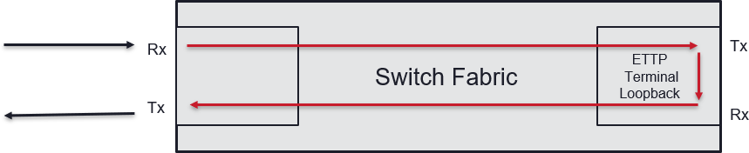

* + Below is the command used to enable terminal loopback on port 3:

oc-if:interfaces interface 3 config terminal-loopback true

* + Displaying the ETTP details to confirm that the feature is enabled. Please note that the port will go DOWN when terminal loopback is enabled:

5171-0018-A> sho ettps ettp 3

+ ETTP +

| KEY | VALUE |

+ + +

| Name | 3 |

| Description | 3 |

| Type | ettp |

| Admin Status | True |

| Mode | auto |

|  |  |  |  |  |
| --- | --- | --- | --- | --- |
| | | Link Flap Detect | | | False | | |
| | | Link Flap Count | | | 5 | | |
| | | Link Flap Detect Time | | | 10 | | |
| | | Link Flap Hold Time | | | 300 | | |
| | | Duplex | | | full | | |
| | | Port Speed | | | 10Gb | | |
| | | Flow Control | | | off | | |
| | | Auto Negotiation | | | False | | |
| | | Terminal Loopback | | | True | | |
| | | Facility Loopback | | | False | | |
| | | Forward Error Correction | | | auto | | |
| | | PTP Id | | | 3 | | |
| | | ETTP Mode | | | standard-ethernet | | |
| + |  | + |  | + |

+ ETTP STATE +

| KEY | VALUE |

+ + +

| Name | 3 |

| **Oper Status** | **DOWN** |

| Duration Since Last Oper Change | 0 days, 0:00:05 |

| Flow Control | unknown |

| Speed Mbps | 0 |

| Link Flap State | none |

| Ownership | data |

| Auto Negotiation | False |

| Terminal Loopback Operational State | True |

| Facility Loopback Operational State | False |

+ + +

* + Below is the command used to disable terminal loopback on port 3:

oc-if:interfaces interface 3 config terminal-loopback false

Test Case Results:

Passed: Yes No Verified by Date/Time Comments