###### Verification

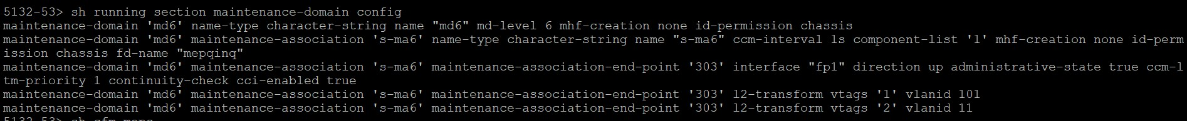



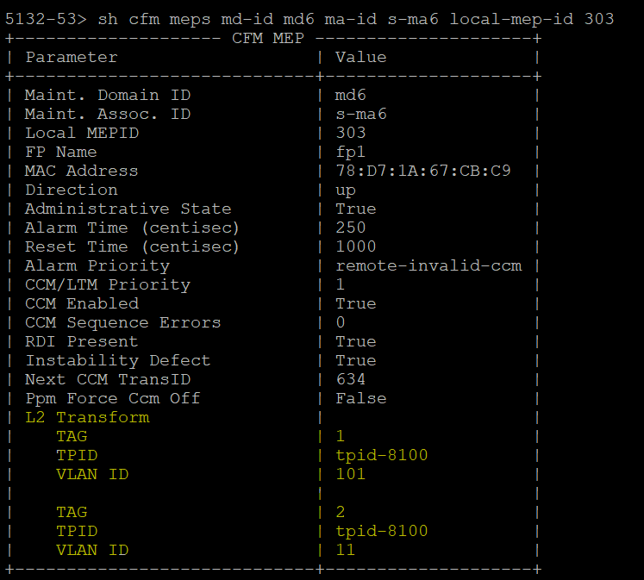

Test Case Results:

Passed: Yes Verified by Date/Time Comments