###### SAT testing with MPLS LDP transport tunnel

**Objective:**

Objective is to configure SAT (Service Activation Test) on an EVPL service by using MPLS LDP as a transport protocol.

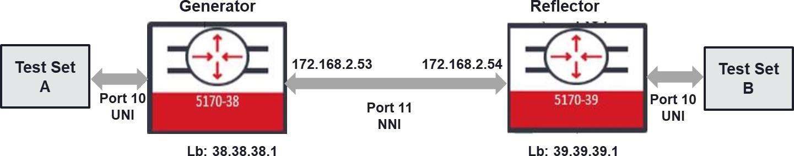

**Procedure:**

Following steps needs to be applied.

* Configure EVPL service by using MPLS LDP as a transport protocol
* Generator and Reflector configurations are slightly different than each other. Generator configuration:
  + Configure SAT Entity
  + Configure SAT KPI Profile
  + Configure SAT Test Profile
  + Configure SAT Test Instance
  + Enable global-sat
* Reflector configuration:
  + Configure SAT Entity
  + Configure SAT Test Instance
  + Enable global-sat
* After Generator and Reflector is configured, “sat-global” needs to be enabled on both

nodes

* SAT test can be started from the Generator node if “sat ping” issued in Generator node gives successful connection with the Reflector node.

**EVPL service creation on Generator and Reflector nodes:**

Following configurations will be used on both Generator and Reflector nodes.

**On both nodes:**

*config*

*classifiers classifier vlan16 filter-entry vtag-stack vtags 1 vlan-id 16*

*fds fd VLAN16 mode vpls exit*

*exit*

*fps fp VLAN16*

*fd-name VLAN16 logical-port agg1 mtu-size 9216*

*classifier-list-precedence 7 classifier-list vlan16*

*stats-collection on*

*egress-l2-transform push-vid-16 vlan-stack 1*

*push-tpid tpid-8100 push-vid 16*

*exit exit exit exit*

**On 5170-38:**

*config*

*oc-if:interfaces interface if11 config name if11 vrfName default cn-if:type ip mtu 1500 admin-status true stats-collection on underlay-binding config fd VLAN16*

*oc-if:interfaces interface if11 ipv4 addresses address 172.168.2.53 config ip 172.168.2.53 prefix-length 30*

*oc-if:interfaces interface lb1 config name lb1 cn-if:type loopback*

*oc-if:interfaces interface lb1 ipv4 addresses address 38.38.38.1 config ip 38.38.38.1 prefix-length 32*

*ldp instance default lsr-id 38.38.38.1*

*ldp instance default interfaces interface if11 enable-ipv4 true mpls interfaces interface if11 label-switching true*

**On 5170-39:**

*config*

*oc-if:interfaces interface if11 config name if11 vrfName default cn-if:type ip mtu 1500 admin-status true stats-collection on underlay-binding config fd VLAN16*

*oc-if:interfaces interface if11 ipv4 addresses address 172.168.2.54 config ip 172.168.2.54 prefix-length 30*

*oc-if:interfaces interface lb1 config name lb1 cn-if:type loopback*

*oc-if:interfaces interface lb1 ipv4 addresses address 39.39.39.1 config ip 39.39.39.1 prefix-length 32 ldp instance default lsr-id 39.39.39.1*

*ldp instance default interfaces interface if11 enable-ipv4 true mpls interfaces interface if11 label-switching true*

**On both nodes:**

*config*

*classifiers classifier vlan_300 filter-entry vtag-stack vtags 1 vlan-id 300 fds fd fd_SAT_LDP_uni*

*mode vpls exit*

*exit*

*fps fp fp_SAT_LDP_uni*

*fd-name fd_SAT_LDP_uni logical-port 10*

*mtu-size 9216*

*classifier-list-precedence 1 classifier-list vlan_300*

*exit exit*

**On 5170-38:**

*config*

*ldp instance default lsr-id 38.38.38.1 target-ldp peers 39.39.39.1*

*pseudowires pseudowire PW_SAT_LDP mode mesh configured-pw peer-ip 39.39.39.1 pw-id 33 l2vpn-services l2vpn L2V_SAT*

*signaling-type ldp pseudowire PW_SAT_LDP service-type vlan*

*forwarding-domain fd_SAT_LDP_uni exit*

*exit*

**On 5170-39:**

*config*

*ldp instance default lsr-id 39.39.39.1 target-ldp peers 38.38.38.1*

*pseudowires pseudowire PW_SAT_LDP mode mesh configured-pw peer-ip 38.38.38.1 pw-id 33 l2vpn-services l2vpn L2V_SAT*

*signaling-type ldp pseudowire PW_SAT_LDP service-type vlan*

*forwarding-domain fd_SAT_LDP_uni exit*

*exit*

**SAT Generator node configuration:**

**SAT Entity configuration:**

*config*

*sat entity ent_gen_ldp port 10*

*role generator*

*mode evc-out-of-service admin-state enabled*

*exit exit*

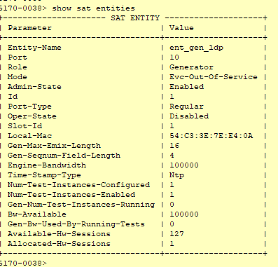

**SAT KPI Profile configuration:**

*config*

*sat kpi-profile kpi_ldp pcp 0 throughput 200000*

*frameloss 100*

*latency 2*

*pdv 2*

*single-outage-max 1*

*sum-outages-max 2 exit*

*exit exit*

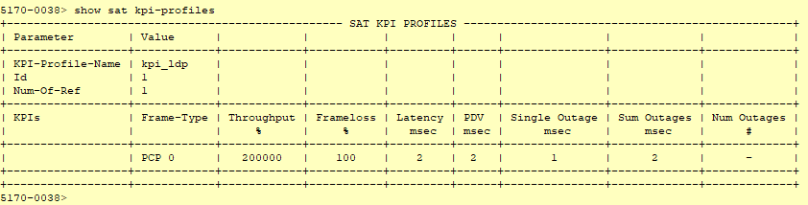

Provisioned throughput number here provides how much of the total bandwidth can be allocated for overheads as in 4 point of decimal and by percent of this number. For the UNI port 10G rate “50000” entry means, up to % 5 of 10G rate can be used for overheads. So customer should be able to use

9.5G rate of traffic.

Provisioned frameloss number here provides how much loss can be tolerated as in 4 point of decimal and b percent of this number. For the UNI port 10G rate “100” entry means, up to % 0.01 loss is accepted.

**SAT Test Profile configuration:**

*config*

*sat test-profile prf_ldp bandwidth 10000*

*interval tCompletion duration tOnce*

*frameloss-test true vid-validation true*

*dst-mac 54:C3:3E:B2:F8:8A*

*kpi-profile-name kpi_ldp encap-type dot1Q*

*frame-size 80 256 512 1280 1518 exit*

*exit*

“dst-mac” in the configuration will be the “shared-mac” MAC address of Reflector which can be

queried via “show system macs.”

It is suggested to use “duration” as “tOnce” and “interval” as “tCompletion.”

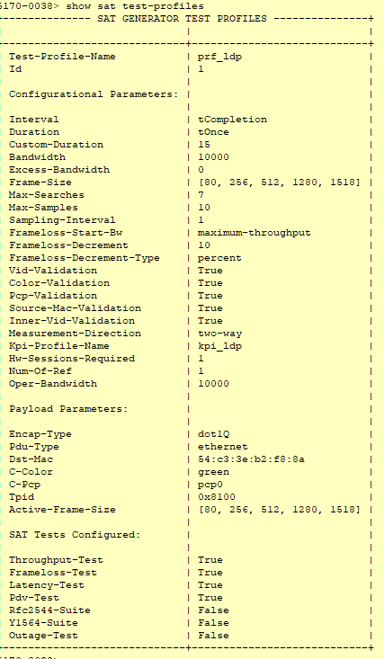

**SAT Test Instance configuration:**

*config*

*sat test-instance ins_gen_ldp*

*flow-point-id fp_SAT_LDP_uni profile prf_ldp*

*dst-mac 54:c3:3e:b2:f8:8a c-vid 300*

*admin-state enabled exit*

*exit*

“dst-mac” in the configuration will be the “shared-mac” MAC address of Reflector which can be queried via “show system macs.”

**5170-0038> show sat test-instances**

+ SAT TEST INSTANCES +

**I Parameter** I Value

+ + +

**Test-Instance-Name ins_gen_ldp**

Flow-Point-Id fp_SAT_LDP_uni

Profile prf_ldp

C-Vid 300

Untagged **Ost-Mac Admin-State** Id

**Current-Interval Total-Intervals**

**Last-Iteration-Start-Timestamp**

**Assoc-Entity Oper-State Active-C-Vid Active-Ost-Mac Active-Start-Bw**

**Required-Start-Bw**

**Active-Frame-Size Test-Start-Timestamp Test-End-Timestamp Session Keys:**

**False**

54:c3:3e:b2:f8:8a

**enabled**

l

0

**Not Run Not Run**

**ent gen_ldp**

disabled 300

54:c3:3e:b2:f8:8a

0

10000.00

[80, 256, 512, 1280, 1518)

**Not Run Not Run**

**Session-Id** Slot-Id Lif-Id S-Vid S-Pcp

S-Color C-Vid C-Pcp

C-Color Untagged

Mask

**Profile running configuration: Interval**

**Duration**

**Sampling-Interval Max-Samples**

**Max-Searches Bandwidth**

**Excess-Bandwidth Frameloss-Start-Bw Frame-Size-List Emix-Sequence**

!<pi-Profile

BW-Alloc-Profile **Vid-Validation Color-Validation PCP-Validation VLAN-TPID**

**VLAN-Encapsulation**

Pdu-Type **Destination MAC Test Configured:**

+ **l '7f"l_f"lf"l":t0,** ■

0

l

33914

0

0

**green**

300

0

**green**

0

11110001

**tCompletion tOnce**

l

10

7

10000

0

**maximum-throughput**

[80, 256, 512, 1280, 1518)

**Not configured**

kpi_ldp

**Not configured True**

**True**

**True**

0x8100

dotlQ

**ethernet**

54:c3:3e:b2:f8:8a

**Frameloss-Test**

+ +

**Enable global-sat**

After all the steps above completed, global-sat needs to be enabled.

*config*

*sat sat-global admin-state enabled*

**SAT Reflector node configuration:**

**SAT Entity configuration:**

*config*

*sat entity ent_ref_ldp port 10*

*role reflector*

*mode evc-out-of-service reflection-level l2-to-l4*

*assoc-gen-vendor-type other admin-state enabled*

*exit exit*

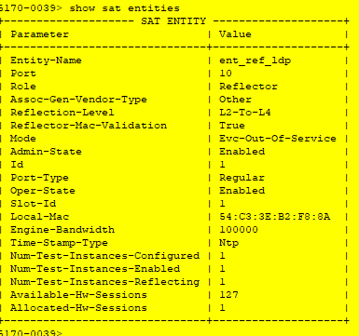

**SAT Test Instance configuration:**

*config*

*sat test-instance ins_ref_ldp flow-point-id fp_SAT_LDP_uni admin-state enabled*

*exit exit*

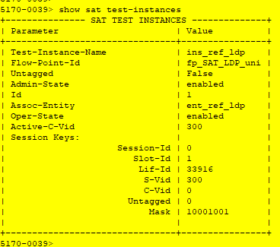

**Enable global-sat**

After all the steps above completed, global-sat needs to be enabled.

*config*

*sat sat-global admin-state enabled*

**Running SAT test**

Before running the SAT test, first step is to check whether Generator and Reflector node can

communicate with each other. This can be done via “ping” on the Generator node.

*sat ping test-instances test-instance ins_gen_ldpr*

After making sure that “ping” is successful SAT can be started with the following command on the

Generator node.

*sat start test-instances test-instance ins_gen_ldpr*



Test results can only be queried after the SAT test is over, till then it is possible to query test status.

*show sat test-instances status*

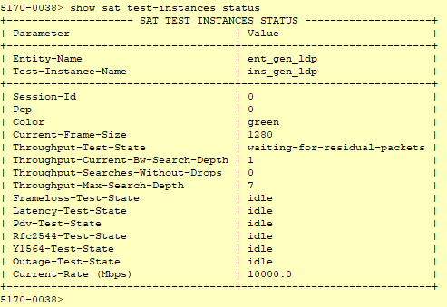

Test results will be shows with the following command after the test is over.

*show sat test-instances statistics*

*!{j,*10.181.36.86 - PuTTY

5170-0038> show sat test-instances statistics

+

SATTEST INSTANCES STATISTICS & RESULTS +

I I I I I I I I I I

+ + + + + + + + + +

Test-Instance-Name ins_gen_ldp I I I 1

Associated-Entity-Name ent_gen_ldp Associated-Test- Profile-Name prf_ ldp Tes't-Bandwidth 10000

Ac'tive deseina'tion MAC

Test-Packet Encapsulation Type Active vtag-stack

Last Test Start timestazrp

Tes't End times'tairq:>

Por't Type Test interval

Test duration

54: c3: 3e :b2: £8: Sa

dotlO

* ·:300

2D20-02-12Tl9 16 222

2020-02-121"19 18 372

regular tCompletion tOnce

|  |  |  |  |  |  |  |  |  |  |  |  |
| --- | --- | --- | --- | --- | --- | --- | --- | --- | --- | --- | --- |
| +  I | Throughput | Results | +  I Frame | +  I | + + +  PCP I Color I Min I Avg | | | + + + +  I Max I KPI Result I Iterations l | | | |
| I |  |  | I Size | I | I I Kbps I Kbps | | | I Kbps I I l | | | |
| + |  |  | + | + | + + + | | | + + + + | | | |
| I |  |  | I 80 | I | o I green I €€25. oo I €€25. oo | | | I 6€25 oo I pass I 2 l | | | |
|  |  |  | 256 |  | green 8550. 72 8550. 72 | | | 8550 72 pass | | | |
|  |  |  | 512 |  | green 9323. 30 9323. 30 | | | 9323 30 pass | | | |
|  |  |  | 1280 | I | 0 green 9692. 30 9692. 30 | | | 9692 30 pass 2 | | | |
|  |  |  | 1518 | I | 0 green 9715. 74 9715. 74 | | | 9715 74 pa.ss 2 | | | |
| + | + | | | + | + | + | + | + | + | + | + |

I

I

|  |  |  |  |  |  |  |  |  |  |  |  |  |
| --- | --- | --- | --- | --- | --- | --- | --- | --- | --- | --- | --- | --- |
| I I | Latency Results | I Frame  I Size |  | I I | PCP I I | Color | I Min  I usec | I Avg  I usec | I Max  I usec | I KPI  I | Result I Samples  I | J |
| + |  | + | + |  | + |  | + | + | + | + | + | + |

|  |  |  |  |  |  |  |  |  |  |  |  |  |  |  |
| --- | --- | --- | --- | --- | --- | --- | --- | --- | --- | --- | --- | --- | --- | --- |
| I |  | I 80 |  | I | 0 |  |  | green | I 8 | I 523 | I 1042 | I pa.ss | I 10 | l |
|  |  | 256 |  | I | 0 |  |  | green | I 8 | 21 | 29 | pass | 10 |  |
|  |  | 512 |  |  |  |  |  | green | I 9 | 441 | 895 | pass | 10 |  |
|  |  | 1280 |  |  |  |  |  | green | 11 | 67 | 118 | pass | 10 |  |
| + |  | I 1518  + | + | I | 0 | + | | green | I 11  + | I 22  + | I 27  + | I pass  + | I 10  + | + |

I POV Results I Frame I PCP I Color I Avg I I I KPI Result I Samples l I I Size I I I usec I I

+ + + + + + + + + +

I I 80 I 0 I green I 0 I I I pass I 10 l

I I 256 I O I green I O I I I pa.ss I 10 l

512 I O green I O pass 10

1280

1518

green 0

green 0

pass 10

pass 10

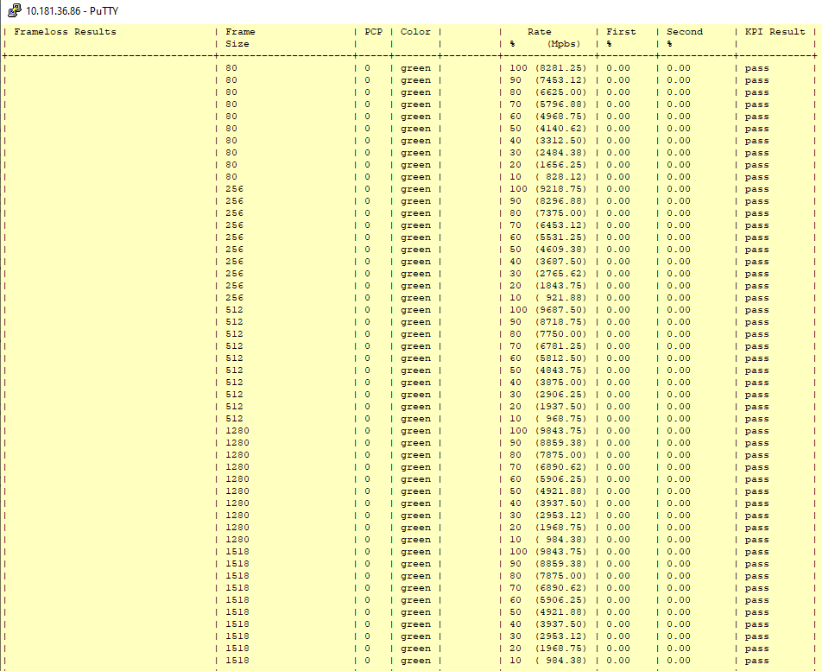

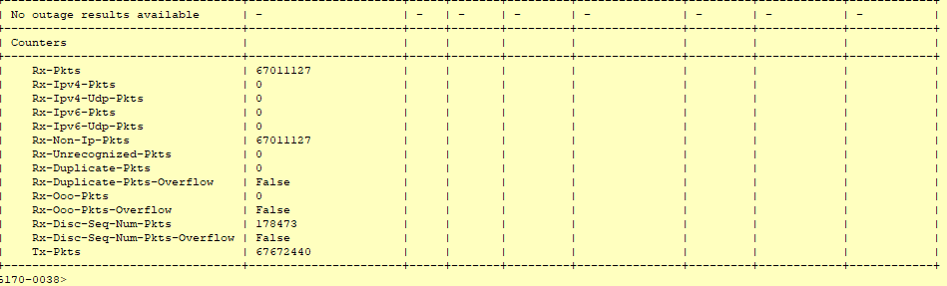

Test Case Results:

Passed: Yes No Verified by Date/Time Comments