###### L2 Loop Detect

***Objective:***

The objective is to configure a down MEP with Layer 2 loop detection enabled. When Layer 2 loop detection is enabled, the device detects and counts received frames that it originally sent .When the loop prevention is enabled the device will block the flow point on which the down mep is created. The flow point block will only affect the data traffic of which the flow point is a part of. The CCMs will be allowed to ingress and egress uninterrupted.







In the test that follows, the customer network is replaced with a Ciena device that can be configured to loop the traffic back. A simple way would be to mirror ingress traffic back on the same port or use a facility loopback. Of course, a physical loopbacks could be used

***Procedure***

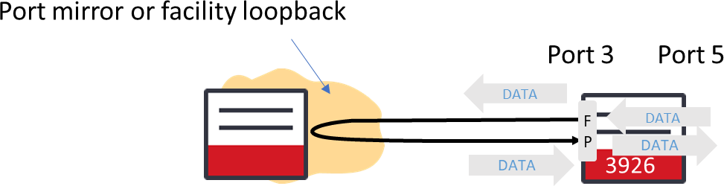

***Configuration***

classifiers

classifier vlan1000 filter-entry vtag-stack vtags 1

vlan-id 1000

exit exit

fds

fd fd1000_1 mode vpls vlan-id 1000

exit exit

fps

fp fp1000_5

fd-name fd1000_1 logical-port 5

stats-collection on classifier-list vlan1000

exit exit

fps

fp fp1000_3

fd-name fd1000_1 logical-port 3

stats-collection on classifier-list vlan1000

exit exit

cfm-global-config admin-state enable

exit

maintenance-domain md_1000_6 name-type character-string name md_1000_6

md-level 6

mhf-creation none

id-permission chassis exit

maintenance-domain md_1000_6 maintenance-association ma_1000_6 name-type character-string

name ma_1000_6 ccm-interval 1s component-list 1 fd-name fd1000_1 mhf-creation none

id-permission chassis

exit

exit

maintenance-domain md_1000_6 maintenance-association ma_1000_6 maintenance-association-end-point 1000

direction down interface fp1000_3

administrative-state true ccm-ltm-priority 1 continuity-check

cci-enabled true

lowest-fault-priority-defect remote-mac-error fng-alarm-time 250

fng-reset-time 1000

exit exit exit

maintenance-domain md_1000_6 maintenance-association ma_1000_6 maintenance-association-end-point 1000

l2-transform vlanid 1000 pcp pcp-7 tpid tpid-8100

exit exit exit exit

maintenance-domain md_1000_6 maintenance-association ma_1000_6 maintenance-association-end-point 1000

l2-loop-config admin-state enable prevention enable pdu-count 10

wtr-timer 1

exit exit exit exit

***Procedure***

* Make sure the customer device/network is not looping.
* Display the CFM l2-loop detect status



* Verify that the flow point is currently unblocked.
* Inject some traffic on port 5 and verify that it egresses port 3

3926_146> show ettps ettp 3 statistics

+ ETTP STATISTICS +

|  |  |  |  |  |  |  |
| --- | --- | --- | --- | --- | --- | --- |
| |  +  | | KEY  Name |  |  | |  +  | | VALUE  3 | |  +  | |
| | |  |  |  | | |  | | |
| | |  | In Bytes |  | | | 744 | | |
| | |  | In Packets |  | | | 3 | | |
| | |  | In Broadcast | Packets | | | 0 | | |
| | |  | Out Bytes |  | | | 52463196 | | |
| | |  | In Multicast | Packets | | | 3 | | |
| | |  | Out Packets |  | | | 52501 | | |
| | | Out Unicast Packets | | | | | 52457 | | |
| | | In Errors | | | | | 0 | | |
| | | Out Errors | | | | | 0 | | |
| | | Out Broadcast Packets | | | | | 0 | | |
| | | In Undersize Packets | | | | | 0 | | |
| | | Out Multicast Packets | | | | | 44 | | |

* On the customer device, create a loop
* Verify that that loop is detected and that the traffic stops flowing

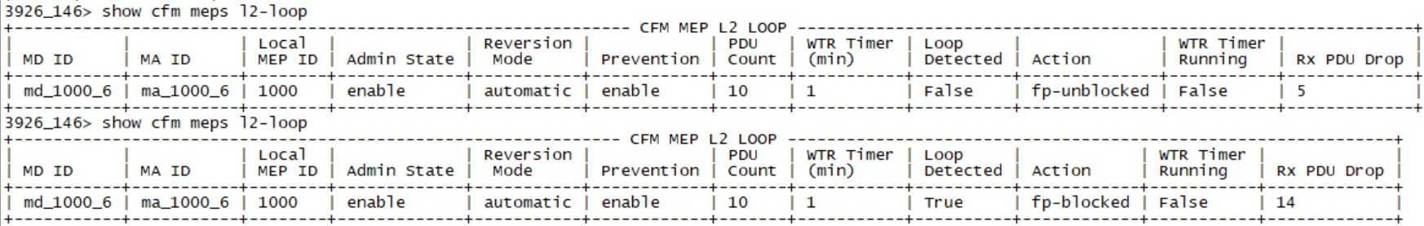

3926_146> clear ettps statistics

3926_146> show ettps ettp 3 statistics

+ ETTP STATISTICS +

|  |  |  |  |  |  |  |  |
| --- | --- | --- | --- | --- | --- | --- | --- |
| |  +  | | KEY  Name |  |  |  | |  +  | | VALUE  3 | |  +  | |
| | |  |  |  |  | | |  | | |
| | |  | In | Bytes |  | | | 348 | | |
| | |  | In | Packets |  | | | 3 | | |
| | |  | In | Broadcast | Packets | | | 0 | | |
| | | Out Bytes | | |  | | | 348 | | |
| | | In Multicast | | | Packets | | | 3 | | |
| | | Out Packets | | | | | | 3 | | |
| | | Out Unicast Packets | | | | | | 0 | | |
| | | In Errors | | | | | | 0 | | |
| | | Out Errors | | | | | | 0 | | |
| | | Out Broadcast Packets | | | | | | 0 | | |
| | | In Undersize Packets | | | | | | 0 | | |
| | | Out Multicast Packets | | | | | | 3 | | |
| | | In 64 Octet Packets | | | | | | 0 | | |

* On the customer device/network, fix the loop
* Verify that, after one minute, the flow point unblocks and the traffic flows again

926_146> show ettps ettp 3 statistics

+ ETTP STATISTICS +

|  |  |  |  |  |  |  |  |
| --- | --- | --- | --- | --- | --- | --- | --- |
| |  +  | | KEY  Name |  |  |  | |  +  | | VALUE  3 | |  +  | |
| | |  |  |  |  | | |  | | |
| | |  | In | Bytes |  | | | 436 | | |
| | |  | In | Packets |  | | | 2 | | |
| | |  | In | Broadcast | Packets | | | 0 | | |
| | | Out Bytes | | |  | | | 4268 | | |
| | | In Multicast | | | Packets | | | 2 | | |
| | | Out Packets | | | | | | 36 | | |
| | | Out Unicast Packets | | | | | | 0 | | |
| | | In Errors | | | | | | 0 | | |
| | | Out Errors | | | | | | 0 | | |
| | | Out Broadcast Packets | | | | | | 0 | | |
| | | In Undersize Packets | | | | | | 0 | | |
| | | Out Multicast Packets | | | | | | 36 | | |

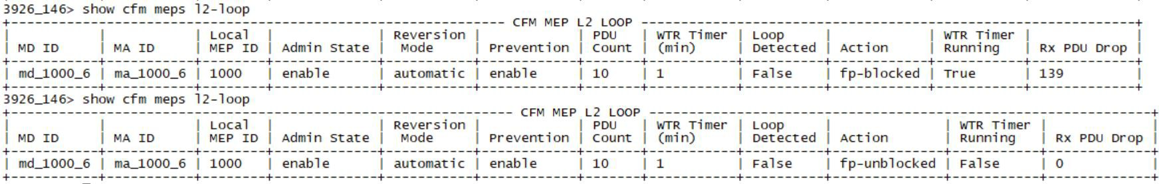

3926_146> show ettps ettp 3 statistics

+ ETTP STATISTICS +

|  |  |  |  |  |  |  |
| --- | --- | --- | --- | --- | --- | --- |
| |  +  | | KEY  Name |  |  | |  +  | | VALUE  3 | |  +  | |
| | |  |  |  | | |  | | |
| | |  | In Bytes |  | | | 872 | | |
| | |  | In Packets |  | | | 4 | | |
| | |  | In Broadcast | Packets | | | 0 | | |
| | |  | Out Bytes |  | | | 512752 | | |
| | |  | In Multicast | Packets | | | 4 | | |
| | |  | Out Packets |  | | | 554 | | |
| | | Out Unicast Packets | | | | | 506 | | |
| | | In Errors | | | | | 0 | | |
| | | Out Errors | | | | | 0 | | |
| | | Out Broadcast Packets | | | | | 0 | | |
| | | In Undersize Packets | | | | | 0 | | |

Test Case Results:

Passed: Yes No Verified by Date/Time Comments