###### Remote MEP – Deletion of dynamically discovered remote MEP

***Objective:***

* Verify that dynamically discovered remote MEP can be deleted.

Pre-requisites:

* Create a CFM session on a service.
* Topology:

UP MEP 19

UP MEP 20

UP MEP 21



Node 19

Node 20

Node 21

CFM session

***Procedure:***

* Ensure that remote MEP can be discovered. Ex:

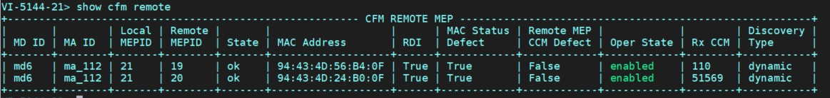

* Delete the MEP on Node 19. Check on Node 21 for remote meps.

no maintenance-domain 'md6' maintenance-association 'ma_112' maintenance-association-end-point ‘19’

On Node 21 – remote CFM me pis now showing up as failed:

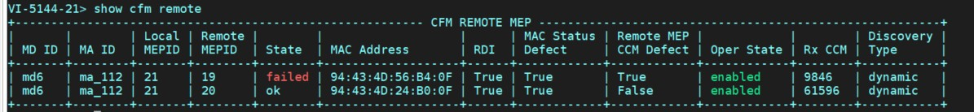

* Delete the remote CFM mep on Node 21. Note the deletion is on CLI and not in Config mode. cfm delete remote-mep md-id md6 ma-id ma_112 local-mep-id 21 remote-mep-id 19

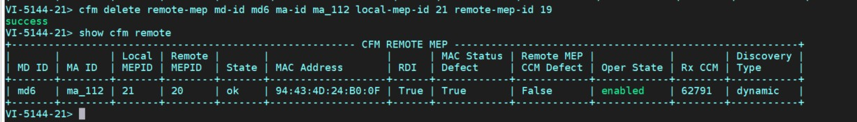

Test Case Results:

Passed: Yes No Verified by Date/Time Comments

* + 1. MEP Support on QinQ

**CFM/Y.1731 PDU’s with l2-transform on MEP and flow-point**

Outgoing CFM or y.1731 pdu’s can be untagged, single tagged or double tagged. Tag on packet is determined by l2-transform configured on the MEP and egress/ingress transform configured on the fp on which the MEP is created.

From 10.7.0 onwards, all types of ingress and egress transforms will be applicable to the UP

MEP. The packet format for all types of CFM PDU’s will be same as the data traffic.

Xform on MEP : Dual-Tagged

The input packet format with MEP transform applied from CFM application :

|  |  |  |  |
| --- | --- | --- | --- |
| **DA - SA** | **TAG1** | **TAG2** | **CFM PDU** |

Example configuration for l2-transfrom on the MEP(double-tagged).

***Objective:***

The objective of this test is to create UP MEP L2-transform with double tag.

***Topology:***

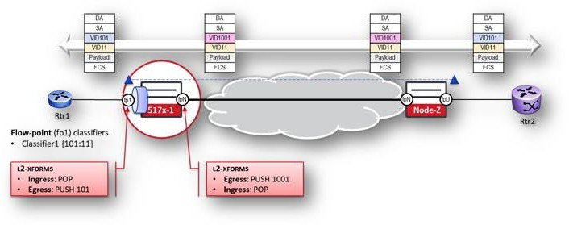

***Procedure:***

***Please note the configuration below highlights the configuration on one of the nodes 517x-1 from the above-mentioned topology***