* + 1. MEP Support on QinQ

**CFM/Y.1731 PDU’s with l2-transform on MEP and flow-point**

Outgoing CFM or y.1731 pdu’s can be untagged, single tagged or double tagged. Tag on packet is determined by l2-transform configured on the MEP and egress/ingress transform configured on the fp on which the MEP is created.

From 10.7.0 onwards, all types of ingress and egress transforms will be applicable to the UP

MEP. The packet format for all types of CFM PDU’s will be same as the data traffic.

Xform on MEP : Dual-Tagged

The input packet format with MEP transform applied from CFM application :

|  |  |  |  |
| --- | --- | --- | --- |
| **DA - SA** | **TAG1** | **TAG2** | **CFM PDU** |

Example configuration for l2-transfrom on the MEP(double-tagged).

***Objective:***

The objective of this test is to create UP MEP L2-transform with double tag.

***Topology:***

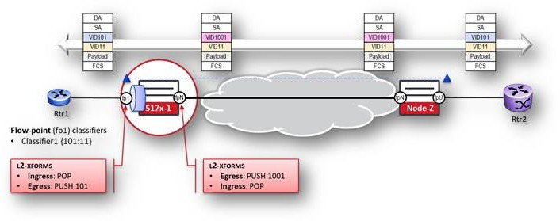

***Procedure:***

***Please note the configuration below highlights the configuration on one of the nodes 517x-1 from the above-mentioned topology***

**Test Case Results:**

Passed: Yes No Verified by Date/Time Comments