###### WebGUI – Create IP Interface

***Objective:***

Validate that IP interfaces can be created from WebGUI.

***Procedure:***

* Go to the browser and launch the WebGUI for the relevant node.

[https://x.x.x.x](https://x.x.x.x/)

default credentials : diag/ciena123

* Also on CLI, display the current L3 IP interfaces.

show ip interface brief

**5162-004> show ip int b**

+

IP INTERFACES BRIEF +

| | | | | Status | | Underlay |

| Interface | IP Address | VRF | Origin | Admin | Oper | Role | Binding |

+ + + + + + + + +

| mgmtbr0 | 10.181.35.223 | default | STATIC | UP | UP | management | - |

| remote | unassigned | default | - | UP | UP | management | remote-fd |

+ + + + + + + + +

* On the browser, go to Navigation Pane on left hand side, Interfaces Settings/L3 Interface/. Then on right hand side pane, L3 interfaces would be display. Click on top right hand corner “Create Interface” button.

* Fill in necessary information and Save.

* Validate on CLI that the loopback has been created.

show ip interface brief

**5162-004> show ip int b**

+

IP INTERFACES BRIEF +

| | | | | Status | | Underlay |

| Interface | IP Address | VRF | Origin | Admin | Oper | Role | Binding |

+ + + + + + + + +

| mgmtbr0 | 10.181.35.223 | default | STATIC | UP | UP | management | - |

| remote | unassigned | default | - | UP | UP | management | remote-fd |

**| lb1 | 62.62.62.223 | default | STATIC | UP | UP | data | - |**

**+ + + + + + + + +**

* Create another IP interface that is not loopback. Click on Create Interface button.
* Input the L3 Interface name and then click on Create FD link to create FD.
* On the Create FD page, click on Create FP to create the FP.
* On the Create FP page, click on Create Classifier to create classifiers necessary. Click Save when done.
* Once back on FP page, fill in necessary information and click Save. Similary for FD page.
* Back on L3 Interface, fill out necessary information. Click Save.

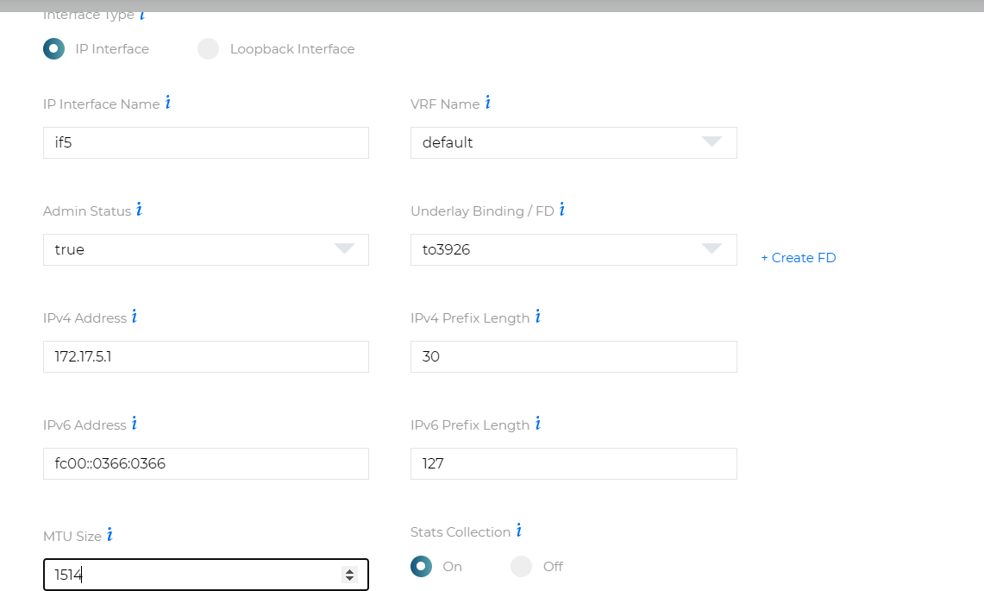

* Validate the interface got created by clicking on the newly created L3 IP interface.

* Validate the CLI that the interface has been created.

5162-004> show ip int b

+

IP INTERFACES BRIEF +

| | | | | Status | | Underlay |

| Interface | IP Address | VRF | Origin | Admin | Oper | Role | Binding |

+ + + + + + + + +

| mgmtbr0 | 10.181.35.223 | default | STATIC | UP | UP | management | - |

| remote | unassigned | default | - | UP | UP | management | remote-fd |

| lb1 | 62.62.62.223 | default | STATIC | UP | UP | data | - |

| if5 | 172.17.5.1 | default | STATIC | UP | UP | data | to3926 |

+ + + + + + + + +

* Validate that a ping to the remote interface in if5 will be successful. Please note, this is assuming the corresponding IP interface has already been created on the remote node.

5162-004> **ping ip dest 172.17.5.2**

Sending 5 ICMP Echos to 172.17.5.2, timeout is 1 second

Codes:

'!' - Success, '.' - Timeout, Type 'Ctrl+C' to abort

! seq_num = 1 RTT = 3.18 ms TTL = 255

! seq_num = 2 RTT = 3.30 ms TTL = 255

! seq_num = 3 RTT = 3.30 ms TTL = 255

! seq_num = 4 RTT = 3.43 ms TTL = 255

! seq_num = 5 RTT = 3.42 ms TTL = 255 Success Rate is 100.00 percent (5/5) Round-trip min/avg/max = 3.18/3.33/3.43 5162-004>

Test Case Results:

Passed: Yes No Verified by Date/Time Comments