Add a frame to COS map to a flow point

Objective:
Objective is to verify binding of a frame to COS map to an ingress flow point

In this section, following the steps will configure the parts of the picture highlighted in red.


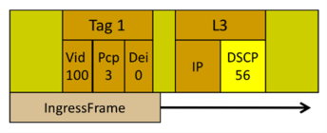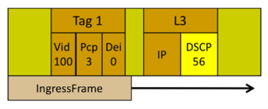
PCP COS Color COS Color PCP

Forwarding Domain FD1
Flow Point Flow Point
FP1 FP2
 | Port 1 |  | Port 2

Procedure:
- Go to the configuration terminal
  - config

- Enter the following command
fps fp FP1 logical-port 1 fd-name FD1
frame-to-cos-map FTC1 classifier-list VLAN100 stats-collection on

- Go back out of configuration terminal
# exit

- Check if the frame to COS map is associated with the flow point:
  - show flow-point FP1

You should see something like the following:
name FP1
fd-name FD1 logical-port 1
mtu-size 2000
frame-to-cos-map FTC1
classifier-list VLAN100
stats-collection on

Test Case Results:
Passed: Yes No Verified by Date/Time Comments

