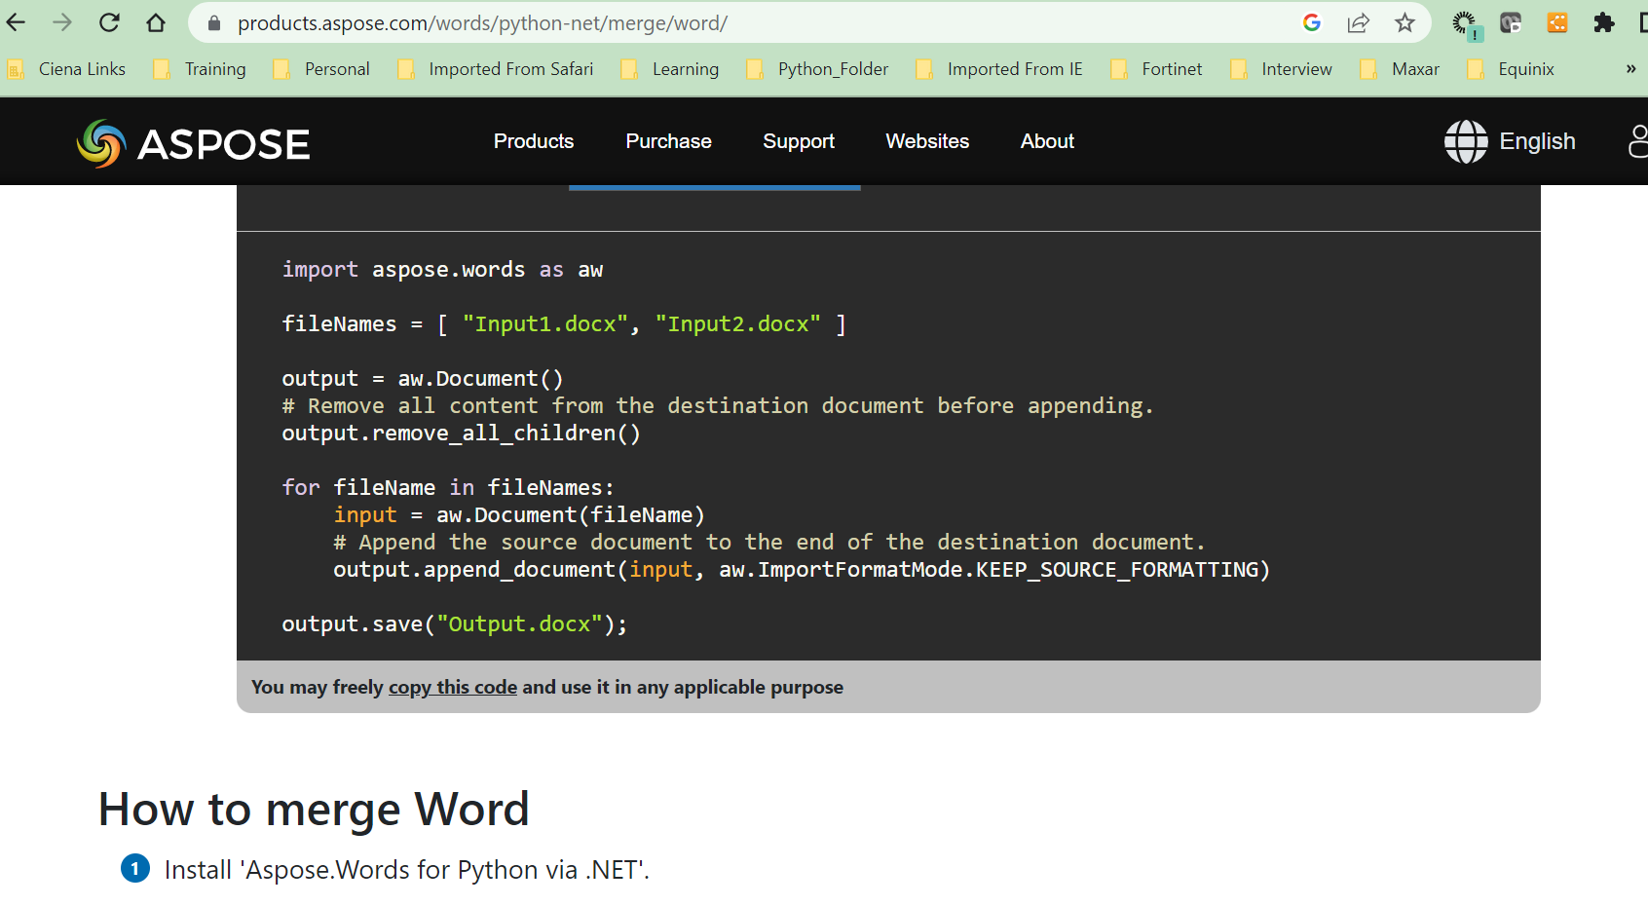

**Evaluation Only. Created with Aspose.Words. Copyright 2003-2022 Aspose Pty Ltd.**

|  |  |  |  |  |
| --- | --- | --- | --- | --- |
| 12-21-  2020 | Final SAOS 10.5.1 | Reviewed and made edits according to review feedback. | Abhishek Jain/Manoj Sharma/Jagan Kumar Veluchamy/Jean-Luc Dupont/Kevin Estabrooks/Vineeth/ Jagannath  Rajamannar/Tina Wu | Approver : Nathan Sivanathan |
| 6-28-2021 | Final SAOS 10.6 | Reviewed and made edits according to review feedback. | AbhishekJain/Manoj Sharma/JaganKumar Veluchamy/Jean-Luc Dupont/Kevin Estabrooks/Vineeth/ Jagannath Rajamannar/Tina  Wu/Izack Vail | Approver : Nathan Sivanathan |
| 9-9-2021 | Draft SAOS 10.6.1 | Added additional  testcases for SAOS 10.6.1 | Kevin Estabrooks/Soukaina Zahidi/Tina Wu/Izack Vail | Approver: Nathan Sivanathan |
| 12-3-2021 | Final SAOS 10.7.0 | Reviewed and made edits according to review feedback. | AbhishekJain/Manoj Sharma/JaganKumar Veluchamy/Jean-Luc Dupont/Kevin Estabrooks/Vineeth  /Jagannath Rajamannar/Tina  Wu/Hicham/Izack Vail | Approver : Nathan Sivanathan |
| 5-18-2022 | Draft SAOS 10.7.1 | Added additional testcases for SAOS 10.7.1 | Abhishek Jain/Manoj Sharma/Jagan Kumar Veluchamy/Kevin Estabrooks/Vineeth/Hars h/Jagannath Rajamannar/Tina Wu/Soukaina Zahidi/Izack  Vail | Approver: Nathan Sivanathan |