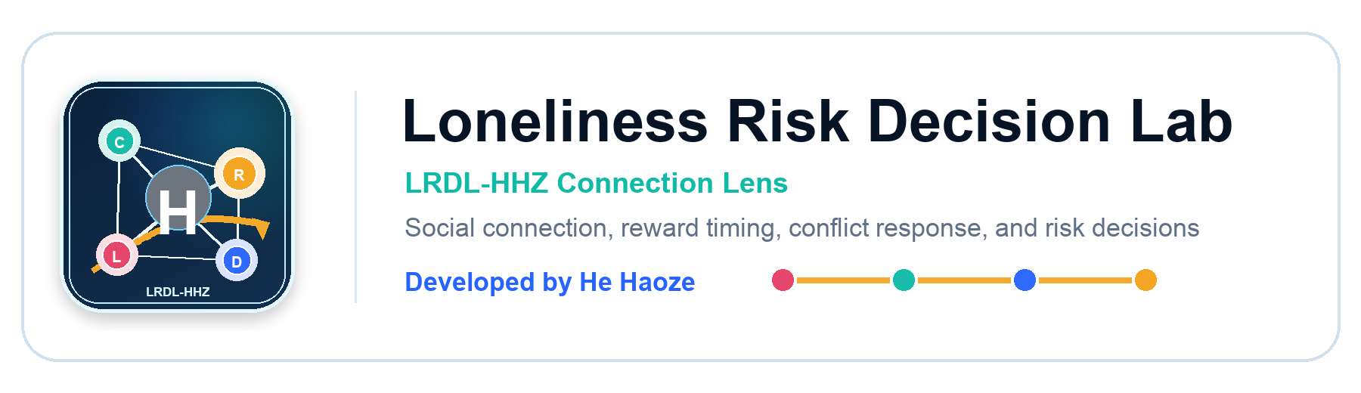
QUANTITATIVE PSYCHOLOGY AND STATISTICS REPORT
Loneliness, Social Connection, and Risk Decisions
A research-product system for measuring how perceived isolation relates to immediate rewards, impulsive spending, risky choice, and conflict response.
Developed by He Haoze (何昊泽)
Field | Value
Developer | He Haoze (何昊泽)
Logo / IP mark | LRDL-HHZ Connection Lens
Target population | Late adolescents and emerging adults, ages 16-24
Data status | 420 synthetic pilot rows plus separated live submissions
Current public survey | https://haobosun940-crypto.github.io/loneliness-risk-decision-lab/survey
GitHub repository | https://github.com/haobosun940-crypto/loneliness-risk-decision-lab
Permanent deployment path | https://dashboard.render.com/blueprint/new?repo=https://github.com/haobosun940-crypto/loneliness-risk-decision-lab

Abstract
This report presents a complete research design and pilot analysis for the question of whether loneliness predicts risk-oriented decision making. The study boundary combines social psychology, behavioral decision science, and applied statistics. The predictor is perceived loneliness, interpreted alongside social connectedness as a possible buffer. The outcome is a composite Risk Decision Index built from delay-choice tasks, impulsive-spending items, high-risk choices, and conflict-response scenarios. The system includes a public website, survey route, scoring API, SQLite database, statistical dashboard, PDF paper, Word report, Excel workbook, slide deck, video asset, and reproducible source repository.

Research Boundary
The research follows the boundary formula of broad field plus specific population plus specific variable plus specific outcome plus specific context. This keeps the topic narrow enough for quantitative analysis while still preserving a clear psychological mechanism.
Boundary element | Operational definition
Broad field | Social psychology, behavioral decision science, and applied statistics
Specific population | Late adolescents and emerging adults in school, college, and early-career peer networks
Specific variable | Loneliness score with social connectedness as a theoretically important buffer
Specific outcome | Risk Decision Index, scaled from 0 to 100
Specific context | Digitally mediated peer communication and real-world social contact

Theory and Hypotheses
Loneliness is treated as perceived social isolation rather than simple physical solitude. The psychological mechanism is that perceived isolation may increase social threat monitoring, urgency, rejection sensitivity, and short-horizon regulation. Those mechanisms can plausibly shift reward timing, spending, risk tolerance, and conflict interpretation.
- H1: Higher loneliness will predict a higher Risk Decision Index.
- H2: Social connectedness will negatively predict the Risk Decision Index and partially buffer loneliness.
- H3: The loneliness association will be strongest for immediate reward and impulsive spending.
- H4: Higher loneliness will be associated with more defensive conflict choices, especially withdrawal or reactive replies.

Measurement and Experiment Design
The questionnaire combines self-report indicators and short behavioral choice tasks. The self-report measures estimate loneliness, connection, digital contact, offline contact, stress, and sleep. The tasks estimate immediate-reward bias, impulsive spending, high-risk choice, and defensive conflict response. Each construct is converted into a 0-100 score so the dashboard, workbook, and model outputs can be compared on a common scale.
Construct | Measurement role
Loneliness Index | Loneliness Index (custom 7-item short battery, 0-100)
Social Connection Index | Social Connection Index (custom 6-item behavioral/perceived support battery, 0-100)
Immediate Reward Bias | Immediate Reward Bias (6 binary delay-choice tasks, 0-100)
Impulsive Spending Score | Impulsive Spending Score (5 Likert items, 0-100)
High-Risk Choice Score | High-Risk Choice Score (5 binary choice tasks, 0-100)
Conflict Defense Score | Conflict Defense Score (5 conflict-response scenarios, 0-100)
Risk Decision Index = .35*Reward + .25*Spending + .25*Risk + .15*Conflict | Risk Decision Index = .35*Reward + .25*Spending + .25*Risk + .15*Conflict

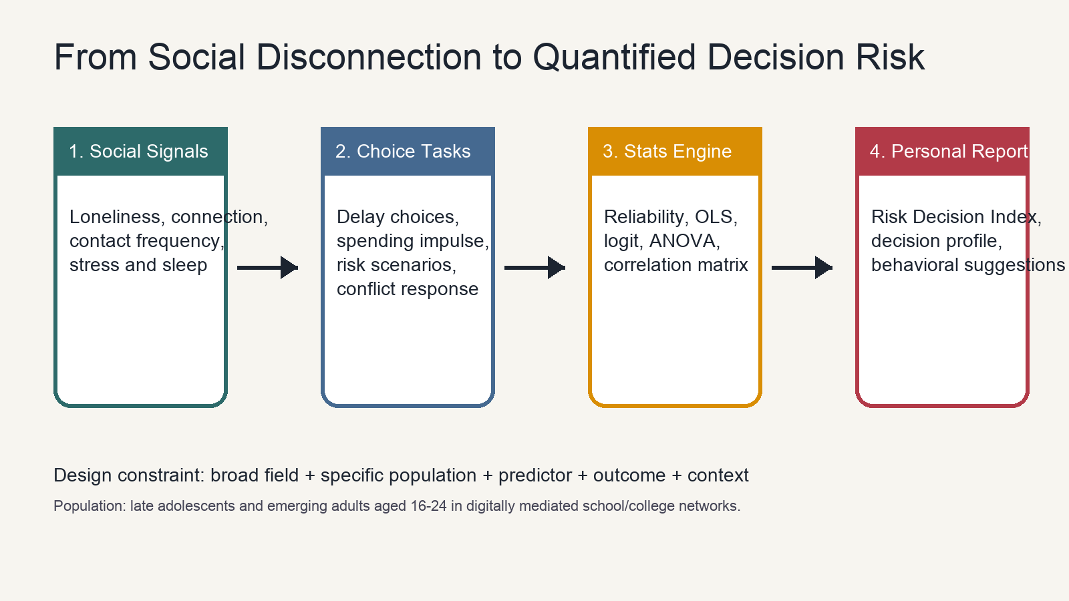
Figure 1. Research system workflow from question boundary to questionnaire, scoring, database, models, and reporting.

Statistical Analysis Plan
The analysis has four layers: reliability, correlation, ANOVA, and regression. Reliability checks whether the custom loneliness and social-connection batteries are internally coherent. Correlations describe zero-order relationships. ANOVA tests whether low, moderate, and high loneliness groups differ in Risk Decision Index. OLS regression estimates whether loneliness remains associated with risk after social connection, stress, age, sleep, platform sessions, and the loneliness-by-connection interaction are included.
Analysis | Purpose
Cronbach alpha | Check internal consistency of psychological item batteries
Correlation matrix | Show pairwise associations among constructs
ANOVA | Compare Risk Decision Index across loneliness tertiles
OLS regression | Estimate the controlled association between loneliness and risk
Logistic tendency model | Model top-quartile risk classification as an odds outcome

Results
The synthetic pilot shows strong internal consistency: alpha=0.911 for the loneliness battery and alpha=0.892 for the social-connection battery. ANOVA yields F(2, 417)=258.59, eta squared=0.554, and permutation p=0.0007. In this demonstration dataset, the group difference is large and directionally consistent with the hypothesis.
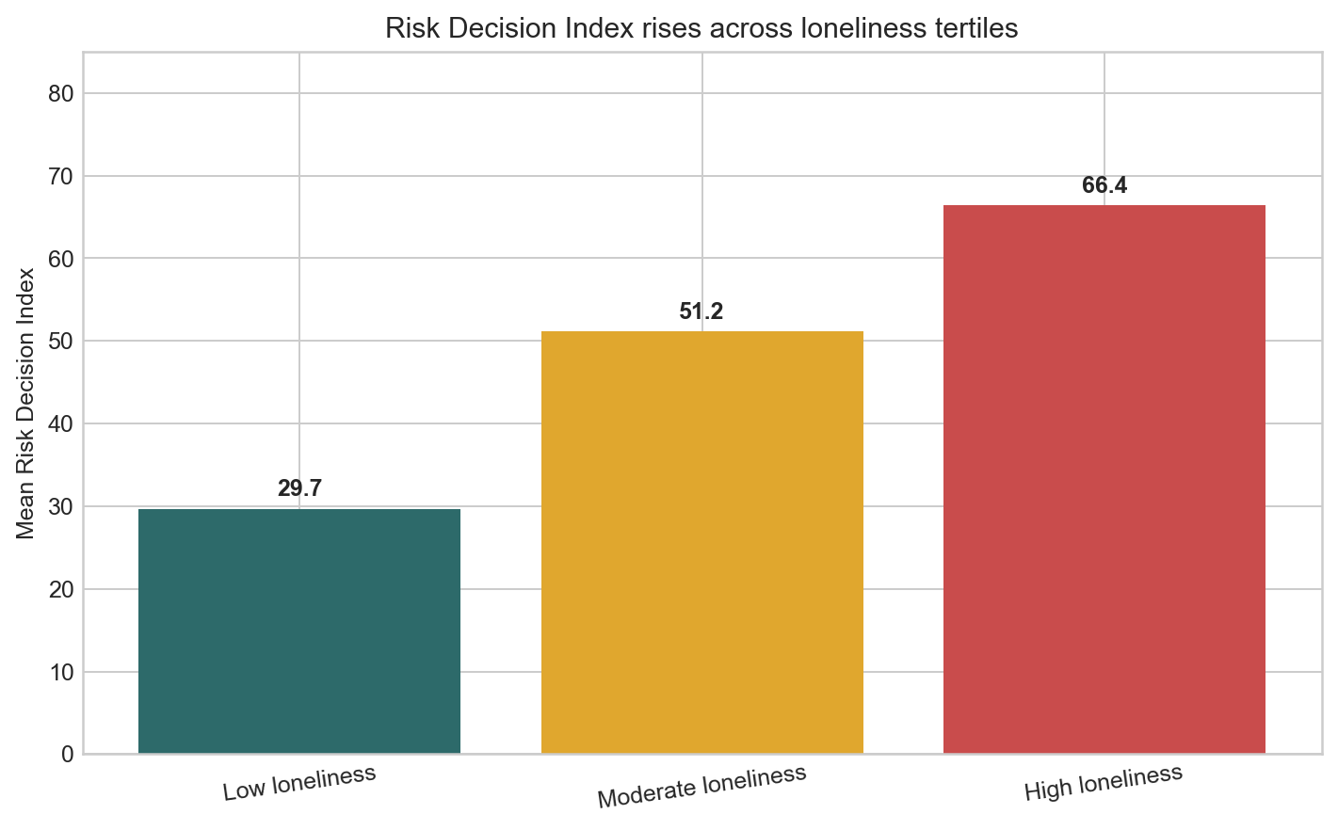
Figure 2. Risk Decision Index rises across low, moderate, and high loneliness groups.
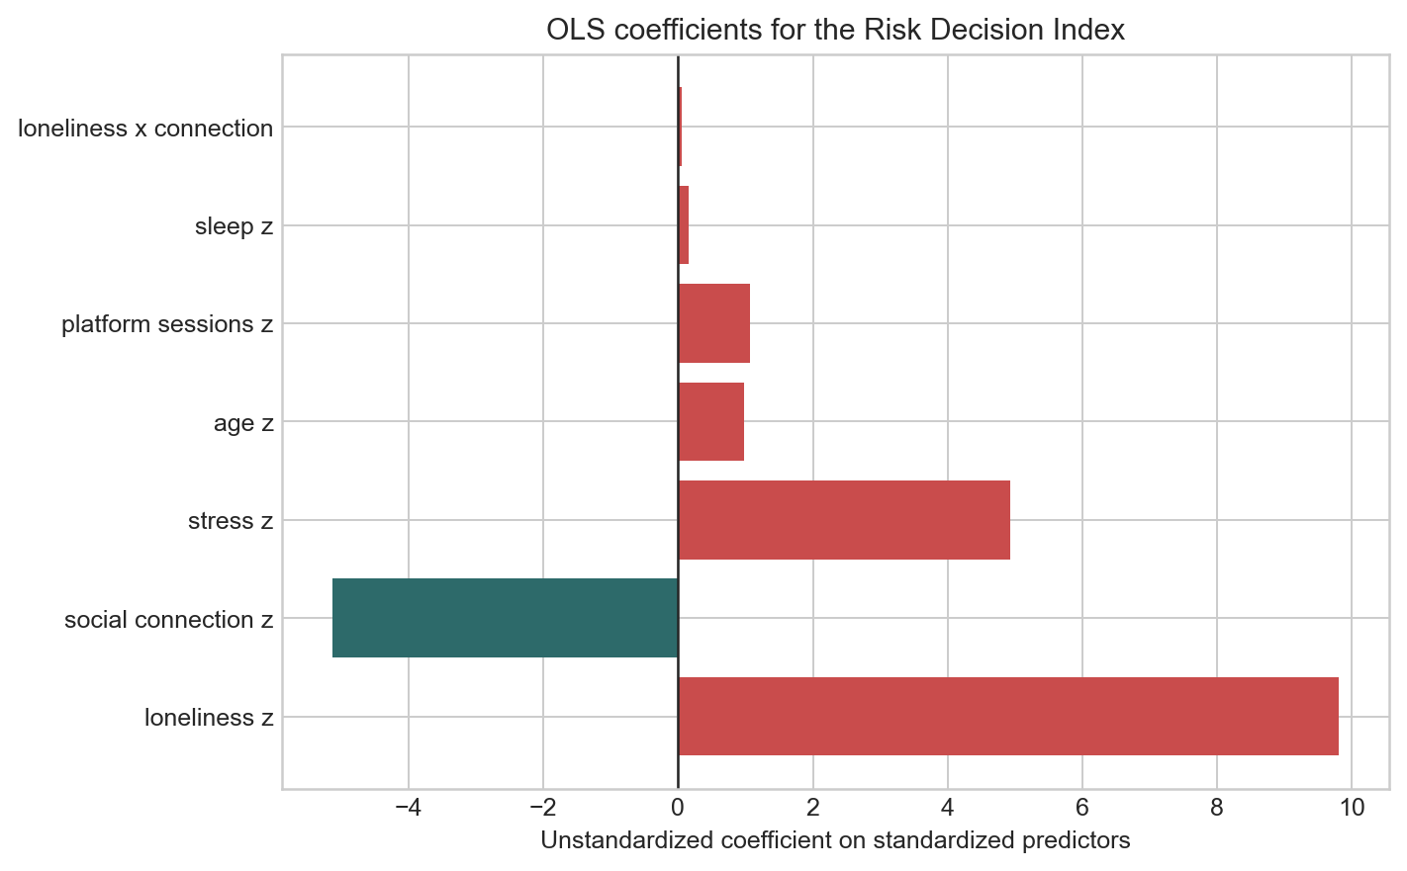
Figure 3. OLS coefficients separate loneliness from social connection, stress, and controls.
Term | Estimate | SE | p approx
Intercept | 48.07 | 0.59 | <.001
loneliness z | 9.81 | 0.79 | <.001
social connection z | -5.13 | 0.63 | <.001
stress z | 4.94 | 0.67 | <.001
age z | 0.98 | 0.51 | 0.054
platform sessions z | 1.07 | 0.59 | 0.071
sleep z | 0.15 | 0.65 | 0.814
loneliness x connection | 0.05 | 0.53 | 0.921

Interpreting the Visualizations
The charts should be read as evidence tools, not decoration. The ANOVA bar chart communicates group separation. The regression coefficient chart communicates controlled association. The scatterplot communicates individual-level variation around the trend, which is important because psychological prediction is probabilistic rather than deterministic.
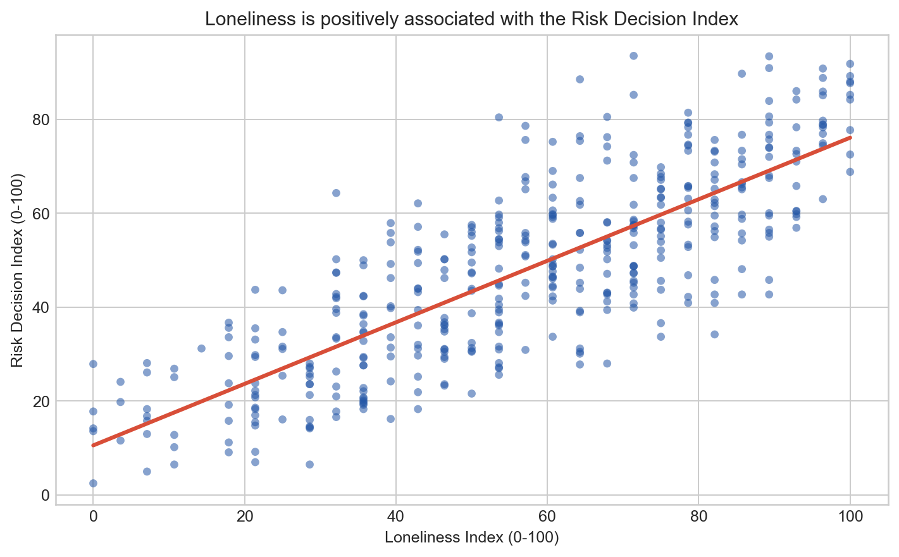
Figure 4. Individual-level scatterplot showing the loneliness-risk pattern and residual variation.
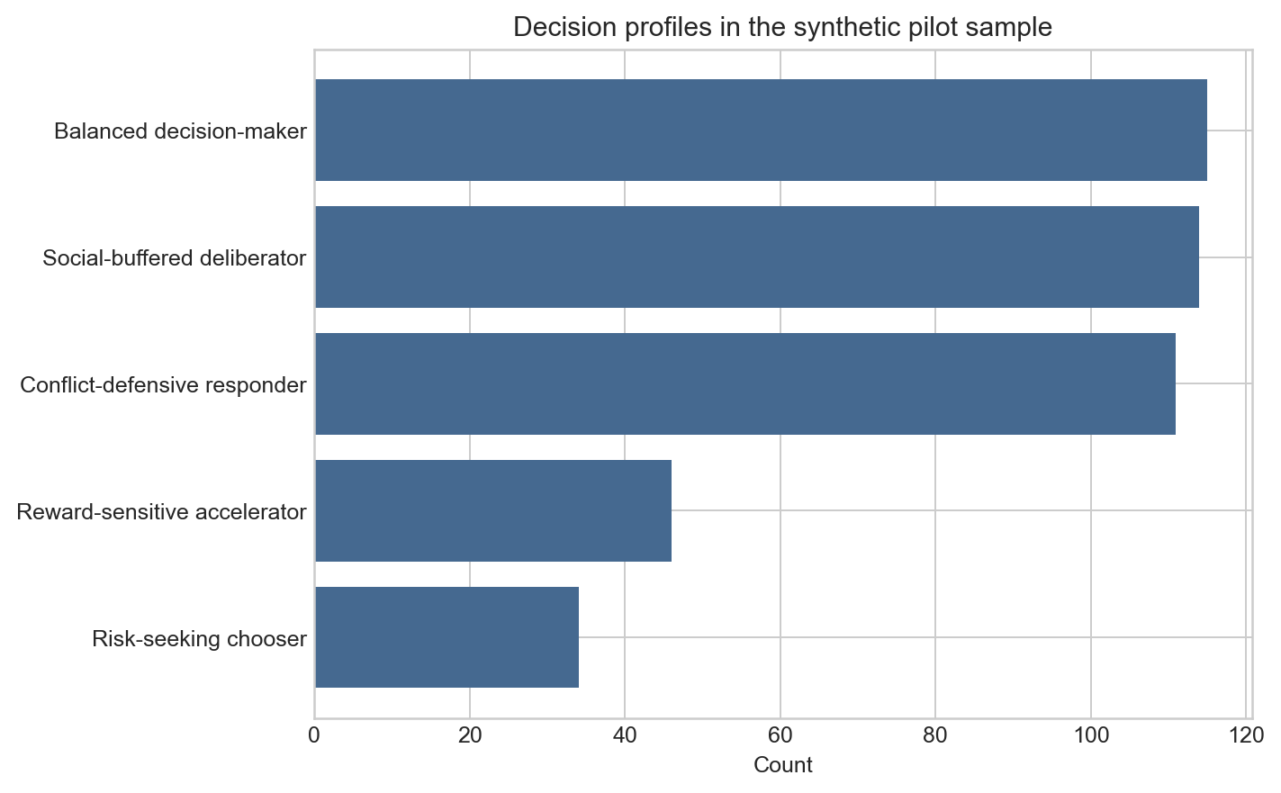
Figure 5. Decision-type labels summarize behavioral tendency and are not clinical categories.

Public Website and Data Pipeline
The website is designed as the live research instrument. Participants enter the survey at /survey, receive a personal risk-decision profile, and can submit the response into SQLite. The dashboard route shows summary statistics, recent live submissions, CSV export, and model outputs. The data pipeline keeps synthetic pilot rows and live submissions separated so demonstration data cannot be mistaken for actual human-subject observations.
Route or artifact | Function
/survey | Public questionnaire and personal report generation
/dashboard | Live data preview, QR sharing, CSV export, and statistical cockpit
/research | Workflow, model outputs, ANOVA, and interpretation
/downloads | PDF, Word, PPTX, workbook, video, CSV export, and full package
GitHub | https://github.com/haobosun940-crypto/loneliness-risk-decision-lab
Render Blueprint | https://dashboard.render.com/blueprint/new?repo=https://github.com/haobosun940-crypto/loneliness-risk-decision-lab

Ethics, Data Disclosure, and Limitations
- The seeded pilot rows are synthetic demonstration data, not collected human-subject observations.
- Live submissions should be used only with clear consent language and minimal identifying information.
- The Risk Decision Index is educational and statistical; it is not a clinical diagnosis.
- The model is cross-sectional and cannot prove that loneliness causes risk decisions.
- A stronger next study should collect a real sample, predefine inclusion criteria, and rerun reliability, ANOVA, and regression on live data only.

Conclusion
This project demonstrates how a broad psychological topic can become a rigorous quantitative research system. The core contribution is the integration of theory, measurement, database design, live survey collection, statistical modeling, and publishable reporting. In the synthetic pilot, loneliness is positively associated with Risk Decision Index, while social connectedness is negatively associated with risk. The next scientific step is to collect real responses through the public survey, preserve transparent data-source labels, and update the report when live data are sufficient for empirical claims.

References and Public Links
Current public survey: https://haobosun940-crypto.github.io/loneliness-risk-decision-lab/survey
GitHub repository: https://github.com/haobosun940-crypto/loneliness-risk-decision-lab
Render Blueprint: https://dashboard.render.com/blueprint/new?repo=https://github.com/haobosun940-crypto/loneliness-risk-decision-lab

1. Russell, D. W. (1996). UCLA Loneliness Scale (Version 3): Reliability, validity, and factor structure. Journal of Personality Assessment, 66(1), 20-40. URL: https://doi.org/10.1207/s15327752jpa6601_2
2. Hughes, M. E., Waite, L. J., Hawkley, L. C., & Cacioppo, J. T. (2004). A short scale for measuring loneliness in large surveys. Research on Aging, 26(6), 655-672. URL: https://doi.org/10.1177/0164027504268574
3. Hawkley, L. C., & Cacioppo, J. T. (2010). Loneliness matters: A theoretical and empirical review of consequences and mechanisms. Annals of Behavioral Medicine, 40(2), 218-227. URL: https://doi.org/10.1007/s12160-010-9210-8
4. Cacioppo, J. T., & Hawkley, L. C. (2009). Perceived social isolation and cognition. Trends in Cognitive Sciences, 13(10), 447-454. URL: https://doi.org/10.1016/j.tics.2009.06.005
5. Lee, R. M., Draper, M., & Lee, S. (2001). Social connectedness, dysfunctional interpersonal behaviors, and psychological distress: Testing a mediator model. Journal of Counseling Psychology, 48(3), 310-318. URL: https://doi.org/10.1037/0022-0167.48.3.310
6. Blais, A. R., & Weber, E. U. (2006). A Domain-Specific Risk-Taking (DOSPERT) scale for adult populations. Judgment and Decision Making, 1(1), 33-47. URL: https://doi.org/10.1017/S1930297500000334
7. Kirby, K. N., Petry, N. M., & Bickel, W. K. (1999). Heroin addicts have higher discount rates for delayed rewards than non-drug-using controls. Journal of Experimental Psychology: General, 128(1), 78-87. URL: https://doi.org/10.1037/0096-3445.128.1.78
8. Rook, D. W., & Fisher, R. J. (1995). Normative influences on impulsive buying behavior. Journal of Consumer Research, 22(3), 305-313. URL: https://doi.org/10.1086/209452
9. Duclos, R., Wan, E. W., & Jiang, Y. (2013). Show me the honey! Effects of social exclusion on financial risk-taking. Journal of Consumer Research, 40(1), 122-135. URL: https://doi.org/10.1086/668900
10. Mead, N. L., Baumeister, R. F., Stillman, T. F., Rawn, C. D., & Vohs, K. D. (2011). Social exclusion causes people to spend and consume strategically in the service of affiliation. Journal of Consumer Research, 37(5), 902-919. URL: https://doi.org/10.1086/656667
11. Office of the U.S. Surgeon General. (2023). Our Epidemic of Loneliness and Isolation: The U.S. Surgeon General's Advisory on the Healing Effects of Social Connection and Community. URL: https://www.hhs.gov/sites/default/files/surgeon-general-social-connection-advisory.pdf
12. Our World in Data. Social Connections and Loneliness. URL: https://ourworldindata.org/social-connections-and-loneliness
13. Centers for Disease Control and Prevention. Youth Risk Behavior Surveillance System (YRBSS). URL: https://www.cdc.gov/yrbs/

