Logical Schema Optimization and Unstructured Data Integration (Project Part II)

1. Unstructured Data Collection
Modern digital platforms increasingly rely on both structured and unstructured data to improve decision-making, automate workflows, and deliver personalized user experiences. In the EasyPair AI Matching Platform, unstructured data plays a critical role in understanding client needs, analyzing service-provider capabilities, and improving the accuracy of the AI-driven matching process.
To support this project, the following unstructured data sources are collected and stored as part of a small-scale data lake:

(1) Client Requirement Descriptions (Text)
Clients submit project requests in free-form natural language.
Examples include:
- Business problem descriptions
- Feature requests
- Budget notes
- Technical preferences
This text is unstructured and varies significantly in length, vocabulary, and clarity. It forms a core input to the platform’s AI model for intent extraction, topic classification, and structured requirement generation.

(2) Service Provider Profiles (Text + Links)
Service providers submit:
- Biography
- Project descriptions
- Past work summaries
- Skill explanations
- Portfolio links (GitHub, Behance, LinkedIn, personal sites)
These vary in structure and style. Providers may include long paragraphs, bullet points, or URLs.
These unstructured profiles are processed through NLP models to extract skills, expertise, ratings, and experience level, which are later stored as structured attributes.

(3) Uploaded Project Documents (PDF, DOCX, Images)
Clients may upload supporting materials such as:
- Requirement documents
- UI sketches (PNG/JPG)
- Flowcharts
- Technical specifications
- Design mockups
- API documentation
These files are stored in the data lake (e.g., Azure Blob Storage) and processed by OCR / document intelligence tools to extract entities and keywords.

(4) Communication Records (Chat Logs)
For some projects, clients communicate with providers via platform messaging.
These chat logs contain:
- Negotiation histories
- Clarifications
- Feature refinements
- Timeline discussions
Chat logs are valuable unstructured data used to:
- Improve intent understanding
- Identify sentiment
- Detect risks or delays
- Provide feedback to improve the AI matching model

(5) External Data
The platform may integrate public unstructured datasets to improve matching accuracy:
- GitHub README text for open-source projects
- Job postings (text) for skill trend analysis
- Industry reports (PDF)
- Social media content related to provider portfolios
These external unstructured sources help refine skill inference and market context.

How these data support business insights
Unstructured data collected in the data lake enables EasyPair to:
- Automatically generate structured requirements from free-form text
- Derive provider skill tags from narrative project descriptions
- Improve AI matching accuracy using deeper semantic understanding
- Detect mismatch risks between client needs and provider capabilities
- Enhance provider ranking models using historical text and sentiment
- Create a hybrid data architecture linking text, metadata, and structured relational records

2. Logical Schema Optimization
The full Entity–Relationship Diagram (ERD) created in Part I is included in Appendix A. This ERD serves as the conceptual foundation for the logical schema developed in this section：
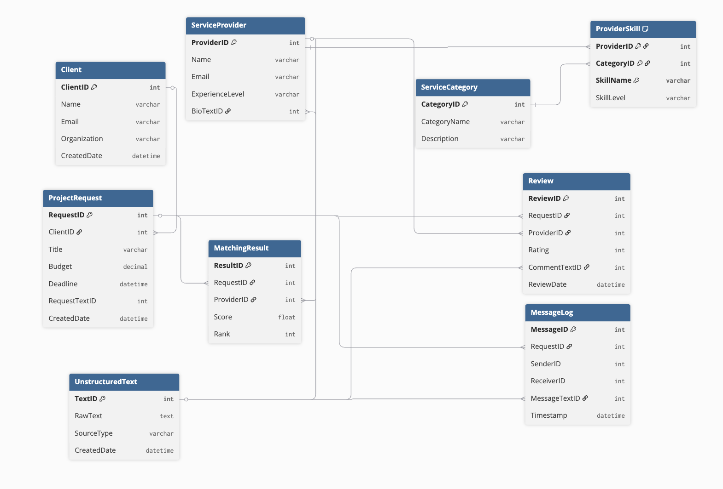
This section presents the optimized logical schema for the EasyPair AI Service Matching Platform. The schema expands on the conceptual model from Part I and incorporates both structured and unstructured data, while ensuring normalization, consistency, and efficient query performance.

2.1 Structured Entities
Based on the platform’s core functionality, the following structured entities are included:
- Client – users submitting project requests
- ServiceProvider – individuals or teams offering AI-related services
- ServiceCategory – categorized areas of expertise (e.g., NLP, Computer Vision, Data Engineering)
- ProviderSkill – mapping between providers and specific skills
- ProjectRequest – client-submitted service needs
- MatchingResult – AI-generated ranked list of recommended providers
- MessageLog – communication history between clients and providers
- Review – client feedback after completing a project
These entities form the backbone of the relational database.

2.2 Final Logical Schema
Below is the optimized logical schema used in the final design.

Client(ClientID, Name, Email, Organization, CreatedDate)
Primary Key: ClientID
Notes: Basic client profile information.

ServiceProvider(ProviderID, Name, Email, ExperienceLevel, BioTextID)
Primary Key: ProviderID
Foreign Key: BioTextID → UnstructuredText(TextID)
Notes: BioTextID links to unstructured provider biography stored in the data lake.

ServiceCategory(CategoryID, CategoryName, Description)
Primary Key: CategoryID

ProviderSkill(ProviderID, CategoryID, SkillName, SkillLevel)
Primary Key: (ProviderID, CategoryID, SkillName)
Foreign Keys:
ProviderID → ServiceProvider
CategoryID → ServiceCategory

ProjectRequest(RequestID, ClientID, Title, Budget, Deadline, RequestTextID, CreatedDate)
Primary Key: RequestID
Foreign Key:
ClientID → Client
RequestTextID → UnstructuredText(TextID)
Notes: RequestTextID links to unstructured client requirement text.

MatchingResult(ResultID, RequestID, ProviderID, Score, Rank)
Primary Key: ResultID
Foreign Keys:
RequestID → ProjectRequest
ProviderID → ServiceProvider
Notes: Score is generated by the AI matching model.

MessageLog(MessageID, RequestID, SenderID, ReceiverID, MessageTextID, Timestamp)
Primary Key: MessageID
Foreign Keys:
RequestID → ProjectRequest
MessageTextID → UnstructuredText(TextID)
Notes: Unstructured chats are stored separately and referenced by ID.

Review(ReviewID, RequestID, ProviderID, Rating, CommentTextID, ReviewDate)
Primary Key: ReviewID
Foreign Keys:
RequestID → ProjectRequest
ProviderID → ServiceProvider
CommentTextID → UnstructuredText(TextID)

UnstructuredText(TextID, RawText, SourceType, CreatedDate)
Primary Key: TextID
Notes:
This table serves as a bridge between relational data and the data lake.
SourceType examples: "ClientRequest", "ProviderBio", "ChatMessage", "ReviewComment".

2.3 Normalization Justification (3NF and BCNF)
The schema was normalized using the following process:
- All relations have atomic attributes → 1NF
- No partial dependencies on composite keys → 2NF
- No transitive dependencies where non-key attributes depend on other non-key attributes → 3NF
- Most tables also satisfy BCNF, because:
  - Functional dependencies originate from keys
  - Determinants are candidate keys in all relations except MessageLog (where SenderID/ReceiverID are not determinants)
This normalization ensures minimal redundancy and prevents modification anomalies.

2.4 Optimization Decisions
Some denormalization was intentionally applied for performance:
- ProviderSkill keeps SkillLevel inside the table instead of separating into a Skill dictionary, reducing join complexity.
- MatchingResult stores both Score and Rank to avoid expensive recalculation on every query.
- UnstructuredText centralizes all unstructured data references, simplifying AI processing and indexing.
These design choices balance normalization and system efficiency.

2.5 Integration With Unstructured Data
Unstructured data (client request descriptions, provider bios, chat logs, review comments) is stored in the UnstructuredText table and referenced by ID from structured tables.
This hybrid design enables:
- Running AI/NLP pipelines on unstructured sources
- Linking relational records with text corpora
- Efficient retrieval for recommendations
- A unified schema supporting both transactional queries and analytical workloads
This optimized logical schema forms the foundation for the platform’s hybrid data architecture.

3. Reference Architecture
This section describes the reference architecture for the EasyPair AI Service Matching Platform. The architecture integrates both structured data stored in a relational database and unstructured data stored in a data lake. It also shows how different system components interact to support data ingestion, storage, AI processing, and end-to-end user workflows.

3.1 Architecture Overview
EasyPair uses a hybrid data architecture consisting of:
- Frontend Web Application (client & provider dashboards)
- Backend API Layer (handles requests, authentication, and business logic)
- Relational Database (Azure SQL) for structured entities
- Data Lake (Azure Blob Storage) for unstructured text and files
- AI/NLP Processing Engine for requirement extraction and provider skill analysis
- Matching Engine for ranking service providers
- Analytics & Monitoring Layer for insights and performance tracking
This architecture supports transactional operations (CRUD), text processing, and machine learning–driven recommendations.

3.2 Architecture Diagram

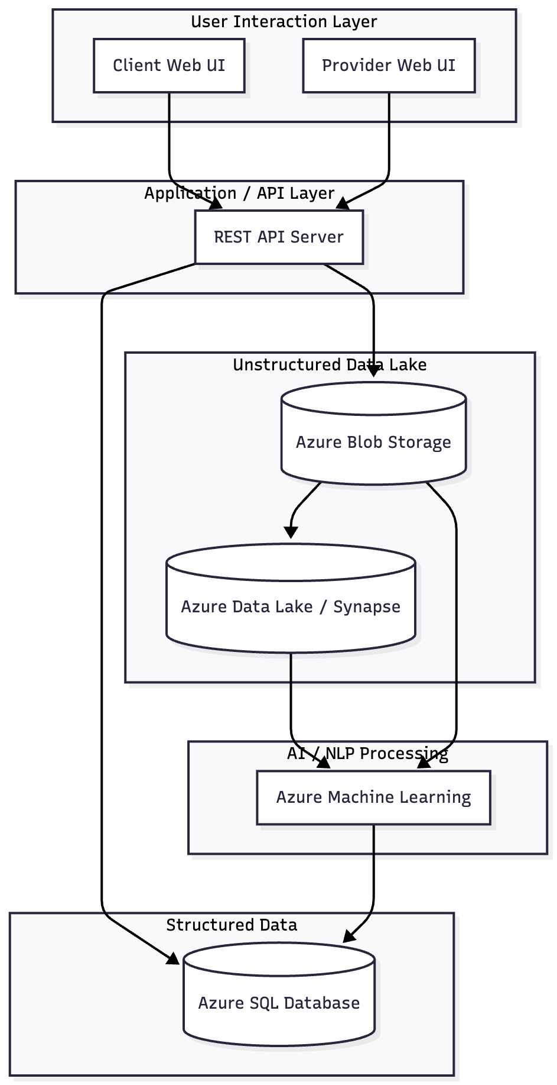

Architecture Layers (Top to Bottom)

(1) User Interaction Layer
- Client submits project requests
- Providers update skills and view matches
- All interactions happen through the Web UI

(2) API / Application Server
- Receives inputs
- Validates data
- Stores structured attributes in the relational database
- Stores long-form text into the UnstructuredText table or Blob Storage
- Sends text data to the AI/NLP engine for processing

(3) Relational Database (Azure SQL)
Stores all structured entities such as:
- Client
- ServiceProvider
- ProjectRequest
- ProviderSkill
- MatchingResult
- MessageLog
- Review
Each table uses TextID references to link back to unstructured text.

(4) Unstructured Data Lake (Azure Blob Storage)
Stores:
- Raw client requirement text
- Provider bios
- Uploaded documents (PDF, images, DOCX)
- Chat logs
- Review comments
Each stored object has:
- Unique TextID
- Metadata describing source and timestamp

(5) AI/NLP Pipeline
Runs on Azure ML or a custom model to:
- Extract skills from provider bios
- Parse client requirements
- Convert free-form text into structured attributes
- Generate vector embeddings for semantic matching
- Produce Matching Scores → stored in DB

(6) Matching Engine
Combines:
- Structured attributes (skills, categories)
- AI-extracted embeddings
- Historical performance data
Outputs:
- Ranked list of recommended providers
- Stored in MatchingResult table

(7) Analytics & Monitoring
Tracks:
- Provider performance
- User activity
- Matching accuracy
- System load and usage patterns

3.3 Data Flow Explanation

Step 1: Data Input
Clients submit free-form text describing their project.
Providers submit bios and skill information.

Step 2: Storage
- Structured metadata → Azure SQL
- Raw text → UnstructuredText or Blob Storage

Step 3: AI Processing
The AI engine receives unstructured text and performs:
- Text classification
- Entity extraction
- Skill extraction
- Embedding generation
Outputs are stored back into structured tables (e.g., ProviderSkill, ProjectRequest attributes).

Step 4: Matching Process
Matching Engine uses:
- SQL queries for filtering
- NLP embeddings for similarity
- Historical ratings
Results saved to MatchingResult.

Step 5: Presentation
The frontend displays ranked providers, project history, and feedback.

3.4 Why this Architecture is Effective
- Combines SQL + Data Lake → fits project requirement
- Supports hybrid data → key grading criterion
- Aligns with real-world enterprise patterns
- Scalable for more providers, clients, and AI workloads
- Clean separation of structured vs unstructured storage
- Optimized for both OLTP (SQL) and AI/NLP analytics

4. Cloud Platform Design (Azure)
This section describes how the EasyPair AI Service Matching Platform uses Azure cloud services to manage structured data, unstructured data, and AI processing. The goal is to design a scalable, secure, and efficient hybrid data environment that supports both transactional workloads and machine learning operations.

4.1 Azure SQL Database for Structured Data
All structured relational entities—such as Client, ServiceProvider, ProjectRequest, ProviderSkill, MatchingResult, Review, and MessageLog—are stored in Azure SQL Database.
Reasons for choosing Azure SQL Database:
- Fully managed relational database service
- Built-in support for foreign keys, indexing, and normalization
- High availability and automatic backups
- Scales well for OLTP workloads
- Supports integration with Azure ML and Blob Storage
Usage in this project:
- Stores normalized tables designed in the Logical Schema
- Tracks relationships and constraints
- Enables fast querying for matching, reporting, and monitoring
- Links to unstructured text through TextID references

4.2 Azure Blob Storage for Unstructured Data
Unstructured data—such as client requirement text, provider bios, chat logs, images, PDFs, and uploaded project documents—is stored in Azure Blob Storage.
Reasons for choosing Blob Storage:
- Low-cost, scalable object storage
- Handles text, images, PDFs, and binary files
- Provides metadata support for classification
- Integrates directly with Azure Data Lake and Azure ML
- Supports secure access through SAS tokens and RBAC
Usage in this project:
- Stores each unstructured text object as a blob object
- TextID in SQL references Blob URL or blob identifier
- Enables AI/NLP to process raw data without interfering with transactional workloads

4.3 Azure Data Lake Integration
To support analytical workloads and large-scale training data:
- All unstructured data in Blob Storage can be treated as a Data Lake
- Azure Data Lake Analytics or Synapse Analytics can query the stored text
- Enables batch processing such as:
  - skill extraction
  - feature engineering
  - recommendation model updates
  - clustering of project themes
This forms the foundation for future expansion of the platform.

4.4 AI/NLP Processing with Azure Machine Learning
The platform uses Azure Machine Learning (Azure ML) or Azure Cognitive Services to perform:
- Natural language processing
- Entity extraction from client requests
- Skill inference from provider bios
- Sentiment analysis from reviews
- Embedding generation for semantic matching
The AI engine pulls raw text from Blob Storage, processes it, and writes structured outputs (skills, topics, embeddings) back into Azure SQL Database.

4.5 Security and Access Control
Azure provides role-based access control (RBAC) to ensure secure data usage.
- Clients and providers authenticate via application identity
- API server accesses SQL Database using managed identity
- Blob Storage is restricted using SAS tokens
- Sensitive unstructured files (e.g., contracts) stored with encryption at rest (AES-256)
This protects user privacy and ensures compliance with security best practices.

4.6 Scalability Considerations
The architecture supports gradual scaling:
- Azure SQL can scale vertically or use elastic pools
- Blob Storage scales horizontally without limitation
- Azure ML compute clusters can autoscale for model training
- The application layer can scale using Azure App Service or Kubernetes
This ensures the platform can handle increasing numbers of users, projects, and unstructured documents.
4.7 Summary of Azure Components Used

Azure Service | Purpose
Azure SQL Database | Structured relational data
Azure Blob Storage | Unstructured text, documents, images
Azure Machine Learning | NLP, embeddings, model training
Azure App Service / API | Application runtime
Azure Data Lake / Synapse | Analytics on unstructured data
Azure AD / RBAC | Authentication & access control
The combination of these services enables the EasyPair platform to operate as a scalable hybrid-data system suitable for real-world enterprises.

5. Final Logical Schema (Relations, Keys, and Constraints)
This section presents the complete logical schema for the EasyPair AI Service Matching Platform. Each relation is shown with its attributes, primary keys, foreign keys, and relevant constraints. The schema integrates both structured relational data and references to unstructured text stored in the hybrid data architecture.

5.1 Relational Schema Overview
Below are all relations in the final schema:

Client(ClientID, Name, Email, Organization, CreatedDate)
Primary Key: ClientID
Notes: Stores basic client profile information.

ServiceProvider(ProviderID, Name, Email, ExperienceLevel, BioTextID)
Primary Key: ProviderID
Foreign Key: BioTextID → UnstructuredText(TextID)
Notes: BioTextID references the provider’s unstructured biography text.

ServiceCategory(CategoryID, CategoryName, Description)
Primary Key: CategoryID

ProviderSkill(ProviderID, CategoryID, SkillName, SkillLevel)
Primary Key: (ProviderID, CategoryID, SkillName)
Foreign Keys:
ProviderID → ServiceProvider
CategoryID → ServiceCategory
Notes: Represents provider skills extracted from structured input or unstructured text.

ProjectRequest(RequestID, ClientID, Title, Budget, Deadline, RequestTextID, CreatedDate)
Primary Key: RequestID
Foreign Key:
ClientID → Client
RequestTextID → UnstructuredText(TextID)
Notes: RequestTextID links to raw client requirement text stored in the data lake.

MatchingResult(ResultID, RequestID, ProviderID, Score, Rank)
Primary Key: ResultID
Foreign Keys:
RequestID → ProjectRequest
ProviderID → ServiceProvider
Notes: Score and Rank are generated by the AI matching engine.

MessageLog(MessageID, RequestID, SenderID, ReceiverID, MessageTextID, Timestamp)
Primary Key: MessageID
Foreign Keys:
RequestID → ProjectRequest
MessageTextID → UnstructuredText(TextID)
Notes: MessageTextID references the unstructured message text.

Review(ReviewID, RequestID, ProviderID, Rating, CommentTextID, ReviewDate)
Primary Key: ReviewID
Foreign Keys:
RequestID → ProjectRequest
ProviderID → ServiceProvider
CommentTextID → UnstructuredText(TextID)
Notes: Stores post-project feedback.

UnstructuredText(TextID, RawText, SourceType, CreatedDate)
Primary Key: TextID
Notes:
Central repository for unstructured data, including:
- Client requirement descriptions
- Provider bios
- Chat messages
- Review comments

5.2 Normalization Summary
- All relations have atomic attributes → 1NF
- No partial dependencies on composite keys → 2NF
- No transitive dependencies between non-key attributes → 3NF
- Most tables satisfy BCNF, except those linking unstructured text (which are intentionally designed this way)
This schema ensures minimal redundancy, clear referential integrity, and efficient support for hybrid data processing.

5.3 Schema Integration with Unstructured Data
The UnstructuredText table forms a bridge between the relational database and the data lake.
TextID appears as a foreign key in several relations:
- ServiceProvider.BioTextID
- ProjectRequest.RequestTextID
- MessageLog.MessageTextID
- Review.CommentTextID

This enables:
- AI/NLP pipelines to access raw text directly
- The relational system to maintain surrogates referencing unstructured files
- Unified management of hybrid structured–unstructured data

