Bruce Hao

DATA604

Assignment 10

**Problem 8.5**

Scenario A: Based on 50 replications, we see an average net profit of $11,246.

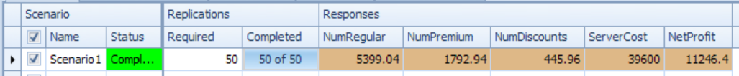

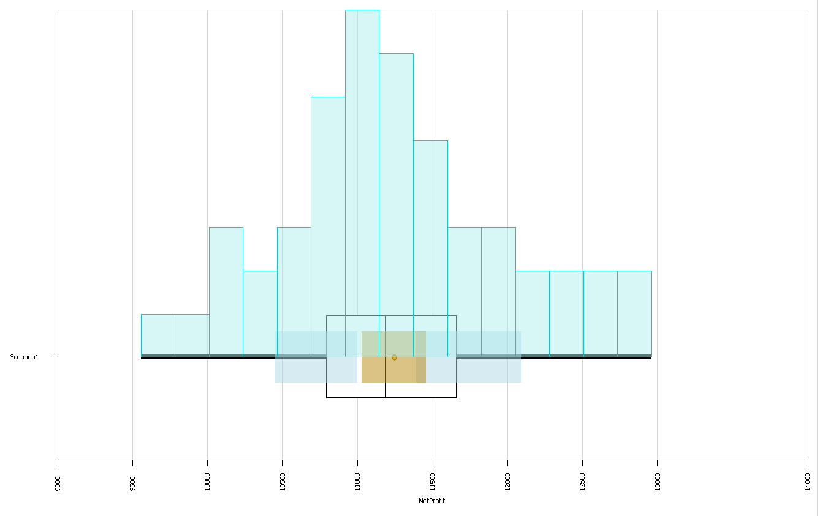

Scenario B (allow agents to handle all customer types): Based on 50 replications, we see an average net profit of $14,321.

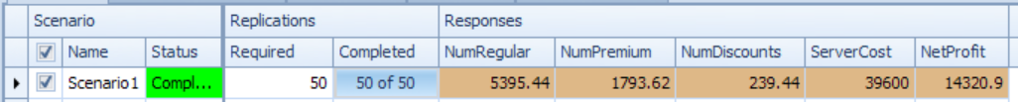

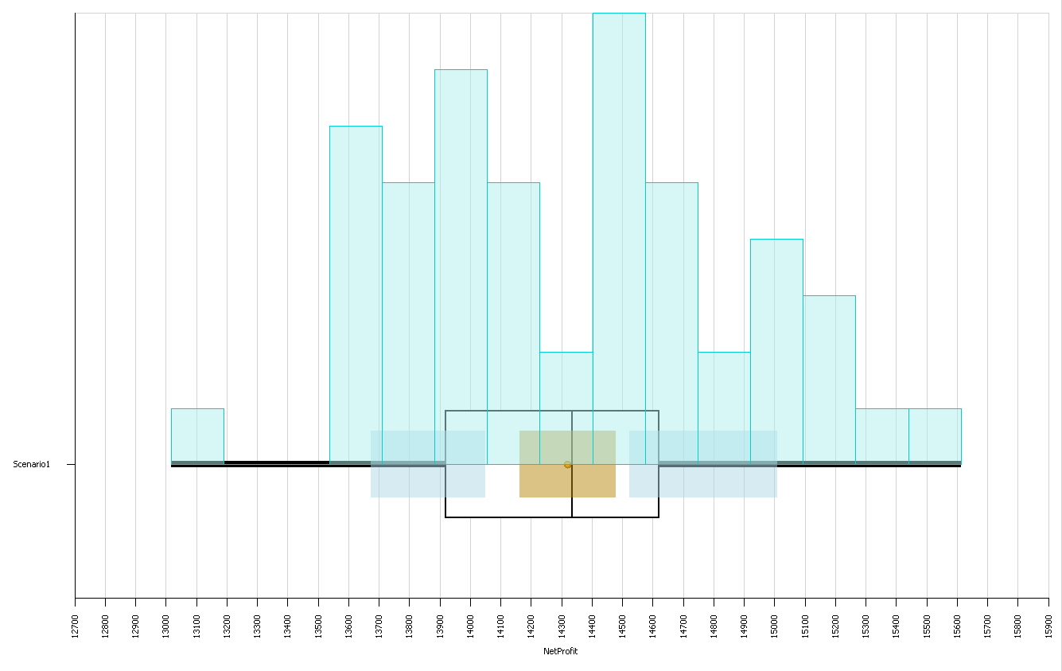

Scenario C (allow agents to handle all customer types, but prioritize premium customers): Based on 50 replications, we see an average net profit of $17,851.

