Bruce Hao

DATA604

Assignment 5

**Problem 4.2:**

Based on a M/M/1 queue with lambda = 120 and mu = 190,

* Rho = lambda / mu = 63.16%
* L = rho / ( 1 – rho) = 1.71 units
* W = L / lambda = 0.0143 hours or 0.8571 minutes
* Wq = W – E(S) = 0.0090 hours or 0.5422 minutes
* Lq = lambda * Wq = 1.08 units

Based on Simio model with lambda = 120, mu = 190, 120 hour total run time with 20 hour warmup

* Steady state time entities spend in system = 0.0152 hours
* Expected number of entities processed (NumberDestroyed) = 12001

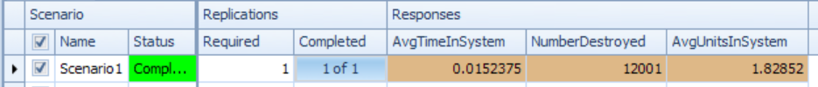

**Problem 4.3:**

Based on Simio experiment with lambda = 120, mu = 190, 120 hour total run time with 20 hour warmup, 100 replications

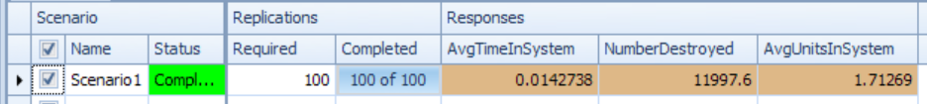

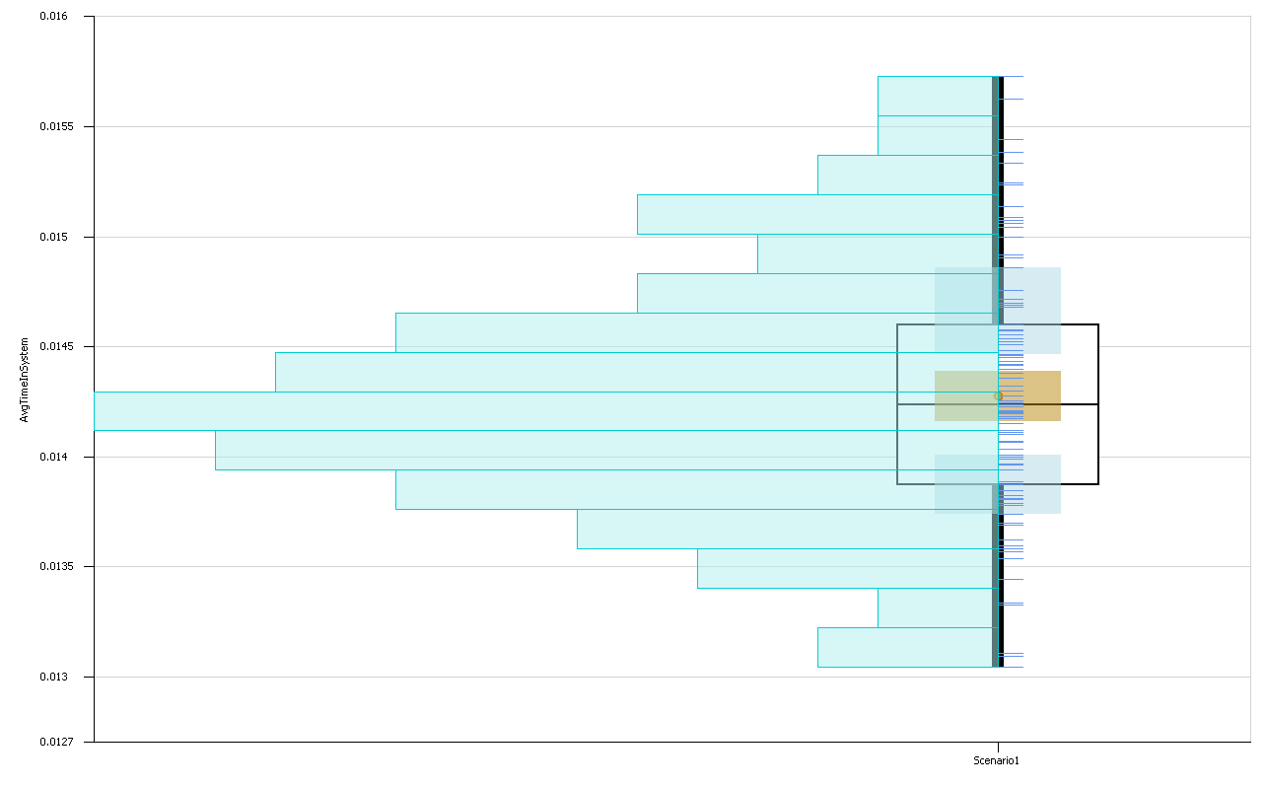

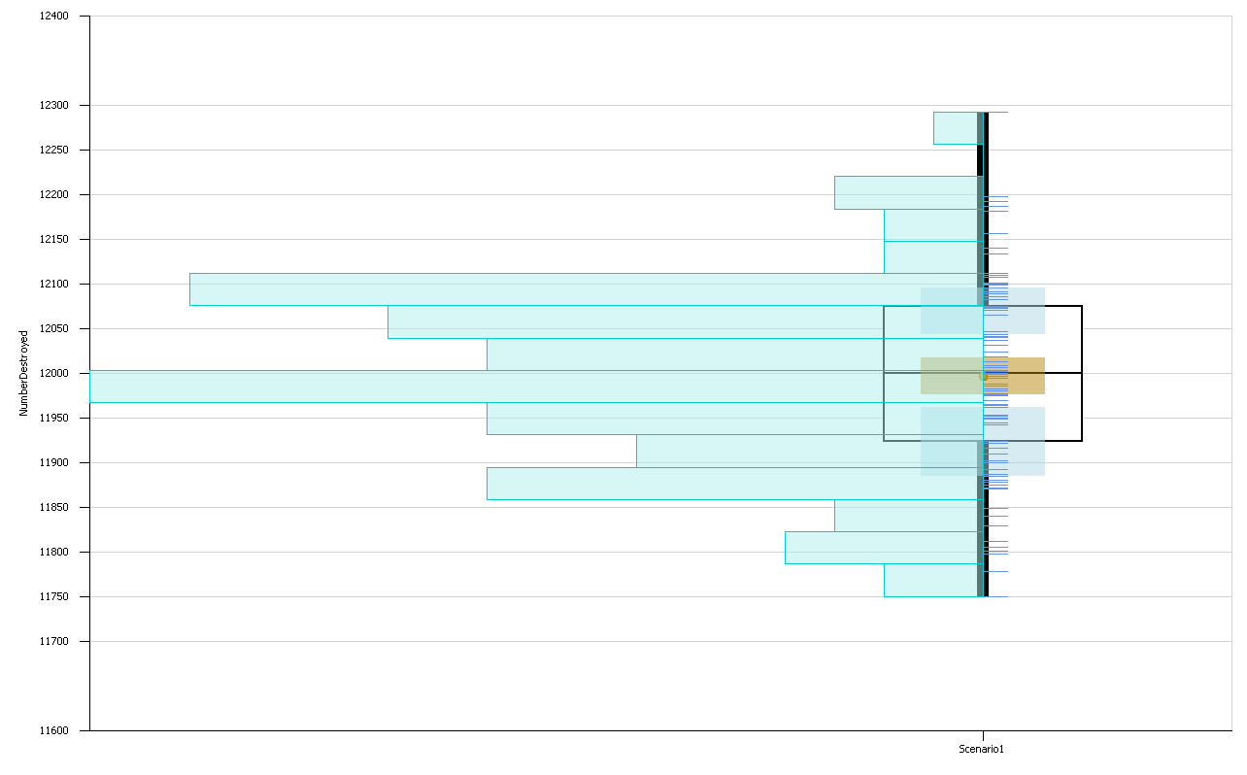

**Problem 4.9:**

The processes-based simulation completed much more quickly than the previous simulation, and the results were within the confidence intervals, i.e. statistically the same.

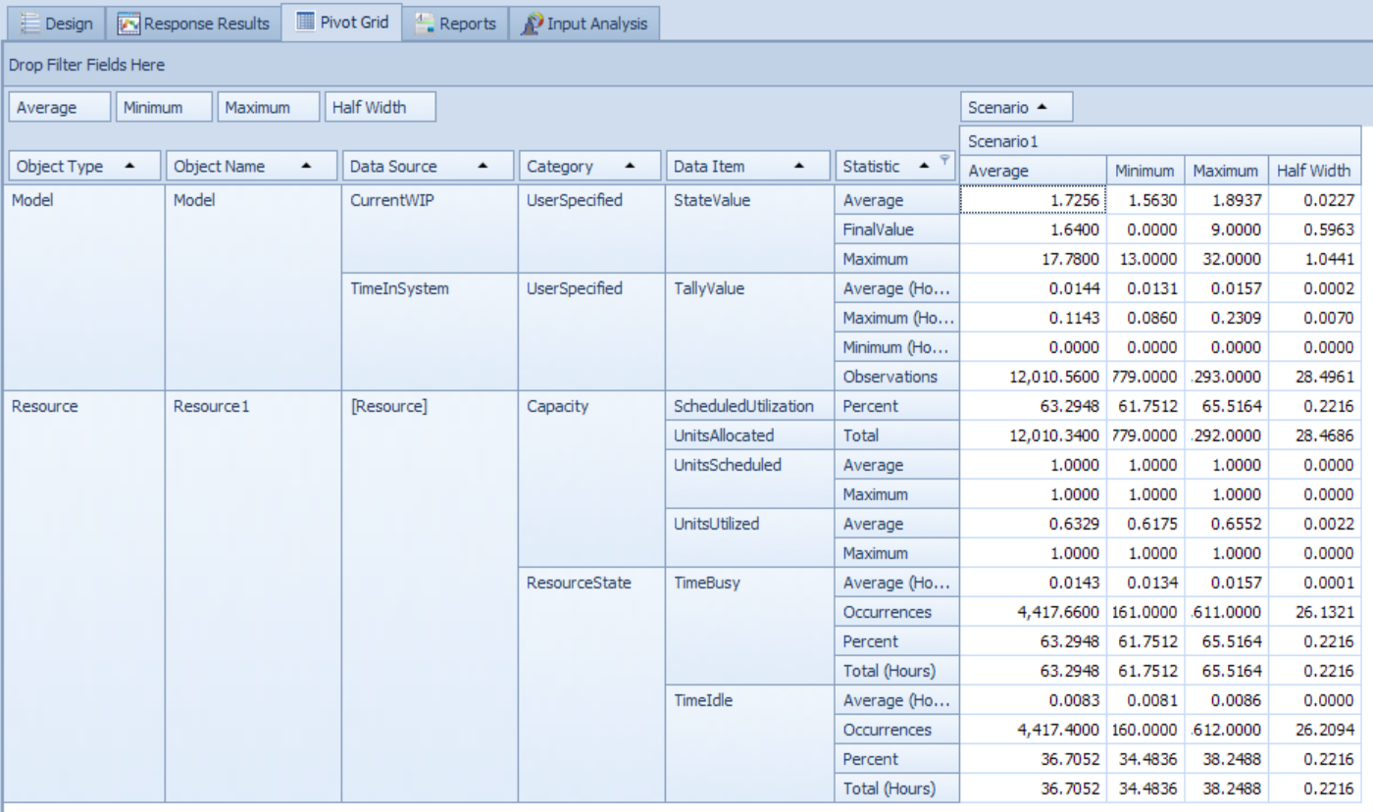

**Problem 4.12:**

