Bruce Hao

DATA604

Assignment 6

**Problem 5.1:**

Basically,

Basically, properties stay constant during a simulation; whereas, states can change.

Properties States

Basic data types 17 8

Runtime change No Yes

Where stored object instance object runspace

Server example processing time number processed

Entity example initial speed current speed

Cost example cost per hour accrued cost

Failure example failure rate last failure time

Batching example desired batch size current batch size

**Problem 5.2:**

The *parent object* is an instance of the object in which the process is defined. The *associated object* is the related object that triggered this process to execute.

**Problem 5.3:**

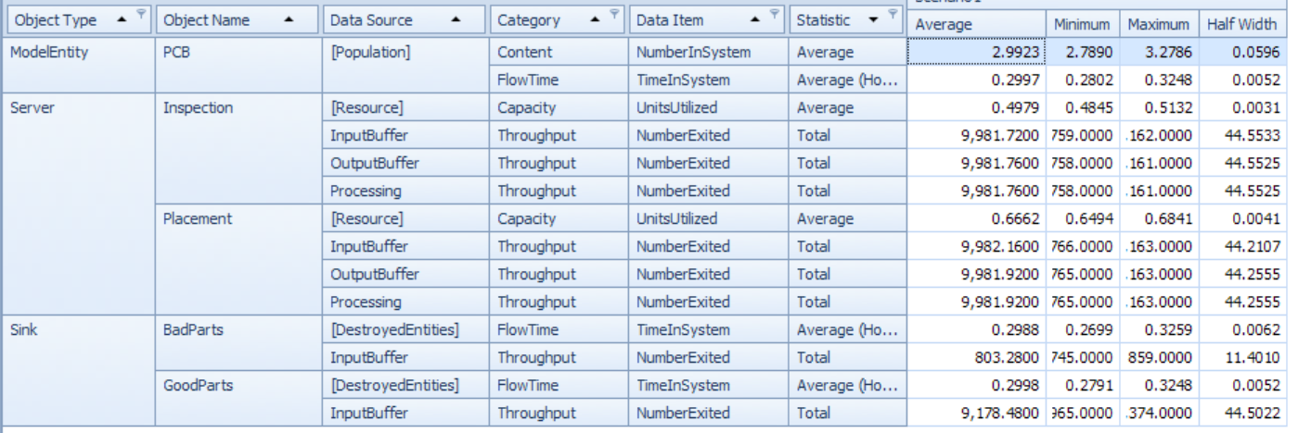

**Problem 5.4:**

I had to revisit the lecture video to figure out how to get the timing to work. I ended up using a rate table to schedule arrivals between 9am and 5pm (thank you for mentioning that the integers inputted there are actually interpreted as random exponential means). In addition, I set up two work schedules, but I had schedule these from 9am to 6pm in order to ensure that all customers already in the system were served and exited before the servers stopped processing. I supposed I could have used the fixed capacity setting, basically saying that servers need to stay at work until all customers are served.

Apologies for the eye chart (like the pun?), but the experiment results for 30 replications of 24 hours each are shown below:



**Problem 5.5:**

