Bruce Hao

DATA604

Assignment 7

**Problem 5.6**

To model the one hour overlap in shifts, I added three rows to the Inspector work schedule day pattern:

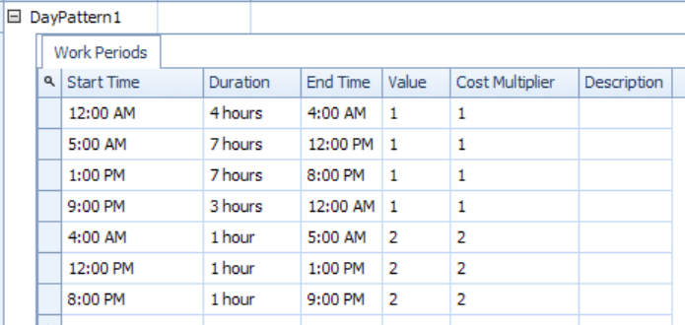

I then ran two experiments, one for the original model and one for the updated model. At first, using 30 days and 5 days of warmup, I was getting different results (although the 95% confidence intervals overlapped somewhat), so I extended the experiments to 100 days with 10 days of warmup. After that the results were basically indistinguishable. Since the maximum inspection utilization was 78% in the original model, increasing capacity did not change the results. The only thing it did was to reduce the maximum inspection utilization to 61%.

*Original model*

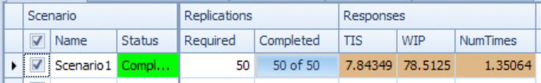

*Updated model*

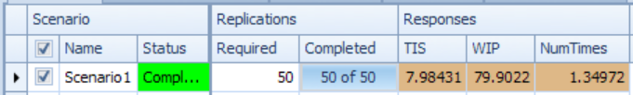

**Problem 5.7**

Changing the ‘definition’ of a bad board from simply 8% of all inspected boards to those boards that failed inspection 3 times dramatically reduced the number of bad boards from 2,343.7 to 53.8, on average.

*Original model*

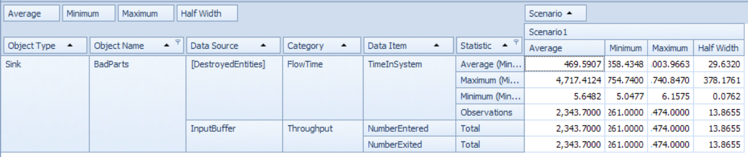

*Updated model*

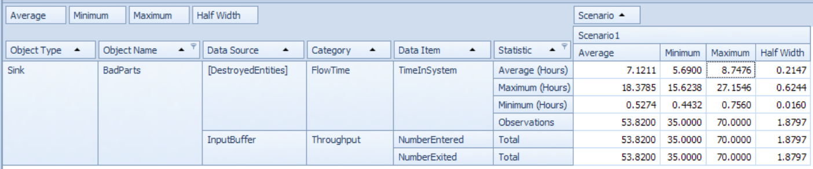

**Problem 5.8**

Based on 50 replications of a 110 day experiment with 10 days warmup, the proportion allocated to the fast, medium and slow fine pitch machines were 38%, 34% and 29%, which are consistent with what the book predicted (aside from some rounding error).

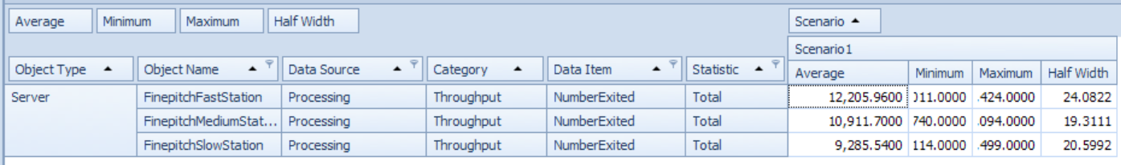

**Problem 5.9**

Model diagrammed below:

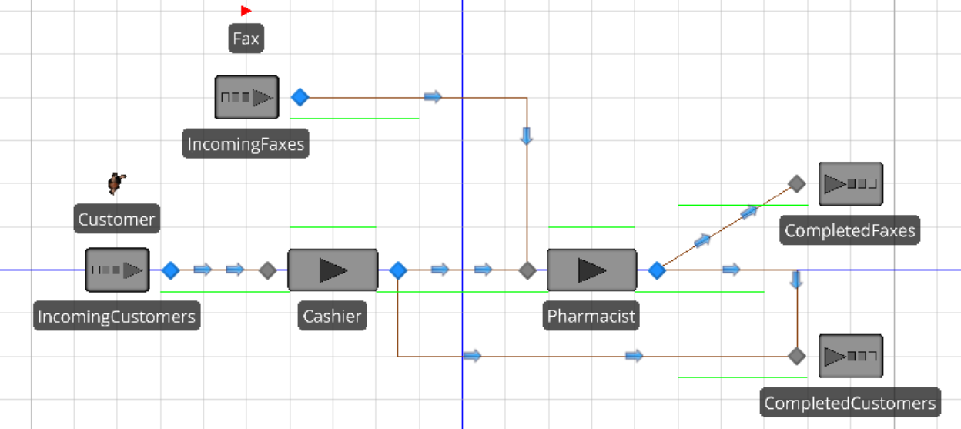

Experiment results:

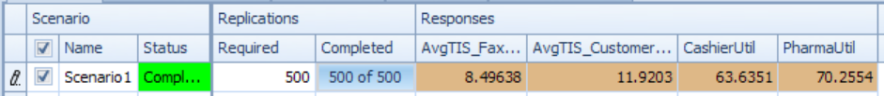

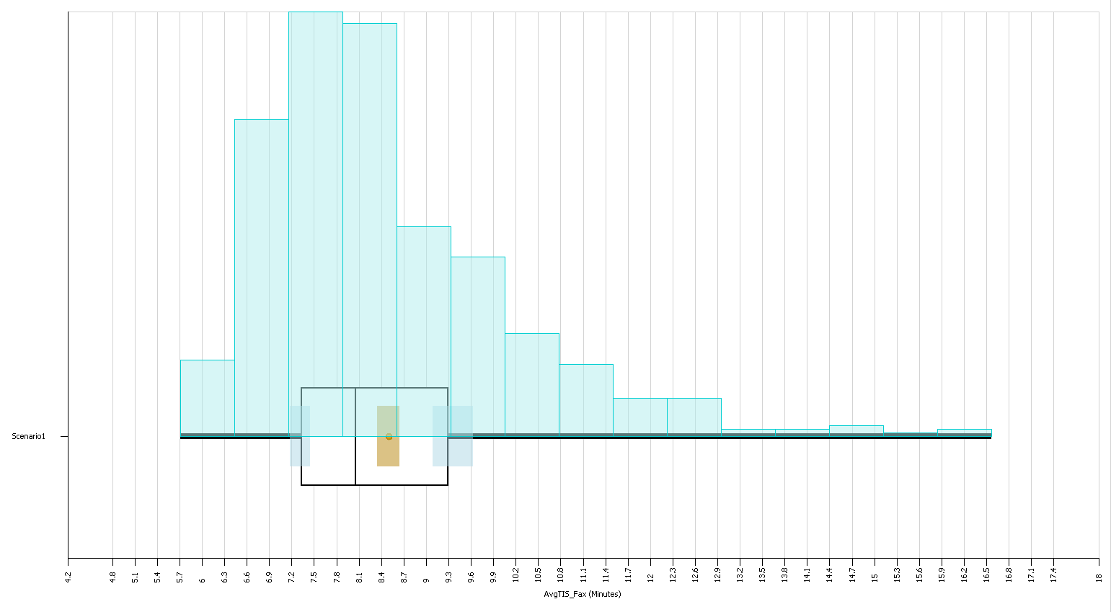 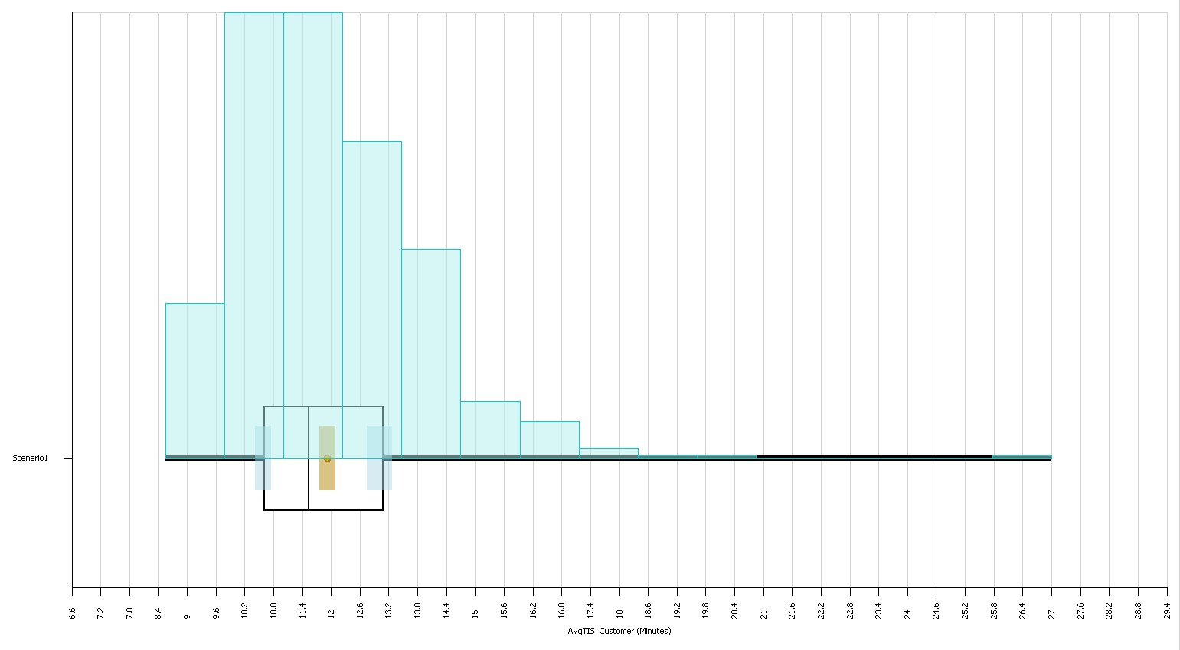

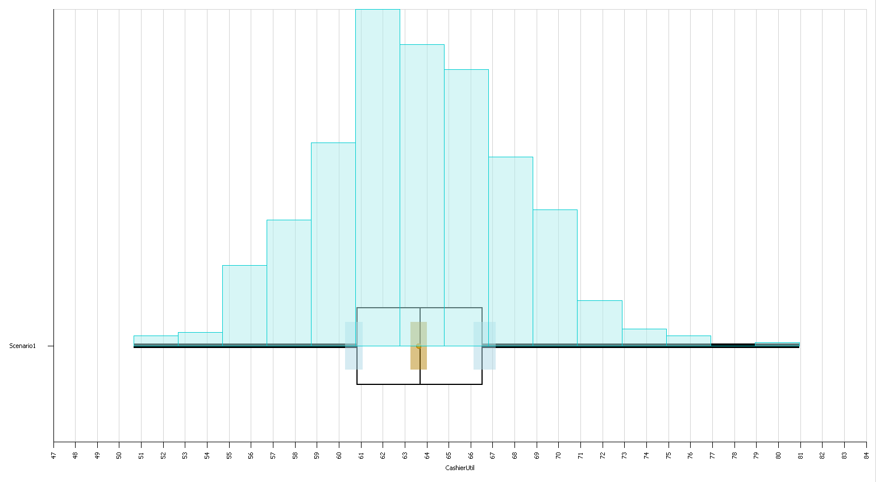 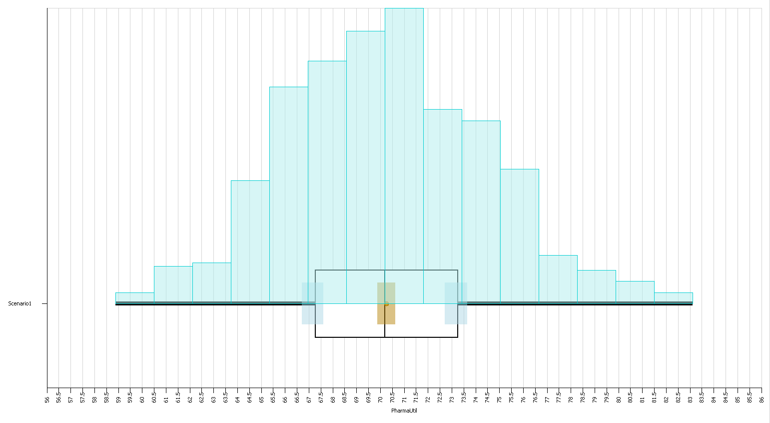

I wanted to see what if anything would happen if pharmacists prioritized physical customers over faxes:

* Pharmacist prioritizes physical customers over faxes using entity priority and server ranking rule
* Separate sinks for physical customers and faxes (using Entity.Is.[EntityName]) routing logic

It appears that having pharmacists prioritize physical customers over faxes results in statistically significant fewer minutes in system for customers on average.

