Bruce Hao

DATA604

Assignment 9

**Problem 7.6**

Based on the currently scheduling system, the doctor sees fewer than 10 patients on average (out of 24 scheduled), and average wait times are about 30 minutes. Even if she were willing to stay until 12:30pm in case her last appointment was 30 minutes late, she’d still average finishing her last patient visit before noon.

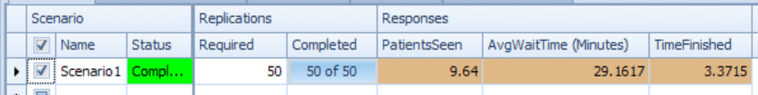

It seems like switching to 2-3 patients every 20 minutes isn’t that much better. She might see half a more patients per day on average, but wait time goes up to 33 minutes. Sounds like she needs better patients.

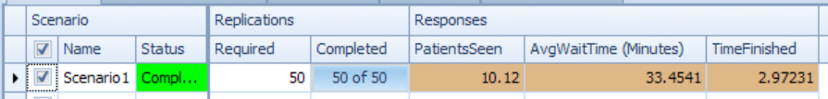

**Problem 7.7**

The results below were based on a 10 day experiment with 1 day warm up, using the original setup.



The results below were based on a 10 day experiment with 1 day warm up, using the additional severe -> urgent entity.



Throughput is basically unchanged except for the split of severe into severe and severe_urgent. Wait times were basically unchanged, too, except that the new severe_urgent patients definitely waited the longest as a result of having to go through registration and the exam rooms rather than being sent directly to the trauma rooms after sign in.

**Problem 7.8**

Since the minimum total staffing level is 12 people on shift at all times, we need to cover 12 hours break time per shift or 36 hours per day given 3 shifts per day. Assuming 1) staff only work full-time and 2) 3 regular shifts per day, we need at 2 additional people per shift and 6 additional people per day.

The original model had a constant total capacity of 18, so we’ll start by trying the minimum staffing levels for each server to see where utilization is the highest. Then we’ll add the 2 people to those servers.

*Minimum staffing:*

Compared to the original setup, throughput is about the same, but wait times definitely ticked up.



We can also see that utilization is highest in the exam rooms. So we’ll add 1 person there, and then re-run.

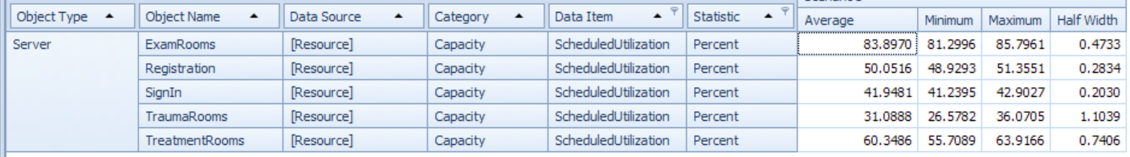

*Minimum staffing + 1 in exam room:*

Wait times for routine visits dropped significantly in this case.



Capacity utilization is still highest in the exam room, so we’ll add 1 person there again.

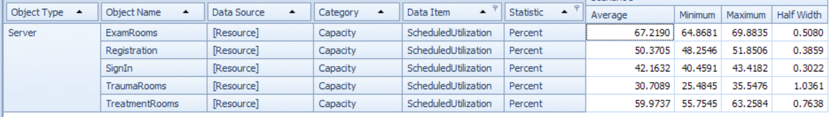

To keep things simple, we’ll keep capacity at sign-in, registration, treatment rooms and trauma fixed at the minimum levels of 1, 2, 4 and 1, respectively. We’ll then build a work schedule only for the exam rooms, where during each shift, exam room workers will need to cover 12 hours of break time. The schedule below minimizes the number of additional people, but as breaks do not always occur around mid-shift. Some employees will have to take their breaks as early as 1 hour after starting a shift or 1 hour before ending a shift.

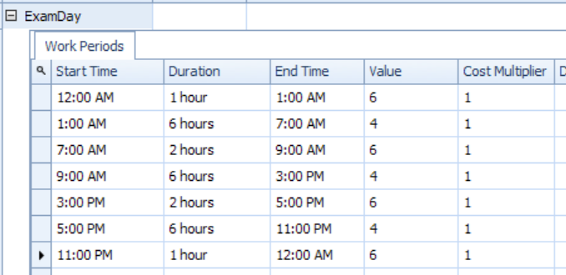

*Final model:*



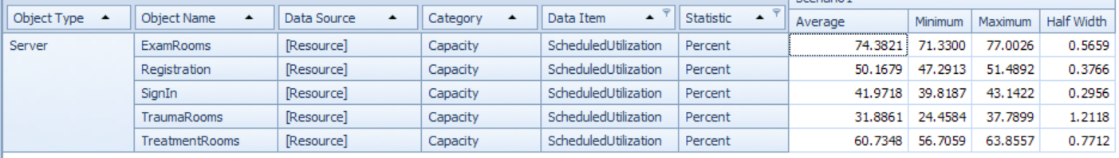

As for handover time, I’m assuming that although there is 30 minutes of 2 people overlapping, capacity remains constant at 1 person during handover.