1st draft of the proposal of the report

Region: California

So far, we have conducted two main analyses. First, we compared global average temperature trends to that of the United States and established a clear relationship of increasing average temperatures. Second, we looked at the relationships between temperature and CO2 and the SOI Index.

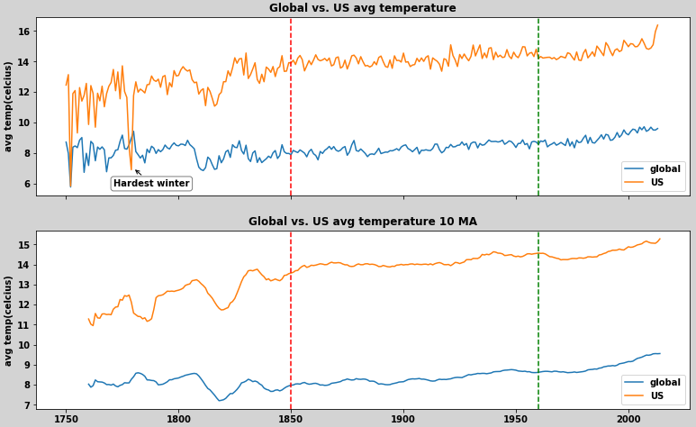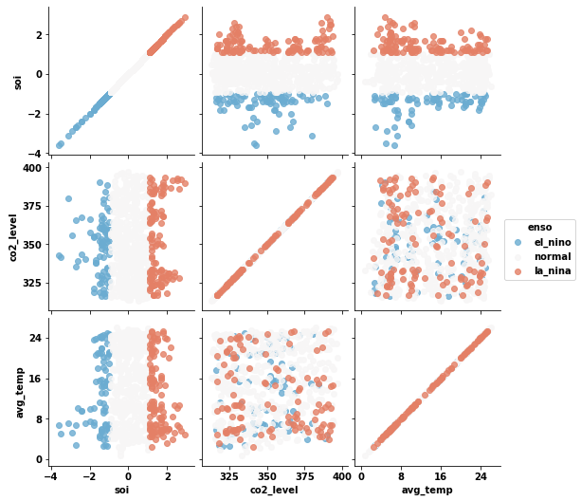

We have been able to use several datasets (with their links below) to do this preliminary analysis and perform additional data cleaning for future use. Most of the data analysis has been at a more superficial level but we will narrow down our scope to California while focusing on these variables.

1. Global SST <https://www.kaggle.com/berkeleyearth/climate-change-earth-surface-temperature-data>
2. CITY/COUNTY SST <https://www.kaggle.com/berkeleyearth/climate-change-earth-surface-temperature-data>
3. CO2 atm level <https://www.kaggle.com/ucsandiego/carbon-dioxide>
4. SOI <https://www.ncdc.noaa.gov/teleconnections/enso/indicators/soi/>

One very useful paper that we found was from a 2018 report released by the California Natural Resources Agency[1]. The paper provides a good summary of different variables and how they are projected to change as the climate warms. For the sake of brevity, our other papers are not included here.

Future Work:

Our approach will be to conduct research on several California cities and come up with a list of locations that are representative of the region. Dataset 2 provides land surface temperature readings for cities in terms of longitude and latitude. We plan to use our previous approach but, rather than look at the U.S. as a whole, use our list of city latitudes and longitudes to filter the dataset and hone in on the California region. Our main variables studies will be ENSO Events(and associated SOI indices), CO2 levels, and average temperature.

1. http://www.climateassessment.ca.gov/state/docs/20180827-SummaryBrochure.pdf