**Udacity Nanodegree Program Project 7**

**A Brief Analysis on California’s Climate**

**Abstract:**

This report introduces California’s climate system and a brief overview on the regional impact of changing climate patterns on droughts, wildfires, and other climate-related events. Temperature anomalies for the California region are calculated based on deviations from mean temperature for the 1960-1990 period. Additionally, monthly Palmer Drought Severity Index (PDSI) values from 1960-2016 in the California region are analyzed, classified along a spectrum of extreme drought events to extreme wet events (highly negative to highly positive PDSI value). Using data from Berkeley Earth, the National Oceanic and Atmospheric Administration, and other online sources, linear regressions were run to find how temperature anomalies correlate with both PDSI values and carbon dioxide levels.

Preliminary results show that both global and California temperatures have been increasing since 1960 The linear regression models show that PDSI and temperature anomalies have a strong, negative correlation (p-value = 0.012), while temperature anomalies and carbon dioxide levels have a strong, positive correlation (p-value = 0.007). A linear model with dummy variables demonstrates that wet events have significant statistical correlation to temperature anomalies whereas drought events and temperature anomalies do not have a statistically significant relationship.

**Introduction:**

Climate change is one of the largest environmental threats humanity has ever faced. The burning of fossil fuels and anthropogenic carbon emissions have contributed to a global atmospheric CO2 content of 405 ppm(parts per million) by 2017, around 40% higher than the pre-industrial level of 280ppm back in the mid-1700s[1]. Climate change encompasses global phenomena such as increased temperatures, sea level rise, and extreme weather events such as droughts and monsoons. At this current pace, the extent of climate change effects may cause catastrophic environmental and societal damage as the earth systems struggle to adapt to this unprecedented rate of change. Although climate change is a global phenomenon, its impacts can very heterogenous across different regions. The chosen region for this detailed climate study was California.

The first part of this analysis examines global and regional temperature trends using moving averages starting from 1895 to 2015. This is done primarily to visualize historical temperature trends and how California as a region compares to global average temperatures. Graphing historical temperature trends would also help show significant patterns

The second part of the study draws relationships between climate parameters using statistical regression. California into temperature anomalies in California and how these may be correlated to atmospheric carbon dioxide levels and Palmer Drought Severity Index (PDSI) values, which use temperature and precipitation data to quantify long-term drought events. PDSI values can range anywhere from -10 (extreme dry conditions) and +10 (extreme wet conditions)[2].

**Area description:**

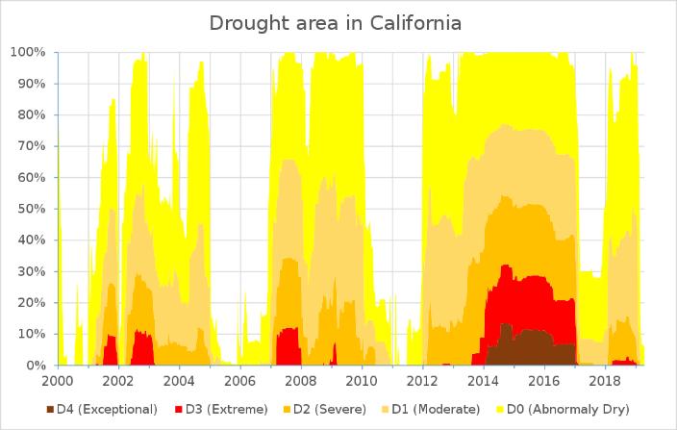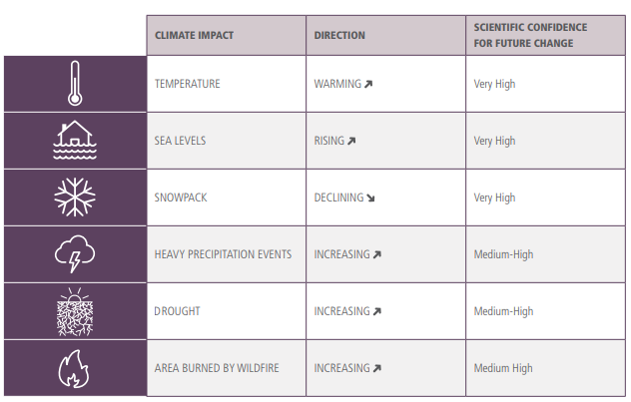California is the most populous state within the United States as well as the largest domestic food producer. Its large land mass and broad range of geographical features results in a wide variety of climates depending on location and topography. Due to its variable climate, California is also prone to extreme climate conditions, which are becoming more frequent and severe due to climate change. For example, California is experiencing a record-high number of extreme heat days (days above 97°F) across its cities- the annual historical average is four days, but 20-30 extreme heat days have been recorded in recent years[3]. The region also experienced one of its worst droughts in history from 2012-2016, ending with the wettest winter ever recorded during that time[4]. As evidenced by Figure 1[5], the drought and wet events in California follow a cyclical pattern and are not necessarily attributed to climate change. However, the drought events in more recent years have been exacerbated by these changes.

Figure 1- Drought Recording in California

California’s severe drought dried a lot of vegetation and induced the most destructive wildfire season in 2018, where 1,893,913 acres were burned[6]. According to the state’s Fourth Climate Assessment, these climate impacts are projected to increase in severity and frequency in the near future: drought events are projected to increase, more forest area will be burned by wildfire, and heavy precipitation events will become more frequent[7].

Figure 2- CA Climate Assessment Projections

**Methods:**

***Data Sources***

The following climate parameters and their respective datasets used for this study are:

1. *Surface temperature*- Berkeley Earth: Earth Surface Temperature Data[8].
2. *Atmospheric CO2*- University of San Diego, California: Carbon Dioxide Levels in Atmosphere[9]
3. *PDSI*- National Oceanic and Atmospheric Administration, Earth System Research Laboratory[10]

***Temperature Rolling Average***

A rolling method was used to calculate the 10 days moving average for both global and local average temperature out of the temperature data from 1895 to 2016. Moving averages smooth out data to make it easier to observe long term trends and not get lost in daily fluctuations given the long time span chosen for this data analysis.

***PDSI Categorization***

Figure 3- Modified PDSI Values

Monthly PDSI data from January 1960 to December 2016 were processed. Standardized PDSI values range from -10 to +10, but for the purpose of this study the range was shortened to -7 and +7. Categories were assigned for varying levels of drought or dry events for each month according to the variable names summarized in Figure 3.

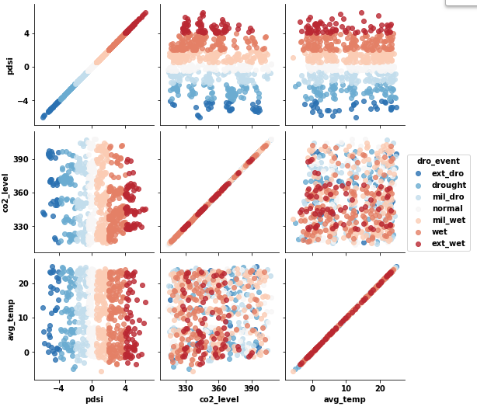***Temperature Anomalies***

Figure 4- Preliminary Plotting

A preliminary plot of categorized drought events, PDSI, atmospheric carbon dioxide, and regional average temperature did not produce any clear relationships. In order to address this, a decision was made to compare drought events and atmospheric carbon dioxide levels to temperature anomalies instead. The mean temperature between the years 1960-1990 was calculated to establish a baseline mean temperature for the California region- any deviations from this temperature are then recorded as temperature anomalies.

***Regression Analysis***

Using the recorded temperature anomalies, two regressions are run to identify relationships between the variables and the strength of those correlations: 1) atmospheric CO2, and 2) PDSI. An OLS regression was also done to identify relationships between drought events and temperature anomalies.

**Results:**

*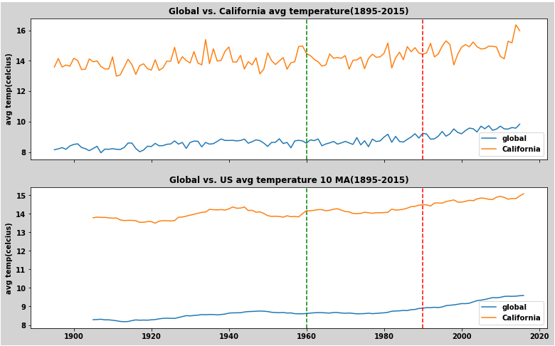****Global vs. Regional Temperature Trends***

Figure 5- Temperature Trends

The historic temperature trends show that from the year 1960 onward there is a steady increase in global temperature, which includes California as a region. Global temperatures range from 6°C-8°C and California temperatures range from 14°C-16°C. Figure 4 does support the observation that temperatures have been increasing for the past decades despite the inherent seasonality in temperature recordings.

***Regressions on Atmospheric CO2 and PDSI***

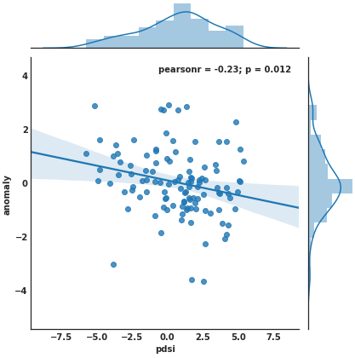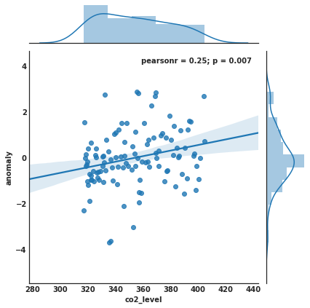PDSI and temperature anomalies have a negative correlation with a p-value of 0.012. Atmospheric CO2 and temperature anomalies have a positive correlation with a p-value of 0.007. Given that these p-values are significantly lower than 0.05, it can be concluded that both of these relationships are statistically significant.

Figure 6- CO2 and PDSI Regressed Against Temp. Anomaly

The linear model with dummy variables shows that wet events have a statistically significant correlation with temperature anomalies, whereas the relationship with drought events is not statistically significant.

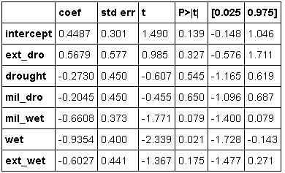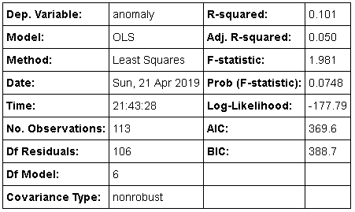

Figure 7- OLS Regression of Drought Events

**Discussion:**

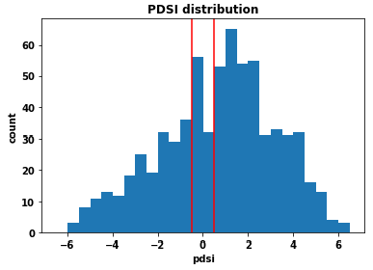Based on the regression between temperature anomalies and atmospheric CO2, it can be inferred that temperature and CO2 have a positive relationship: as atmospheric CO2 increases, more positive temperature anomalies (higher than average temperatures) can be expected. Global and regional temperature trends reinforce this interpretation as well- the increase in average global temperatures can also be attributed to the increase in atmospheric CO2. The results also confirm the strong relationship between PDSI values and temperature anomalies: lower PDSI values indicative of stronger drought events are strongly related with more positive temperature anomalies.

Figure 8- Monthly PDSI Counts: Jan.1960 – Dec. 2016

What is not entirely clear is the relationship between actual drought events and temperature anomalies. Figure x demonstrates that historically, there were more wet events than drought events in California. But based on existing literature, this distribution may eventually skew to the right, with spikes occurring in highly positive PDSI values. California’s dry season is expected to lengthen, and intensity of rainfall is expected to increase as explained by the wet getting wetter, dry getting drier phenomenon[11].

**Conclusion:**

California will be facing more extreme weather events and more abrupt changes between wet and drought periods. This “precipitation whiplash” can exacerbate the current issues affecting California: drier periods and more extreme heat days make larger areas more prone to wildfire combustion, whereas wetter periods with intense rainfall can flood communities destroy infrastructure[12]. To address issue, it is recommended that the state of California should continue with pushing progressive climate change policies that curb greenhouse gas emissions, while identifying most vulnerable regions and maximize community resilience to climate change impacts. Its aging water infrastructure can also be improved as a preventative response to more extreme flooding events.

**References**

1. R. Lindsey. “Climate Change: Atmospheric Carbon Dioxide”. Aug. 1, 2018. Retrieved from <https://www.climate.gov/news-features/understanding-climate/climate-change-atmospheric-carbon-dioxide>
2. Dai, Aiguo & National Center for Atmospheric Research Staff (Eds). Last modified 12 Jul 2017. "The Climate Data Guide: Palmer Drought Severity Index (PDSI)." Retrieved from <https://climatedataguide.ucar.edu/climate-data/palmer-drought-severity-index-pdsi>
3. Energy Upgrade California. “How Is Climate Change Affecting California?” 2018. Retrieved from <https://www.energyupgradeca.org/climate-change/>
4. P. Sarah. "Northern California gets its wettest winter in nearly a century". Apr. 13, 2017. Los Angeles Times. Retrieved from <https://www.latimes.com/local/lanow/la-me-ln-california-precipitation-record-20170413-story.html>
5. United States Drought Monitor: Tabular Data Archive. Jan. 12, 2017. Retrieved from <https://droughtmonitor.unl.edu/Data/DataTables.aspx>
6. California Department of Forestry and Fire Protection. “2018 Fire Statistics. Nov. 4, 2018. Retrieved from <http://cdfdata.fire.ca.gov/incidents/incidents_stats>
7. California Natural Resources Agency. “California’s Changing Climate2018: A Summary of Key Findings from California’s Fourth Climate Change Assessment”. Aug.27, 2018. Retrieved from <http://climateassessment.ca.gov/state/docs/20180827-SummaryBrochure.pdf>
8. <https://www.kaggle.com/berkeleyearth/climate-change-earth-surface-temperature-data>
9. <https://www.kaggle.com/ucsandiego/carbon-dioxide>
10. <https://www.esrl.noaa.gov/psd/data/index.html>
11. Geophysical Fluid Dynamics Laboratory. “Will The Wet Get Wetter and the Dry Drier?” Retrieved from <https://www.gfdl.noaa.gov/will-the-wet-get-wetter-and-the-dry-drier/>
12. S. Zoe. “Climate change will put California in a destructive cycle of floods and droughts”. Apr. 25, 2018. Retrieved from <https://qz.com/1261868/climate-change-is-set-to-bring-precipitation-whiplash-to-california/>