Author |  | Review | Approval
Title: Lingaraja MH |  | Title1:  Title2: - | Title1: -  Title2: -
Distribution
Title1: -  Title4: - |  | Title2: -  Title5: - | Title3: -  Title6: -
Executive  Summary | This is the Software Detailed Design Document for the IP Command Protocol Module in Geely ADAS ASDM3 Performance Project.

High level Design IP Command Protocol

Table of Contents

1 General Information 3
1.1 Revision history * 3
1.2 Purpose and Scope 3
1.3 Referenced documents 3
1.3.1 External documents 3
1.3.2 Internal Documents 3
1.4 Terminology and definitions 3
2 SW atomic architectural unit design 5
2.1 Overview 5
2.1.1 Behaviour Diagrams 9
2.1.1.1 IPCP message transaction 9
2.1.1.2 Sequence Diagram 10
2.1.1.3 Components of IPCP layer 11
2.1.1.3.1 Messgae handling component 11
2.1.1.3.2 Timer and Retransmission component 11
2.1.1.3.3 Error handling component 11
2.2 Traceability 12
3 FEATURES 12
3.1 Services 12
3.1.1 Provided 12
3.1.1.1 IPCP_Init 12
3.1.1.2 IPCP_ReceiveTask 12
3.1.1.3 IPCP_TransmitTask 13
3.1.1.4 IPCP_add_time_stamp 13
3.1.2 IPCP_update_time_stamp 13
3.1.2.1 Ipcp_Rexmt_pkt 14
4 Configuration 14
5 Compilation Options 14

General Information

Revision history *
Revision | Date | Author(s) | Description/comment
1.0 | 07.01.2019 | Lingaraj Marapli | Initial Draft

Purpose and Scope
The purpose of this document is to describe the Software Detailed Design of the IP Command Protocol on the Performance MicroControllerUnit(MCU)in "Geely ADAS ASDM3" project.

Referenced documents

External documents
Id | Title | Reference
E3175102 | ASDM Base Tech SWRT_E3 | PLM

Internal Documents
Id | Title | Reference

Terminology and definitions
Terminology | Meaning
API | Application Programming Interface
BYTE | 8 bits, permitting values between 0 to 255
IPCP | Internet protocol command protocol
IP | Internet Protocol
LSC | Local Software Component
PDU | Protocol Data Unit
RMT | Request monitoring timeout
TCP | Transmission Control Protocol
UDP | User Datagram Protocol
WFA | Wait-For-Ack
WFR | Wait-For-Response
EHR | Electronic Horizon Requester
EHP | Electronic Horizon Provider

SW architectural design

Overview

In the Geely ADAS ASDM3 performance ECU EHRv3 will receive ADASIS messages over IP Command Protocol. The IP Command Protocol (IPCP) takes care about handshake and communication management between EHR and EHP.

The IP Command protocol specification can be found here: IPCP command protocol

For IP Command Protocol communication, the figure below shows the relation between the PDU header on the application layer, the UDP/TCP handling on the transport layer and the IP handling on the network layer.

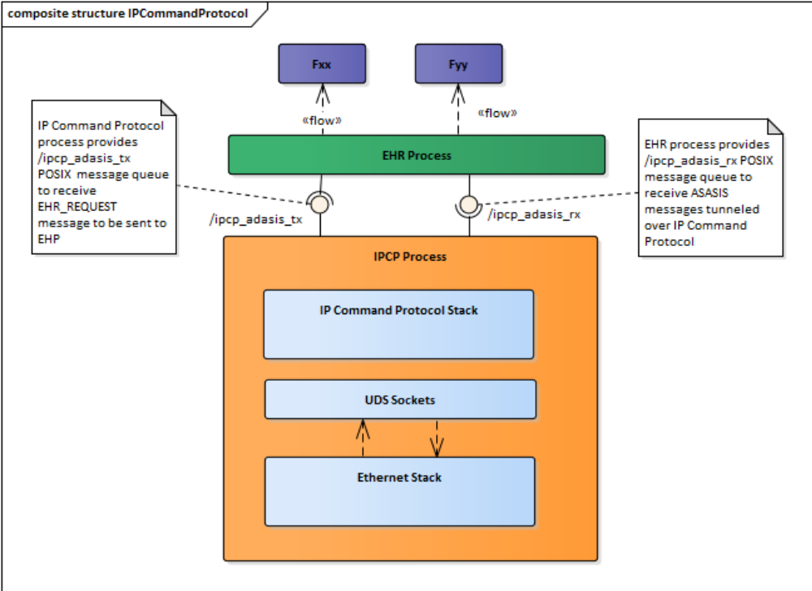

Figure: IPCP Architecture

PDU Header | DATA
Application Layer

UDP Header | UDP Payload
Transport Layer

IP Header | IP Payload
Network Layer

Figure: Overview figure of the PDU proprietary data structure using UDP

IP Command Protocol Header structure

ServiceID [16 bit] |  | OperationID [16 bit]
Length [ 32 bit]
SenderHandleID [32 bit]
Protocol Version [8 bit] | OpType [8 bit] | Data type [8 bit] | Proc [1 bit] | Reserved [7 bit]
Payload [variable size]

Figure: IP Command Protocol Header Format on Application Layer

The following table defines the OperationTypes that shall be supported for E2u.2 release

Number | Friendly Name | Description
0x01 | SETREQUEST_NORETURN | A message that does not require any response from the receiver. Using UDP, this OperationType is only used in conjunction with notification messages.  E.g. set a new value.
0x05 | NOTIFICATION | Notifications are typically used when an application subscribes on a certain parameter which is sent on events for this notification type. The receiver of a  message of this notification type shall respond with an ACK message.
0x70 | ACK | Acknowledgement for UDP messages. The ender/receiver shall make use of the SenderHandleID (and the IP source address) to identify/distinguish which message to send/receive acknowledgement on.  Note: The acknowledgment messages do not carry any payload.
0xE0 | ERROR | This message type is a response containing an error message. The first payload byte consists of the 8 bits  ERRORCODE followed by 16 bits ERROR INFORMATION.  This operation type shall NOT be responded to with ACK messages.

Server
Client

OperationID.OperationType

OperationID.Ack

Behaviour Diagrams

IPCP message transaction

Below figure shows the generic assumptions for the IP Command protocol usage for the ADASIS messages tunneling.

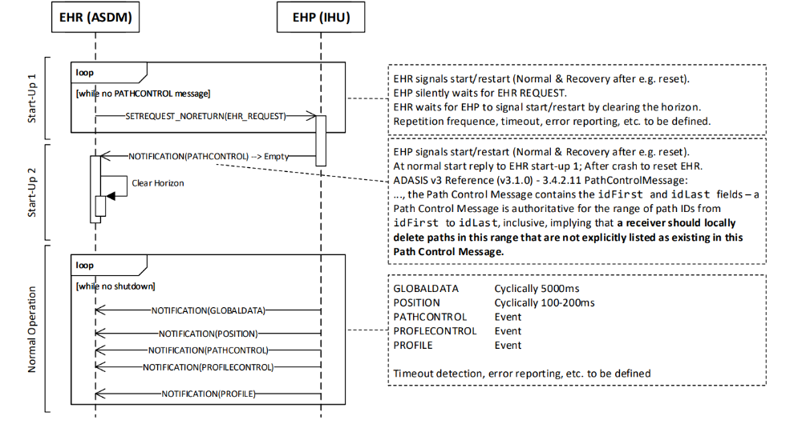

- The IPCP client and EHR are two different processes which communicates witch each other using POSIX message queues.
- The EHR provides the RX message queue used for receiving ADASIS messages. The IPCP process provides TX messages queue for sending status messages (e.g. EHR_REQUEST) to the provider.
- The IPCP notification messages received from EHP are send directly to the RX message queue without IPCP header.
- Requests received from EHR over TX message queue are packed with IP Command Protocol buffer and send out to the EHP.
- Both message queues shall accept up to 1400 bytes long messages. The RX message queue shall be configured for up to 10 messages (TBD).
- The TX message queue shall be configured for max. 10 messages

Sequence Diagram

The below diagram shows the flow of the message handling between IPCP and EHR services/application

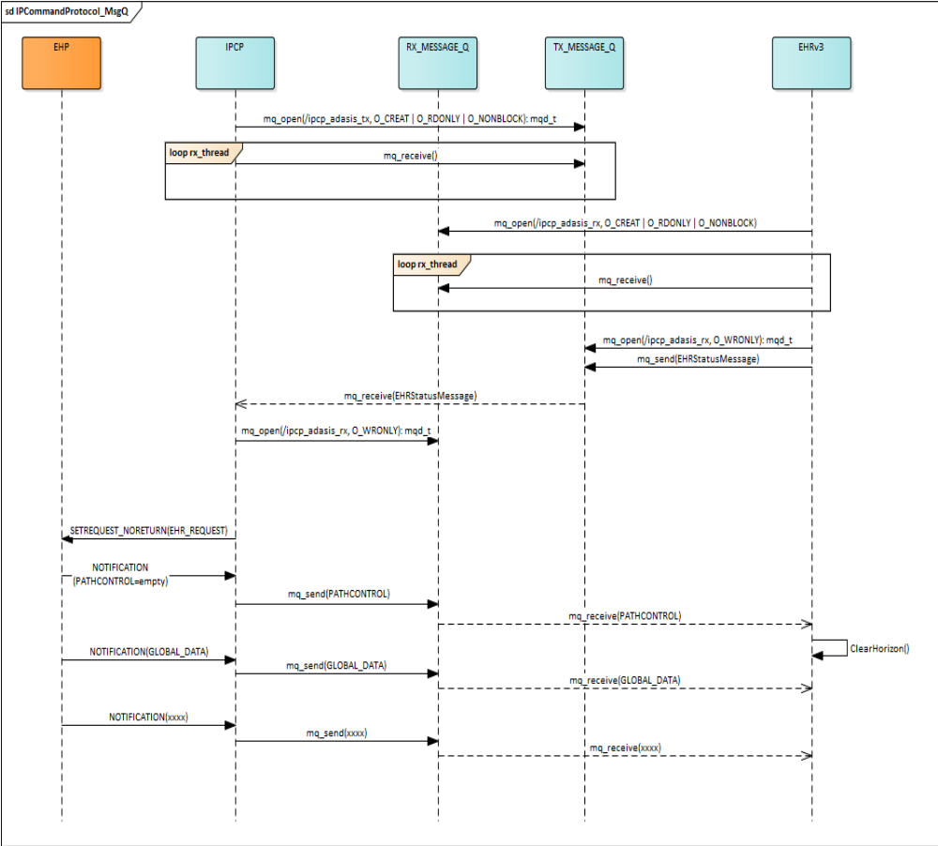

Components of IPCP layer

Messgae handling component
Message handling component implemented with mainly two threads
IPCP Receive task:
- This task is responsible for continuously receiving the messages from IHU system through Socket port.
- Validate the packet header and send ACK to IHU server.
IPCP Transmit task:
- This task is continuously keep receiving the EHR messages
- Build the IPCP packet
- Adding time stamp
- Send the IPCP packet to IHU system

Timer and Retransmission component
- This component adding default time stamp to all EHR messages
- Updating the time stamp and mark the packet TIMEOUT if WFA or WFR time expires
- Re transmit the packet if packet marked with TIMEOUT.

Error handling component
- All the IPCP protocol errors are defined

Traceability
The requirements are mapped on services.

FEATURES

Services

Provided

IPCP_Init

Description :
Initialization function. Must be called before the module can be used. For now it is called at system startup.
Parameters :
Direction | Name | Type | Description
Dynamic Aspect :
Return value :
Type | Description
sint32_t
Function is reentrant :
Constraints :
Covers :

IPCP_ReceiveTask

Description :
Receive & processes IPCP Messages from IHU, send ACK to IHU and push the payload to App.
Parameters :
Direction | Name | Type | Description
Dynamic Aspect :
Return value :
Type | Description
Void*
Function is reentrant :
Constraints :
Covers :

IPCP_TransmitTask

Description :
Packetize and Send the received IPCP Data to IHU system
Parameters :
Direction | Name | Type | Description
Dynamic Aspect :
Return value :
Type | Description
Void*
Function is reentrant :
Constraints :
Covers :

IPCP_add_time_stamp

Description :
Adding default timeout time stamp for sending packet
Parameters :
Direction | Name | Type | Description
Dynamic Aspect :
Return value :
Type | Description
Std_ReturnType | Returns E_NOT_OK is module is not initialized.
Function is reentrant :
Constraints :
The function must be called once for every packet send from ASDM.
Covers :

IPCP_update_time_stamp

Object :
Modifying the time stamp if Timeout occurred for the specific packet
Parameters :
Direction | Name | Type | Description
in | pIPCP_Pkt_Cfg | IPCP_Pkt_Cfg* | Packet buffer
Dynamic Aspect :
Return value :
Type | Description
Function is reentrant :
Constraints :
The function must be called periodically, ideally every 1 ms, to work correctly. Calling at a different period will still work fine, but the retransmission of the packet going accordingly.
Covers :

Ipcp_Rexmt_pkt

Object :
Resend the packet which ever timeout occurred
Parameters :
Direction | Name | Type | Description
in | pIPCP_Pkt_Cfg | IPCP_Pkt_Cfg* | Packet buffer
Dynamic Aspect :
See Figure 7.
Return value :
Type | Description
Function is reentrant :
Constraints :
The function must be called periodically, ideally every 1 ms, to work correctly. Calling at a different period will still work fine, but the retransmission of the packet going accordingly.
Covers :

Configuration

TBD

Compilation Options

Module compiled with the standard compilation flags.

