Express front-end printing system

By

Lai Woon Tzer



FACULTY OF APPLIED SCIENCES AND COMPUTING

TUNKU ABDUL RAHMAN UNIVERSITY COLLEGE

KUALA LUMPUR

ACADEMIC YEAR

2017/18

Chapter 1

Introduction

# Introduction

The Express front-end printing System is a system that using to help solve the long queue problem, hardware failure and virus spreading problem that exist in the university printing shop. It is because this kind of problem may be wasting student time, especially for those who needed to print their assignment in school. Therefore, the author created a system that provide a platform for student to customize their own file before upload to a server side.

**Problem**

The problem with overcrowded in the shop can be very serious issue, because it affect the student to waste time on printing .Besides that, some of student that also not responsibility to done the home work at home. They try to editing or doing at the printing shop computer. So it will affect the student queue to waiting the student done the work. Furthermore, it will also affect the business of the shopkeeper, as the student will visit other shop when they not decided to wait.

Besides that, Hardware failure is one of the problem that facing by the printing shop, it is because the printing shop have provide few computer to let the student print the assignment. So computer may have to facing the hardware overload or overheat. For example, the computer storage maybe not enough space for student, because the student put the file to computer and not delete it. Besides that, the computer also will incursion by the virus, because the student pen drive have virus still plug in to printing shop computer. It may will slow down the performance of computer. So, the printing shop have to spend more money to format the computer or buy the new Hardware to upgrade storage and speed up the computer performance.

Moreover, the other problem is virus-spreading problem. Now can heard that, the student always complain about the printing shop computer have the Virus spreading problem when student plug in the pen drive to USB plug of computer. That reason why computer get virus because some of student that pen drive have virus and not clear up properly still plug in to computer so spreading the virus to printing shop computer.

**Solution**

A solution has been proposing to overcome some problem that exist in printing shop. System will provide template for student to maintenance the file, so student no need to printing shop for print file. It is because if every student go to printing shop print file will make the overcrowded in shop.

Besides that, the system also can solve hardware failure. Student only need going to printing shop web-base to maintenance the file. In this case, it can help the printing shop no need provide many computer for student to printing file. Therefore, printing shop computer will not happen hardware overload and overheat.

.

Furthermore, the system can prevent printing shop computer easily get virus. For example, the student pen drive have virus if plug in to computer will spreading the virus to computer. If student can upload the file to service Side at home, it can minimum the printing shop computer get virus from student pen drive. That also can be avoid other student easily get virus on continue using printing shop computer.

The Express front-end system target market is focusing on small company such as university school and secondary school, primary school. Base on research, the author found out the other company printing system have provided different type of printing such as digital Printing, signage & advertising, labels & packaging. But the author company only focusing on printing file, note, t-shirt logo and including sales stationary, so is different with the other company.

## Objectives

* To help staff or customer easy to maintenance their individual part of system, such as if login user is customer will go to customer maintenance else login user is staff will go to staff maintenance.
* To help user retrieve password such as including forget password for those who forget the login password.
* To help staff and customer convenient to maintenance their own module. For example, staff can maintenance staff and customer information but customer only can maintenance own information.
* To let user able to customize their own file format, so user can follow their own preferences to choose the format you want.
* Allow user choose what type of payment to pay their transaction, for example cash or credit card so it will convenient for the user to pay transaction. Furthermore, it will also convenient for the customer pay transaction, user can choose online payment or direct pay cash in front of shop.

## Background

Table 1.1 compare category between existing companies printing system

|  |  |  |  |
| --- | --- | --- | --- |
| **Compare category** | **Printing expert** | **E-print** | **My printer** |
| **Template provided** | YES | YES | YES |
| **Min quantity** | 100 | 200 | 200 |
| **Convenience to complete order** | EASY | HARD | EASY |

The Express front-end printing System target market is focusing on small company such as university school and secondary school, primary school. That have provide printing file, note, t-shirt logo and including sales stationary. Other printing shop are not limited on school that also have sales on business company such as that are digital Printing, signage & advertising, labels & packaging, post press, offset printing, inkjet printing, corporate gift & apparel and so on .(Gogoprint.com.my, 2017)

Based on the research with other company system, the author found the other system have provided template for student, so the student convenient using system not need to design. The Express front-end printing System should be meet other system standard, so it will not be outdated. (Myprinter.com.my 2017)

Compare to other system minimum quantity, Express front-end printing System will more convenience.it is because Express front-end printing System minimum quantity can be one paper or more than 1 and other system minimum quantity is 100 paper or 200 paper, The research result is given in Table 1.1. (E-print.my 2017)

The author found the most convenient to complete order is company printing expert system compare to E-print system and My printer. That the reason is Printing expert system not required many input compare to E-print system, can refer Table 1.1 for the research result. Therefore, Express front-end printing System should follow the other system standard to reduce unnecessary required input. (Printexpert.my 2017)

## Advantages and Contributions

## In the market, that author found that the express front-end printing system have competitive advantage compare with the other printing system. For example, compare with the system minimum quality, Express front-end printing System minimum quantity can be one paper or more than 1 and other system minimum quantity is 100 paper or 200 paper. Besides that, compare complete order the express front- end system will be more advantage, because do not required many input for the user.

## Project Plan

**System scope**

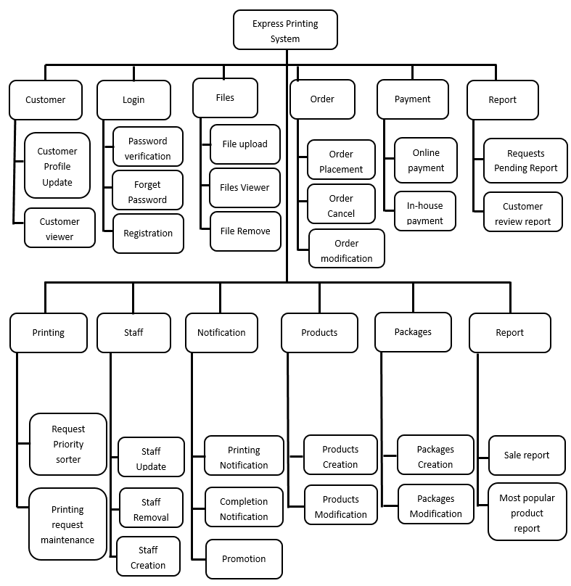

Figure 1.1 Express printing system diagram

The Express front-end printing system have provided eight modules, can refer to the figure 1.1. The author in charge module is login module, customer and staff module, order module and payment module. Customer and staff module is one of the module that inside of the system. Customer and staff module is for the staff and customer to maintenance their own detail. The second is login module, login module allow customer to sign up a new account for those who do not have the account. The third module is order module, order module is for student to do file maintenance and order maintenance. That payment module is for make payment after finished file maintenance and order maintenance.

Here is my partner in charge module, that have printing module and report module, product and package maintenance module and notification module.The module of printing is get printing request from a server side, staff will sort according request priority to print file. Staff can view the printing request including printing property file and printing style and update printing request. Notification module is when the customer make payment is done it will send notification to let customer know the printing is completed. The product and services is to maintain stationary products and services maintenance.

The author in-charge of Express front-end printing System have explain on following:

Login module

Login module is allowing student and staff login to system execute task. Login module will provide student and customer to sign up new account for those who do not have the account in the system.

Customer module

The customer module is allow customer to maintenance own detail such as customer can view own module and update new detail.

Order module

Order module is allow the customer to make order for printing some file. The customer can do file maintenance and make order maintenance.

Payment module

Payment module is a process of allow customer to pay transaction when finish order. The payment method can be separate to two part such as credit card or direct pay to the shop.

**File module**

File module is allow customer to maintenance their file when process ordering. For example, the customer can view their upload file, delete file and update new file.

**Report module**

Report module is a process that allow customer to generate a meaningful report. For example, staff can generate a request pending report.

**1.4.1 Functional requirement**

**1. Login Module**

1. The login module should allow student to retrieve the password such as including forget password for those who forget the login password.
2. The login module should provide staff or customer to sign up new account for those who do not have the account.

**Customer module**

1. Customer module should allow student to do CRUD maintenance, such as can create a new account, retrieve detail, update information and delete old detail.

**Order module**

1. Order module should able student to make order maintenance such as file maintenance and order maintenance.
2. Order module should able student upload different type of file such as pdf, doc, txt, jpg.

**Payment Module**

1. The payment module should allow student to use credit card or cash to make payment.
2. The payment module should allow user to choose the credit card type such as visa, master card to make transaction.

**File Module**

1. The file module should allow customer to view their own upload file, delete file and upload new file.

**Report module**

1. The report module should allow user to generate different type of report such as yearly report or monthly report.

**1.4.2 Non-functional requirement**

1. Usability – the user interface of the system should be easy with which end users can use a particular system to perform a particular function. So that users can understand how is the system processing.
2. Performance – performance is to ensure the system when loose or incorrectly but the system still can performance and It refers to responsiveness of the system to execute any action within a given time interval.
3. Reliability – Reliability is defined as the ability of a system to run or manipulate beyond the regular working hour. That mean the system ability to perform and continue to perform its function without failure.
4. Availability – availability is concerned the system failure and its associated consequences. It mean a system failure occurs when the system no longer process a service consistent with its specification.

**1.4.3 Schedule**

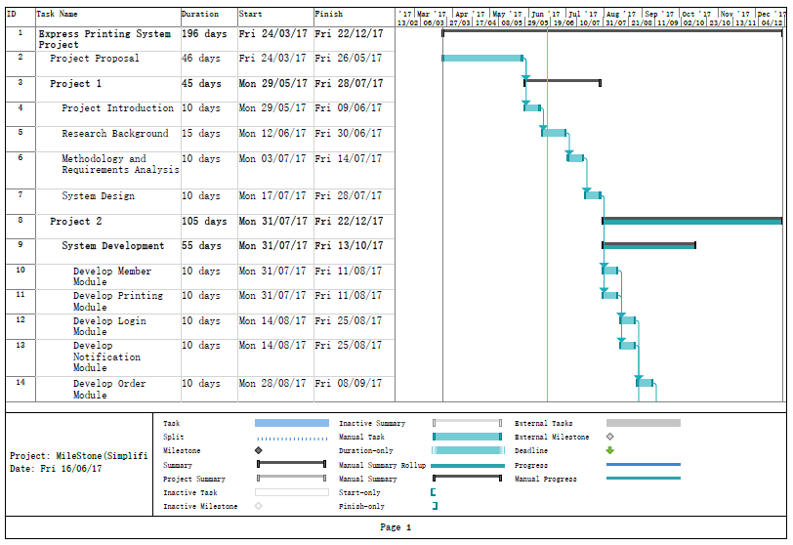

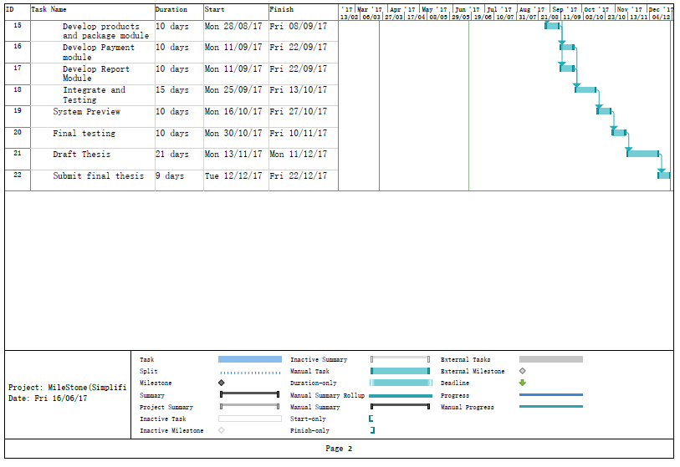

**1.4.4 Development plan**

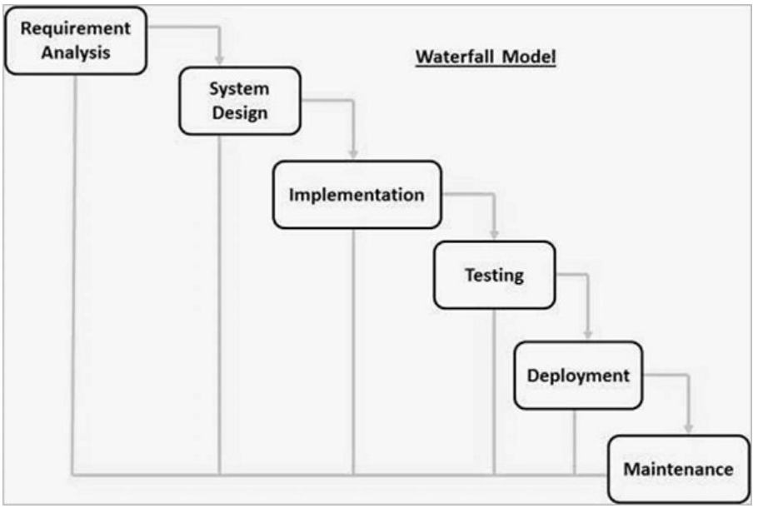

Figure 1.2 waterfall model diagram

The development plan in this project is suitable for using waterfall model. It is because the project is doing step by step after still move to next step. For example, waterfall model that have six stage such as requirement analysis, system design, implementation, testing, deployment and maintenance, can refer to figure 1.2. As this process is sequential, once a step has been completed, the developer is cannot go back to the previous step. Therefore, it will not be scratching the whole project and that are starting from the beginning. The change and error is not accepted in this project, so the project outcome and an extensive plan must be set in the beginning and then followed carefully. (Gogoprint.com.my, 2017)

**1.4.5 Testing approach**

Since the express printing system is divide to several module, the author think the unit testing and functional testing will be suitable in this project. Unit testing is able to test individual unit in the system and functional testing are tested by given appropriate input, verifying the output and compare the actual result with the expected result. Both testing are important due to error can be detect before each module is combine. Furthermore, both system also able to ensure the system meeting the customer requirement.

## Project Team and Organization

Table 1.2 below shown how the module is in charge between the author and his partner.

Table 1.2: Project Team and Organization

|  |  |  |
| --- | --- | --- |
| **Systems and Sub-systems** | **Lai Woon Tzer** | **Kok Hao Guang** |
| **Express front-end printing system** | x |  |
| LOGIN | x |  |
| CUSTOMER | x |  |
| ORDER | x |  |
| PAYMENT | x |  |
| FILE | x |  |
| REPORT | x |  |
| **Express back-end printing system** |  | x |
| PRINTING |  | x |
| NOTIFICATION |  | x |
| PRODUCT |  | x |
| STAFF |  | x |
| PACKAGE |  | x |
| REPORT |  | x |

## Thesis Outline:

The aim of this thesis outline is to provide an overview of this project. This project will separate to 6 chapters which are described as below.

Chapter 1: this chapter is handle the **Introduction** of whole project, which include objective, advantage and distribution, background and project plan.

Chapter 2: This chapter cover the **Research Background** and related work, which include the company background, project background, literature review. Therefore, it is discuss all about the related background in this project.

Chapter 3: This chapter cover the **Methodology and Requirements Analysis**, which may including methodology, fact gathering, fact recording and fact analysis. This chapter is discuss about the functional requirement and non-functional requirement. Besides that, draw the related diagram to presenting the proposed system.

Chapter 4: This chapter cover the **System Design**. This chapter is present the system design and related workflow diagram and design specification such as UML diagram, ERD diagram, use case diagram.

Chapter 5: This chapter cover the **Testing and Result** in the system to confirm the function of the system work according with the planned. For example, it will using test case and test plan tested the system to get what expect result.

Chapter 6: This chapter cover the **Discussion and Conclusion** for the end of the thesis. This chapter will discuss about the limitation of the project and future improvement. It also need to present about summary of the project and project achievement.

## References/Bibliography

Printexpert.my 2017, Print Expert, viewed 14 Apr. 2017, <[http://www.printexpert.my/](http://l.facebook.com/l.php?u=http%3A%2F%2Fwww.printexpert.my%2F&h=ATO6EjvU8fYQs_2BszzZPJgAVUwnmDd5wtVZtlnOvgTwfuW75iRxuZ4JC1rKSMhvYCbvdmWvBqzKPPkfSNUUHATEi4fZ_jR6z0CGRM2dbbOgy7c36nUeeGuhSkrbHjgcCknbv6Ti)>

Myprinter.com.my 2017, One Stop Cheap Online Printing in Malaysia | Printing company | MyPrinter, viewed 14 Apr. 2017, <[http://myprinter.com.my/](http://l.facebook.com/l.php?u=http%3A%2F%2Fmyprinter.com.my%2F&h=ATO6EjvU8fYQs_2BszzZPJgAVUwnmDd5wtVZtlnOvgTwfuW75iRxuZ4JC1rKSMhvYCbvdmWvBqzKPPkfSNUUHATEi4fZ_jR6z0CGRM2dbbOgy7c36nUeeGuhSkrbHjgcCknbv6Ti)>.

E-print.my 2017, e-print Solutions Sdn Bhd|Name Card Printing |Envelope printing|Letter head printing| Flyer & Leaflet printing|leaflet|One Side Poster printing|A4 Full Color Booklet|A5 Full Color Booklet |Long Brochure, viewed 14 April 2017, <[http://e-print.my/](http://l.facebook.com/l.php?u=http%3A%2F%2Fe-print.my%2F&h=ATO6EjvU8fYQs_2BszzZPJgAVUwnmDd5wtVZtlnOvgTwfuW75iRxuZ4JC1rKSMhvYCbvdmWvBqzKPPkfSNUUHATEi4fZ_jR6z0CGRM2dbbOgy7c36nUeeGuhSkrbHjgcCknbv6Ti)>.

Gogoprint.com.my. (2017). *Print Business Cards, Flyers, Brochures Online | Gogoprint*. [online] Available at: https://www.gogoprint.com.my/ [Accessed 14 Jun. 2017].

www.tutorialspoint.com. (2017). *SDLC Waterfall Model*. [online] Available at: https://www.tutorialspoint.com/sdlc/sdlc_waterfall_model.htm [Accessed 14 Jun. 2017].