Express front-end Printing system

By

Lai Woon Tzer



FACULTY OF APPLIED SCIENCES AND COMPUTING

TUNKU ABDUL RAHMAN UNIVERSITY COLLEGE

KUALA LUMPUR

ACADEMIC YEAR

<2017/18>

Chapter 2

Research Background and Related Work

# Research Background and Related Work

The author found out some research similar product that existing in other company, can refer to 2.1 project background. The project background is talk about the express printing system nature of business, explain how existing similar products and services work. Besides that, this also has described the background of the potential market and target users of the express printing system.

In 2.2 literature review, the authors have research some article or method that have implemented in system. For example, using hashing password in database to prevent customer password disclosure to hacker, forget password for those who forget password and using PayPal for make payment.

The authors are choosing the market survey. In 2.3 feasibility study, this survey is to collect opinion from the students about the system author are going to develop. The author are planning to develop is an online printing system that let student print their documents by sending their document to the printing shop. The question will related to the printing system and it will only display out the author in charge module question.

## Project Background

Express printing system is an online printing system. This system objective is to solve the problem that existing in the Tunku Abdul Rahman University College printing shop. In the market, the author found that other printing system company also provide a similar product and services work. For example, Gogoprint Company that have provide printing file, note, assignment, T-shirt logo, but express printing system will provide one more function for sales stationary (Gogoprint.com.my, 2017). The system is providing for the university, so the target market will be on student and other company will of course to customer. Therefore, the express printing system potential market will be focusing on student and teacher. University is high potential market for the printing shop because different course have different note and question paper so student and teacher will printing different assignment, file, question paper and stationary also is one of the necessary for the student and teacher. The other printing system will focusing on the big sales like that will have printing a lot of product digital printing, offset printing, signage & advertising, label & packaging, corporate gift and many more. Due to the sales is biggest so the size of operation will biggest than the author company.

## Literature Review

In the project, the author have implement the hashing method into the system.it is because the system have login module need to prevent the customer password disclosure to hacker. For example, store the password in plain text is never a good idea. Who access to the database also can get the password of all the user. According to the research article name of Rahul rajat singh (2013), that talks about securing user password. For example, can using the salting and hashing method. Salting is a technique that will add a random string to the user entered password and then hash the resulting string.

Second method have implement in system is forget password. Forget password is very important in the system, if the user forget the password that are not allow login to the system. According to the author Mudassar Khan (2015), that will explain about the how to implement the forget password functionality in asp.net. For example, user key in the email address to textbox and the button is clicked. Inside the event handler, a SQL Query is executed on the Login table and the user’s record is fetched using the supplied email address. If the record is found out then the Username and Password will used to sending email to the user and a successful message will displayed in message box.

Nowadays, have a lot of person are using the PayPal method to pay their transaction. PayPal is the most popular payment gateway in the worldwide because PayPal does not charge anything for opening an account and it is free to integrate. The author decides to use PayPal method implement in the system. According to the author Tapan Kumar (2012), the title PayPal Gateway Integration in asp.net. The article will explain thoroughly all the requirement and technique for integrating PayPal in your web application.

Furthermore, due to the system allow user to upload their file. So the author need to implementing upload file method. Base on the research, the author found out a book call build your own asp.net 3.5 web site using c# & vb. That will teach you how to implementing a upload file method. For example, asp.net offers the FileUpload control for uploading files. It provide a text box and browse button to allow users to select files from their own computer ad transfer them to the server (Christian Darie, 2008).

In the author opinion, can knew that are easily to found the article are related to the functionality implementing in the system. According to the research article name of Rahul rajat singh (2013), can know how to securing user password using hashing method. Besides that, to help their user always forget password will using implement a forget password functionality for those forget password Mudassar Khan (2015). Furthermore, that also can use PayPal method for the student pay transaction Tapan Kumar (2012). It can be helping a lot for finish a convenient and efficiency system.

## Feasibility Study

This survey is to collect opinion from the students about the system we are going to develop. The system we are planning to develop is an online printing system that let student print their documents by sending their document to the printing shop. The printing shop will print out the document according to student request and student can collect their document when the printing is done. The total number of survey person is 50. Below is the survey questions that collect from the student and the survey result only display that are related to the author handle module.

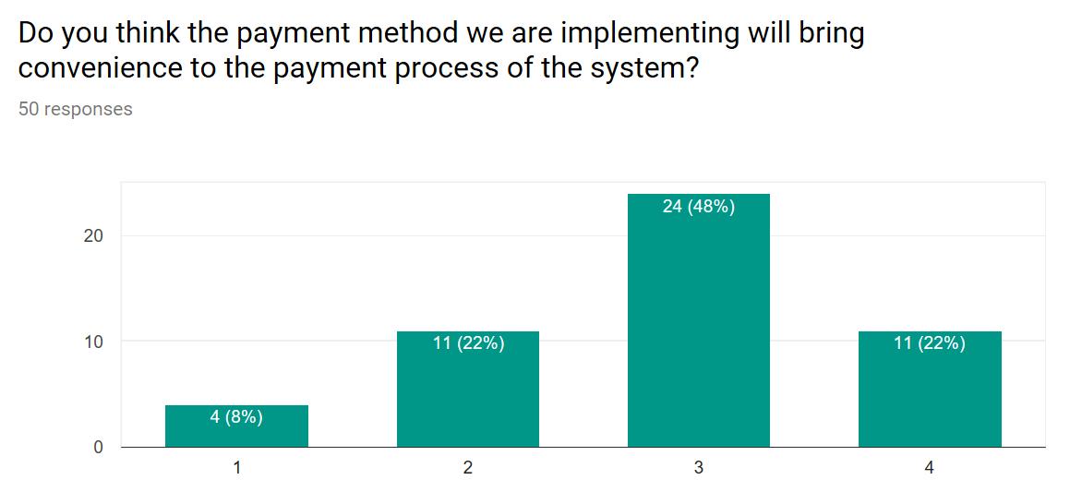

Figure 2.1 bar graph show the convenience of the payment method

The Question is asking if Payment method we are going to implement is top-up system, students can top up credit to their account and use it when it is needed. The way to top up their account is using cash in the printing shop. The bar graph is show 50 person response to the payment method will bring convenience to the payment process of the system.

The survey question way is using linear scale, can refer figure 2.1. Left hand side is very trouble and right hand side is very convenience. Base on the survey result, the author can knew that have 4person will think using top-up method to pay transaction is very trouble, 11 person will think it is trouble, 24 person think is convenient and 11 person think is very convenient. The most higher is range 3, so author can knew using top-up way is more convenient.

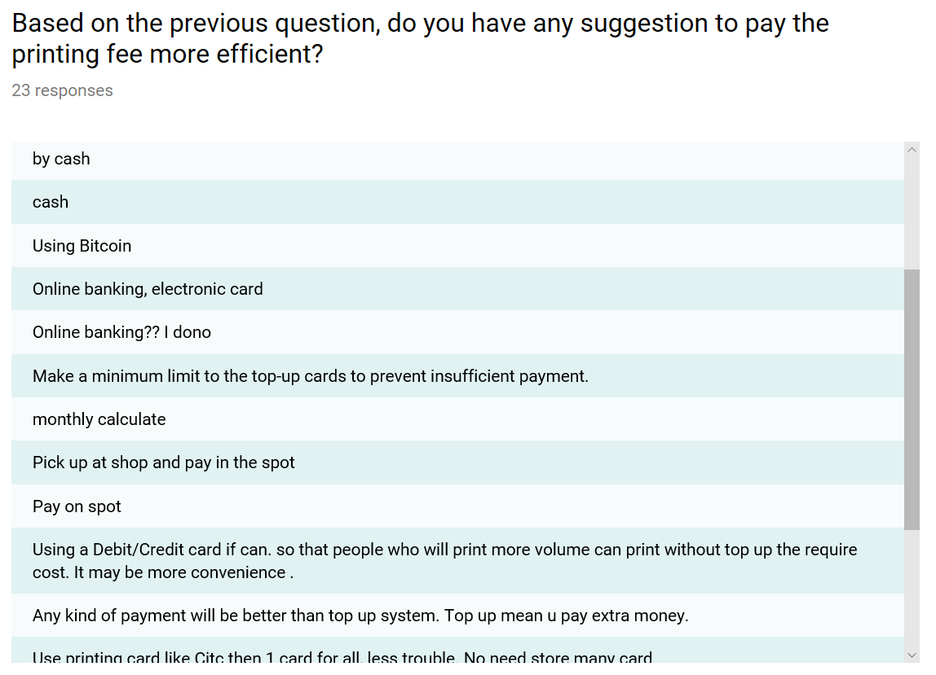

Figure 2.2 suggestion method to pay the printing fee

Base on the survey result, the total have 23 responses can refer to the figure 2.2. Author can know that have 6 people is prefer using E-banking to pay transaction. Besides that, that also has 6 people prefer pay on the spot using cash. Other than that is preferred using Touch and Go or using printing card like Citc. One card for all, that are less trouble and no need store many card. Some response do not using top-up method, because mean need to pay extra money. In the result the author can knew that student prefer using E-banking and pay on the spot by using cash.

## Chapter Summary and Evaluation

In this project, the author hard to find out the relevant article that are related to printing system. This is because if you go find the article it will only show out what the new brand of the printing technology. So after discuss with the partner and teacher change to find the method have implement in system. In literature review part, the author try to found out the retrieve password and PayPal article that have implement in the system.

In Feasibility study, the author chooses market survey. The target of market survey will be Tunku Abdul Rahman University College student. This is hard to think a question that are relevant to the system and some of the question will be similar. So need to think properly, it can help to let student know have what function have implement in this system and will it satisfier about the function. After discuss with the partner and try to ask about teacher who expert in the market survey, so questionnaire still can done in proper way.

## References/Bibliography

Rahul rajat singh (2013). *A Beginner's Tutorial for Understanding and Implementing Password Hashing and Salting*. [online] Available at: https://www.codeproject.com/Articles/608860/Understanding-and-Implementing-Password-Hashing. [Accessed 19 Jun. 2013].

Kumar, M. (2012). *PayPal Gateway Integration in ASP.NET - CodeProject*. [online] Codeproject.com. Available at: https://www.codeproject.com/Tips/474197/PayPal-Gateway-Integration-in-ASP-NET [Accessed 11 Oct. 2012].

Khan, M. (2015). *Implement Forgot Password functionality in ASP.Net using C# and VB.Net*. [online] Available at: https://www.aspsnippets.com/Articles/Implement-Forgot-Password-functionality-in-ASPNet-using-C-and-VBNet.aspx [Accessed 2 Feb. 2015].

Gogoprint.com.my. (2017). *Print Business Cards, Flyers, Brochures Online | Gogoprint*. [online] Available at: https://www.gogoprint.com.my/ [Accessed 3 Jul. 2017].

Christian Darie. (2008). *Build Your Own ASP.NET 3.5 Web Site Using C# & VB; 3rd Edition*. SitePoint, pp.615-618.