Express front-end printing system

By

Lai Woon Tzer



FACULTY OF APPLIED SCIENCES AND COMPUTING

TUNKU ABDUL RAHMAN UNIVERSITY COLLEGE

KUALA LUMPUR

ACADEMIC YEAR

<2017/18>

Chapter 4

System Design

# System Design

In chapter 4, this chapter will describes the various areas of design for the Express printing system. The areas of design may include screen design, database and reports. The author will describe the various tools and techniques used, the rationale for using them, any problems faced and how they resort to solve or reduce the impact of the problems faced. For example, the typical techniques will use for design that include sequence diagram and ERD diagram.

## System Design

System design will describe and illustrate all the necessary designs that will related to proposed system. For example, user interface, ERD diagram, Sequence diagram, data dictionary and report. The author will separate all the diagram into separate section and all diagram will provide explained and labeled with proper caption.

**4.1.1 Sequence diagram**

**Customer Module**

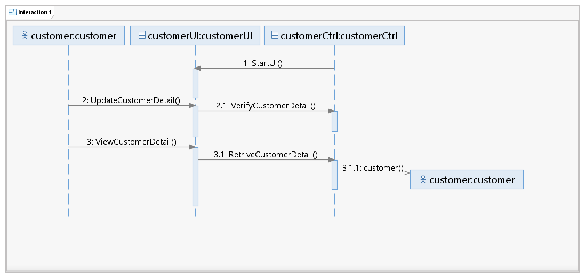

Figure 4.1 Sequence Diagram for Customer Module

The figure 4.1 sequence diagram are show the Customer module in the express printing system. The diagram describe process of the customer maintenance their information.

**Order module**

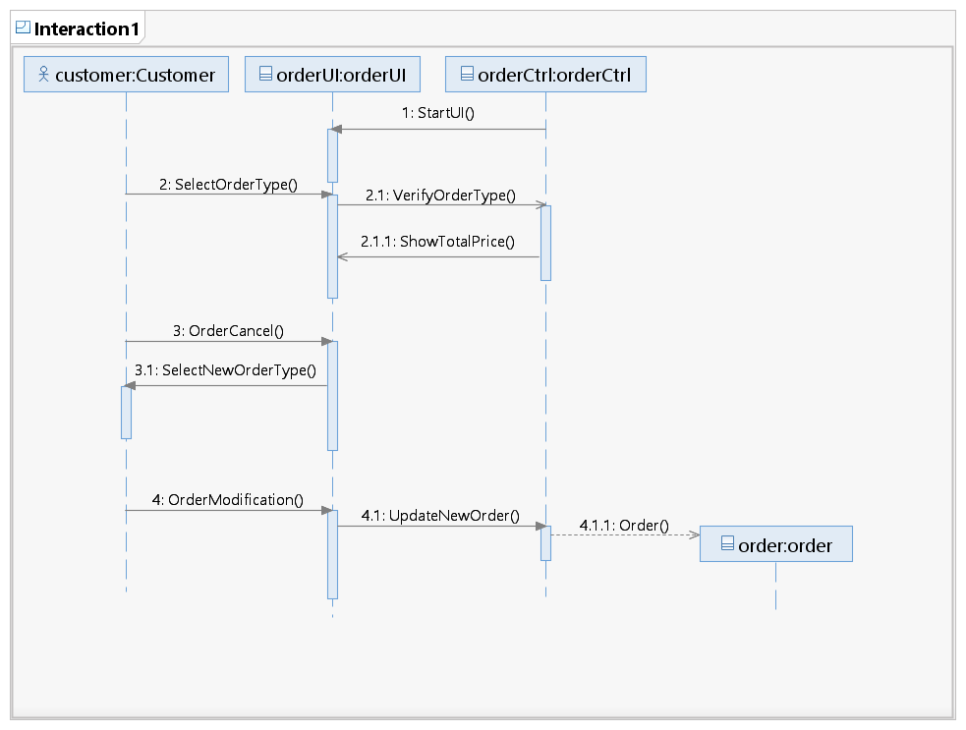

Figure 4.2 Sequence Diagram for Order Module

The figure 4.2 sequence diagram are show the order module in the express printing system. The diagram describe the process of customer to make order.

**Payment diagram**

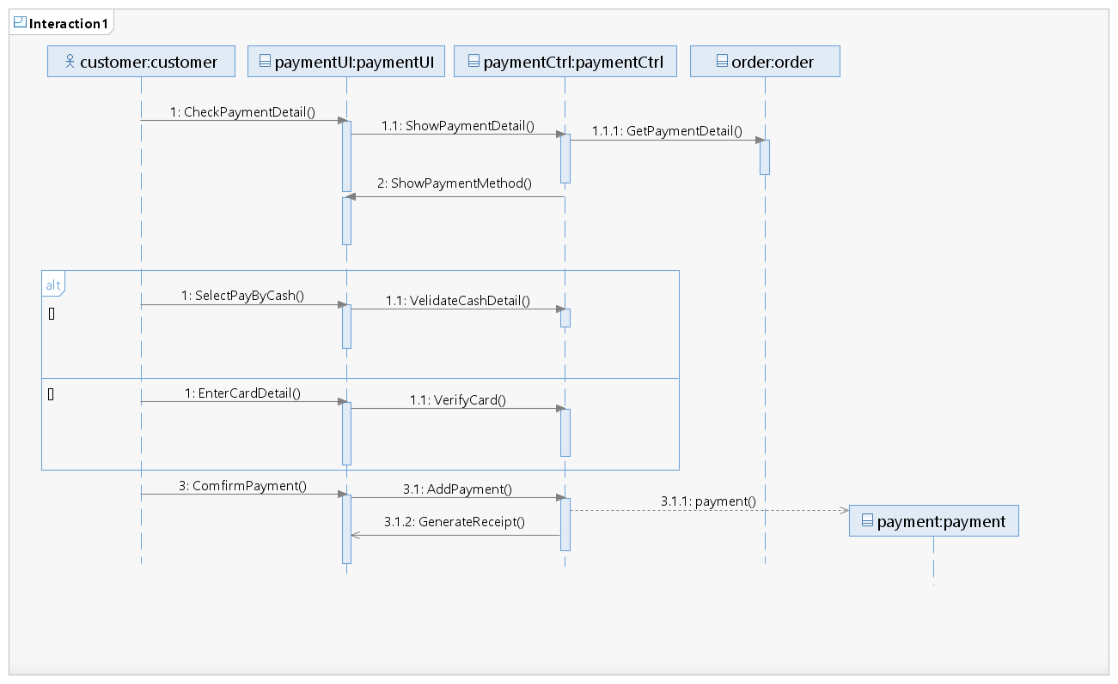

Figure 4.3 Sequence Diagram for Payment Module

The figure 4.3 sequence diagram are show the payment module in the express printing system. The diagram describe the flow of the process of customer to make transaction after done the order.

**4.1.2 Screen Design**

**Login Screen**

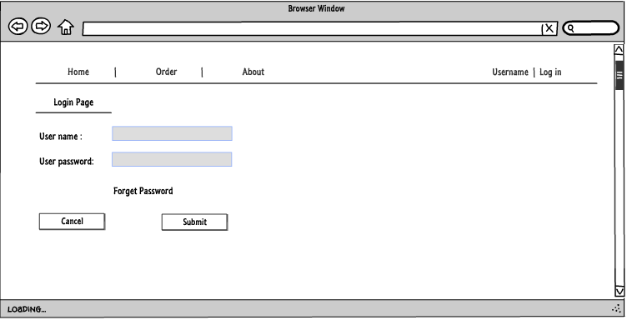

**Figure 4.4 Screen design of login module**

The figure 4.4 is show the screen design of login module. It will allow the user to login the system and click forget password**.**

**Order module**

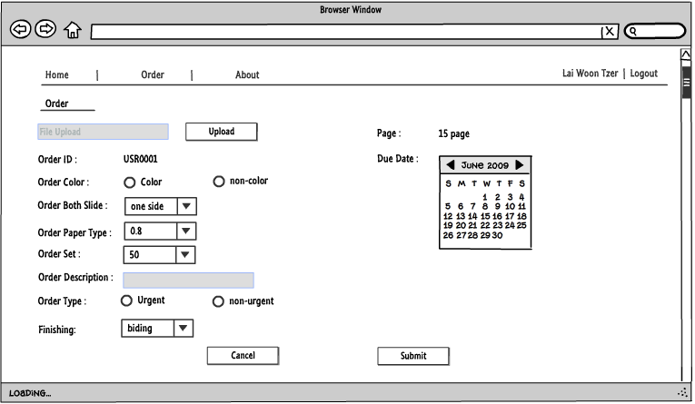

**Figure 4.5 Screen design of order module**

The figure 4.5 is show the screen design of the order module. It will allow customer to upload file and make order.

**Payment Module**

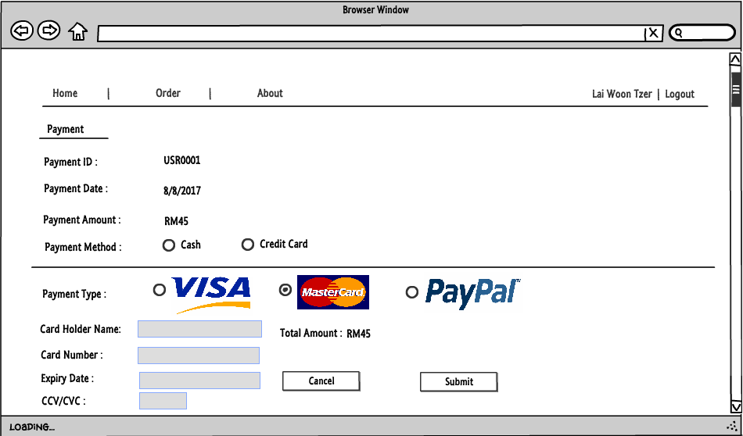

.

**Figure 4.6 Screen design of payment module**

The figure 4.6 is show the screen design of payment module. After done the order, it will display out the payment detail and allow customer to choose what type of payment method to pay transaction.

**4.1.3 Entity Relationship Diagram**

The purpose of drawing entity relationship diagram is allowing author easy understand the relationship between each entity and that will use into database (Ling and Teo, 1994). So the author can know which the primary key and foreign key.

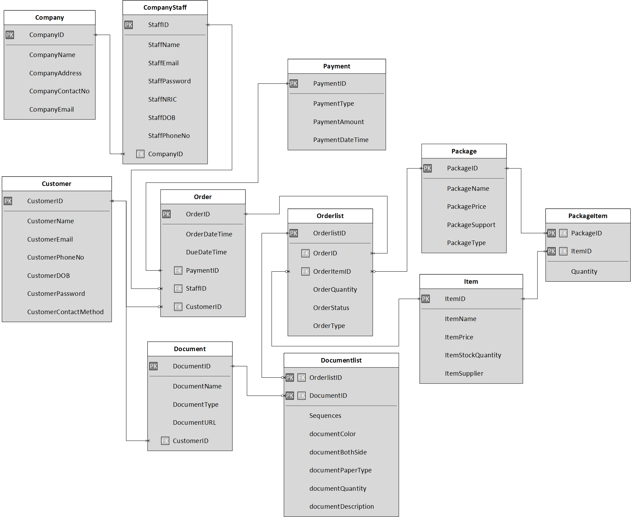

Figure 4.7 ERD for Express printing system

Figure 4.7 show all the entity, attribute and relationship between each entity. The entity relationship diagram are show the entire entity of the express printing system. This including the author express front-end printing system and his partner in charge system like express back-end printing system.

**4.1.4 Data Dictionary**

**Company Table**

|  |  |  |  |  |  |
| --- | --- | --- | --- | --- | --- |
| **Name** | **Type** | **Allow Null** | **Description** | **Key**  **(PK/FK)** | **Reference** |
| companyID | VARCHAR | NO | The ID number of company such as CO1001. | PK |  |
| companyName | VARCHAR |  | The name of company. |  |  |
| companyAddress | VARCHAR |  | The address of the company. |  |  |
| companyContactNo | BYTE |  | The contact number of the company. |  |  |
| companyEmail | NUMBER |  | The email address of the company format must similar [xxx@.xxx.com](mailto:xxx@.xxx.com) . |  |  |

Table 4.1 Data Dictionary for Company Table

**Company Staff**

|  |  |  |  |  |  |
| --- | --- | --- | --- | --- | --- |
| **Name** | **Type** | **Allow Null** | **Description** | **Key**  **(PK/FK)** | **Reference** |
| StaffID | Varchar | No | The format of staff ID will begin with the company ID and follow by a ‘S’ word with 3 series number behind, E.g. “CO1001S001”. | PK |  |
| StaffName | Varchar | No | The full name of the staff |  |  |
| StaffEmail | Varchar | No | The email of the staff. The format of email must contain an ‘@’ symbol and dot behind. E.g. “jack21@gmail.com” |  |  |
| StaffPassword | Byte | No | The password string which already hashed |  |  |
| StaffNRIC | Varchar | No | The staff IC number. The IC number will be stored with ‘-’ in it. |  |  |
| StaffDOB | Date | No | The date of birth of the staff. It is stored in the format of “DD/MM/YYYY” |  |  |
| StaffPhoneNo | Varchar | No | The staff’s contact number |  |  |
| CompanyID | varchar | No | The unique number that represent the company. The format of the company ID is begin with “CO” which represent the word company and follow by 4 series number. E.g. “CO1001”. | FK | Company (CompanyID) |

Table 4.2 Data Dictionary for Company Staff Table

**Customer Table**

|  |  |  |  |  |  |
| --- | --- | --- | --- | --- | --- |
| **Name** | **Type** | **Allow Null** | **Description** | **Key**  **(PK/FK)** | **Reference** |
| customerID | VARCHAR | NO | The ID number of customer such as CO1001 | PK |  |
| customerName | VARCHAR |  | The name of customer. |  |  |
| customerEmail | VARCHAR |  | The Email of customer such as must similar [xxx@.xxx.com](mailto:xxx@.xxx.com). |  |  |
| customerPasswordNumber | BYTE |  | The password number of customer such as minimum 8 number. |  |  |
| customerPhoneNumber | NUMBER |  | The phone number of customer. |  |  |
| customerBOD | DATE |  | The birth of date of customer such as dd/mm/yyyy. |  |  |
| customerContactMethod | VARCHAR |  | The contact method of customer such as whatsapp, wechat, email and messenger. |  |  |

Table 4.3: Data Dictionary for customer Table

**Order Table**

|  |  |  |  |  |  |
| --- | --- | --- | --- | --- | --- |
| **Name** | **Type** | **Allow Null** | **Description** | **Key**  **(PK/FK)** | **Reference** |
| orderID | VARCHAR | No | The ID number of order such as 170810D10001. | PK |  |
| orderDateTime | DATE |  | The date and time of order format should be like dd/mm/yyyy and h/mm/ss. |  |  |
| dueDateTime | DATE |  | The due date and time of order format should be like dd/mm/yyyy and h:mm:ss. |  |  |
| orderType | VARCHAR |  | The order type of order such as urgent or normal. |  |  |
| customerID | VARCHAR | No | The ID number of customer such as CU10001. | FK | Customer(customerID) |

Table 4.4 Data Dictionary for Order Table

**Orderlist Table**

|  |  |  |  |  |  |
| --- | --- | --- | --- | --- | --- |
| **Name** | **Type** | **Allow Null** | **Description** | **Key**  **(PK/FK)** | **Reference** |
| orderlistID | VARCHAR | No | The ID number of the order list such as 170810OR10001OL10. | PK |  |
| Quantity | NUMBER |  | The quantity of the order list. |  |  |
| orderID | VARCHAR | No | The ID number of the order such as 170810OR10001. | FK | Order(orderID) |
| packageID | VARCHAR | No | The ID number of the package such as P1001. | FK | Package(packageID) |

Table 4.5 Data Dictionary for Package Table

**Payment Table**

|  |  |  |  |  |  |
| --- | --- | --- | --- | --- | --- |
| **Name** | **Type** | **Allow Null** | **Description** | **Key**  **(PK/FK)** | **Reference** |
| PaymentID | VARCHAR | NO | The ID number of payment such as 170810PM10001. | PK |  |
| paymentType | VARCHAR | NO | The type for make payment such as cash and credit card. |  |  |
| paymentAmount | NUMBER | NO | The amount of payment. |  |  |
| paymentDateTime | DATE | NO | The date and time of payment like dd/mm/yyyy and h:mm:ss . |  |  |

Table 4.6 Data Dictionary for Payment Table

**Document Table**

|  |  |  |  |  |  |
| --- | --- | --- | --- | --- | --- |
| **Name** | **Type** | **Allow Null** | **Description** | **Key**  **(PK/FK)** | **Reference** |
| documentID | VARCHAR | NO | The ID number of document such as 170810D10001. | PK |  |
| documentName | VARCHAR | NO | The document of name. |  |  |
| documentType | VARCHAR | NO | The document of type such as doc, pdf, pptx. |  |  |
| documentURL | VARCHAR | NO | The URL of the document. |  |  |
| customerID | VARCHAR | NO | The ID number of member such as CU10001. | FK | customer(customerID) |

Table 4.7 Data Dictionary for Document Table

**Document List Table**

|  |  |  |  |  |  |
| --- | --- | --- | --- | --- | --- |
| **Name** | **Type** | **Allow Null** | **Description** | **Key**  **(PK/FK)** | **Reference** |
| orderListID | VARCHAR | NO | The ID number of the order list such as 170810OR10001OL10. | FK | Order list(orderlistID) |
| documentID | VARCHAR | NO | The ID number of the document such as 170810D10001. | FK | Document(documentID) |
| sequences | VARCHAR |  | To arrange the sequence of the document. |  |  |
| documentColor | VARCHAR |  | To determine the colour of order document. |  |  |
| documentBothSide | VARCHAR |  | To determine the order document is both side or one side. |  |  |
| documentPaperType | NUMBER |  | To determine the quality of paper. |  |  |
| documentQuantity | NUMBER |  | The quantity of the page. |  |  |
| documentDescription | VARCHAR |  | The description of the order. |  |  |

Table 4.8 Data Dictionary for Document List Table

**Item table**

|  |  |  |  |  |  |
| --- | --- | --- | --- | --- | --- |
| **Name** | **Type** | **Allow Null** | **Description** | **Key**  **(PK/FK)** | **Reference** |
| ItemID | Varchar | No | The item id format is begin with the word ‘I’ and follow by 4 series number, e.g. “I1001”. | PK |  |
| ItemName | Varchar | No | The name of the item |  |  |
| ItemPrice | Double | No | The unit price of the item |  |  |
| ItemStockQuantity | Number | No | The quantity of item left in the stock |  |  |
| ItemSupplier | Varchar | No | The supplier of the item |  |  |

Table 4.9 Data Dictionary for Item Table

**Package Table**

|  |  |  |  |  |  |
| --- | --- | --- | --- | --- | --- |
| **Name** | **Type** | **Allow Null** | **Description** | **Key**  **(PK/FK)** | **Reference** |
| PackageID | Varchar | No | The package id is contain the word ‘P’ and 4 series number, e.g. “P1001”. | PK |  |
| PackageName | Varchar | No | The name of the package |  |  |
| PackagePrice | Varchar | No | The price of the package |  |  |
| PackageSupport | Varchar | No | The format of document the package be able to support (only for printing request package) |  |  |
| PackageType | Varchar | No | The type of package (E.g. printing or goods only) |  |  |

Table 4.10 Data Dictionary for Package Table

**Package Item Table**

|  |  |  |  |  |  |
| --- | --- | --- | --- | --- | --- |
| **Name** | **Type** | **Allow Null** | **Description** | **Key**  **(PK/FK)** | **Reference** |
| PackageID | Varchar | No | The package id is contain the word ‘P’ and 4 series number, e.g. “P1001”. | PK+FK | Package (PackageID) |
| ItemID | Varchar | No | The item id format is begin with the word ‘I’ and follow by 4 series number, e.g. “I1001”. | PK+FK | Item (ItemID) |
| Quantity | Number | No | The quantity of the item included in the package |  |  |

Table 4.11 Data Dictionary for Package Item Table

**4.1.5 Report Design**

**Monthly Sales Report**



**Express Printing Shop**

**Monthly Sale Report for month of August**

|  |  |  |  |
| --- | --- | --- | --- |
| **Order ID** | **Order date** | **Order list** | **Sub-Total (RM)** |
| OD1001 | 12/8/2017 | ORL1001 | 10.00 |
| OD1002 | 13/8/2017 | ORL1002 | 9.00 |
| OD1003 | 14/8/2017 | ORL1003 | 6.00 |
| OD1004 | 15/8/2017 | ORL1004 | 4.00 |
| OD1005 | 16/8/2017 | ORL1005 | 6.00 |
| **Total** | | | **35.00** |

Generated date: 16/08/2017 1 Page

Figure 4.8 Yearly Sales Report

**Report Title:** Yearly Sales Report

**Report Purpose:** The figure 4.8 is show the total amount of yearly sales. The report will list all of the order ID that is being make sales in 2017.

**Pending order Report**



**Express Printing Shop**

**Pending order Report for daily in 2017**

|  |  |  |  |  |  |  |
| --- | --- | --- | --- | --- | --- | --- |
| **Customer ID** | **Contact Number** | **Order ID** | **Order Date** | **Order Type** | **Order list ID** | **Package ID** |
| CU1001 | 016-2231546 | OD1001 | 12/8/2017 | Urgent | ORL1001 | PA1001 |
| CU1002 | 016-3453456 | OD1002 | 12/8/2017 | Urgent | ORL1002 | - |
| CU1003 | 012-5556666 | OD1003 | 12/8/2017 | Urgent | ORL1003 | PA1002 |
| CU1004 | 017-4445555 | OD1004 | 12/8/2017 | normal | ORL1004 | - |
| CU1005 | 016-2337788 | OD1005 | 12/8/2017 | normal | ORL1005 | PA1003 |

Generated date: 12/8/2017 1 Page

Figure 4.9 pending order report

**Report Title:** Pending order report

**Report Purpose:** The figure 4.9 show the Report is used to list out all the pending request in the system. The purpose of generating this report is to let owner can view the pending request. The report will list out all the pending order and order list and package list.

## Chapter Summary and Evaluation

The 4.1 system design is the harder part facing by the author. It is because the system design need to draw a sequence diagram. It need to think what the next step of the going flow is and which class is handle the step (Wheeler, 2017). Besides that, the screed design also one of the problem faced. Due to the system is never do before, so the author need to think a good interface inside of the mind and start to draw it out. For example, the author is using lumzy to draw the website interface. Furthermore, the 4.1.3 Entity relationship diagram is most important for doing a system, it is because ERD is implement in database (Pigott and Hobbs, 2011)**.** If the database not doing well it will affect the system to store data or retrieve data. So the author and partner need to discuss and rectify many time. Besides that, the author also go to website for search some correct way to do a data dictionary. For example the data type and key (Brandenburg, 2017).

Last but not least, report is generated for the CEO know how the result of the sales (Mark Kolakowski, 2017). So, the author need to generate a meaningful report. Conclusion, the all of the problem have been solve due to the partner and teacher helping for given some guideline.

## References/Bibliography

Wheeler, J. (2017). *Creating Sequence Diagrams with Google Docs Drawings | Sequence Diagram Basics | InformIT*. [online] Informit.com. Available at: http://www.informit.com/articles/article.aspx?p=1676463 [Accessed 9 Aug. 2017].

Brandenburg, L. (2017). *What is a Data Dictionary?*. [online] Bridging-the-gap.com. Available at: http://www.bridging-the-gap.com/data-dictionary/ [Accessed 9 Aug. 2017].

Pigott, D. and Hobbs, V. (2011). Complex knowledge modelling with functional entity relationship diagrams. *VINE*, 41(2), pp.192-211.

Ling, T. and Teo, P. (1994). *A normal form object-oriented entity relationship diagram*. Kent Ridge, Singapore: National University of Singapore, Dept. of Information Systems and Computer Science.

Mark Kolakowski, M. (2017). *Overview of Management Reporting Systems*. [online] The Balance. Available at: https://www.thebalance.com/management-reporting-1286950 [Accessed 10 Aug. 2017].